Selenium Testing
To perform UI testing using selenium on https://www.easemytrip.com/

Tests Performed
Test 1: Search Bus Function (Happy Path)
- Navigating to the bus page
- Input the Source, Destination and Date Fields and press enter
- Select the first bus
- Verify the details on the bus

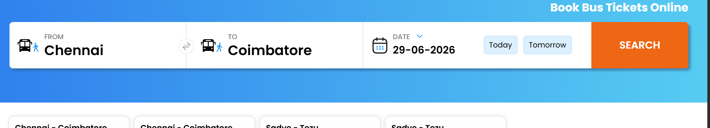
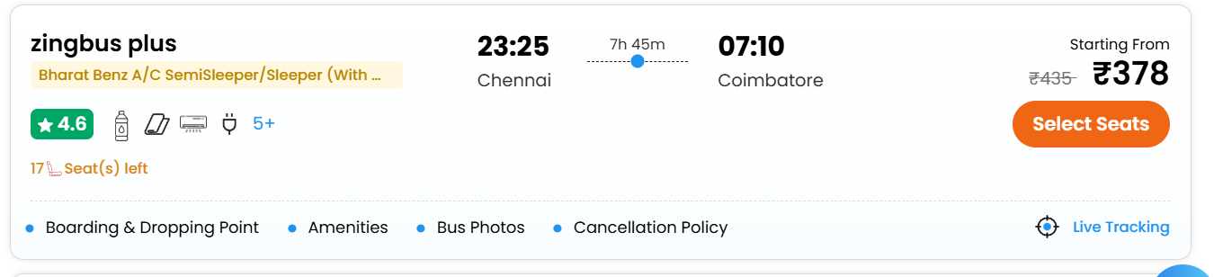

Sample Data

Environment & Setup
A new java project in Intellij

Folder Structure
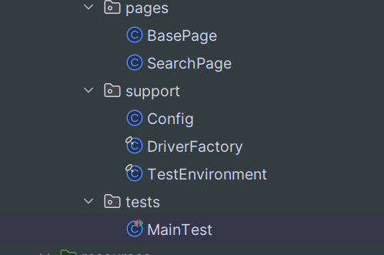
BasePage:-Contains the driver function calls and page initialization
SearchPage:-Contains the searchPage logic functions
Config:-Contains the configuration like baseUrl
DriverFactory:-Helps in creating the chrome driver
MainTest:-Contains the test function for checking UI website

Pom.xml – Contains the dependencies
junit-jupiter ---> For the test Tag recognitions
selenium ---> for performing the UI testing
hamcrest matchers --> provides the functions for assertions
maven-surefire plugin ---> Helps in running the Test files and setting up the configuration

Results:
