---- Selenium Cucumber BDD Automation Framework
---------- 1. Project Introduction ------------------------------------
This project is developed to automate the retail shopping application.
The main objective is to automate the complete checkout process from product search to order confirmation.
The framework is developed using Selenium, Cucumber, Java, Maven, and JUnit.

2. Tools Used
Tool | Purpose
Java | Programming language
Selenium | Browser automation
Cucumber | BDD framework
Maven | Dependency management
JUnit | Test execution
IntelliJ IDEA | Development tool
Allure Report | Reporting
Extent Report | Reporting

3. Framework Flow
text
Feature File
↓
Step Definition
↓
Page Classes
↓
Selenium WebDriver
--------------The feature file contains business scenarios.
--------------Step definitions call the page methods.
--------------Page classes perform browser actions.

4. Project Structure
Folder | Purpose
bdd | Steps, Hooks and World classes
pages | Page Object classes
components | Reusable components
support | Driver setup
features | Feature files
runner | Test runner

5. Page Object Model
The framework follows the Page Object Model design.
Each page contains its own locators and methods.
Example:
Page | Purpose
CatalogPage | Search products
ProductPage | Add products to cart
CartPage | Cart operations
CheckoutPage | Place order
This makes the framework easy to maintain.

6. Hooks
Hooks are used to manage browser execution.
Hook | Purpose
@Before | Launch browser
@After(order=1) | Capture screenshot if scenario fails
@After(order=0) | Close browser

7. Scenario Details
Scenario 1: Buy a Single Product End to End
Step | Expected Result
Open catalog | Application opens
Search product | Product displayed
Add product | Product added to cart
Open cart | Cart displayed
Place order | Order completed
Result: Passed
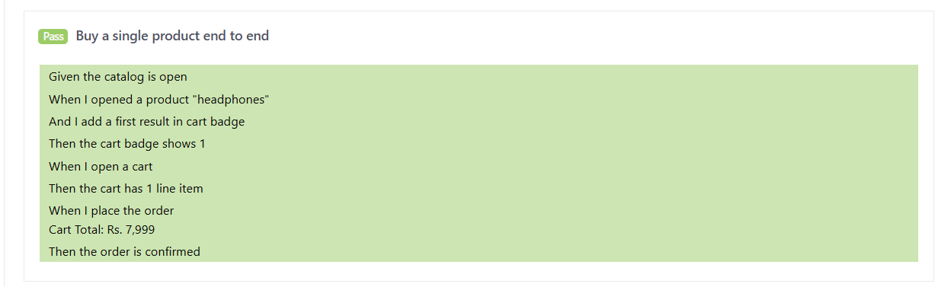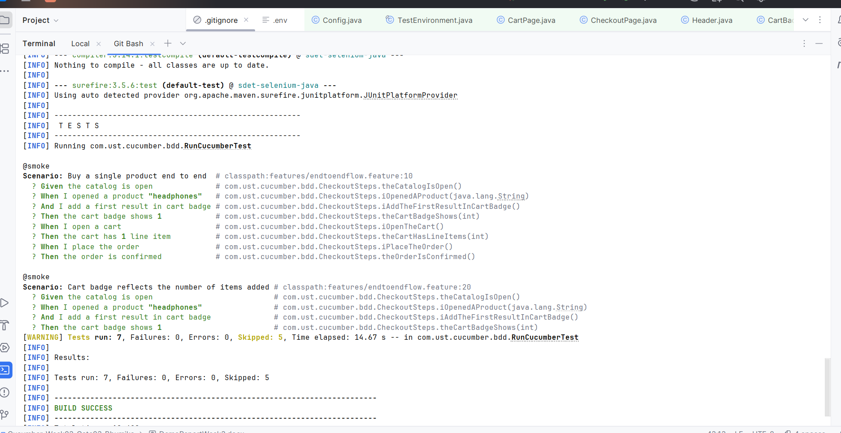
Scenario 2: Cart Badge Reflects Number of Items
Step | Expected Result
Add one item | Cart badge shows 1
Result: Passed
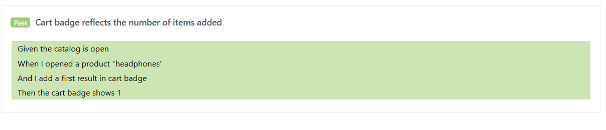

Scenario 3: Buy Multiple Products
Product | Result
Headphones | Passed
Shoes | Passed
Laptop | Passed
Result: Passed
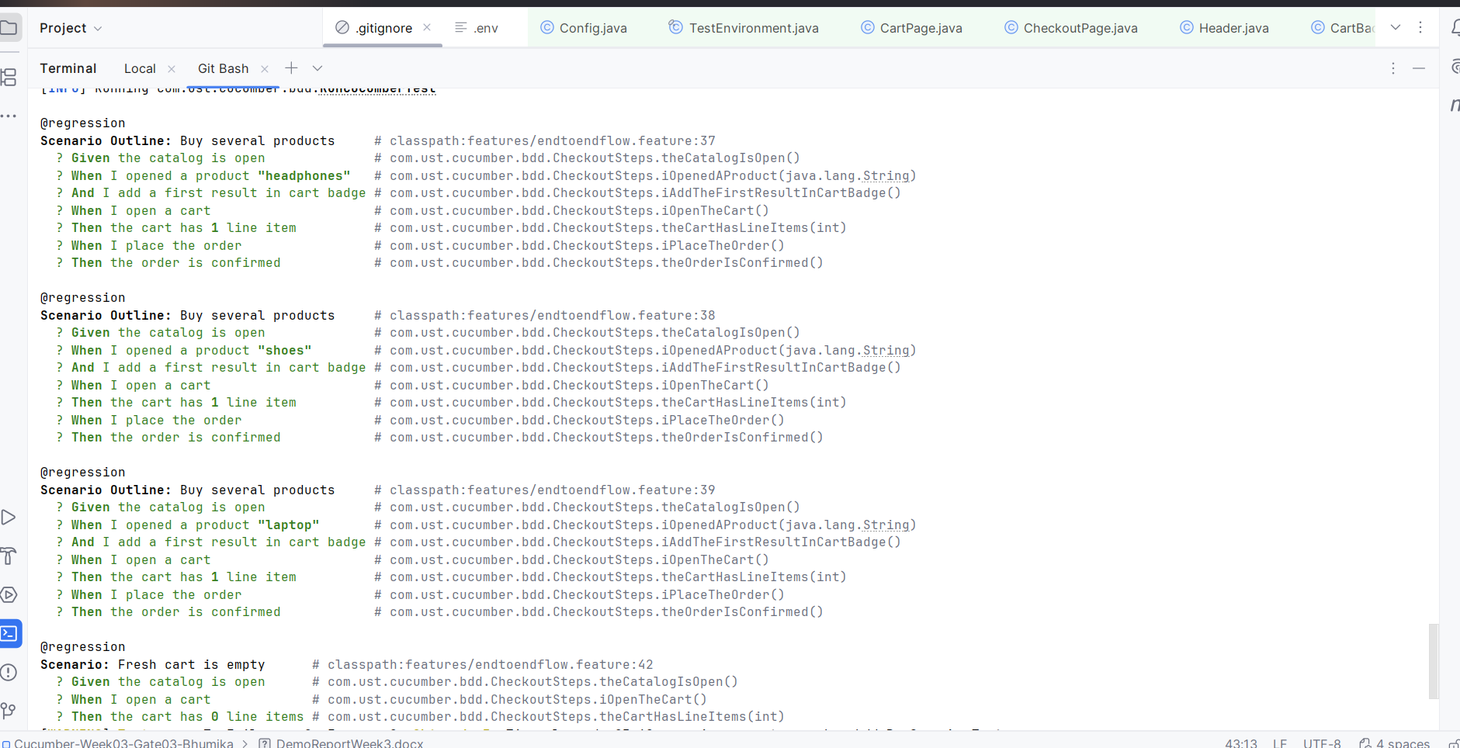

Scenario 4: Fresh Cart is Empty
Validation | Result
Cart line count | 0
Result: Passed

Scenario 5: Failure Scenario
Expected | Actual
Cart count = 2 | Cart count = 1
Result: Failed
This scenario is created to verify screenshot capture during failure.
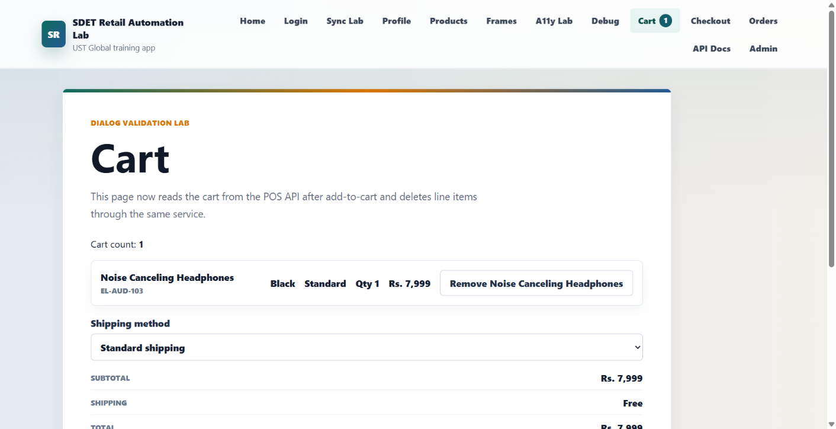

8. Reports
Report | Location
Cucumber Report | target folder
Extent Report | test-output folder
Allure Report | allure-results folder

9. Execution Commands
For Run all scenarios:
mvn clean test
Run smoke scenarios:
mvn test -Dcucumber.filter.tags="@smoke"
Run regression scenarios:
mvn test -Dcucumber.filter.tags="@regression"
Run failure scenario:
mvn test -Dcucumber.filter.tags="@negative"

10. Headless Execution
Command | Purpose
mvn test -Dheadless=true | Run tests without opening browser
The browser runs in the background without launching the UI.
This helps in faster execution and CI/CD execution.

11. Allure Report
Feature | Description
Passed Scenarios | Shows passed tests
Failed Scenarios | Shows failed tests
Step Details | Displays execution steps
Screenshots | Attached on failures
Environment Information | Shows execution environment
Command:
allure generate allure-results --clean -o allure-report

12. Extent Report
Feature | Description
Pass Statistics | Shows passed tests
Fail Statistics | Shows failed tests
Scenario Details | Execution information
Screenshots | Failure screenshots
System Information | Environment details
The report is generated automatically after execution.

13. Screenshot Capture
Event | Result
Scenario Failure | Screenshot captured
Allure Report | Screenshot attached
Extent Report | Screenshot attached
This helps to identify failures quickly.

14. Conclusion
This framework automates the retail checkout application using Selenium and Cucumber.
The framework follows the Page Object Model and provides reporting, screenshots, reusable code, headless execution, Allure reporting, and Extent reporting.
The framework supports smoke, regression, and failure scenarios and is easy to maintain and execute.

