Playwright UI Automation Test Report

Objective
To build a scalable UI automation framework using Playwright with Page Object Model (POM), Fixtures, and reusable test architecture to ensure end-to-end application validation of website https://www.shoppersstop.com and First the home page visible and perform valid and invalid search for test

Github Link
My Branch name is Shahbaz_QA_gate1 and link is

Environment Setup
- Tools: Node.js, Playwright Test Runner, TypeScript/JavaScript, VS Code
Install Commands:
- npm init playwright@latest
- npx playwright install
- Reporting Tools: HTML Reporter, Allure

Framework Architecture
The framework is built using:
- Page Object Model (for UI abstraction)
- Fixtures (for reusable setup like login, credentials)
- Test files (business scenarios)
- Config file (playwright.config.ts)

Workflow
1. Start test execution
2. Load fixtures (credentials, page, browser)
3. Navigate using page.goto()
4. Use Page Object methods
5. Execute assertions
6. Generate report

Folder Structure
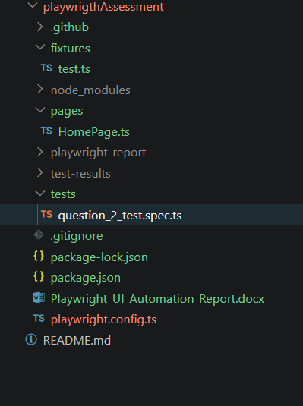

Page Object Model
Each UI page is represented as a class containing locators and methods. This improves maintainability and avoids duplication.
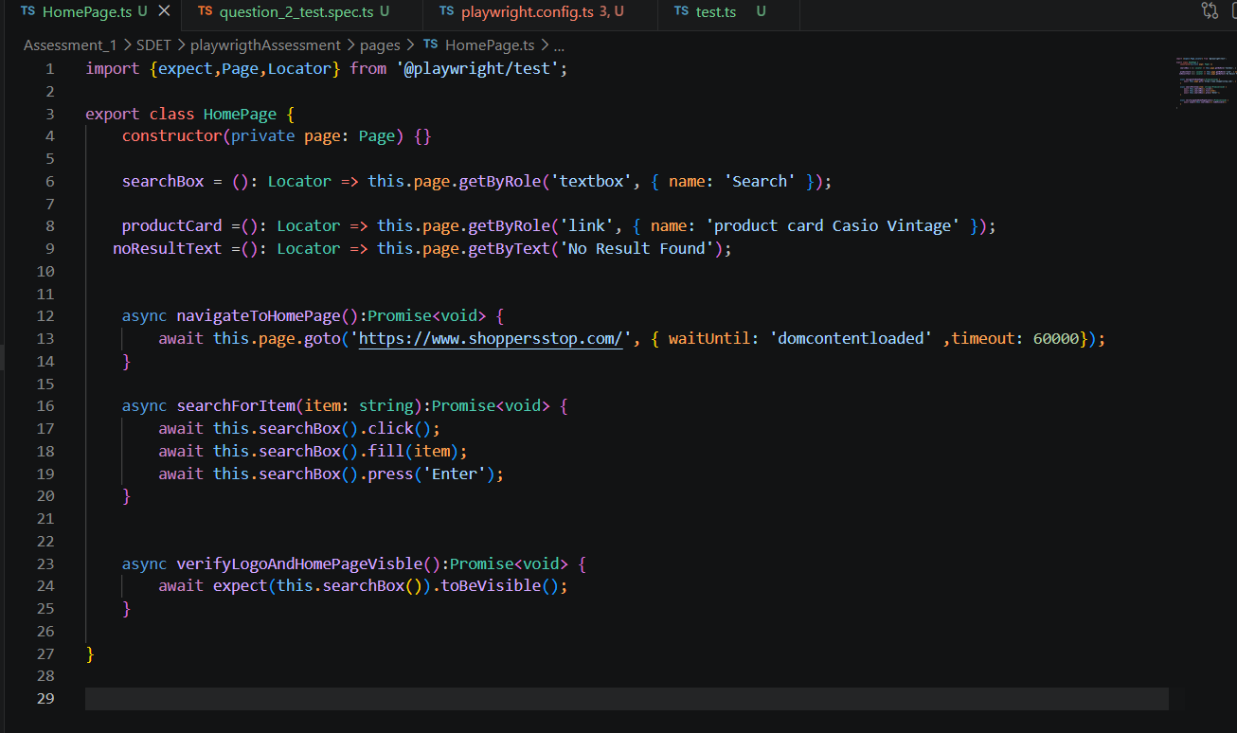

Fixtures Usage
Fixtures are used to provide reusable resources like page, browser, login session, and credentials. All user credentials are stored in fixtures for centralized management.
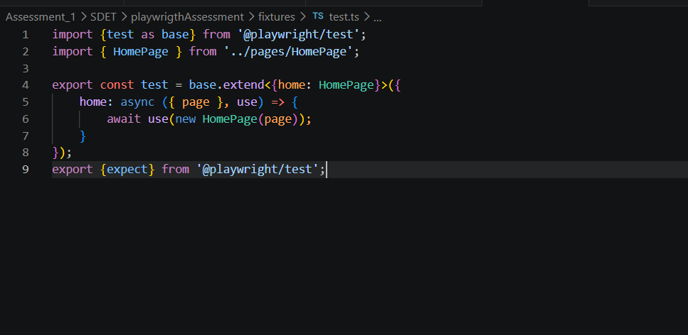

Code – Home Page with Search for happy and negative
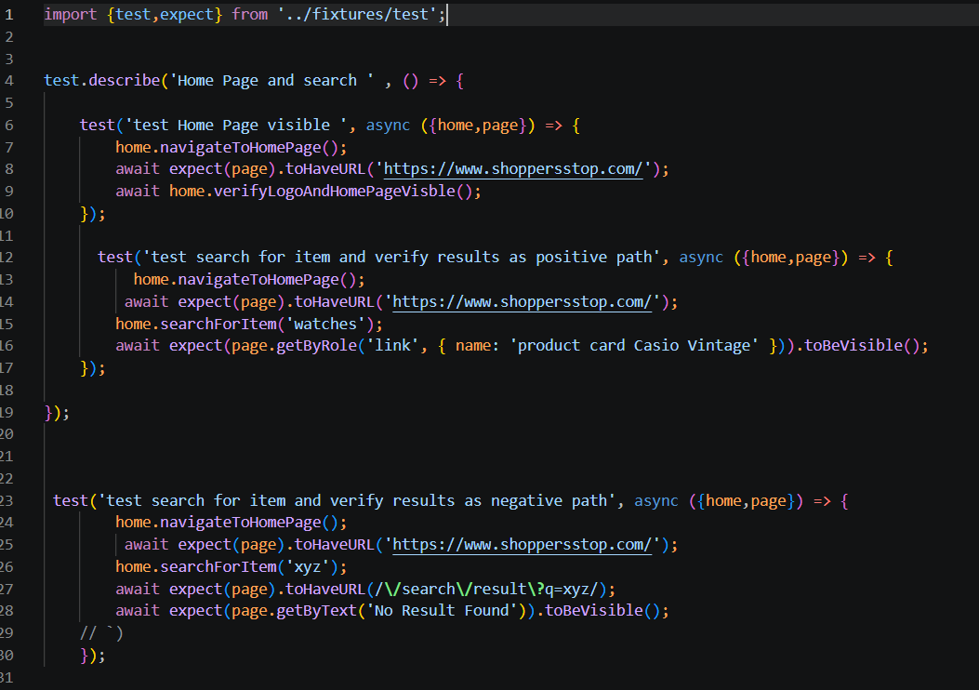

Commands
- npx playwright test
- npx playwright show-report

Result Evidence
Attach screenshots, videos, and trace files generated during execution.
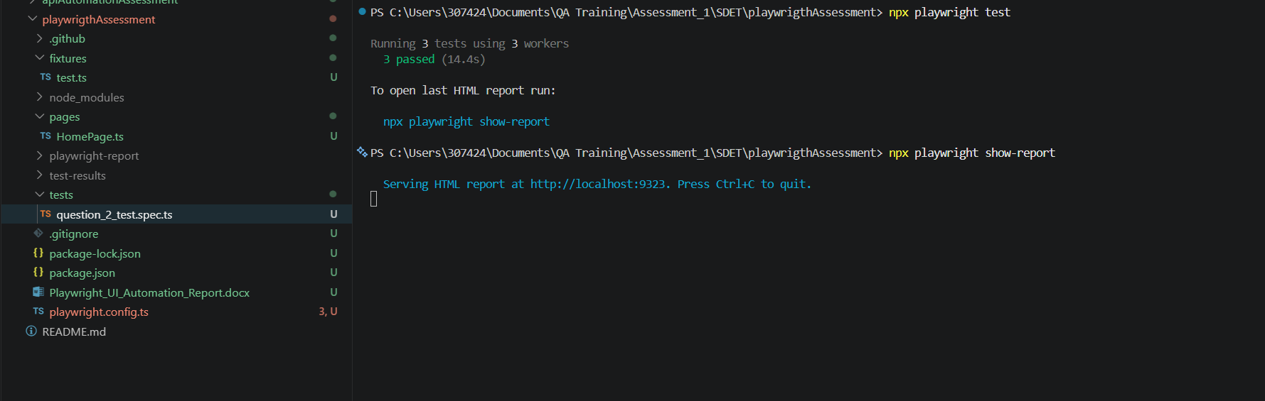

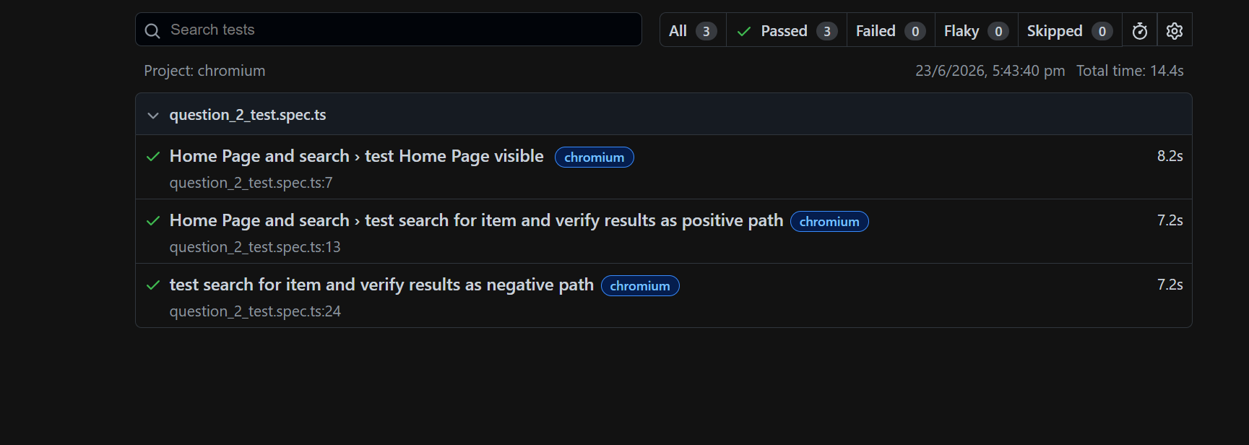
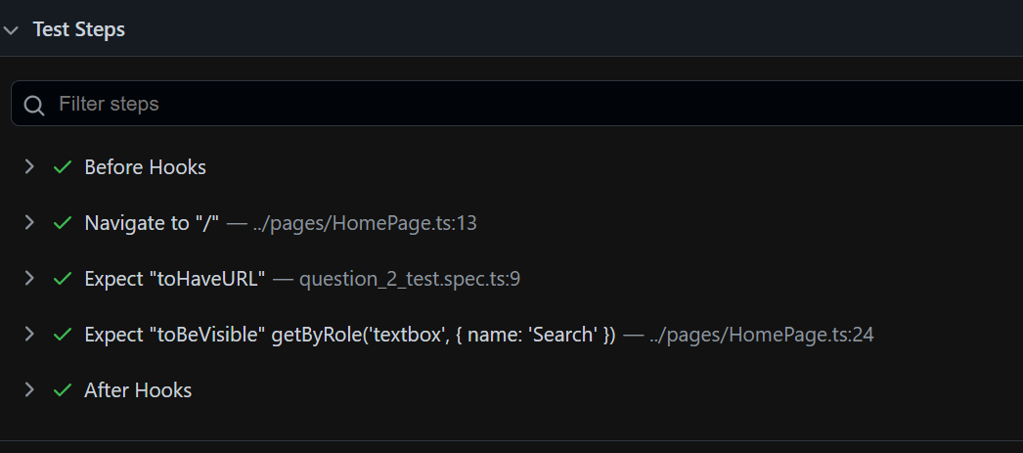

How to Solve Issues
Check locators,
wait strategies,
fixture setup,
test data, and
network conditions.

Limitations
Dependent on UI stability, network speed, and environment configuration.

Conclusion
Playwright framework ensures scalable, maintainable, and fast UI automation using modern testing practices.

