Catalog Checkout – Test Scenario Documentation

Feature Overview:

- Feature Name: Catalog Checkout

- UserStory:
---------
As a shopper, I want to search the catalog, add a product to my cart and complete checkout so that I can purchase products successfully and ensure the purchase flow works correctly on every application build.

- Background
----------
Given the catalog is open (This step is executed before every scenario and ensures that the user starts from the catalog page.)

-> Smoke Test Scenarios
-----------------
- Buy a Single Product End-to-End

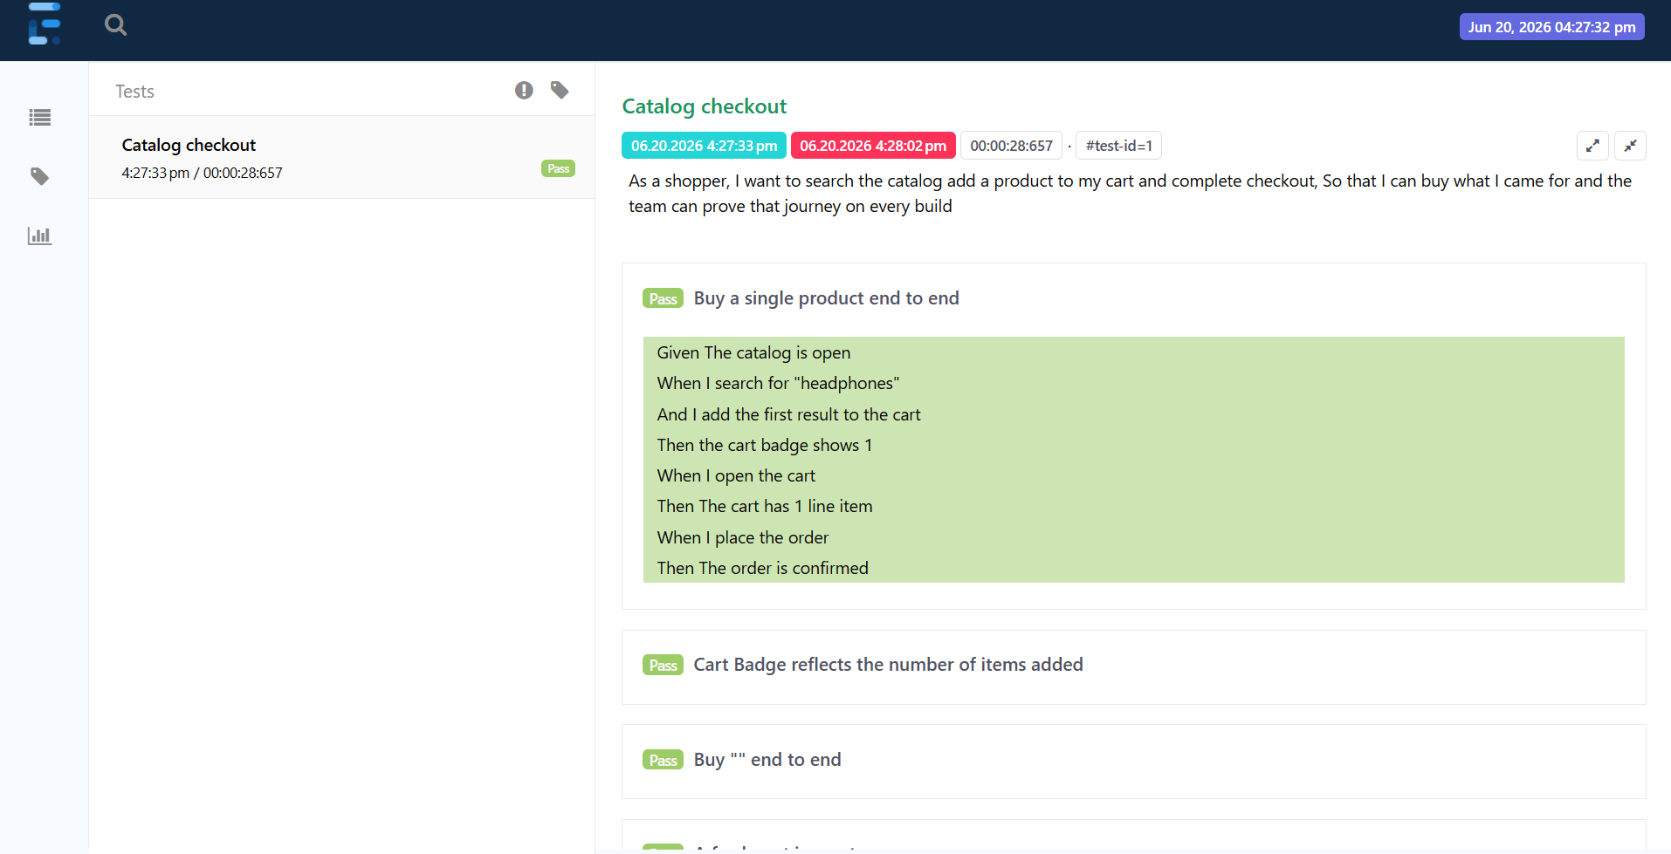
- Objective:
Verify that a shopper can search for a product, add it to the cart and successfully place an order.

- Test Steps:
The user searches for "headphones" in the catalog and adds the first product from the search results to the shopping cart.The cart badge should update and display 1 item. The user then opens the cart and verifies that it contains one product. After confirming the cart contents, the user proceeds to checkout and places the order. The order should be completed successfully and an order confirmation message should be displayed to the user.

- Expected Result:
The order is placed successfully and an order confirmation is displayed.

2) Cart Badge Reflects Added Item Count

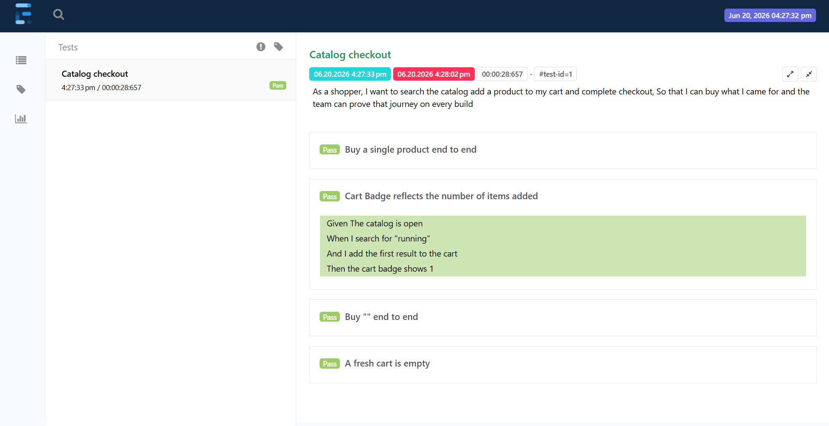
- Objective:
Verify that the cart badge count updates correctly after adding a product.

- Test Steps:
The user searches for "running" in the catalog and views the matching products displayed in the search results.
The user then adds the first product from the results to the shopping cart.
After the product is added, the cart badge should update and display a count of 1, confirming that the item has been successfully added to the cart.

- Expected Result:
Cart badge accurately reflects the number of items added.

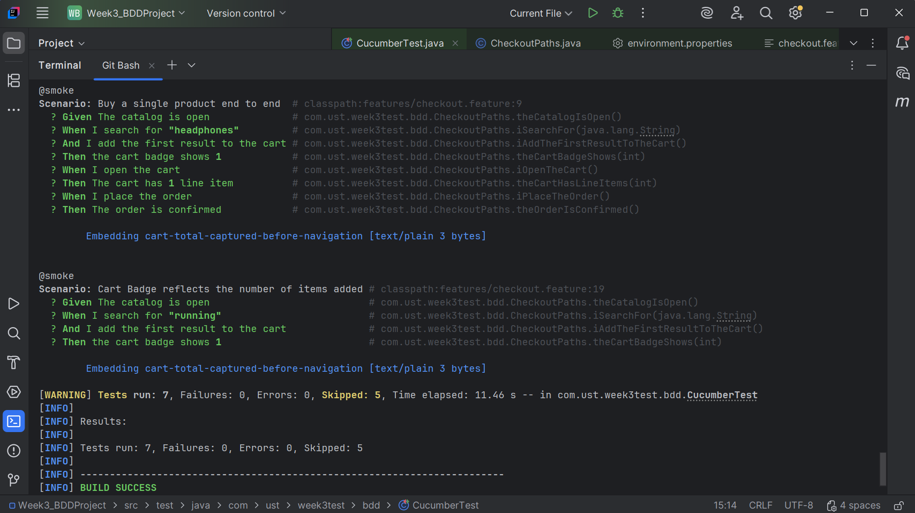

-> Regression Test Scenarios
---------------------
3) Buy Product End-to-End Using Multiple Test Data

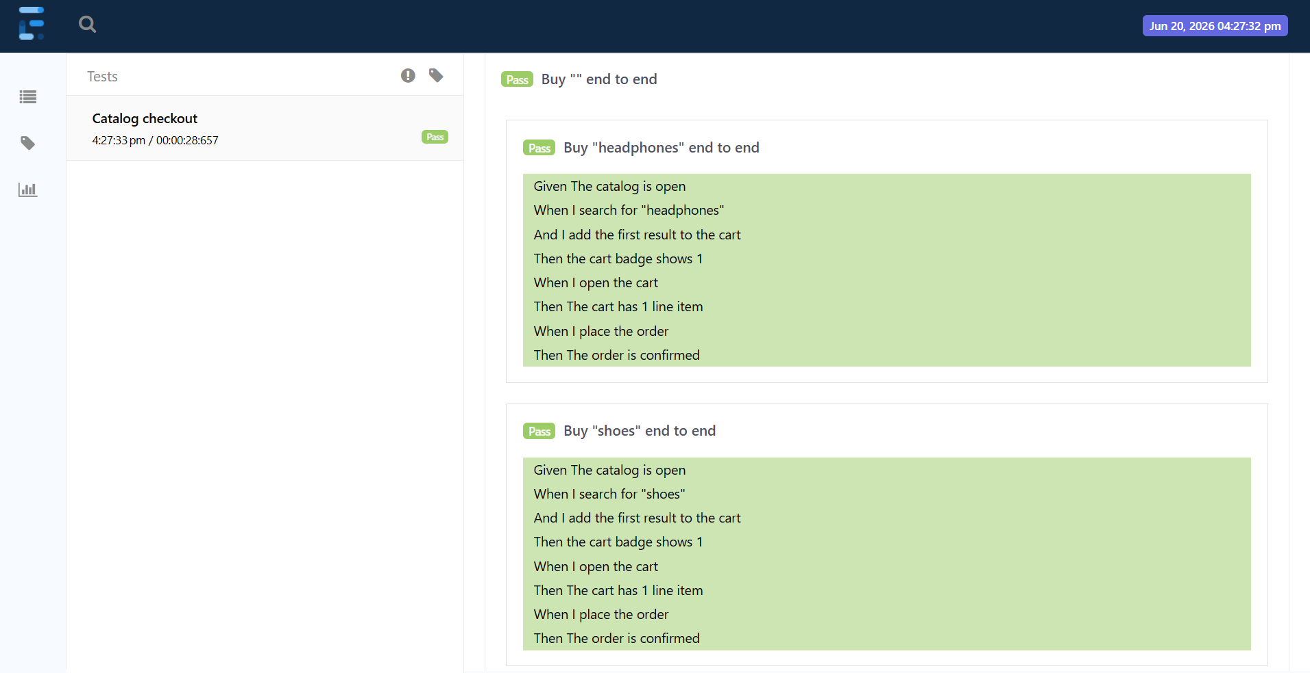
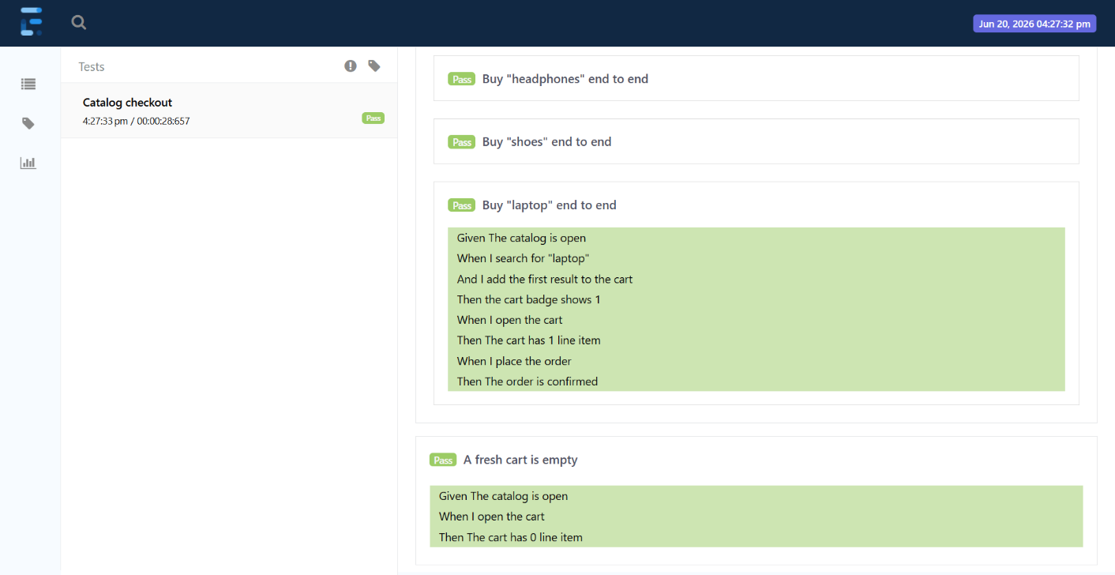
- Objective:
Verify that different products can be purchased successfully using data-driven testing.

- Test Data:
| Product | Expected Count |
| ---------- | ------------------ |
| headphones | 1 |
| shoes | 1 |
| laptop | 1 |

- Test Steps:
The user searches for a product using the test data provided, such as headphones, shoes or a laptop.
From the search results, the user adds the first available product to the shopping cart.
The cart badge is then verified to ensure it displays the expected item count.
The user opens the cart and confirms that the correct number of items is present.
After verifying the cart contents, the user proceeds to place the order.
The checkout process should complete successfully and an order confirmation message should be displayed,
indicating that the purchase was successful.

- Expected Result:
Each product can be purchased successfully and the order is confirmed.

4) Verify Fresh Cart is Empty

- Objective:
Verify that a newly opened cart contains no products.

- Test Steps:
The user opens the shopping cart without adding any products. The cart page should open successfully
and the user should be able to verify that the cart is empty. The cart should display 0 line items, confirming that no products have been added.

- Expected Result:
An empty cart should show 0 items.

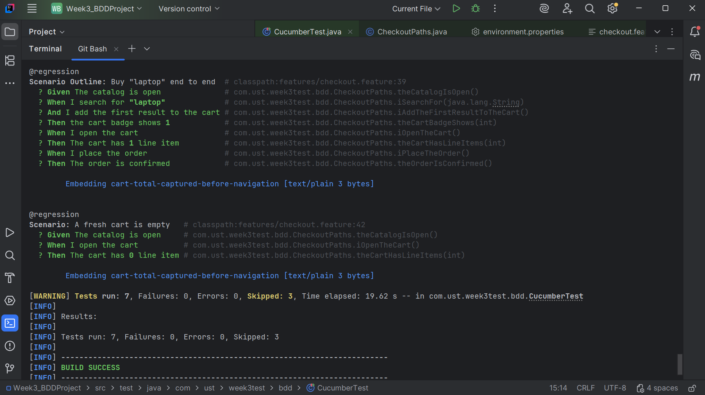

-> Negative Test Scenario
--------------------
5) Attempt to Buy a Product Not Available in Catalog
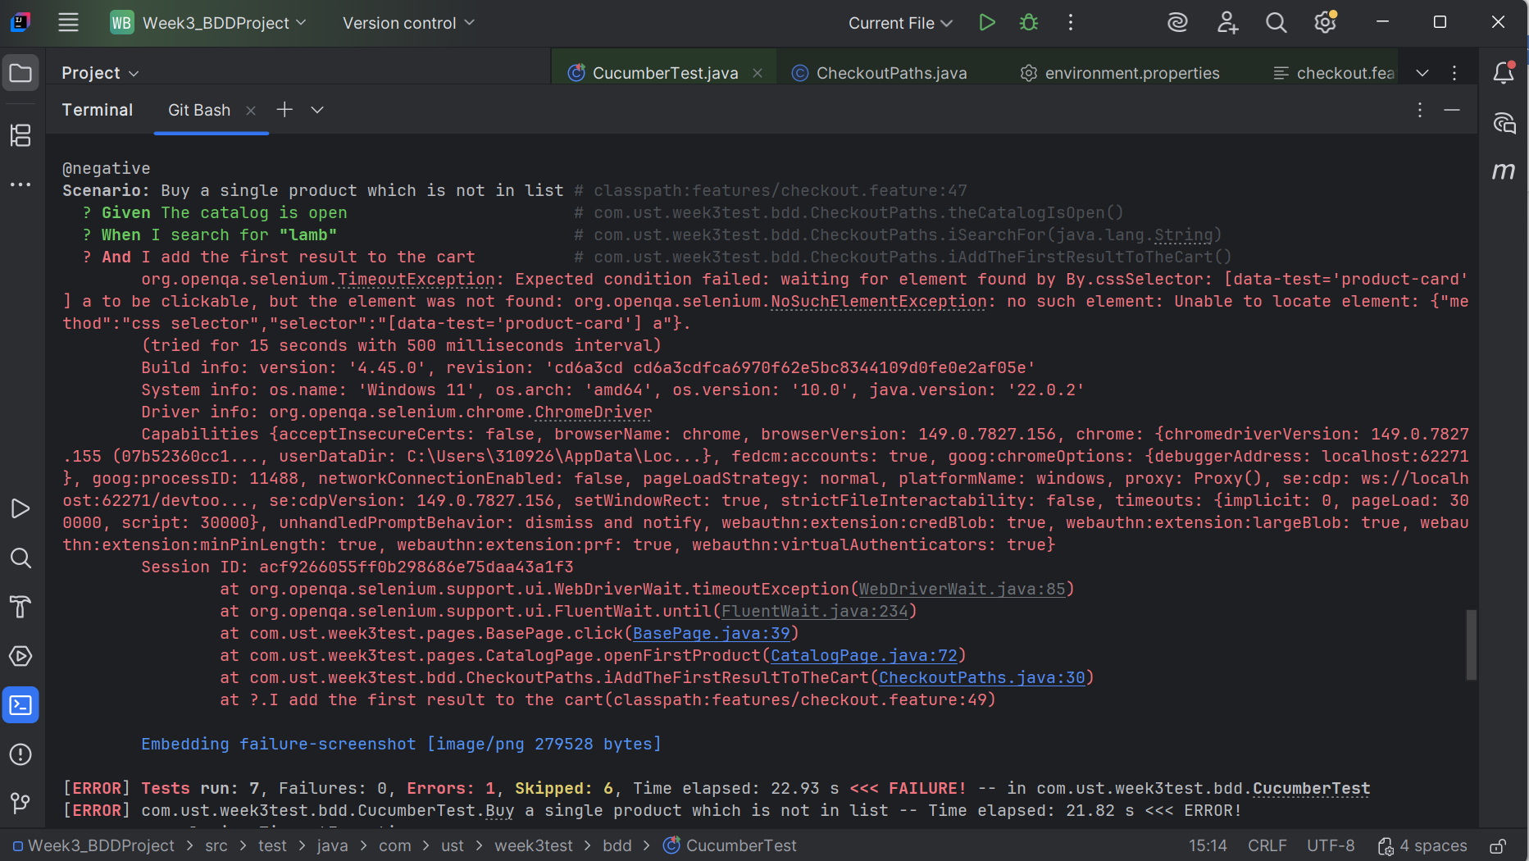

- Objective:
Verify system behavior when a user searches for a product that does not exist.

- Test Steps:
The user searches for "lamb" in the catalog.
Since no products matching the search term are available, the system should display a message indicating that no products were found.
When the user attempts to add a product to the cart, the system should prevent the action because there are no search results available.
An appropriate error or informational message should be displayed and no items should be added to the shopping cart.

- Expected Result:
User should be informed that no products are available, and no item should be added to the cart.

- Validation Points:
* Search results list should be empty.
* Cart badge should remain 0.
* No product should be added to the cart.
* Appropriate "No products found" message should be displayed.

