Name:J.Ragumaan
Date:04-07-2026
Week5-Assessment(Advanced playwright UI Testing):

Issue & fixes
Verify whether the login test is flaky due to clicking the Sign in button before the application finishes hydrating
Command to run:npx playwright test login.spec.ts - -repeat-each=10
Image1:Green after repeating 10 times (no failure).
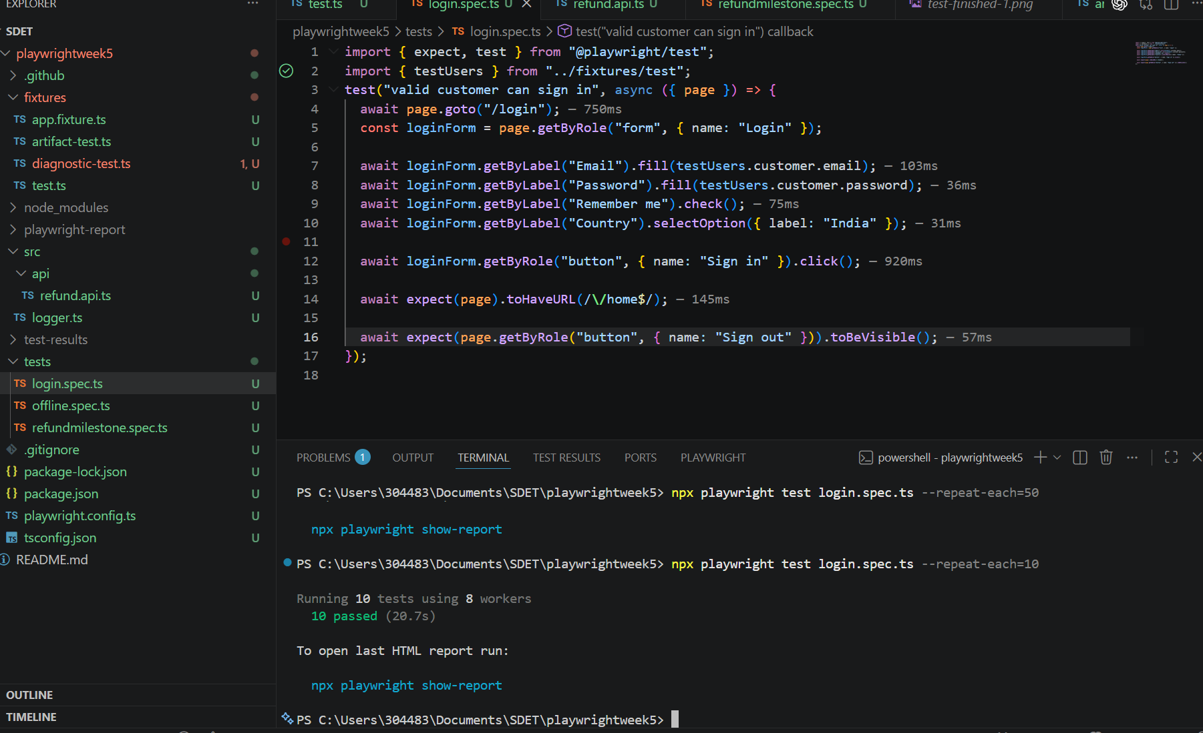

Image2: Playwright report out-put(for 10 repeatation)
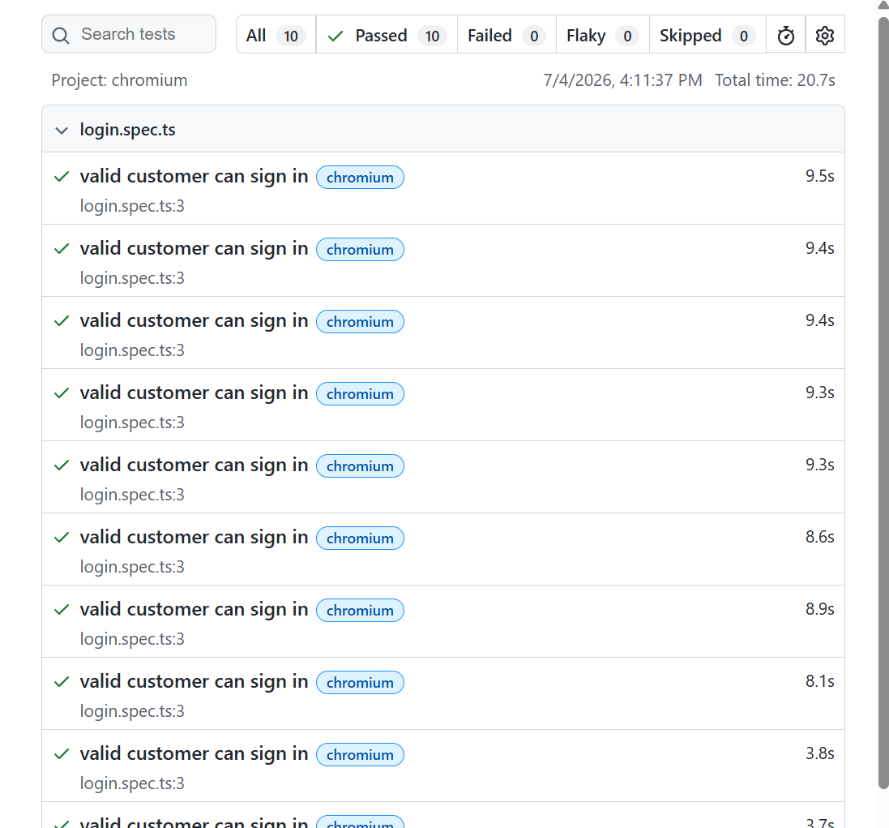
Image3: Screen shot on success full test passed
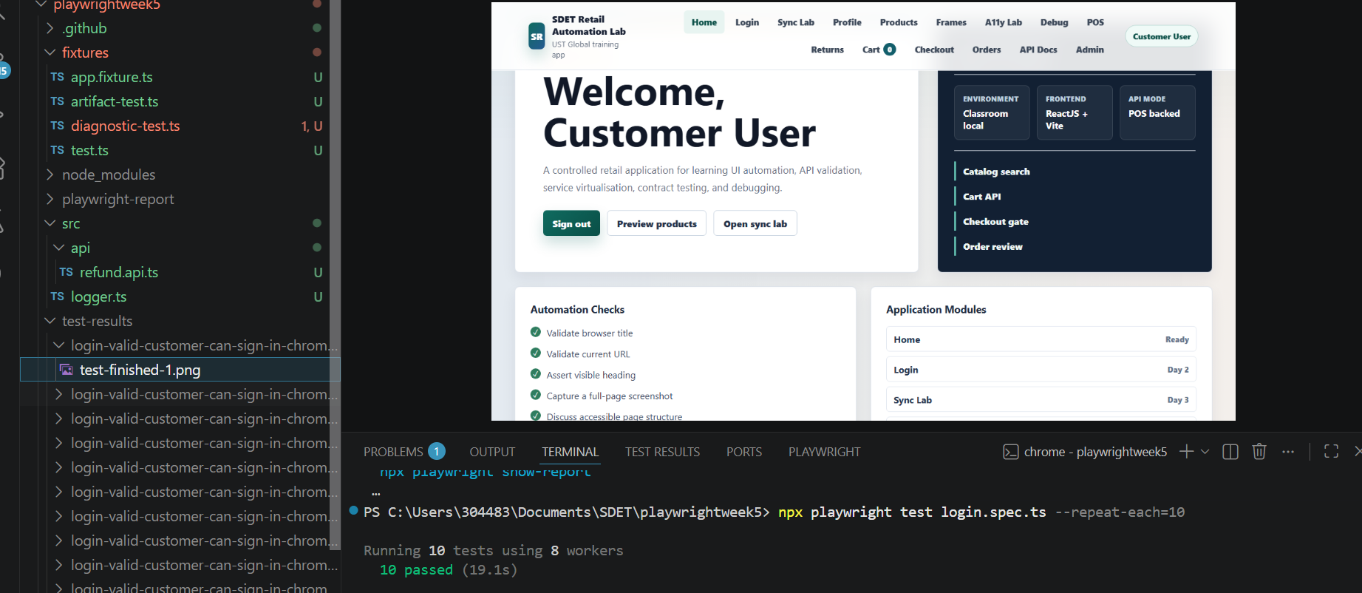
Image4:Playwright report(After 50 runs)-Greens
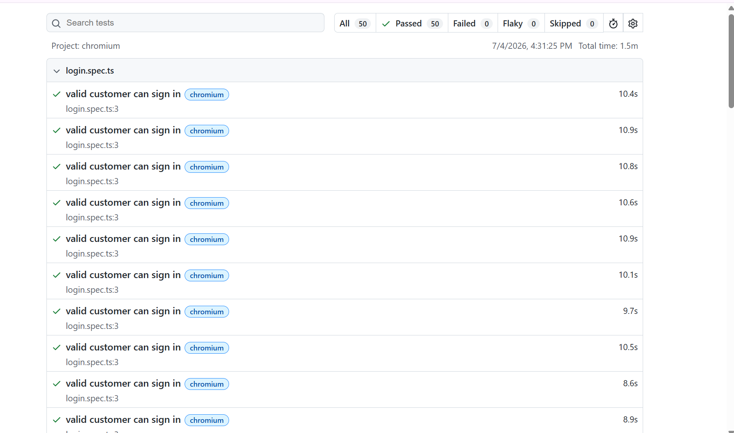

Image4:commandline evidence
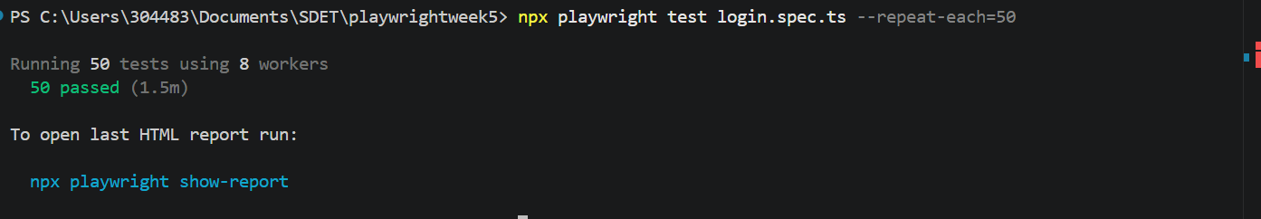
Conclusion: There is no flaky while running it 10 times and while running it 50 times application login function is working properly (Why because while opening the login page we wont go to click the sign in button we will be entering credentials later only we will click in this mean time everything is getting loaded so don’t get any flaky. Application is working fine.
Issue &fixes(cart total of By paisa)
Symptom:
Scenario: Cart Total Stabilization
Objective:
Ensure refund calculations are accurate and free from one-paisa rounding errors.
Issue:
When monetary values are calculated using floating-point numbers, rounding differences can cause the final cart total or refund amount to differ by one paisa.
Root Cause:
The calculations relied on decimal (floating-point) arithmetic, which is not suitable for financial transactions due to precision limitations.
Fix Implemented:
- Performed all monetary calculations using integer paise instead of decimal currency values.
- Added an invariant check to verify that the sum of all prorated tax shares equals the original order tax.
Verification:
- Line Amount: 65000 paise
- Prorated Tax: 2500 paise
- Refund Amount: 67500 paise
- Sum of Tax Shares: 10000 paise
All assertions passed successfully, confirming that the refund calculation is exact and no rounding errors occur.
Evidence:test passed (Green)
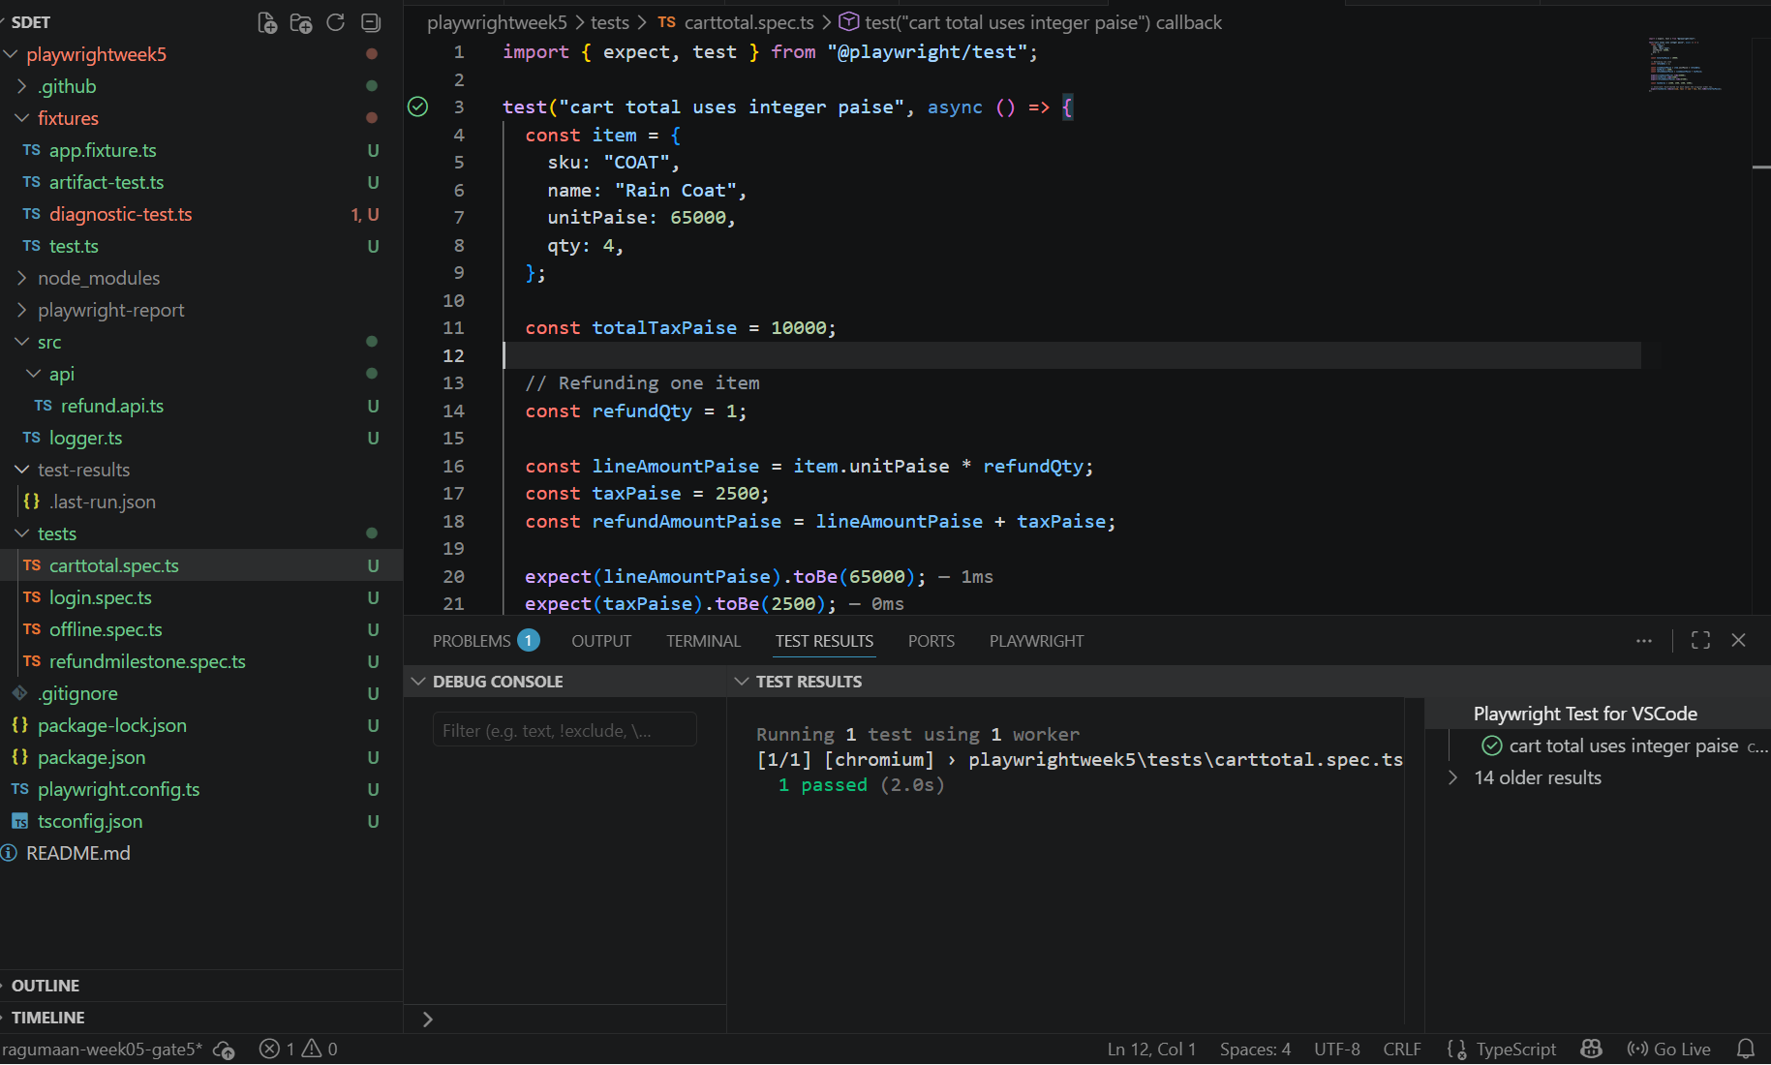
Image2:Playwright report

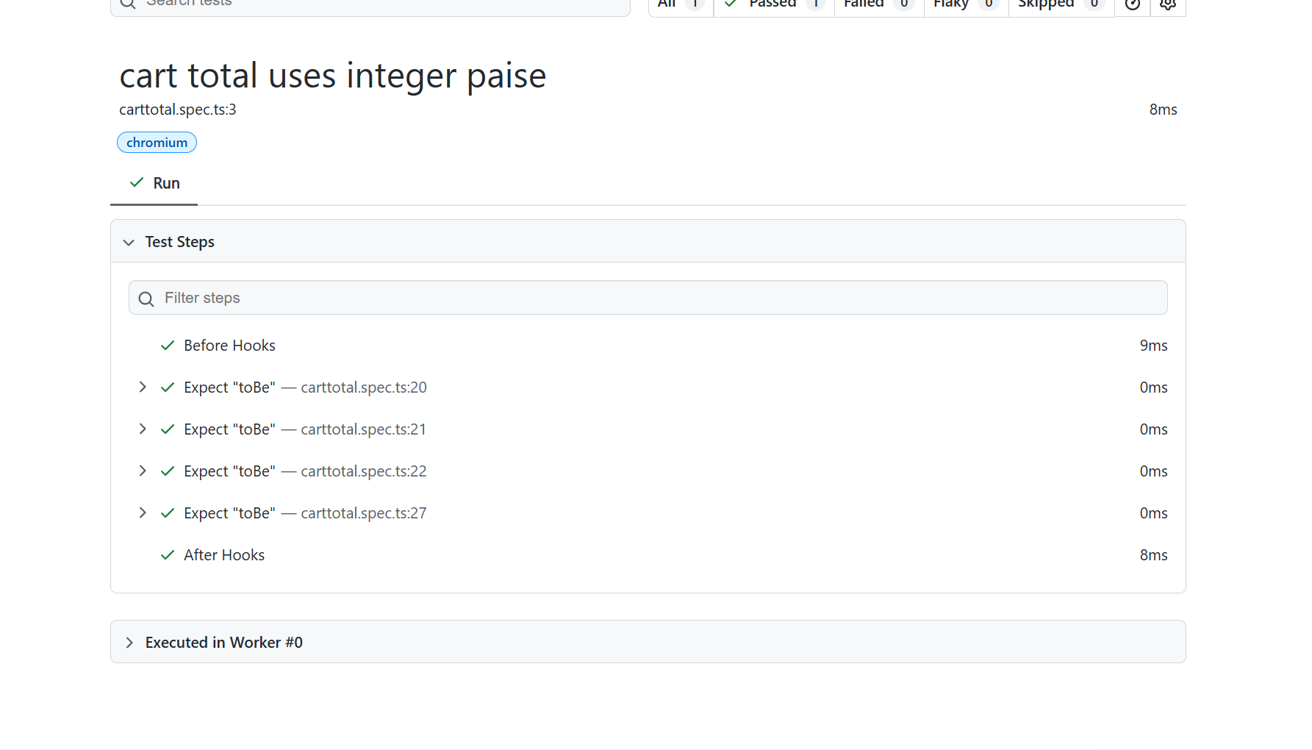

Issue & fixes(Offline)
Symptom:
We are unable to load the page because system is set to offline.
Cause of issue:
We are making the system offline before loading the page we cant see the application because we are offline .

Image1:We can able to see here we are running setOffline(true) first so we cant open the application so next line will through error
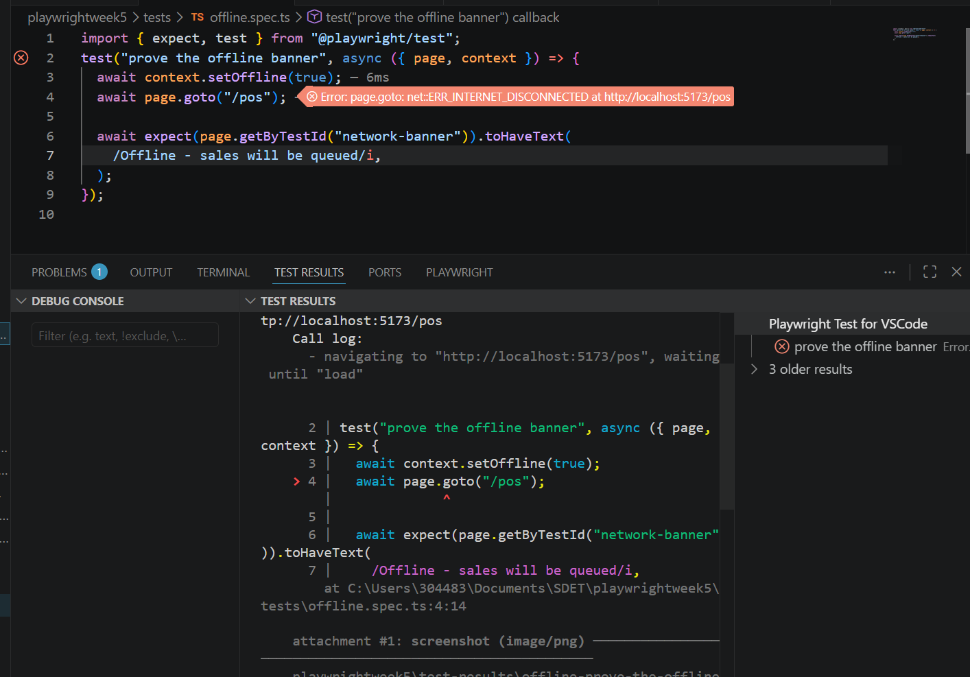

Image2:test-results-we have collected the image, trace.zip,video.webm
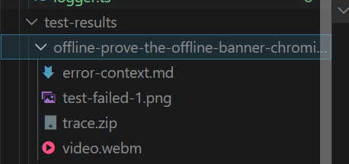

After Fix:test passed successfully

Image3:Green tick(passed)
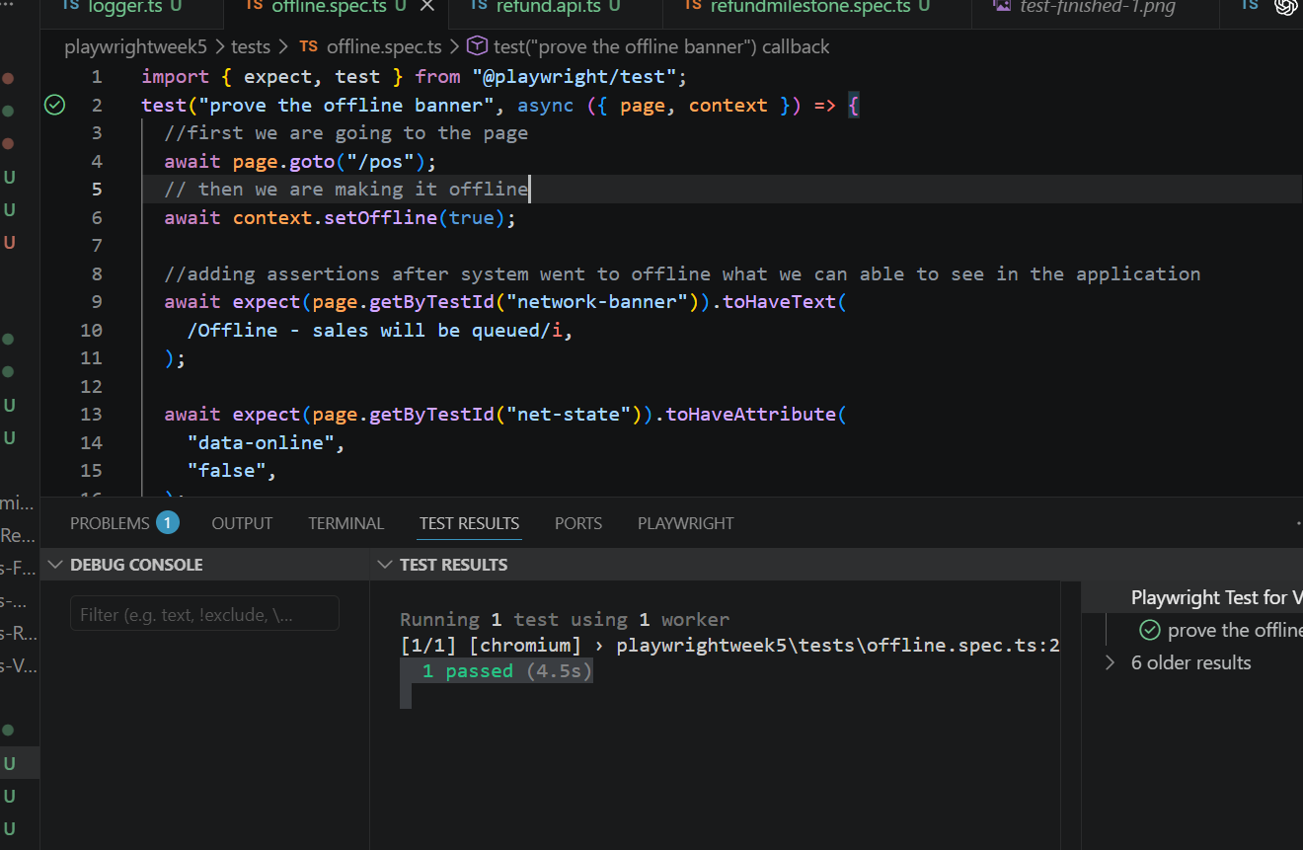
The test got passed because we have loaded the page first and then we set it to offline so in offline also now we can work.But the thing will be in pending state once we get back to online we can see the status of the product synced.
Playwright report proofs
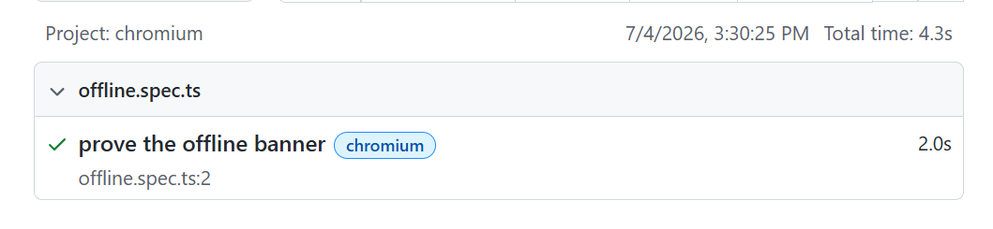
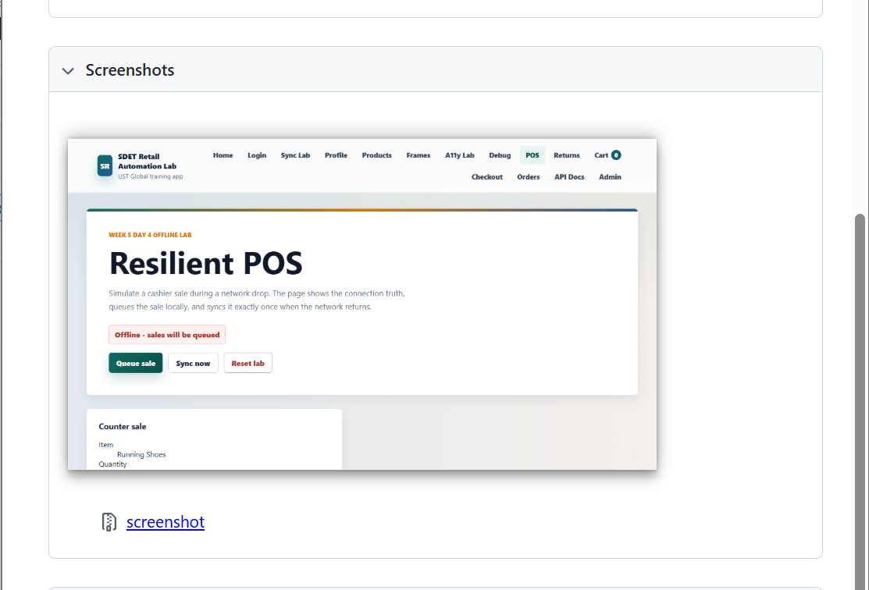

Issue & fixes
Symptom
Duplicate refund requests were processing twice, creating two separate transactions and causing a duplicate payout.
Cause of issue:
The refund API treated every request as completely new because it lacked an Idempotency-Key to detect duplicate submissions.
Evidence
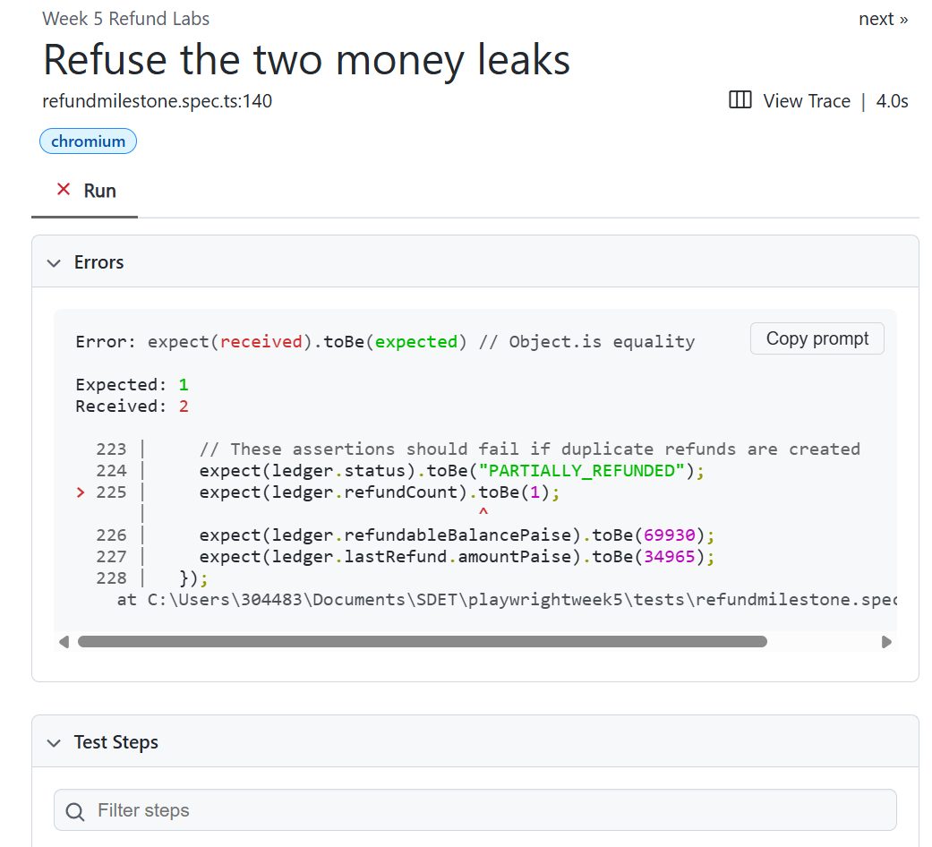

Failed Test
- Test Case: Refuse the two money leaks
- Assertion: expect(ledger.refundCount).toBe(1);
- Result: Failed (Expected 1, but received 2).
See the attached failing Playwright HTML report screenshot
After Fix :
- Test Case: Refuse the two money leaks (Executed with the new Idempotency-Key)
- Result: Passed (refundCount correctly equals 1).
- See the attached passing Playwright HTML report screenshot with the green checkmark.
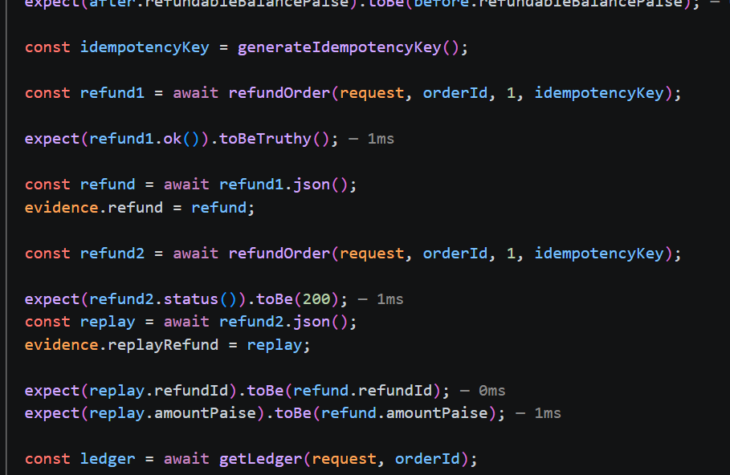

Playwright report:test case passed
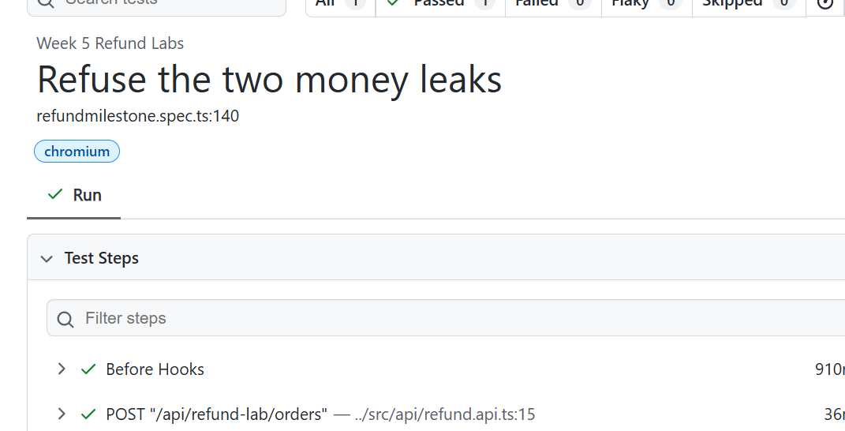
Attachment:
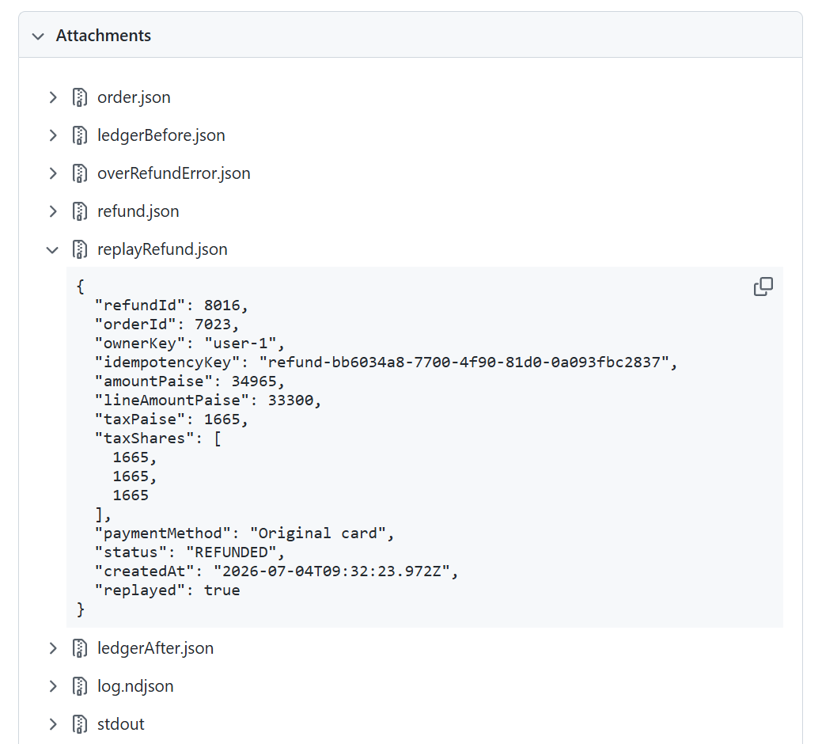
Fix
We added an Idempotency-Key header to every refund request. The backend now logs the initial request and simply returns the existing refund data if the same key is submitted again, blocking duplicate creations.

Conclusion: The application was successfully stabilized by resolving issues related to duplicate refunds, offline synchronization, and monetary calculations. Each issue was analyzed to identify its root cause, corrected with an appropriate solution, and verified through automated Playwright tests. The successful execution of the tests confirms that the implemented fixes improved the application's reliability, accuracy, and overall stability.

