Week 4 Assessment Documentation

1. Project Overview
This project focused on Contract Testing, UI Automation, and CI/CD validation.
We created two modules:
• consumer-storefront – acts as consumer
• provider-catalog – acts as provider

2. Tools Used
• Java – programming language
• Maven – build tool
• JUnit 5 – testing framework
• Pact – contract testing
• WireMock – mock server
• Selenide – UI automation
• GitHub Actions – CI/CD pipeline

3.project structure:

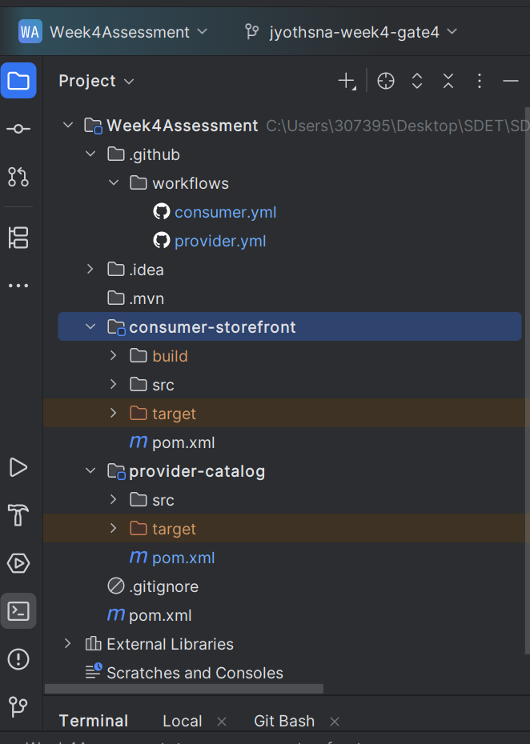

3. Consumer Contract Testing
Consumer defines expected API behavior from provider.
Example:
GET /catalog/SKU-1
Expected response:
{
sku: SKU-1,
availability: IN_STOCK,
priceMinor: 129900
}
Pact generates contract JSON inside target/pacts.

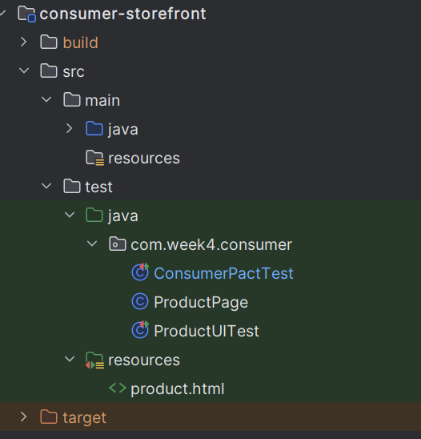

4. Positive Scenario
Product exists:
• Request: GET /catalog/SKU-1
• Status: 200
• Valid response body returned

5. Negative Scenario
Product missing:
• Request: GET /catalog/SKU-999
• Status: 404
• Response:
{ message: Product not found }

6. Pact File Generation
After mvn test:
target/pacts/storefront-web-catalog-service.json
This file contains:
• Consumer name
• Provider name
• Interactions
• Request
• Response

7. Provider Verification
Provider verifies pact generated by consumer.
Created CatalogProviderPactTest.java
Used:
@Provider("catalog-service")
@PactFolder("../consumer-storefront/target/pacts")
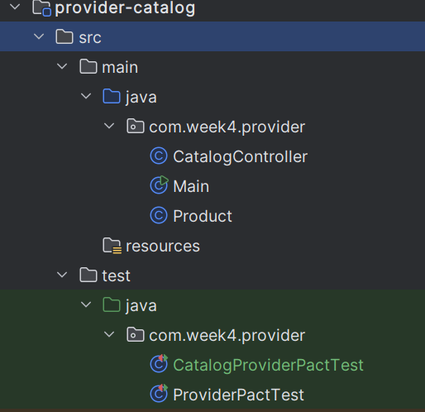

8. WireMock
WireMock simulates provider API.
Started on port 8089.
Used stubFor() to return mock responses.

9. Provider States
Examples:
@State("SKU-1 exists")
@State("SKU missing")
These must match consumer .given() states.

10. Verification Flow
• Read pact JSON
• Read interaction
• Match provider state
• Hit provider endpoint
• Compare response
If matched → success

11. UI Automation
Created ProductUITest.java
Used Selenide to open local HTML page.
Validated product availability badge.

12. Page Object Model
Created ProductPage class.
Benefits:
• reusable code
• cleaner tests
• easier maintenance

13. Issues Faced
• Pact signature mismatch
• Connection refused localhost
• Duplicate dependency versions
Fixes included correct pact version and correct ports.
THE FINAL OUTPUT

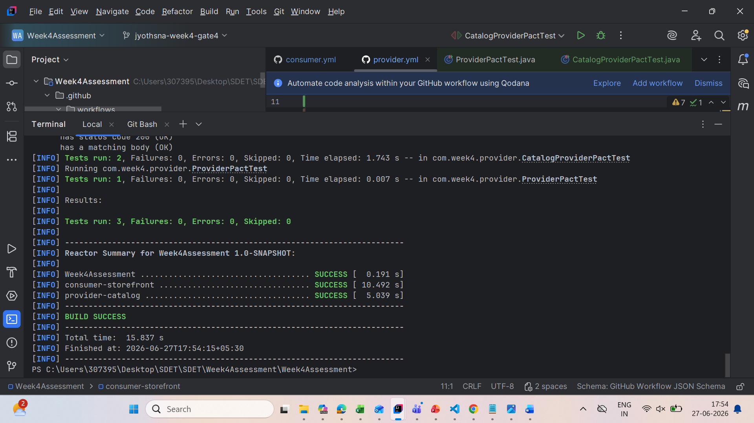

14. GitHub Actions
Created:
• consumer.yml
• provider.yml

Consumer pipeline:
• Checkout code
• Setup Java
• Run consumer tests

Provider pipeline:
• Checkout code
• Setup Java
• Run provider tests

15. Pact Broker
Pact Broker stores contracts centrally.
Helps share pacts between consumer and provider automatically.

16. Can I Deploy
Deployment safety gate.
Checks whether deployment breaks existing consumers.

Possible result:
YES → Safe to deploy
NO → Deployment blocked

17. Break Demo
API break:
Rename field priceMinor to price → consumer fails

UI break:
Change text IN STOCK to AVAILABLE → UI test fails

18. Learning Outcome
Learned:
• Contract testing
• Pact generation
• Provider verification
• WireMock stubbing
• UI automation
• CI pipelines
• Safe deployment validation

Conclusion:
This project gave practical experience in modern software testing using Pact, WireMock, Selenide, and GitHub Actions.

