Retail Catalog to Checkout Flow– Test Execution Documention
Automation Framework: Selenium + Java + Cucumber + JUnit5 + PicoContainer + Allure + Extent Reports
Test Scenario 1
Scenario Name: Buy a Single Product End-to-End
@smoke
Step 1: Open the Catalog
The application was launched successfully and the catalog page was loaded.
Expected Result
The product catalog should be displayed.
Actual Result
The catalog page loaded successfully and all products were visible.
Status: Pass
Screenshot
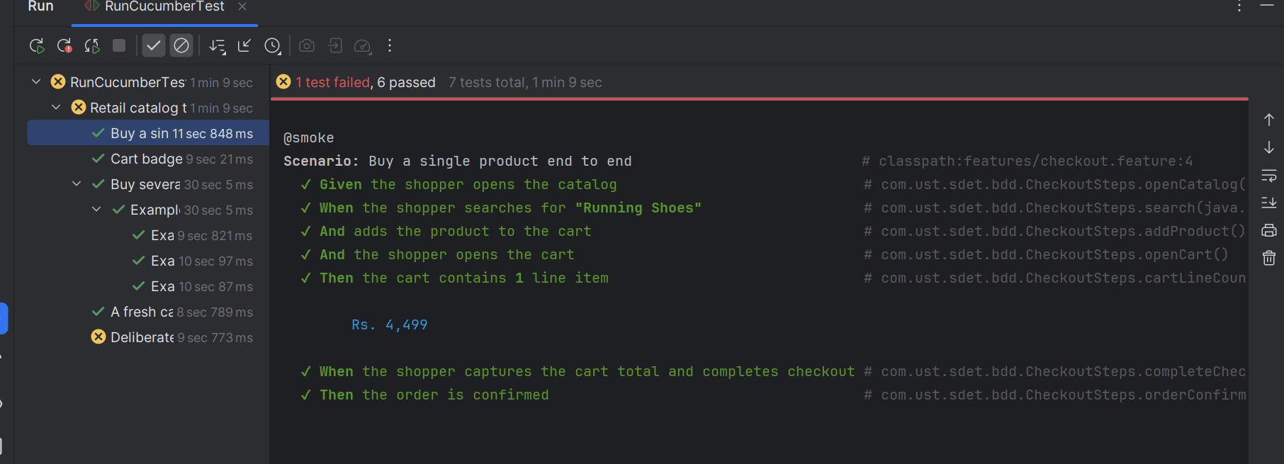
Step 2: Search for "Running Shoes"
The product search functionality was used to search for Running Shoes.
Expected Result
Only products related to Running Shoes should be displayed.
Actual Result
The search results were filtered correctly and Running Shoes was displayed.
Status: Pass
Screenshot
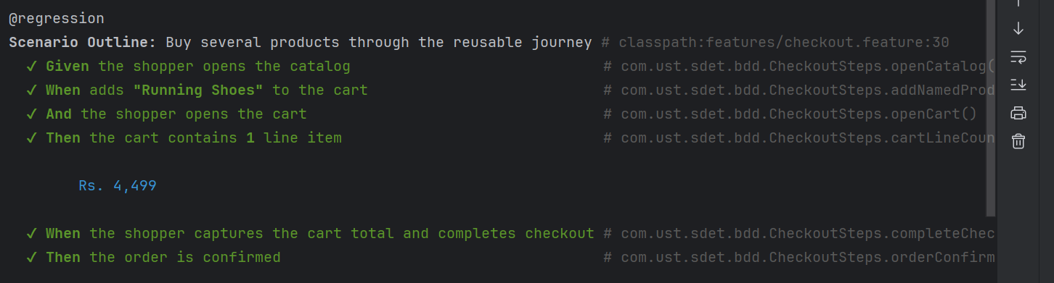
Step 3: Add Product to Cart
The displayed Running Shoes product was added to the shopping cart.
Expected Result
The selected product should be added to the cart and the cart badge should increase.
Actual Result
The product was added successfully and the cart badge count became 1.
Status: Pass

Step 4: Open Shopping Cart
The cart icon was clicked to navigate to the cart page.
Expected Result
Cart page should display the added item.
Actual Result
Cart page opened successfully and showed one line item.
Status: Pass
Screenshot
Step 5: Verify Cart Total and Complete Checkout
The cart total was captured before proceeding with checkout.
Captured Cart Total:
Example: Rs. 4,499
Expected Result
Checkout should complete successfully.
Actual Result
Checkout process completed successfully.
Status: Pass
Screenshot
Step 6: Verify Order Confirmation
The confirmation page was displayed after order placement.
Expected Result
Order confirmation message should be displayed.
Actual Result
Order was placed successfully and confirmation message was displayed.
Status: Pass

Test Scenario 2
Scenario Name : Cart Badge Reflects Number of Items Added
@smoke
Test Steps
- Open catalog.
- Add Travel Backpack to cart.
- Verify cart badge count.
Expected Result
Cart badge should display value 1.
Actual Result
Cart badge displayed value 1.
Status: Pass
Screenshot
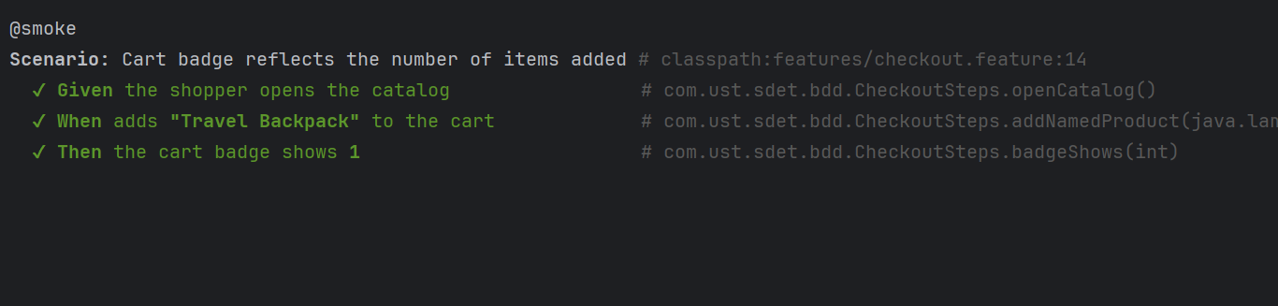
Test Scenario 3
Scenario Name: Buy Several Products Through Reusable Journey
@regression
Product 1 – Running Shoes
Execution completed successfully.
Cart contained 1 item and order was confirmed.
Status: Pass
Screenshot
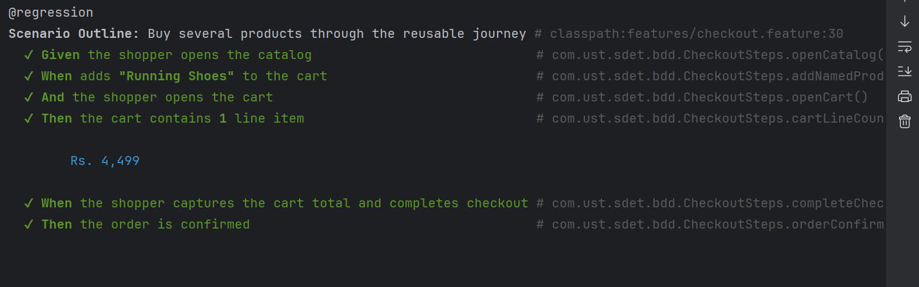
Product 2 – Travel Backpack
Execution completed successfully.
Cart contained 1 item and order was confirmed.
Status: Pass

Screenshot
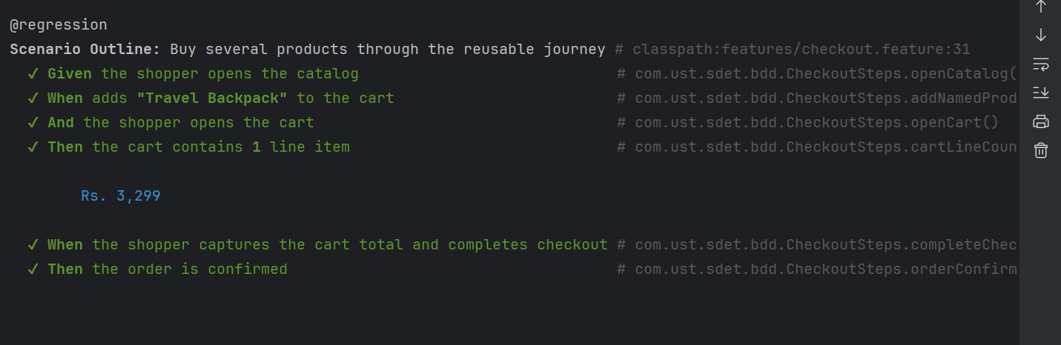
Product 3 – Noise Canceling Headphones
Execution completed successfully.
Cart contained 1 item and order was confirmed.
Status: Pass
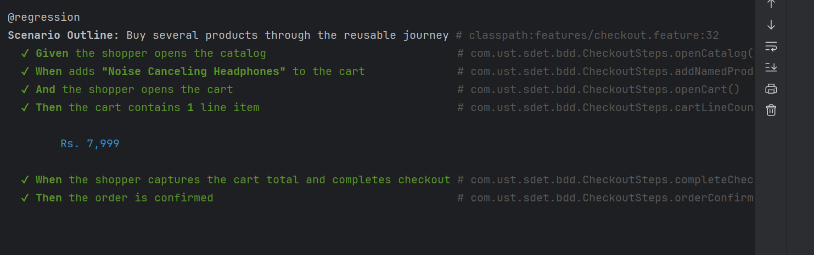

Test Scenario 4
Scenario Name:Fresh Cart Validation
@regression
Test Steps
- Open catalog.
- Open cart without adding products.
- Verify cart is empty.
Expected Result
Cart should contain zero items.
Actual Result
Cart was empty.
Status: Pass
Screenshot
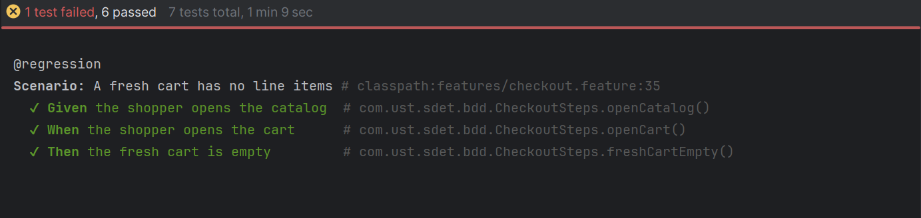
Test Scenario 5
Scenario Name: Deliberate Failure Demonstrates Screenshot Capture
@negative
Test Steps
- Open catalog.
- Add Yoga Mat.
- Verify cart badge equals 2.
Expected Result
Cart badge should display value 2.
Actual Result
Cart badge displayed value 1.
Status: Failed
Observation
Framework automatically captured failure screenshot through Hooks.java using Scenario.attach().
Screenshot
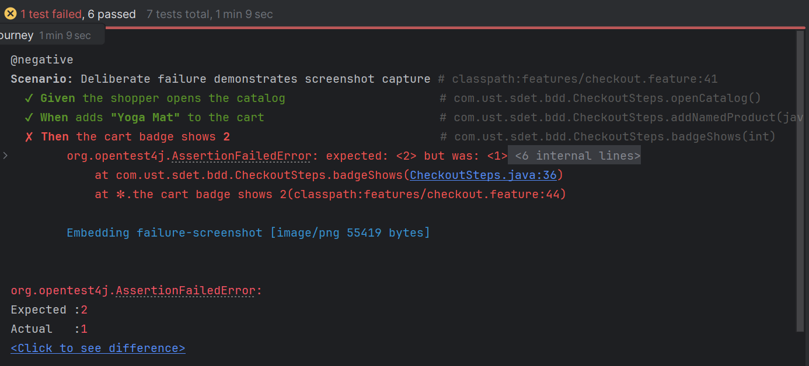
Smoke Test
Command : mvn test -Dcucumber.filter.tags=@smoke
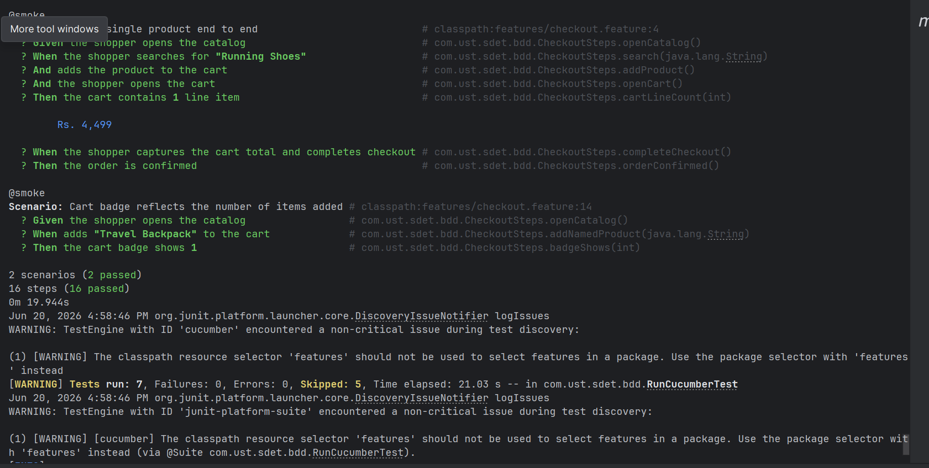
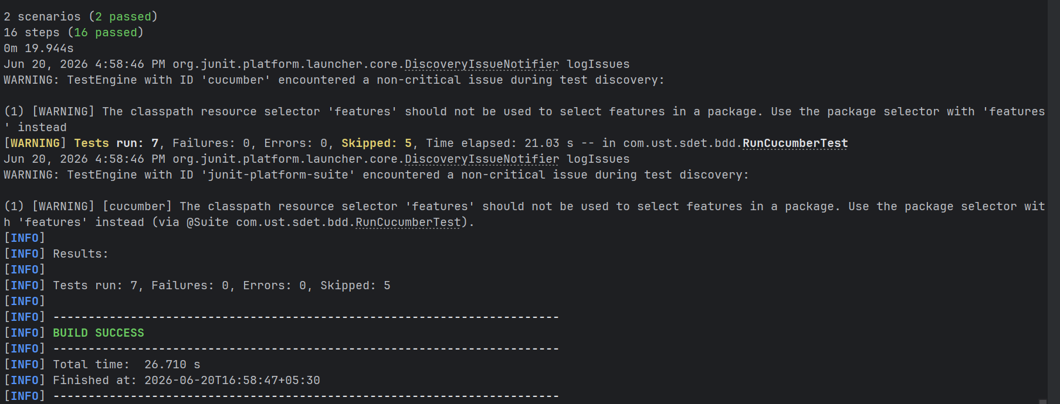

Regression Test
Command : mvn test "-Dcucumber.filter.tags=@regression"
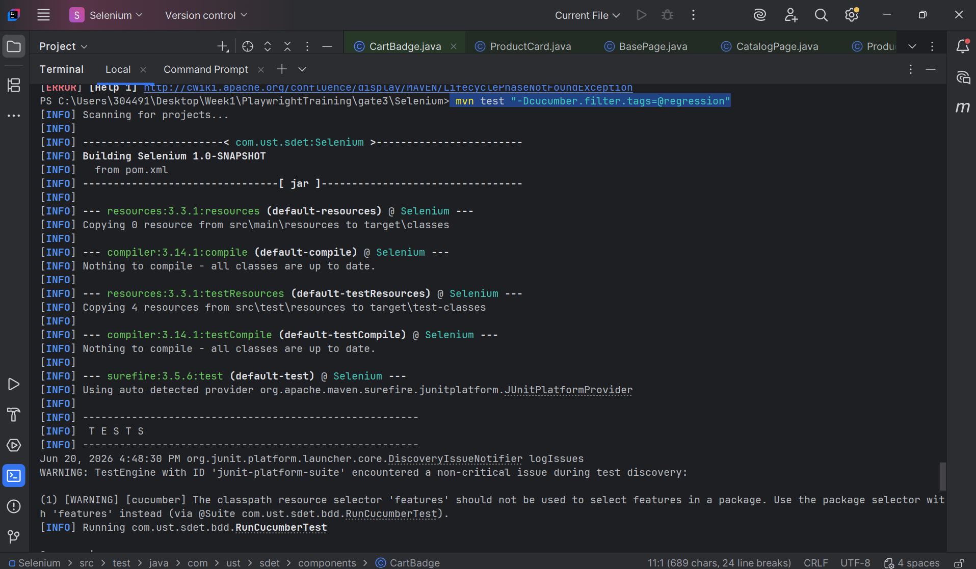
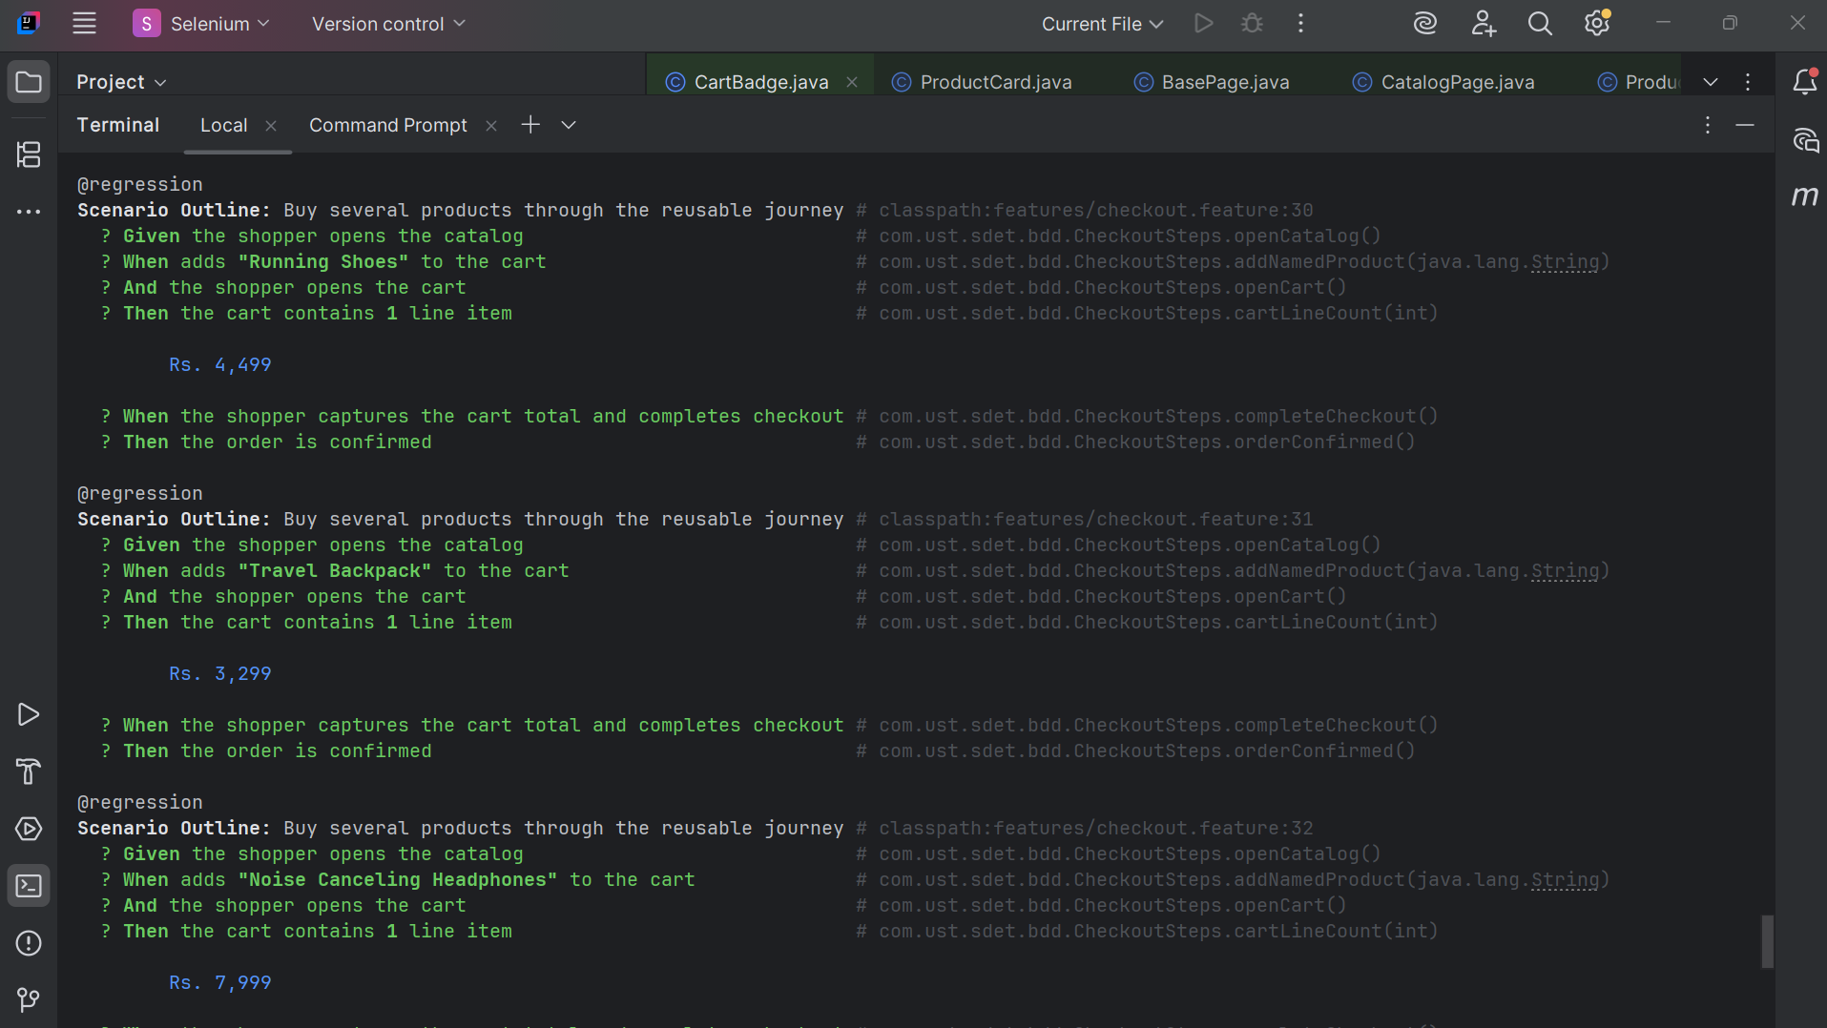

Negative Test
Command : mvn test "-Dcucumber.filter.tags=@negative"
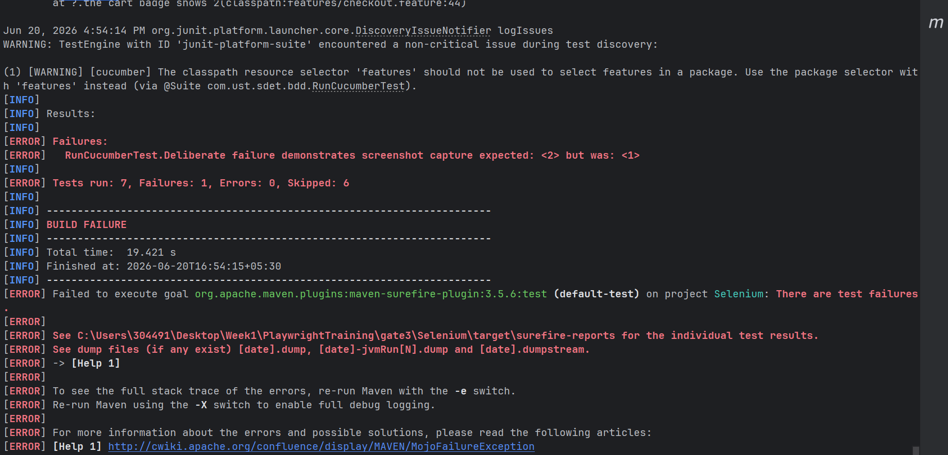

Execution Summary
Scenario | Result
Buy Single Product End-to-End | Pass
Cart Badge Verification | Pass
Reusable Journey – Running Shoes | Pass
Reusable Journey – Travel Backpack | Pass
Reusable Journey – Headphones | Pass
Fresh Cart Validation | Pass
Negative Validation | Failed (Expected)
Overall Result
6 Scenarios Passed
1 Scenario Failed (Intentional Failure for Screenshot Validation)
Framework reporting successfully generated:
- Cucumber HTML Report
- Extent Spark Report
- Allure Report
- Failure Screenshot Attachments

Spark Report:
