Week 4 – Gate 4
Monorepo Project Structure – Consumer, Provider, Selenide Automation
Overview1
Use GitHub Actions workflow automates the complete Consumer-Driven Contract Testing (CDC) process using Pact.
Overview 2
Use selenide to walk through retail app Product page and verify the availability of the product displayed.

The repository contains:
- Consumer Contract Tests (POS)
- Provider Verification (OMS)
- UI Automation (Selenide)
- Pact Broker Configuration
- GitHub Actions CI/CD Pipeline

2. Project Structure
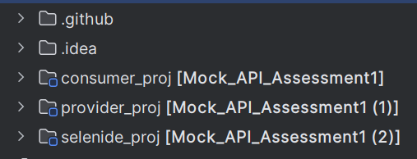

Consumer_project:
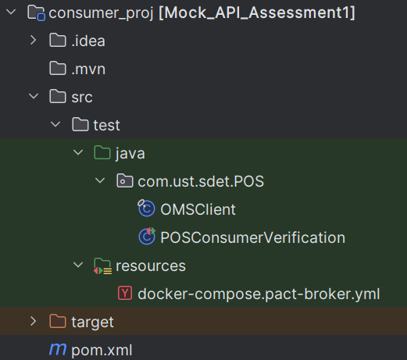

Provider_project:
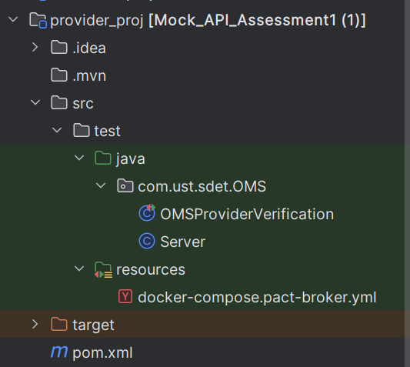

Selenide Project:
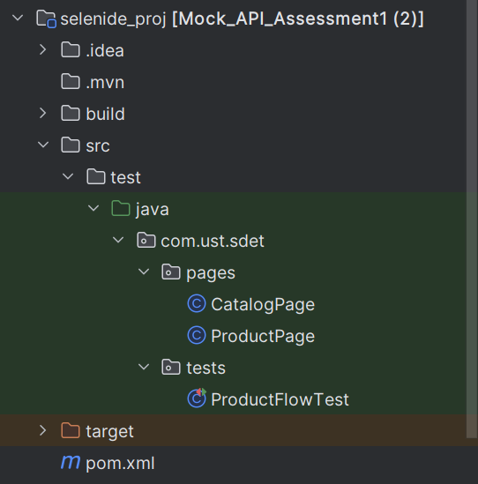

3. Consumer Module
Purpose
The Consumer project is responsible for:
- Calling the Mock APIs
- Defining Consumer expectations
- Generating Pact Contracts
- Publishing contracts to the Pact Broker
Components
OmsClient
Acts as the API client.
Responsible for making requests to OMS.
Example
GET /orders/100

POST /orders

Models
Contains POJOs or Records.
Example
Order Model

Pact Tests
Contains Consumer Pact Tests.
Example
PosOmsConsumerPactTest
Responsibilities
- Start Pact Mock Server
- Send requests
- Validate responses
- Generate Pact file
Output
target/pacts/POS-OMS.json

4. Provider Module
Purpose
Verifies that OMS satisfies the published Consumer contract.
No real OMS service is required.
WireMock simulates the Provider.

Server Package
Contains
WireMockServerManager
Responsibilities
- Start WireMock
- Stop WireMock
- Reset stubs
- Configure ports

States Package
Contains all Provider States.
Example
OrderState
InventoryState
CreateOrderState
Each state prepares WireMock before Pact executes an interaction.

Example
@State("Order with ID 100 exists")

Verification Package
Contains
OMSProviderVerification
Responsibilities
- Download contracts
- Execute Provider verification
- Compare Provider responses with the Pact

5. Retail App Automation Module
Uses Selenide.
Pages
Implements the Page Object Model.
Here, ProductPage and CatalogPage

Tests: Contains UI Test Classes.
ProductFlowTest

Utilities: Contains reusable classes.
DriverFactory
ConfigReader
TestBase

6. Docker Folder
Contains Docker-related files.
Example
docker-compose.pact-broker.yml
Responsibilities
Starts
- Pact Broker
- PostgreSQL

7. GitHub Workflows
Each workflow has a dedicated responsibility.

consumer.yml
Responsibilities
- Checkout
- Setup Java
- Run Consumer Tests
- Publish Pact
Pipeline
Checkout
↓
Consumer Tests
↓
Generate Pact
↓
Publish Contract

provider.yml
Responsibilities
- Start WireMock
- Download Pact
- Verify Provider
- Publish Verification
Pipeline
Checkout
↓
WireMock
↓
Provider Verification
↓
Publish Results

8. Responsibilities
Consumer
- Creates contracts.
- Publishes contracts.
- Does not know Provider implementation.

Provider
- Downloads contracts.
- Uses WireMock.
- Verifies contracts.
- Publishes verification results.

UI Automation
- Validates the User Interface.
- Independent of Contract Testing.

Pact Broker
Stores
- Contracts
- Verification Results
- Deployment History
- Environment Information

GitHub Actions
Automates
- Build
- Testing
- Contract Publishing
- Verification
- Deployment Validation

10. Benefits of this Structure
- Clear separation of responsibilities.
- Easy to maintain and extend.
- Supports independent Consumer, Provider, and UI development.
- Enables scalable CI/CD with dedicated pipelines.
- Encourages reuse of common utilities.
- Follows Consumer-Driven Contract Testing (CDC) best practices.
- Supports local development using WireMock while remaining compatible with a Pact Broker for centralized contract management.

Test Results for Consumer Verification:
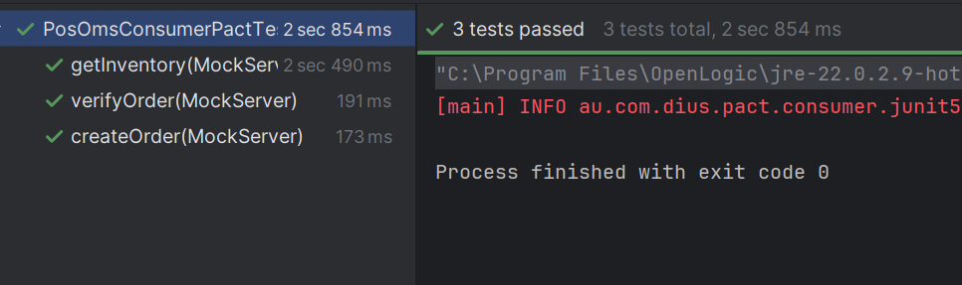
Test Results for Selenide:
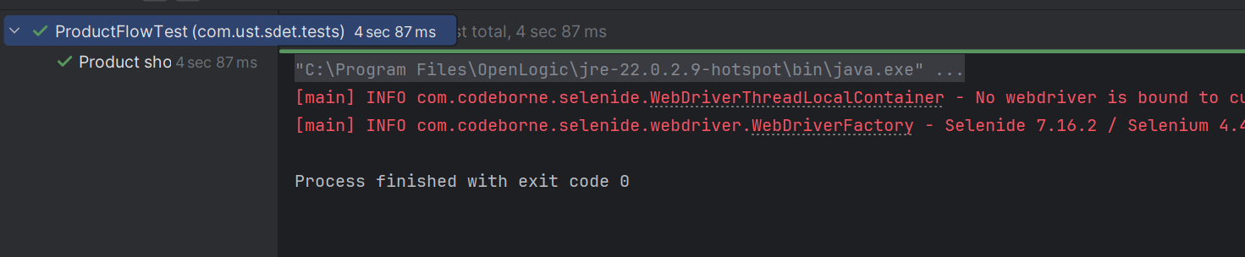

The pipeline performs the following tasks:
- Checks out the source code.
- Sets up the Java environment.
- Installs the Pact CLI.
- Starts a local Pact Broker using Docker.
- Runs Consumer Pact tests and generates Pact contracts.
- Publishes the generated contracts to the Pact Broker.
- Runs Provider verification against the published contracts.
- Publishes Provider verification results to the Pact Broker.
- Records the Provider deployment.
- Checks whether the Consumer can safely be deployed using can-i-deploy.

Workflow Trigger
on: [push, pull_request]
Explanation: The workflow is automatically executed whenever:
Job Definition
jobs:
build:
runs-on: ubuntu-latest
Explanation
Creates a single job named build.
GitHub provisions an Ubuntu virtual machine where all the remaining steps are executed.

Step 0 – Checkout Source Code
- name: Checkout Code
uses: actions/checkout@v5
Purpose
Downloads the latest repository code into the GitHub Actions runner.
Without this step, Maven would not have access to the project files.

Step 1 – Setup Java
- name: Set up Java
Uses:
actions/setup-java@v5
with
distribution: temurin
java-version: 22
cache: maven
Purpose
Installs Java 22.
The Maven cache significantly speeds up subsequent workflow executions by reusing downloaded dependencies.

Step 2 – Install Pact CLI
curl ...
Purpose
Downloads and installs the Pact CLI.
The CLI provides commands such as:
- pact-broker publish
- pact-broker can-i-deploy
- pact-broker record-deployment
These commands interact with the Pact Broker.

Step 3 – Start Pact Broker
docker compose up -d --wait
Purpose
Starts a local Pact Broker inside Docker.
The Broker stores:
- Consumer contracts
- Provider verification results
- Deployment records
- Environment information
Without a running Broker, contracts cannot be published or verified.

Step 4 – Run Consumer Tests
mvn -Dtest=PosOmsConsumerPactTest test
Purpose
Runs only the Consumer Pact tests.
The tests:
- Start a Pact Mock Server.
- Send requests from the Consumer.
- Verify the expected responses.
- Generate a Pact contract.
Output:
target/pacts/POS-OMS.json
This file represents the contract between the Consumer and Provider.

Step 5 – Publish Consumer Contracts
pact-broker publish target/pacts
Options:
--consumer-app-version=${{ github.sha }}

--branch=main

--broker-base-url=http://127.0.0.1:9292
Purpose
Publishes the generated Pact contract to the Broker.
consumer-app-version
Uses the Git commit SHA.
Each commit receives a unique contract version.
Example
POS

Version

5b4ab4186a3...
branch
Specifies the Git branch that produced the contract.
broker-base-url
URL of the Pact Broker.

Step 6 – Run Provider Verification
mvn
Runs
OmsProviderVerificationTest
with
-Dpact.verifier.publishResults=true
-Dpact.provider.version=${{ github.sha }}
Purpose
Downloads the published contract from the Broker.
For each interaction:
- Calls the matching @State method.
- Configures WireMock.
- Sends the request.
- Compares the actual response with the expected contract.
Example
Consumer Contract
GET /orders/100
Provider State
@State("Order with ID 100 exists")
WireMock returns
{
"id":100,
"status":"CONFIRMED"
}
If the response matches the contract, the interaction passes.

Publish Verification Results
-Dpact.verifier.publishResults=true
This uploads the verification result back to the Broker.
The Broker now knows:
OMS

Version

5b4ab418...
has successfully verified the contract.
Without publishing verification results:
- record-deployment fails.
- can-i-deploy cannot determine compatibility.

Step 7 – Record Provider Deployment
pact-broker record-deployment
Options
--pacticipant OMS
--version
--environment production
Purpose
Records that this Provider version has been deployed to Production.
The Broker stores deployment history.
Example
OMS

Version

5b4ab418...

Environment

Production
This information is later used by can-i-deploy.

Step 8 – Can I Deploy
pact-broker can-i-deploy
Options
--pacticipant POS
--version
--to-environment production
Purpose
Checks whether the Consumer is compatible with the Provider currently deployed to Production.
The Broker compares:
Consumer Contract
↓
Provider Verification
↓
Provider Deployment
If compatible
Computer says yes
Otherwise
Computer says no
Deployment should then be blocked.

Deployment Allowed / Blocked

Benefits of this CI Pipeline
- Automatically validates API contracts on every code change.
- Detects breaking API changes before deployment.
- Eliminates dependency on a live Provider during Consumer testing.
- Uses WireMock to simulate Provider responses during verification.
- Stores contracts, verification results, and deployment history in the Pact Broker.
- Prevents incompatible Consumer or Provider versions from being deployed using can-i-deploy.
This workflow provides an end-to-end implementation of Consumer-Driven Contract Testing (CDC), ensuring that both the Consumer (POS) and Provider (OMS) evolve safely and remain compatible throughout the software delivery lifecycle.

Cata

Selenide Testing
Folder Structure:
