REST Assured API Automation Framework Report
Project Title
API Automation Testing Framework for Pet store APIs using REST Assured and JUnit 5

1. Objective
The objective of this project is to design and implement a reusable API automation testing framework using REST Assured to validate Pet Store APIs.

2. User Story
As a QA Automation Engineer,
I want to automate Pet Store API endpoints
Acceptance Criteria
- User should retrieve pet records.
- User should create pet records.
- User should update existing records.
- User should delete records.

3. API Details
Base URL
Swagger UIBase Path

4. Environment & Setup
Software
Operating System:
Windows 10 / Windows 11
IDE:
IntelliJ IDEA
Programming Language:
Java 17+
Build Tool:
Maven
Test Framework:
JUnit 5
API Testing:
REST Assured

5. Project Structure
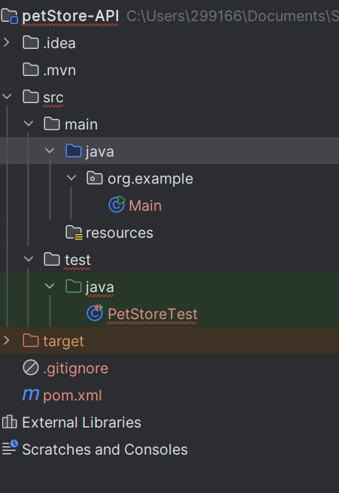

6. Scenarios Covered
Scenario 1
Retrieve all stock inventory
Validation:
- Status code
- Response body
- Schema validation
Expected:
200 OK

Scenario 2
Create pet record
Validation:
- pet ID
- pet details
Expected:
201 Created

Scenario 3
Update pet
Validation:
- pet updated
- pet name
Expected:
200 Ok

Scenario 4
delete pet
Validation:
- Delete Existing pet
Expected:
200 OK

7. How to Run
Open terminal.
Execute:
mvn clean test

8. Test Results
Scenario | Status
Get all stock | Pass
create Product | Pass
Update Product | Pass
Delete Product | Pass
Overall Execution:
Successful

9. Evidence
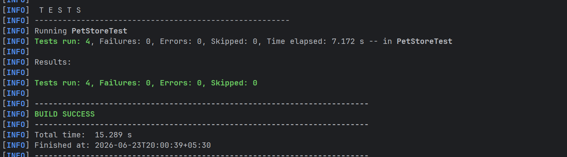

17. Conclusion
The REST Assured API Automation Framework was successfully developed to automate Pet APIs.

