API Testing Report
Name : Shahbaz Ahmad
GitHub branch: shahbaz_assessment_29Jun26
Date: 29-06-2026

Question 4 (jsonplaceholder.typicode)

Objective
To design, develop, and execute API automation tests ensuring reliability, scalability, and correctness of REST APIs using a structured framework. Website https://jsonplaceholder.typicode.com/
GithubLink:-

Environment Setup
Java, Maven, RestAssured, IntelliJ IDEA / Vs code Allure Reporting.

Workflow
1. Read configuration from Config.java
2. Build request using SpecFactory
3. Execute post API
4. Validate response
5. Generate report

Folder Structure
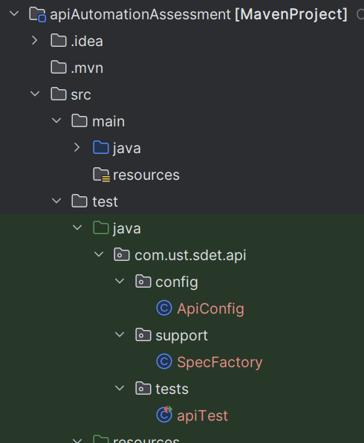

Scenario
"As a QA Engineer, I want to create a new post and verify the response.

Commands
- mvn clean test
- mvn test
- allure generate target/allure-results --clean -o target/allure-report
- allure serve target/allure-results

Result Evidence & Screenshots
Code
Config.java
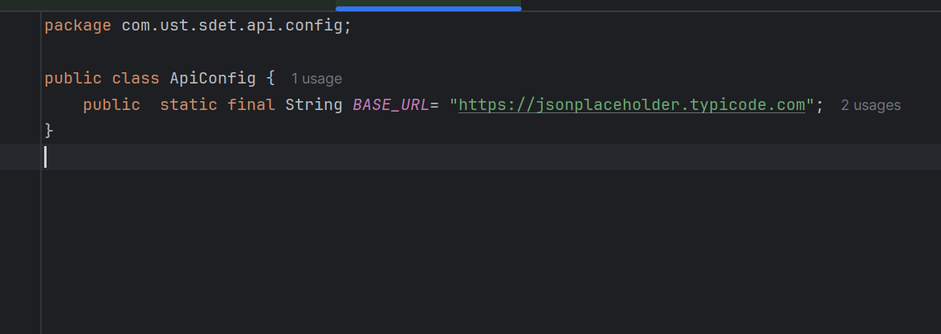
SpecFactory.java
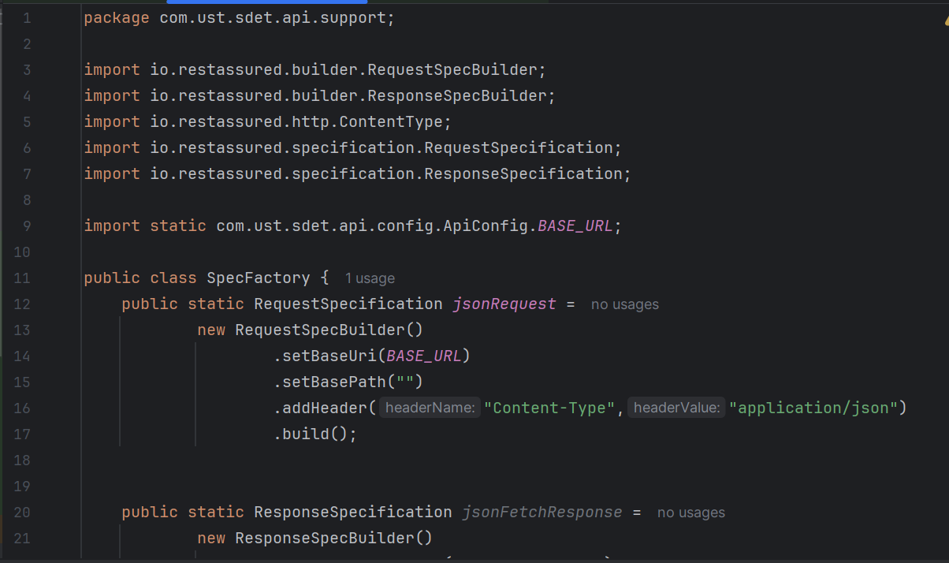
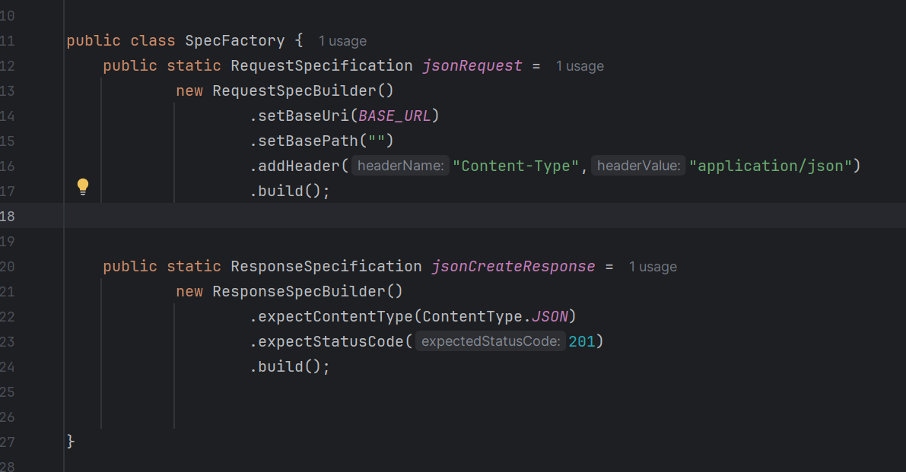
apiTest
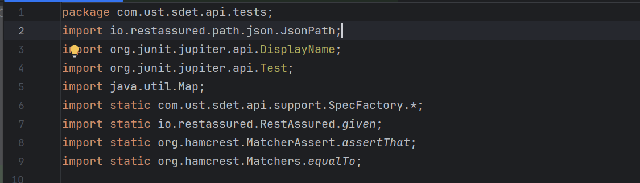
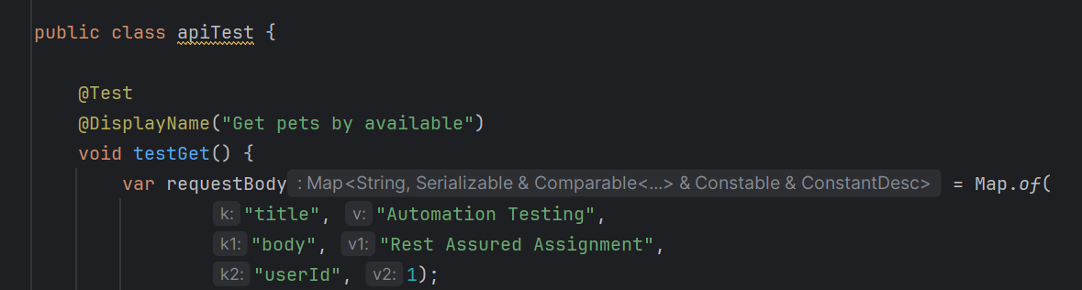
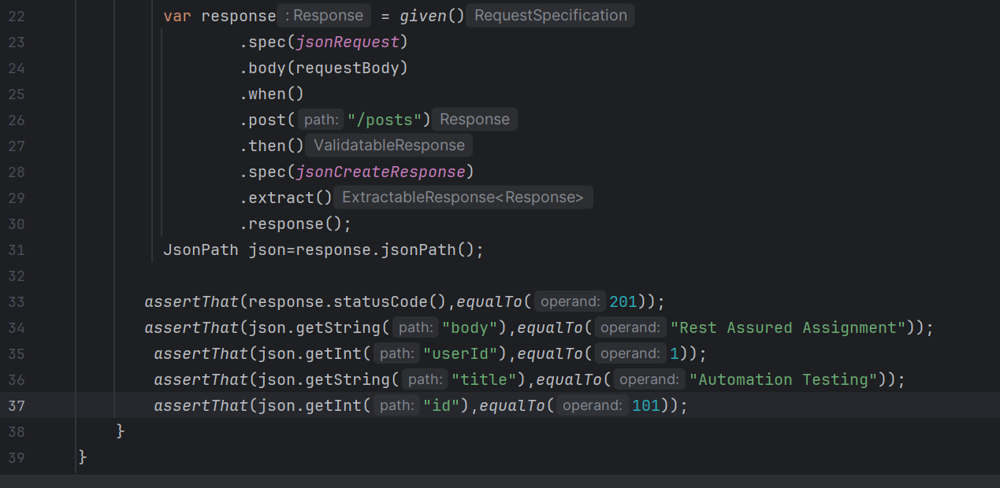

Result
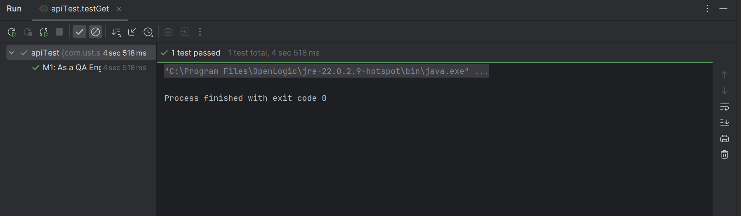
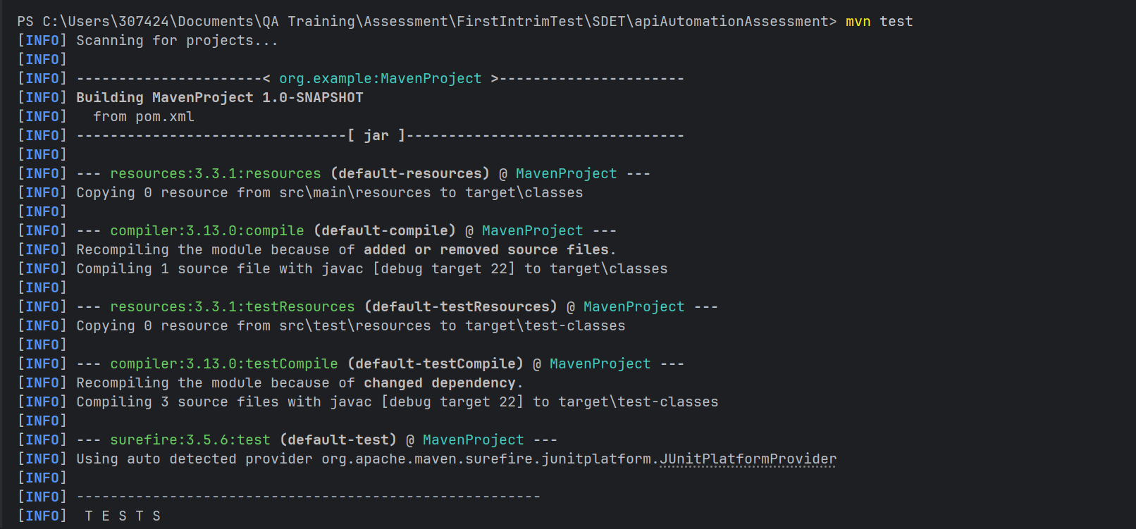
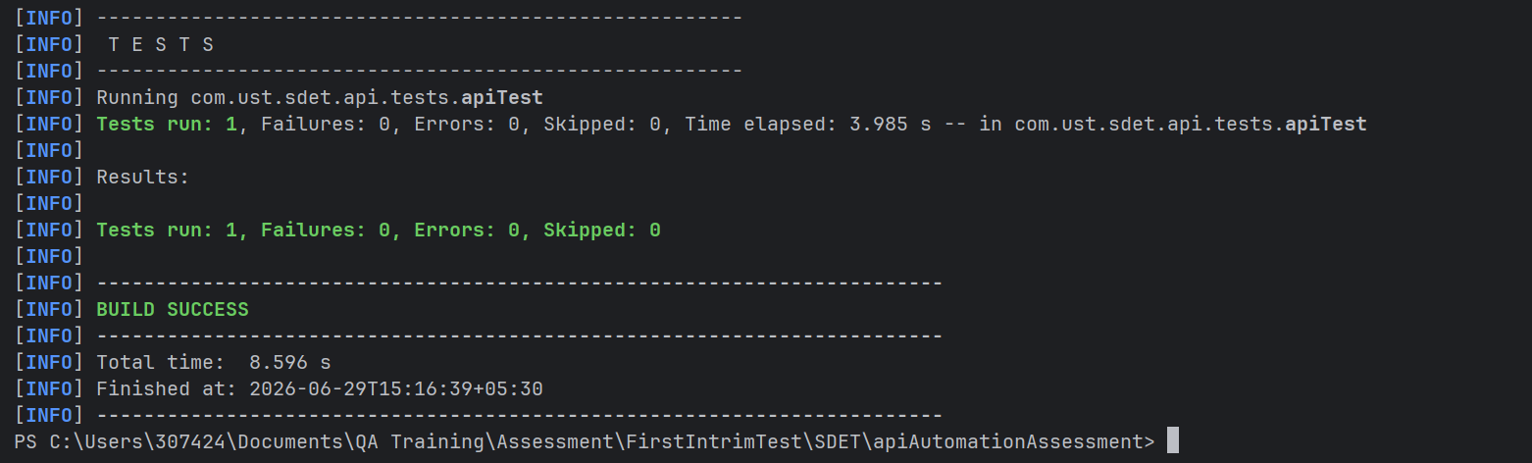

Explaination
- First I declare BaseUrl in Config.java as public .
- Then inside support folder create specFactory.java and define
public static RequestSpecification jsonRequest =
new RequestSpecBuilder()
.setBaseUri(BASE_URL)
.setBasePath("")
.addHeader("Content-Type","application/json")
.build();
public static ResponseSpecification jsonCreateResponse =
new ResponseSpecBuilder()
.expectContentType(ContentType.JSON)
.expectStatusCode(201)
.build();
- Inside tests folder create apiTest.java for test and do post api test on https://jsonplaceholder.typicode.com @Test
@DisplayName("M1: As a QA Engineer, I want to create a new post and verify the response.")
void testGet() {
var requestBody = Map.of(
"title", "Automation Testing",
"body", "Rest Assured Assignment",
"userId", 1);
var response = given()
.spec(jsonRequest)
.body(requestBody)
.when()
.post("/posts")
.then()
.spec(jsonCreateResponse)
.extract()
.response();
JsonPath json=response.jsonPath();
assertThat(response.statusCode(),equalTo(201));
assertThat(json.getString("body"),equalTo("Rest Assured Assignment"));
assertThat(json.getInt("userId"),equalTo(1));
assertThat(json.getString("title"),equalTo("Automation Testing"));
assertThat(json.getInt("id"),equalTo(101));
}
- Assert to check status,id,title,body,userId

Limitations
Dependent on environment configuration, external API availability.

Conclusion
The framework integrates RestAssured for robust API testing, enabling validation of backend services and endpoints.
It supports data-driven and reusable API utilities, improving scalability and reducing duplication.
API layers are modularized, ensuring maintainable request/response handling and validation logic.
Enables end-to-end validation, where data created via API can be reused for UI validation.
Ensures high reliability and coverage of backend workflows.
Easily scalable—new API test cases can be added without impacting existing ones.

