UI Automation Report
Name : Shahbaz Ahmad
GitHub branch: shahbaz_assessment_29Jun26
Date: 29-06-2026

Question 3

OBJECTIVE
To design and implement a hybrid automation framework combining API (RestAssured) and UI (Selenium + Cucumber) testing ensuring end-to-end validation. As a user, I want to apply filters and sorting so I can refine product search results.

Flow
1. Search → “face wash”
2. Apply filter:
* Price range
* Category/Brand
3. Apply sorting:
* Price low → high
4. Capture product list

Github Link:-

TOOLS & TECHNOLOGIES
Java, Maven, Selenium WebDriver, Cucumber BDD, RestAssured, IntelliJ / VsCode

FRAMEWORK WORKFLOW
1. Pass data to UI flow
2. Execute Selenium scenario
3. Validate response (UI )
4. Generate Allure Report

FOLDER STRUCTURE
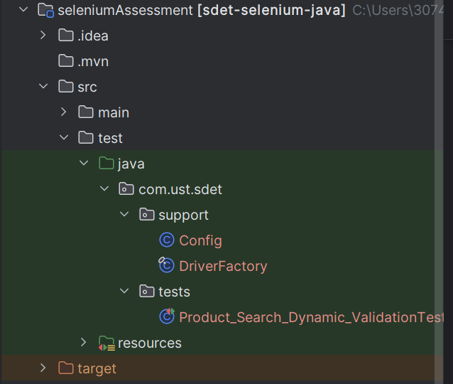

SCENARIOS
As a user, I want to apply filters and sorting so I can refine product search results.

Flow
1. Search → “face wash”
2. Apply filter:
* Price range
* Category/Brand
3. Apply sorting:
* Price low → high
4. Capture product list
COMMANDS
Run full suite:
mvn clean test

Screenshot
DriverFactory
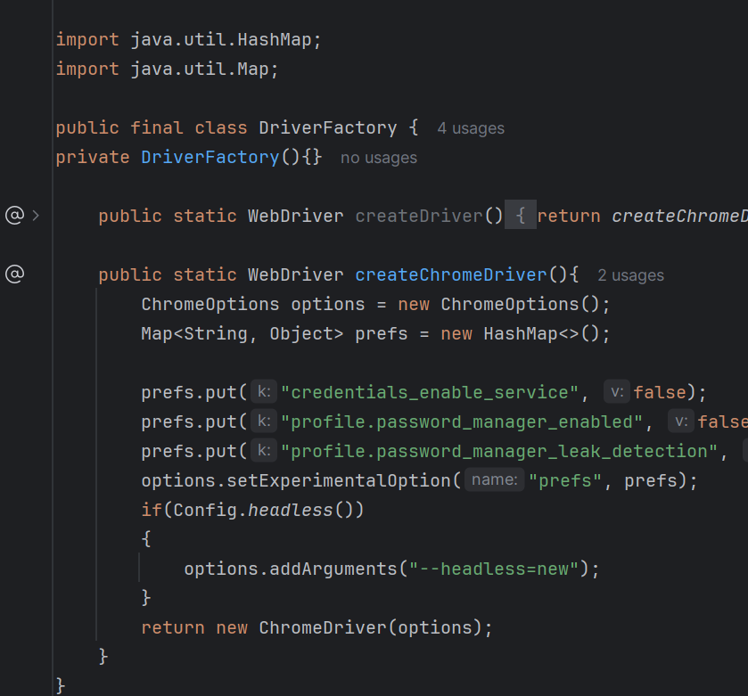

Config.java

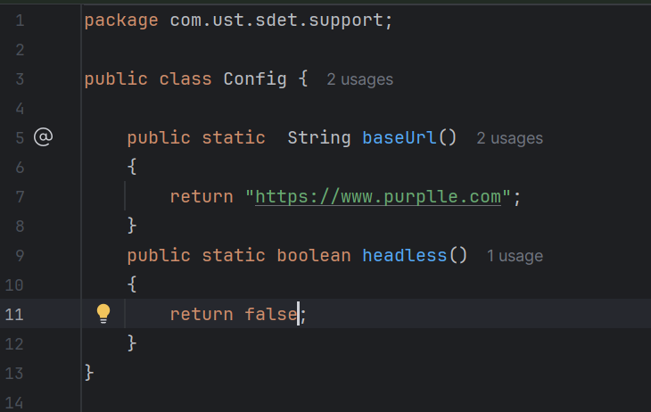

Product_Search_Dynamic_ValidationTest
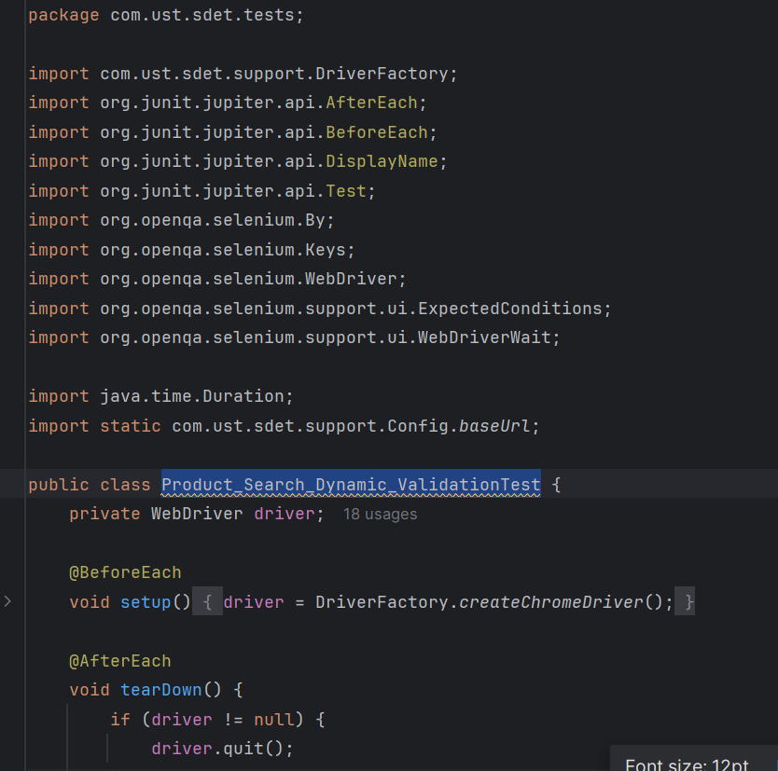
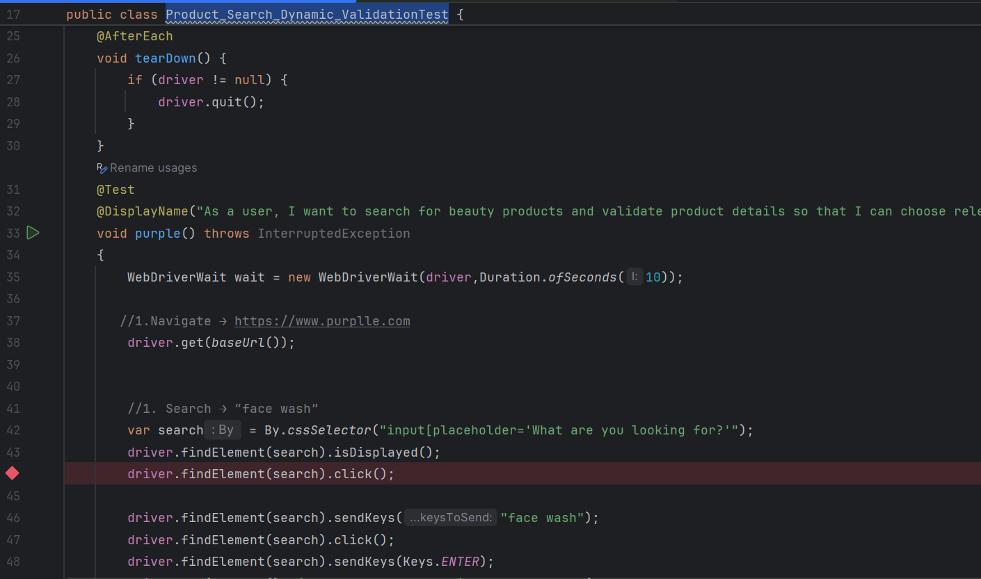
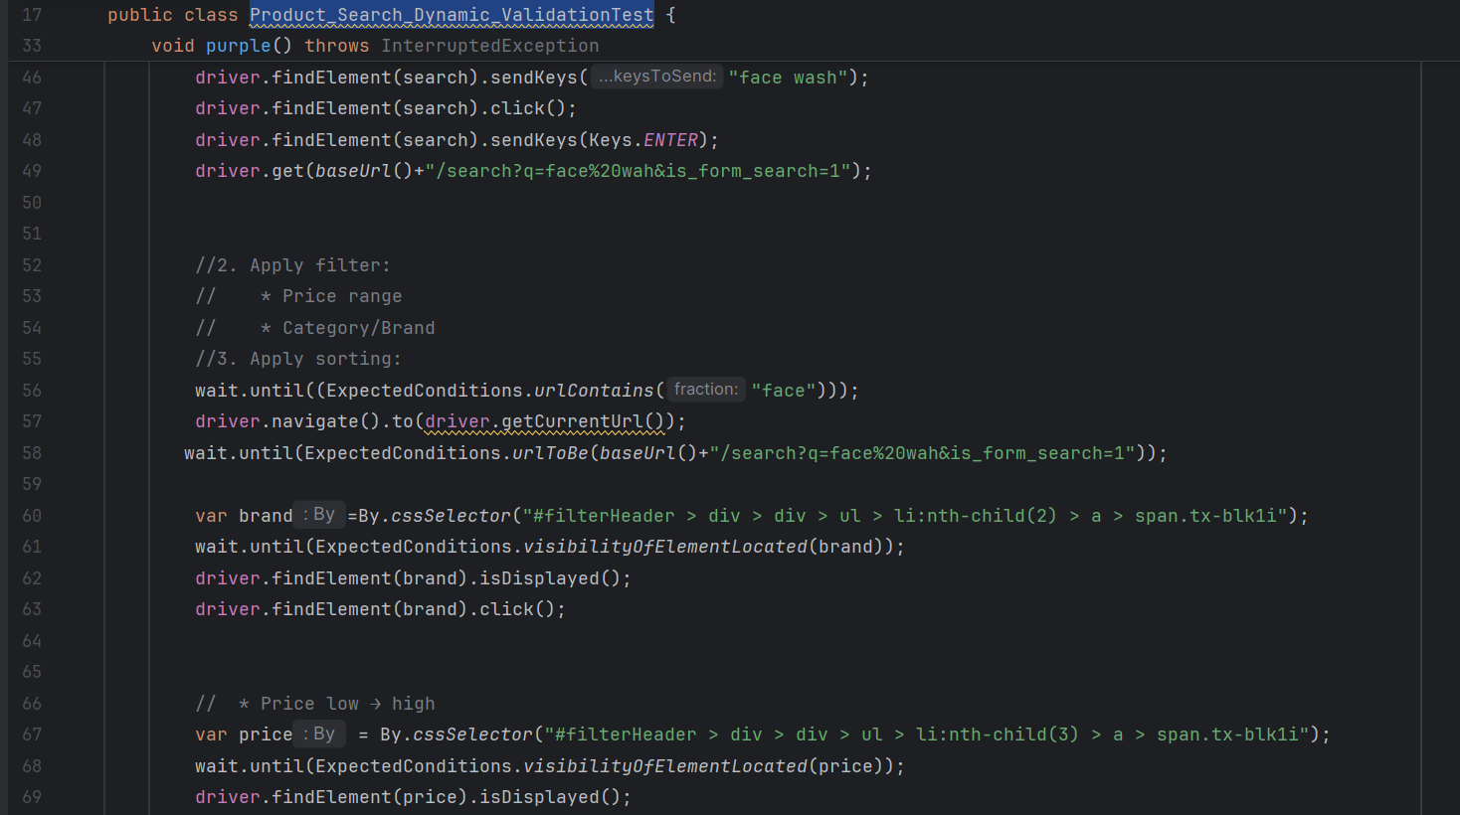
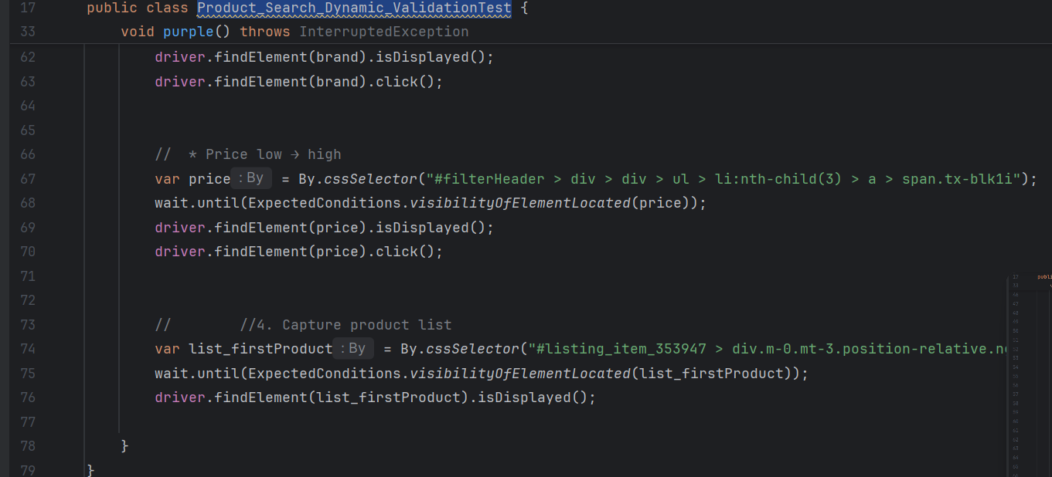

Result
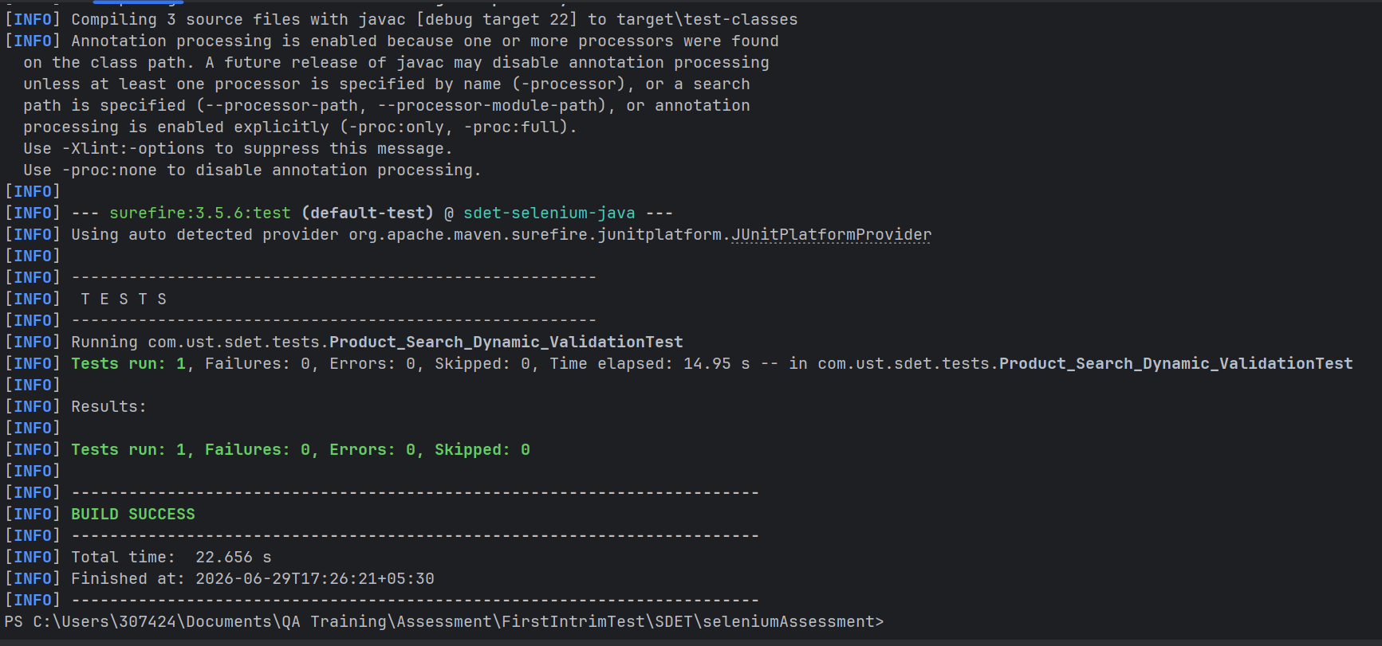

Explanation
1 First create driver factory to communicate with web
2 Config to get base url
3 perform test base on use story
1. Search → “face wash”
2. Apply filter:
* Price range
* Category/Brand
3. Apply sorting:
* Price low → high
4. Capture product list

CONCLUSION
Utilizes Selenium WebDriver for automating browser-based UI testing.
Enables validation of user journeys and frontend workflows.
UI components are modular, and test steps.
Easily extendable for new UI features without breaking existing tests.

