Name:J.Ragumaan
Date:20-06-2026
Assessment report
Catalog to Checkout Order-Week 3 assessment(automation testing using Selenium,Cucumber)

AIM: To Automate Catalog to Checkout flow using selenium and cucumber
Implementation report:
I Have covered From Catalog page to Checkout order life cycle and followed the instruction and implemented all the steps.
Thinks covered:
Assessment Coverage
A total of 5 business scenarios were implemented using Cucumber BDD.
Scenario Distribution
- 2 Smoke Scenarios (@smoke) – Critical user journeys executed on every build.
- 2 Regression Scenarios (@regression) – Broader functional validation covering multiple product combinations.
- 1 Negative Scenario (@negative) – Intentionally failing scenario used to demonstrate failure handling, screenshot capture, and reporting.
Cucumber Design
- Used Scenario for single test flows with fixed test data.
- Used Scenario Outline for data-driven testing where the same flow is executed with multiple sets of test data.
- Implemented Background to avoid duplication of common preconditions.(for open catalog is used in the Background).
- Applied Page Object Model (POM) for maintainability and separation of concerns.
- Used Hooks (@Before and @After) for driver setup, teardown, and screenshot capture.
- Implemented PicoContainer Dependency Injection through the World class for sharing objects between step definitions.
- Integrated Allure and Extent Spark Reports for execution reporting and evidence collection.
- Added automatic screenshot capture using Scenario.attach() for failed scenarios.
- Supported headless execution and tag-based execution through Maven.
Environment Configuration
- Environment-specific values are externalized using a .env file and a TestEnvironment utility class.
- Configuration values such as BASE_URL and HEADLESS are read at runtime instead of being hardcoded.
- This enables the same test suite to run across different environments without code changes.
Example .env
BASE_URL=http://localhost:5173
HEADLESS=true
OutCome:
Evidence-

To run only smoke:
mvn test -Dtest=CtoOutTest "-Dcucumber.filter.tags=@smoke"
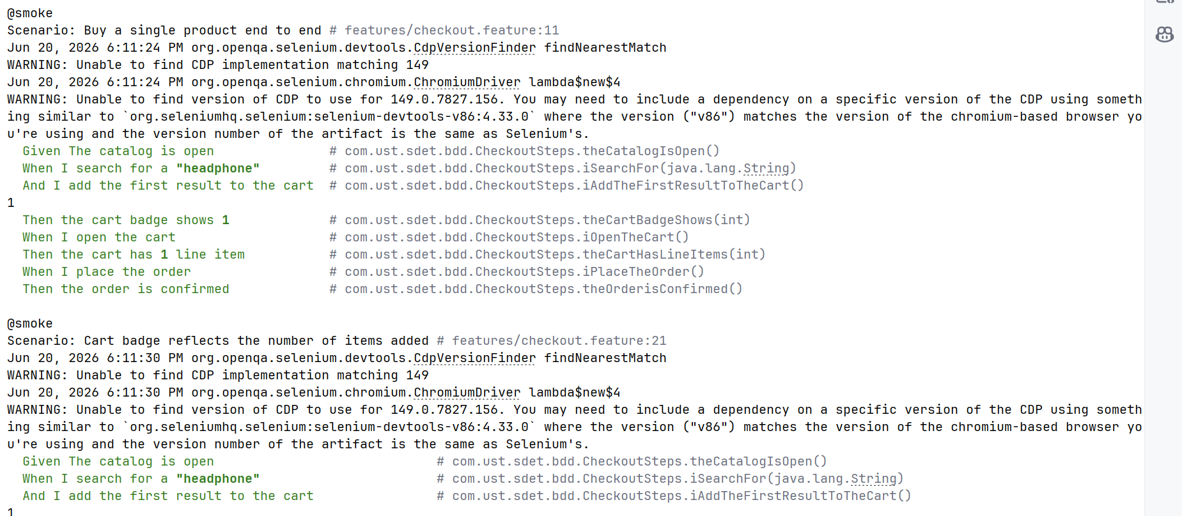

To run only regression:

mvn test -Dtest=CtoOutTest "-Dcucumber.filter.tags=@regression"

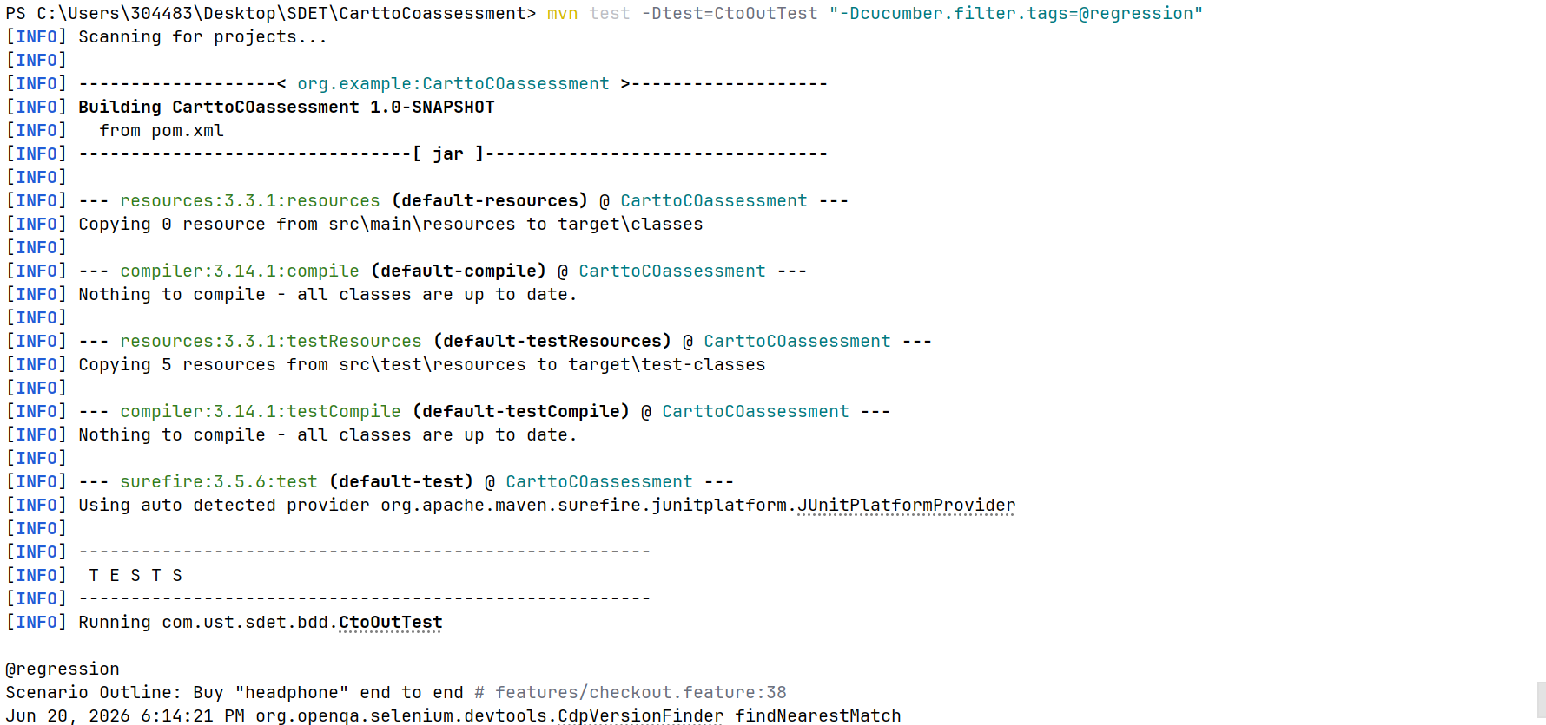
The test which is failed
because We have added only one headphone but we are seeing 2 in the cart So there should be only 1 should be seen in the cart so we need to change the scenario step
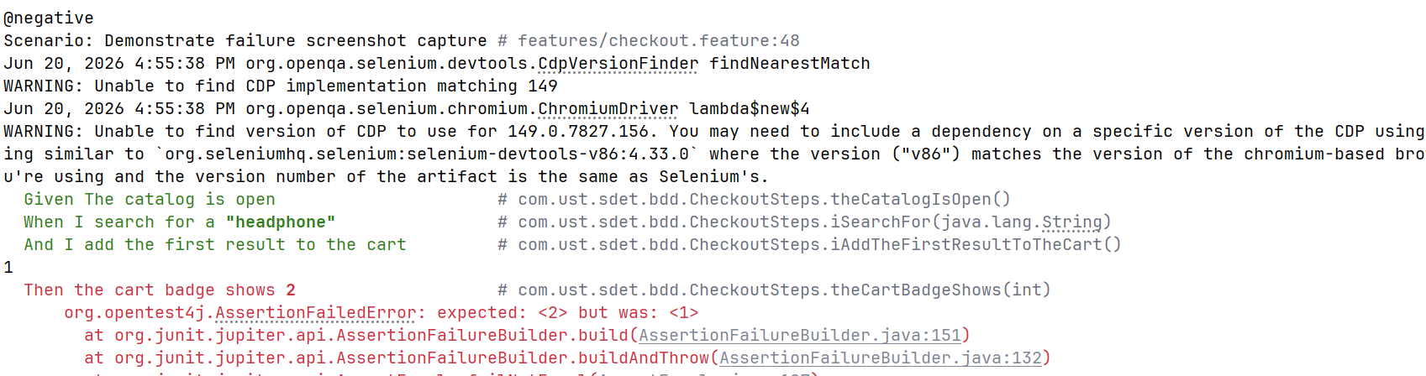

target
|-allure-results
|-image is available(a1e605df-c7be-4d9d-8891-2729e647cd31-attachment)
This is the allure-results image we have got so you can see only one item is there not 2

Img1:Cart Page
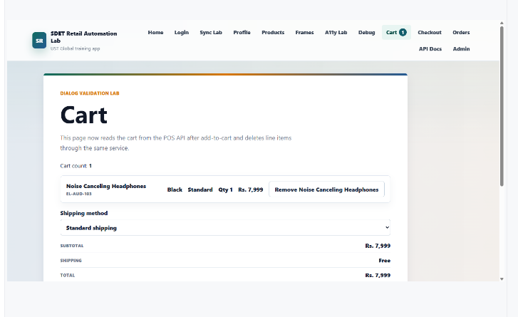

So We have created a positive test here we can see the thing is we have added only one product so it should show 1 product in the cart not 2 if you want to add two items one after another or change the quantity based on need

Img2:Total tests implemented
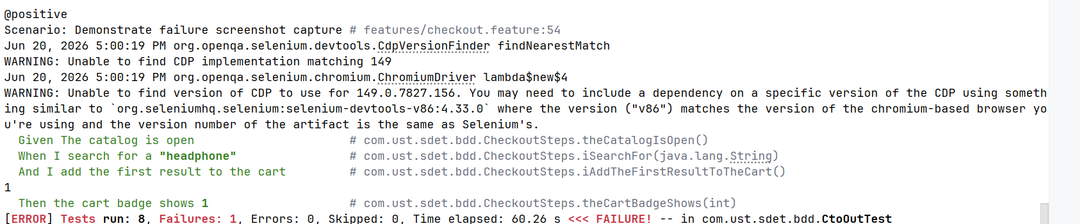

cucumber.filter.tags = @smoke or @regression or @negative or @positive
so we have mention it in the junit-platform.properties.
if we want all the test to run use the command
mvn test -Dtest=CtoOutTest test
ignore particular tag -so Ignored @negative to show Success tests.Because @negative is failing due to wrong logic
mvn test -Dtest=CtoOutTest "-Dcucumber.filter.tags=not @negative" So I used this command to run success path

Img3:@negative test skipped
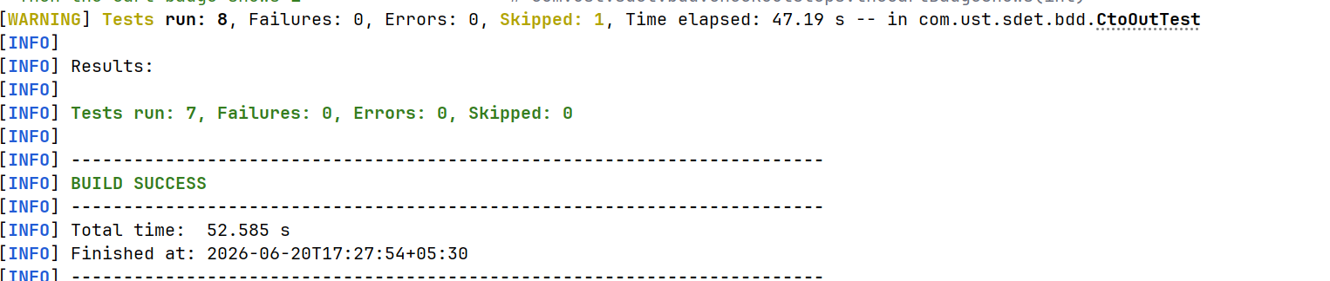
Extent spark report for success tests
Img:4Extent report with success tests
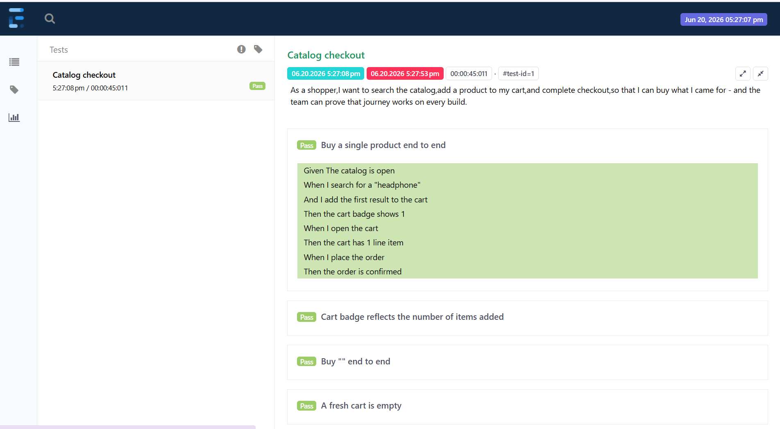

With all the tests extent spark report 1 negative test we can see it
Img5:Spark report with all tests
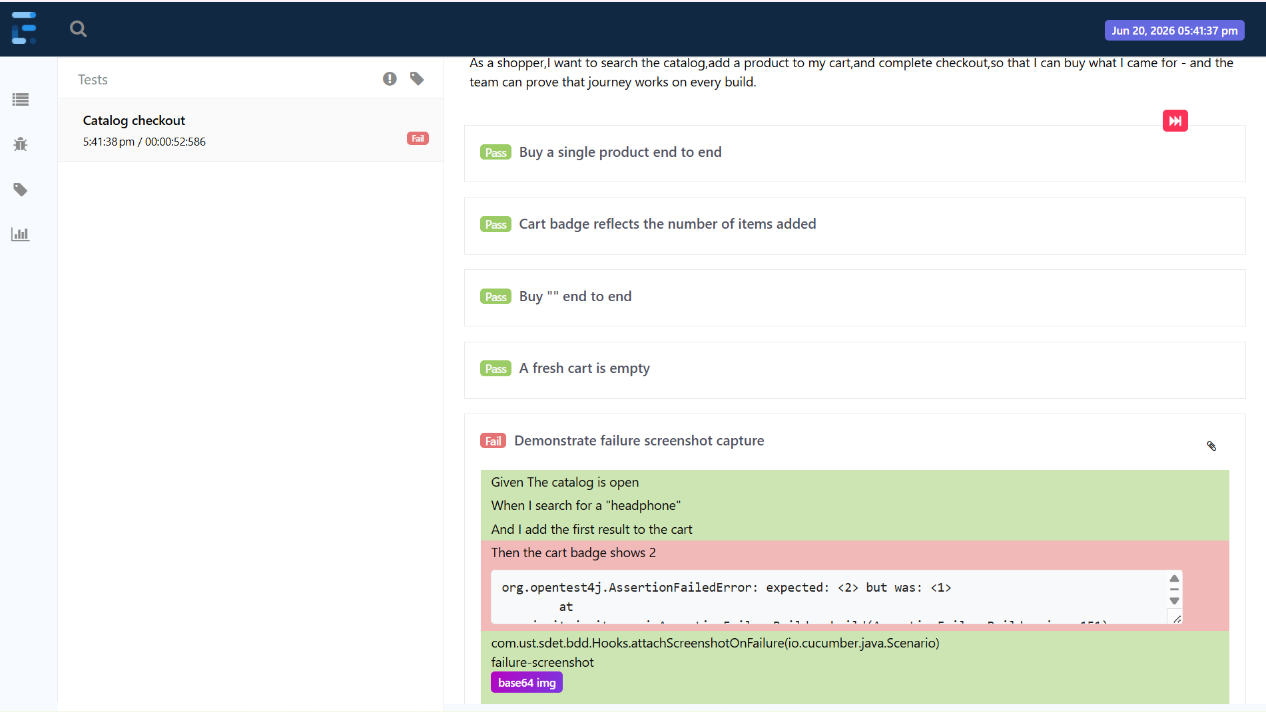

Allure:
For generating allure-report- allure generate allure-results --clean -o allure-report
To open existing report: allure open allure-report
Img6:Allure command
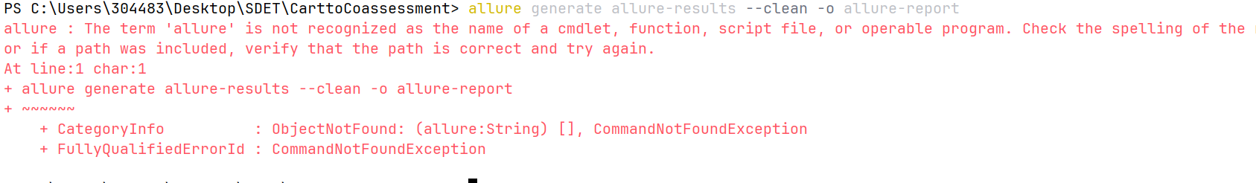
Due to Laptop configurations we are unable to setup allure so that we are not able to performe allure commands

Challenges Faced
• Faced issues configuring Allure in the local environment due to laptop setup limitations.
• Encountered tag filtering issues in Cucumber execution and resolved them through
junit- platform.properties configuration.
• Handled synchronization issues using explicit waits to ensure stable execution.

Conclusion
This assessment demonstrates an end-to-end test automation framework using Selenium, Cucumber, and Java. The framework follows the Page Object Model design pattern, supports tag-based execution, captures screenshots on failures, and generates Allure and Extent reports. Environment-specific configurations are managed externally, making the framework easy to maintain and execute across different environments.

