Selenium BDD Automation Framework – Test Scenarios Documentation
Project Overview
This automation framework is developed using:
- Java
- Selenium WebDriver
- Cucumber BDD
- JUnit 5
- Page Object Model (POM)
- PicoContainer Dependency Injection
- Allure Reporting

Scenario 1: Buy a Single Product End-to-End
Objective
Verify that a user can search for a product, add it to the cart, and successfully place an order.
@smoke
Step 1: Open catalog and Navigate to catalog page.
Expected Result: Catalog page is displayed.
Step 2: Search Product
Action: Search for "headphones".
Expected Result: Matching products are displayed.
Step 3: Add Product to Cart
Action: Add first search result to cart.
Expected Result: Cart badge count becomes 1.
Step 4: Open Cart
Action: Open shopping cart.
Expected Result: Cart contains one line item.
Step 5: Place Order
Action: Proceed to checkout and place order.
Expected Result: Order confirmation message is displayed.
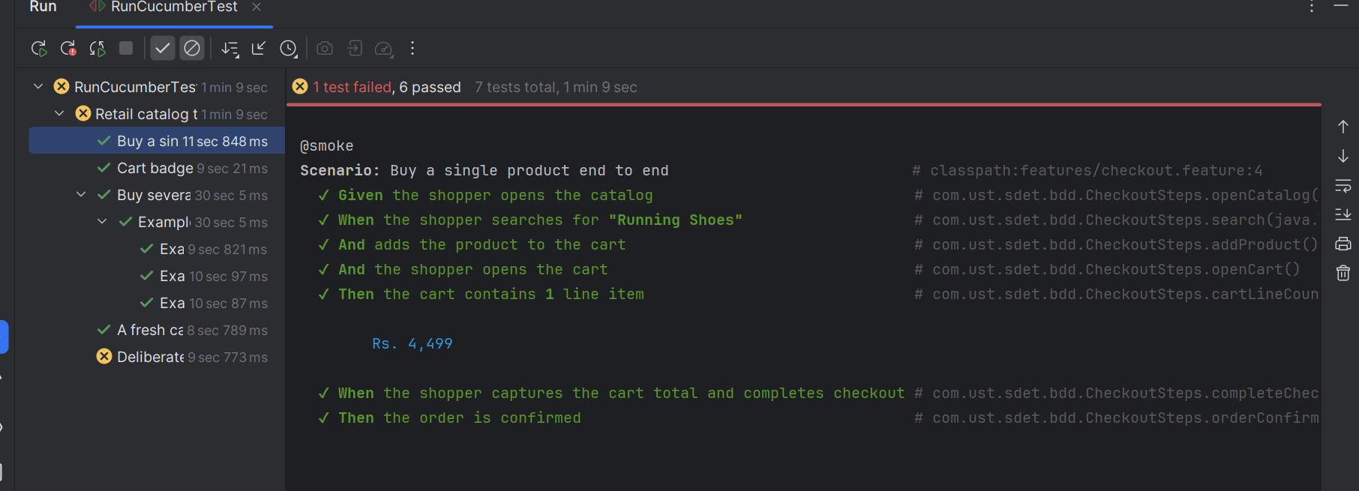

Scenario 2: Login Using Valid Credentials
Verify that valid users can log in successfully.
Test Data
Username | Password
customer@example.com | Password@123
Step 1: Open Login Page
Expected Result: Login form is displayed.
Step 2: Enter Credentials
Expected Result: Username and password fields accept input.
Step 3: Click Sign In
Expected Result: User is redirected to home page.

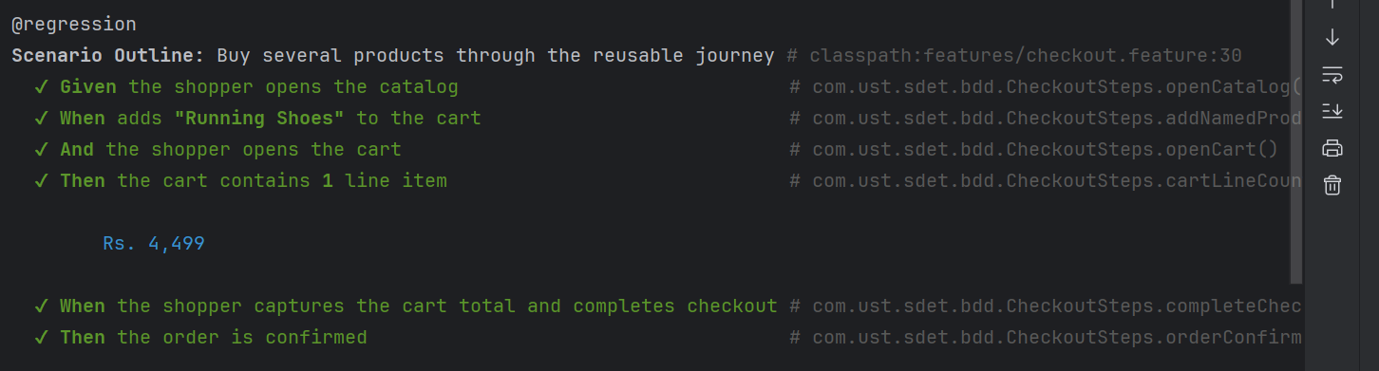

Scenario 3: Sort Products Low to High
Verify products are sorted in ascending order by price.
Step 1: Open Catalog
Step 2: Select Sort Option
Action: Select "Price: Low to High"
Step 3: Verify Sort Order
Expected Result: Products appear from lowest price to highest price.

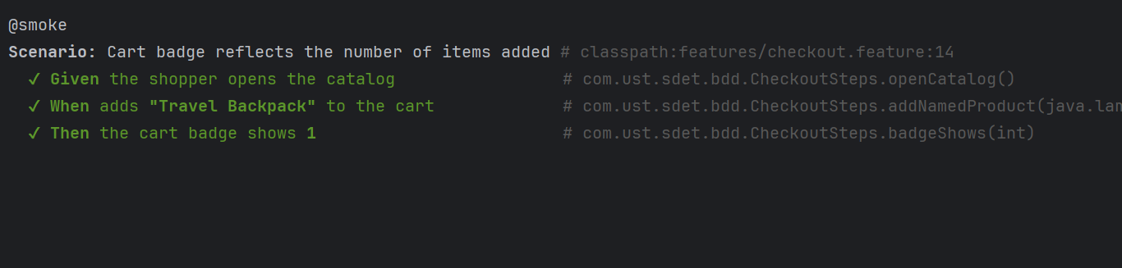

Scenario 4: Cart Badge Updates
Verify cart badge reflects the number of products added.
Products
Lamp
Shoes
Headphones
Steps
- Search product.
- Add first product to cart.
- Verify cart badge count.
Expected Result: Badge updates correctly.

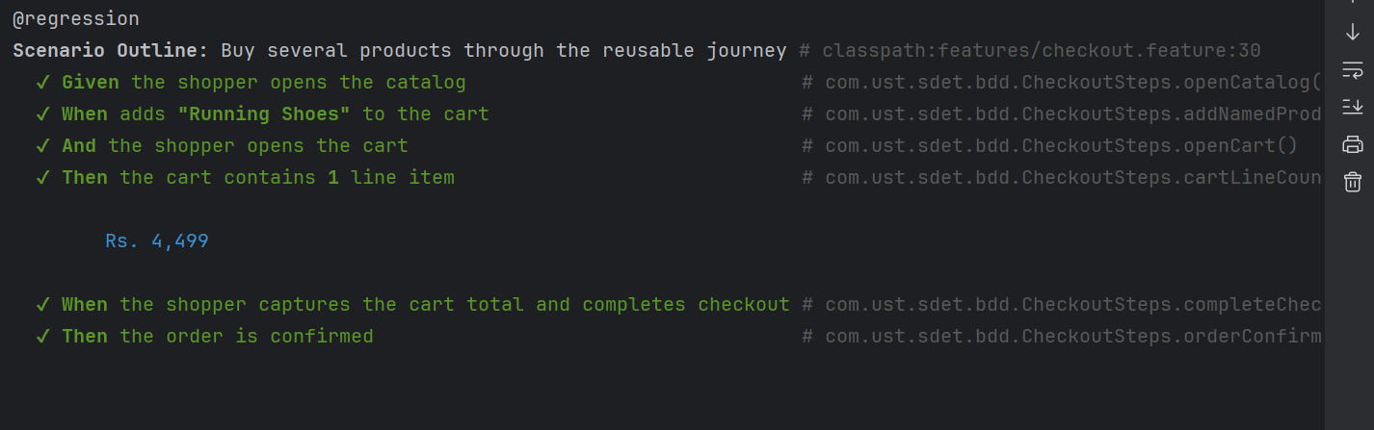

Scenario 5: Login to Checkout Flow
Verify complete business workflow from login through checkout.
Step 1: Login
Step 2: Add Lamp
Expected Result: Cart badge = 1
Step 3: Open Cart
Expected Result: Cart contains 1 item
Step 4: Add Shoes
Expected Result: Cart badge = 2
Step 5: Open Cart
Expected Result: Cart contains 2 items
Step 6: Checkout
Expected Result:Order confirmation displayed

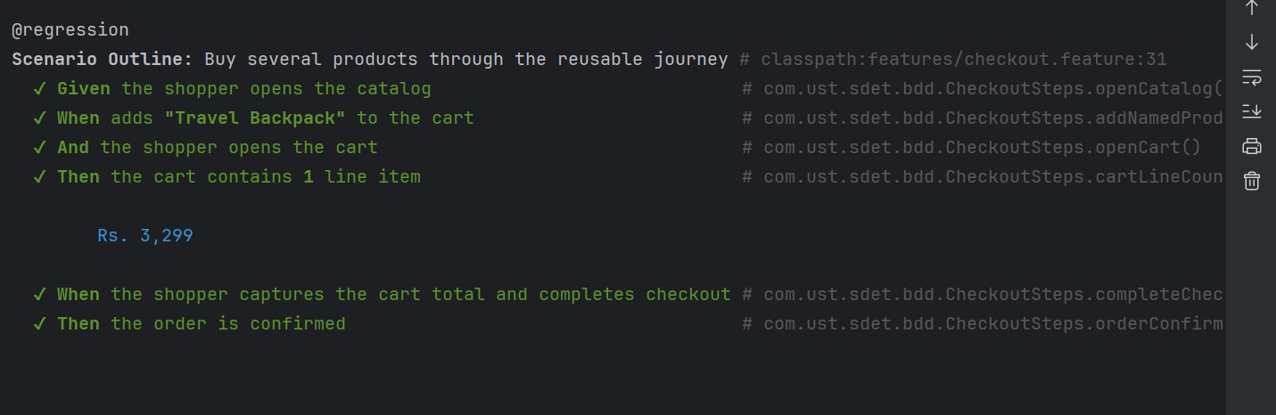

Scenario 6: Buy Multiple Products End-to-End
Verify different products can be purchased successfully.
Products
Headphones
Shoes
Lamp
Steps
- Search product.
- Add first result to cart.
- Verify cart count.
- Open cart.
- Verify line item.
- Place order.

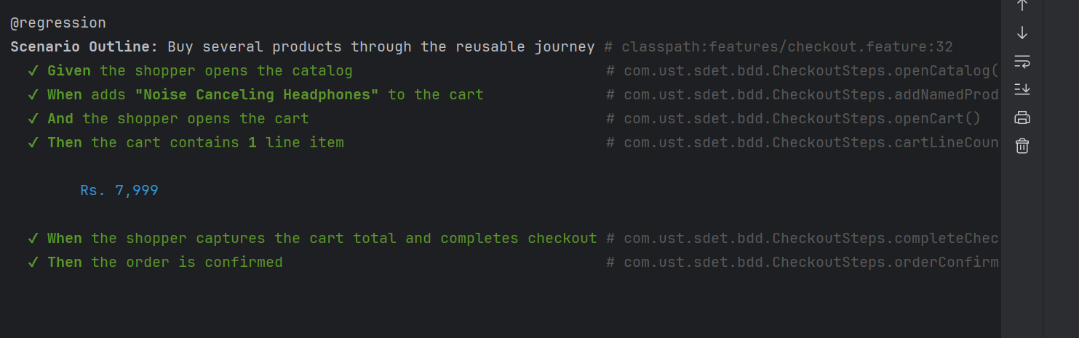

Scenario 7: Fresh Cart Validation
Verify a newly opened cart is empty.
Steps
- Open cart.
Expected Result: Cart contains zero items.

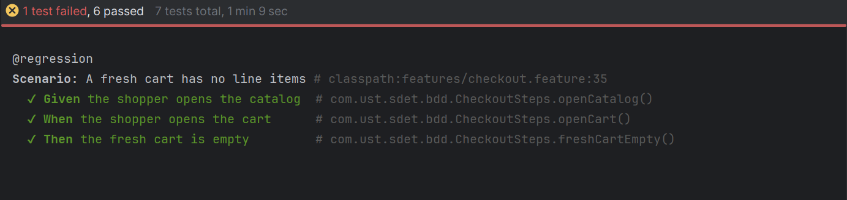

Scenario 8: Invalid Login Validation
Verify invalid users cannot log in.
Test Data
Username | Password
invalid@example.com | password
Step 1: Enter Invalid Credentials
Step 2: Click Sign In
Expected Result:Login should fail.
Step 3: Verify Error Message
Expected Result:Appropriate error message displayed.
Framework Features
- Page Object Model
- Reusable Components
- Explicit Waits
- Cucumber BDD
- PicoContainer Dependency Injection
- Allure Reporting
- Screenshot Capture
- Maven Execution
- Tag-Based Execution (@smoke, @regression, @negative)
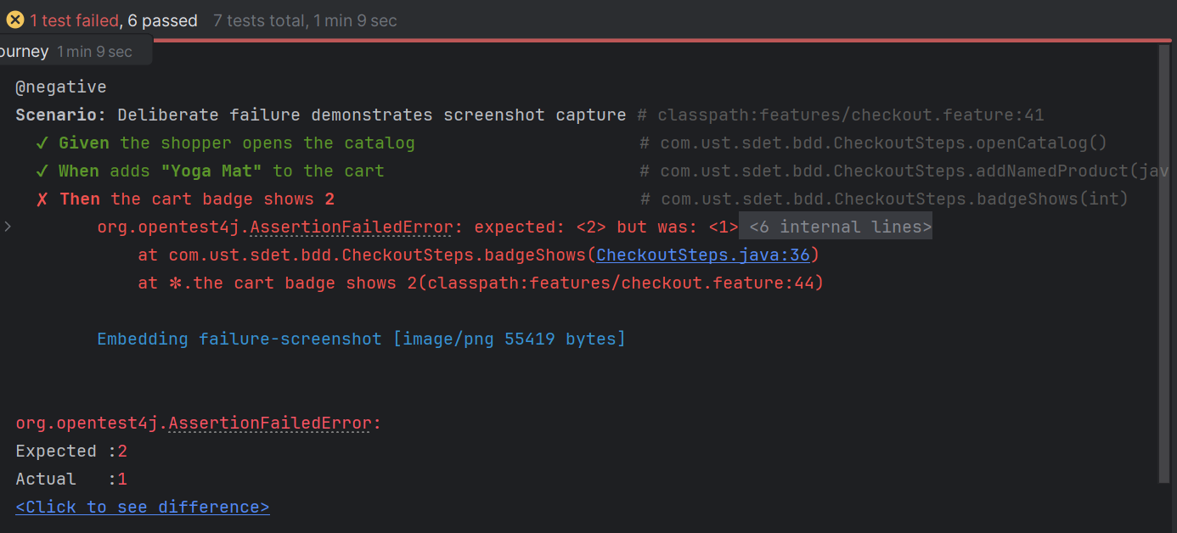

Allure report: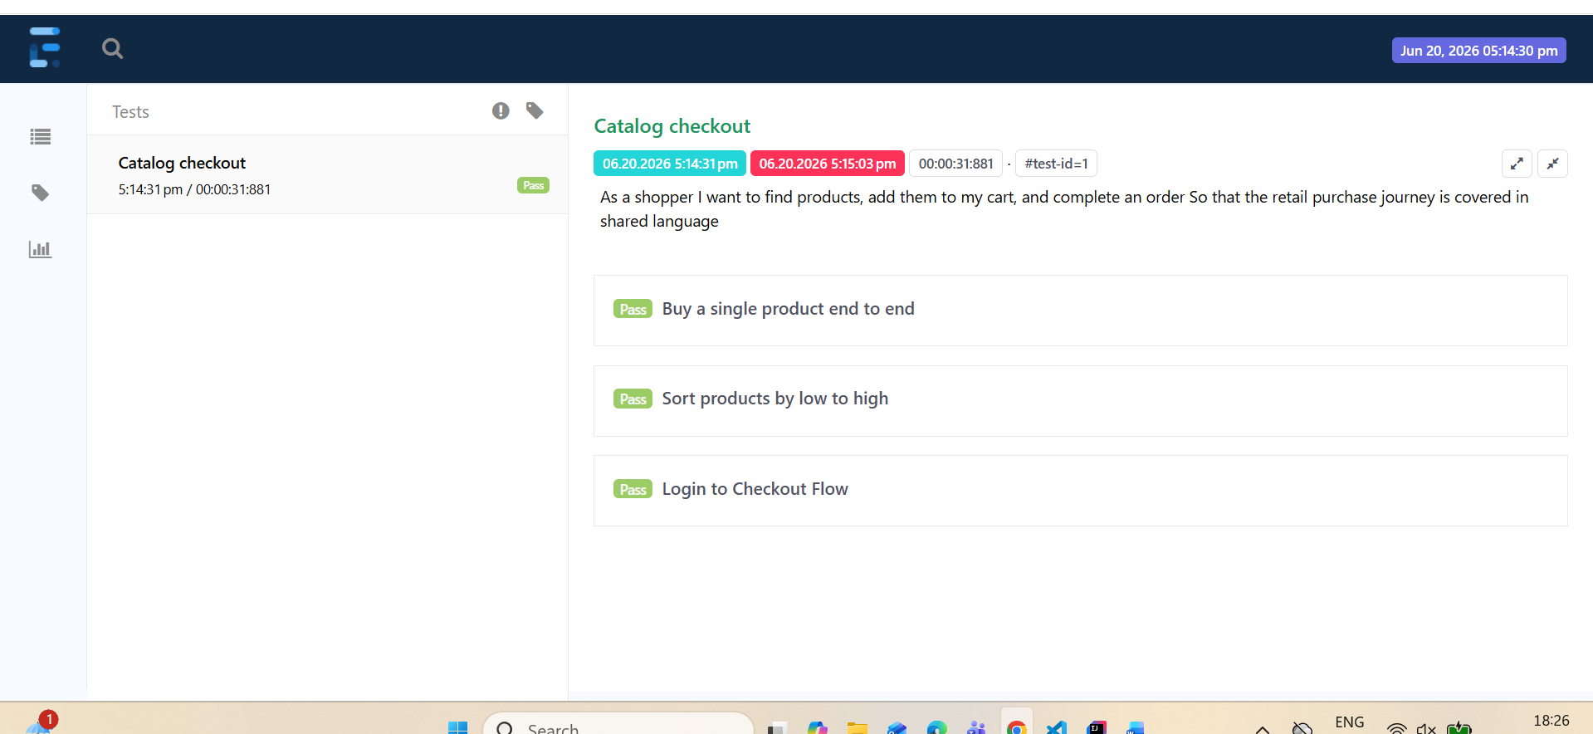
Conclusion
All critical user journeys including login, catalog operations, cart functionality, sorting, checkout, and negative validation are automated and covered through BDD scenarios.

