SDET RETAIL APP TEST REPORT

TOOLS AND FRAMEWORK USED:
- Selenium – For Brower Automation
- Cucumber – For Behaviour Driven Development and shared understanding
- Extent & Allure – For Detailed Reporting
- Page Object Model Design Pattern for Better Maintainability and Code Reusability.
- Java – Programming Language
- Maven – For Project Lifecycle and Dependency management

Features:
- Authentication.feature – The application’s login flow is tested with valid credentials. But Password is intentionally provided wrong in config.properties to make sure screenshot is attached to the report on test failure. To run that successfully, change the password in config.properties from password@321 to password@123.
- SearchAndOrder.feature – A user journey where the order placement is covered from searching the product.
- OrderFlow.feature – A common product purchase journey to test the behaviour with different inputs.
- Cart.feature – The Cart functionalities like updating of cart badge , after adding product to cart and the freah cart is starts with zero.

Test Results Screenshots:
1)Tests Run
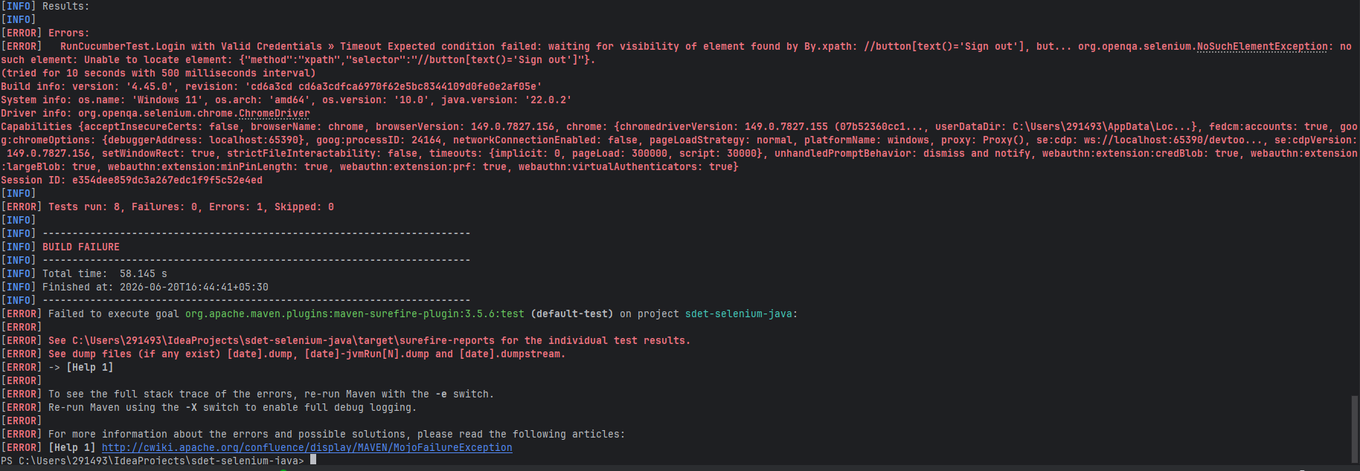
2)Cucumber Report
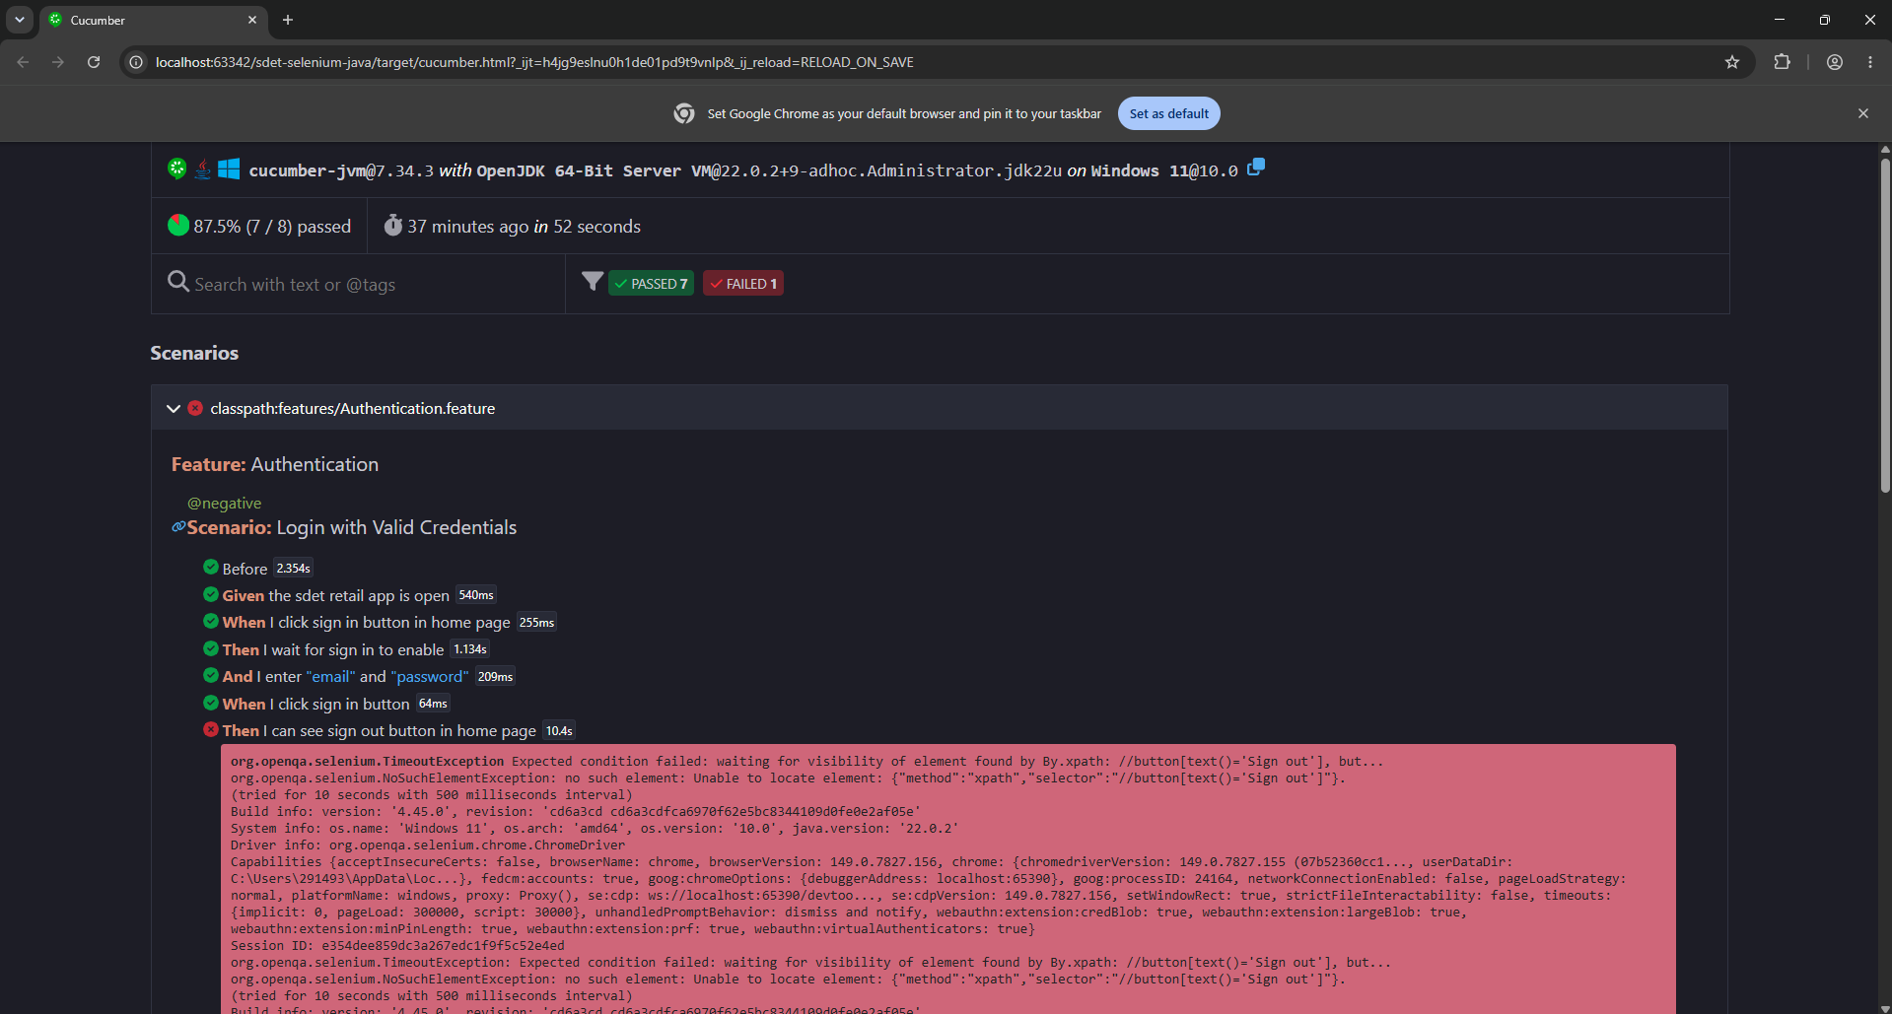

3)Spark Report

