@regression
Run using ‘mvn clean test -Dtest=RunCucumberTest -Dcucumber.tags.filter="@regression"’

1)Multiple inputs using Scenerio outline:-
The items to be searched are stored in the examples
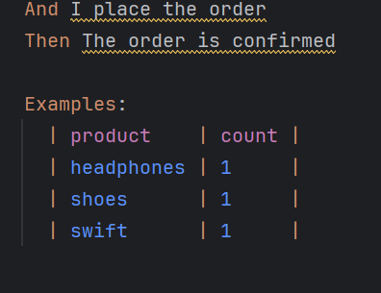
Product - count
Headphones – 1
Shoes – 1
Swift -1
a)Open catalog page
b)Search for the item
c)Add the first result to cart
d)See whether the product is in cart
e)Order is then placed
f)The order is confirmed using the text ‘confirmed’
2)Checking whether cart is empty
a)Go to the cart page
b)Check whether the count is 0

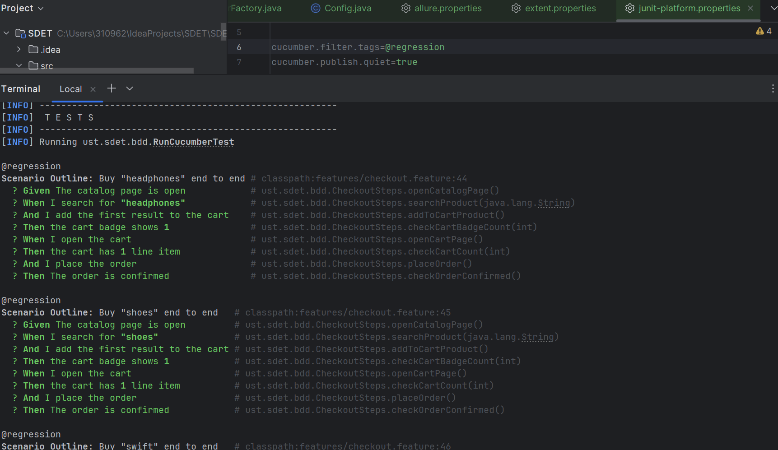
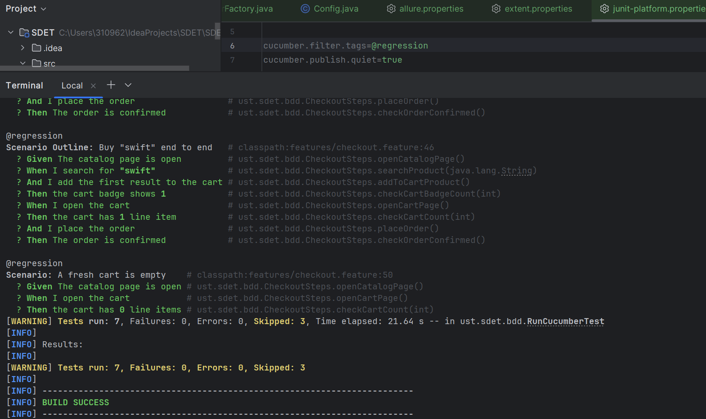

@smoke
Run using ‘mvn clean test -Dtest=RunCucumberTest -Dcucumber.tags.filter="@smoke"’
Or mvn clean test
1)Full flow:-
a)Open catalog page
b)Search for the item
c)Add the first result to cart
d)See whether the product is in cart
e)Order is then placed
f)The order is confirmed using the text ‘confirmed’
2)Checking whether cart badge is correct:-
a)Open catalog page
b)Adding an item
c)Checking cart badge count is 1
d)Open catalog page
e)Adding an item
f)Checking cart badge count is 2

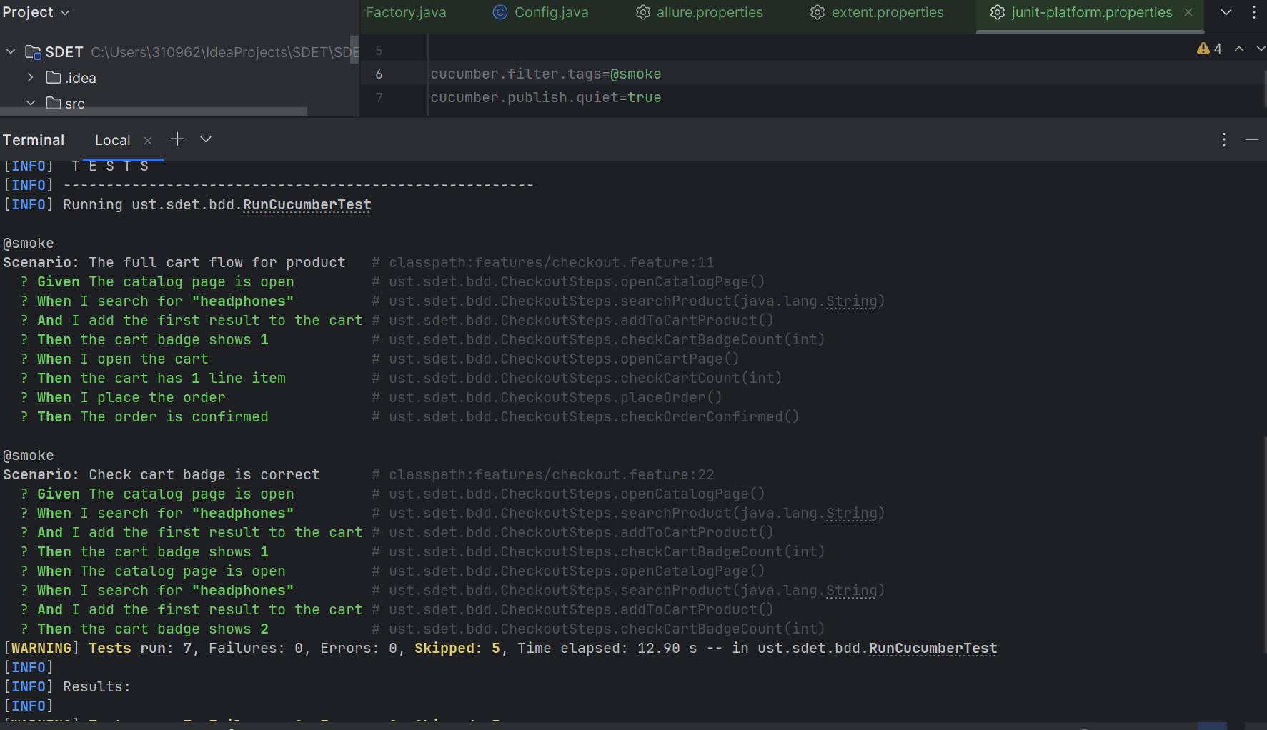

@negative
Run using ‘mvn clean test -Dtest=RunCucumberTest -Dcucumber.tags.filter="@negative"’
1)Adding more items than available stock:-
a)Open catalog page
b)add item to cart
c)Repeat until the addition exceeds the available stock
d)Shows cart count error
Fix(options):- Check for the error ‘Unable to add this item. Check stock and try again.’ Before checking the badge.

