Playwright Automation Framework – Shoppers Stop Test Report

1. Project Title
UI Automation Testing Framework using Playwright – Shoppers Stop Search validation

2. Objective
The objective of this project is to design and implement a scalable UI automation framework using Playwright and TypeScript to validate search functionality for a Shoppers Stop website.
Target Website:
https://www.shoppersstop.com/home

3. User Story
User Story 1 – Existing product
The website should return search results for an existing product and appropriate results with count is to be displayed.

User Story 2 – Non-existing product
The website should return search results for a non-existing product and appropriate results with count is to be displayed.

4. Environment & Setup
Software
Component | Version
Playwright | Latest
TypeScript | Latest
VS Code | Latest
Browser | Chromium

5. Framework Design
Framework Architecture:
Fixture Layer
↓
Flow Layer
↓
Page Layer
↓
Test Layer
Description:
Fixtures
Responsible for:
- Creating reusable test context
- Injecting page objects
File:
Fixtures/test.ts

Flow Layer
Responsible for:
- Business workflow implementation
- Combining page actions
File:
Flows/ShopFlow.ts
Methods:
- searchPositiveProduct()
- searchNegativeProduct()

Page Layer
Responsible for:
- Encapsulating locators
- Maintaining UI interactions
Files:
pages/HomePage.ts
pages/ResultPage.ts

Test Layer
Responsible for:
- Test orchestration
- Assertions
File:
tests/search.spec.ts

6. Project Structure
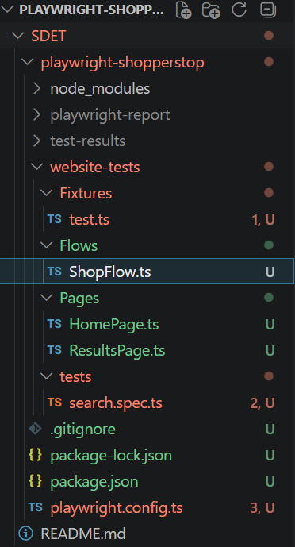

7. Scenarios Covered
Scenario 1 – Existing Product search
Input:
prod – ‘Jackets’
Expected:
- Types ‘Jackets’ in search bar
- Search results displayed
- Results count
Status:
PASS

Scenario 2 – Non existing product search
Input:
prod – ‘atyy$^&*’
Expected:
- Displays “No results found”
Status:
PASS

8. Execution Steps
Install dependencies:
npm install
Install browsers:
npx playwright install
Execute tests:
npx playwright test website-tests/tests --headed
Open report:
npx playwright show-report

9. Test Results
Execution Summary:
Total Tests: 2
Passed: 2
Failed: 0
Execution Mode:
Chromium Browser

10. Evidence
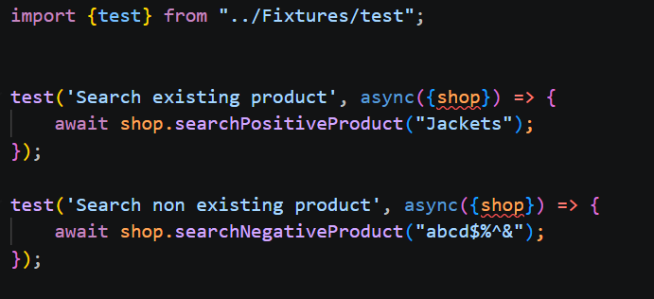
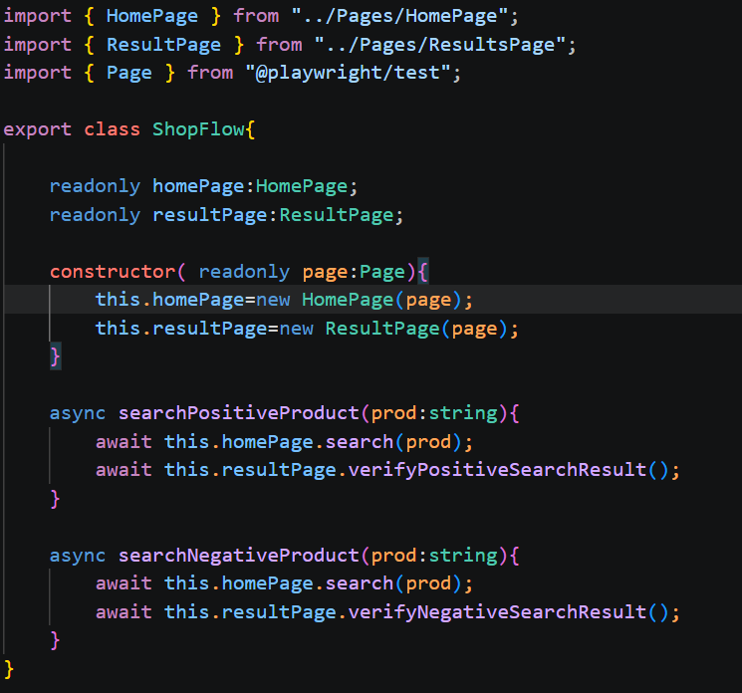

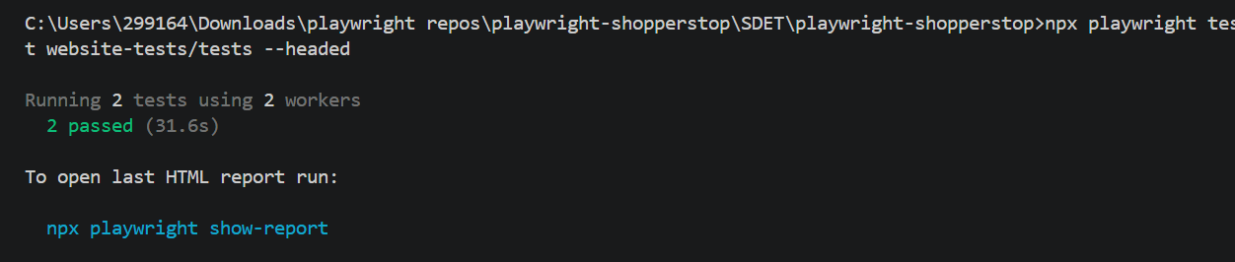

11. Environment Configuration
Playwright Configuration:
- Browser: Chromium
- Base URL Configured

13. Limitations
- Public site introduces flakiness

14. Conclusion
The Playwright automation framework was successfully implemented using Page Object Model, Flow Layer, and Fixtures.
The framework achieved:
- Reusable architecture
- Improved maintainability
- Reduced code duplication
The implemented solution can be extended for regression, cross-browser testing, CI/CD integration, and scalable UI automation.

