REST Assured API Automation Framework Report
Project Title
API Automation Testing Framework for PetStore APIs using REST Assured and JUnit 5

1. Objective
The objective of this project is to design and implement a reusable API automation testing framework using REST Assured to validate Pet Collection APIs.
The framework focuses on:
- Verifying API functionality for CRUD operations
- Performing response validation
- Supporting maintainable and scalable API test automation

2. User Story
I want to automate PetStore API endpoints
So that
I can verify API behavior, validate response contracts, and ensure data integrity without manual testing.

3. API Details
Base URL
https://petstore.swagger.io/
Base Path
/pet
Authentication
x-api-key
special-key

4. Environment & Setup
Software
IDE:
IntelliJ IDEA
Programming Language:
Java 17+
Build Tool:
Maven
Test Framework:
JUnit 5
API Testing:
REST Assured

5. Framework Design
Test Layer
Purpose:
Contains CRUD test implementation.
Files:
- PetStoreApiTest.java

6. Project Structure
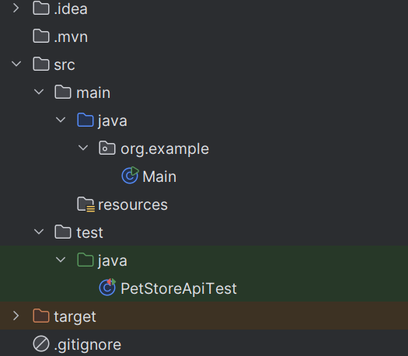

7. Tests Covered
- Returning stock inventory
- Get pet by ID
- Create pet
- Update pet by ID
- Delete pet by ID

8. How to Run
Open terminal.
Execute:
mvn clean test

9. Test Results
Scenario | Status
Return stock inventory | Pass
Get Pet by ID | Pass
Update Pet | Pass
Create pet | Pass
Delete pet | Pass

10. Evidence
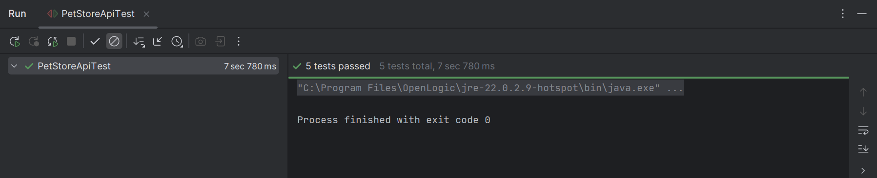

11. Conclusion
The REST Assured API Automation Framework was successfully developed to automate Product APIs.
The framework provides:
- Reusable specifications
- Dynamic test execution
- JSON schema validation
- Maintainable architecture
- Reliable CRUD automation
The implementation reduces manual effort and improves API quality validation through automated execution.

