API Automation Assessment Report
Project Name: Api Testing
Participant: Tetali Hemanth Venkata Reddy
Date: 29-06-2026
Git Repo Url : ust-sdet-training/SDET: Repository for SDET training batch
Branch name : hemanth-qa-gate2
Assessment: API Automation using Rest Assured

1. Objective & User Story
Objective
Develop an automated API test using Rest Assured to create a new post through the JSON Placeholder API and validate that the API returns the expected response with the correct status code and response body.

User Story
As a QA Engineer, I want to create a new post using the JSON Placeholder API and verify that the response contains the expected data, so that I can ensure the POST endpoint is functioning correctly and returns the appropriate response upon successful resource creation.
2. Flow Under Test
Scenario :
- Create a new post and verify the API response.
3. Environment & Setup
Application Details
Item - Value
Application URL - Configured through .env
Framework - Rest Assured
Language - Java 22
Build Tool - Maven
Test Runner - JUnit 5
Schema Validation - JSON Schema Validator
OS - Windows 11
Environment Variables
Stored in: .env file
BASE_URL=https://jsonplaceholder.typicode.com
Execution Command
mvn clean test

4. Framework Design
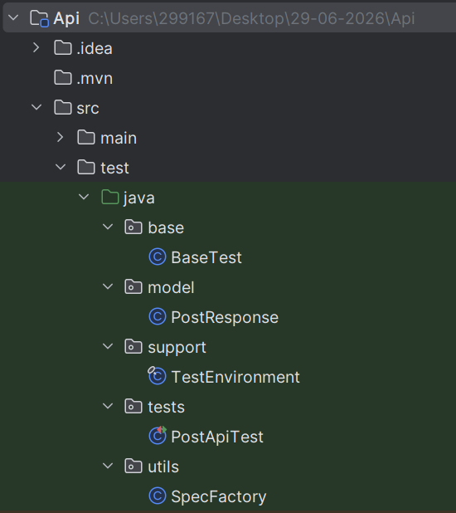

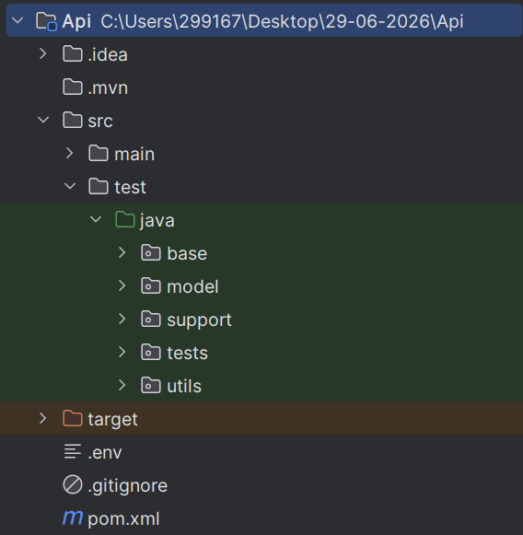

I kept Base url in the .env file and then called to Test Environment from the Test Environment I called to BaseTest.
Then I extended Api test to BaseTest .

5. Test Scenario Covered
As a QA Engineer, I want to create a new post and verify the response.
Base URL: https://jsonplaceholder.typicode.com
Flow
1. Send a POST request to: /posts
2. Request Body:
{
"title": "Automation Testing",
"body": "Rest Assured Assignment",
"userId": 1
}
3. Validate:
a. Status Code = 201
b. Response contains:
a. title
b. body
c. userId
d. id
Expectations
a. POST request
b. Request body creation
c. Response validation
d. Assertions

6. Automation Best Practices Used
• Rest Assured Framework
• JUnit 5
• Request Specification Pattern
• Response Specification Pattern
• Environment Variables (.env)
• JSON Schema Validation
• Reusable Test Utilities
• Token-Based Authentication
• Centralized Configuration
• Assertions for Status Codes
• Assertions for Business Data
• Clean and Maintainable Framework Structure
• Reusable Payload Models
• Maven Dependency Management

7. Execution Result
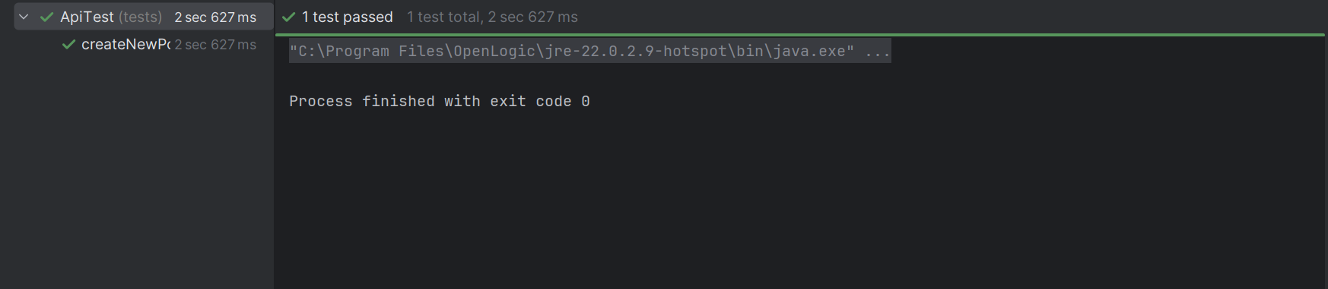
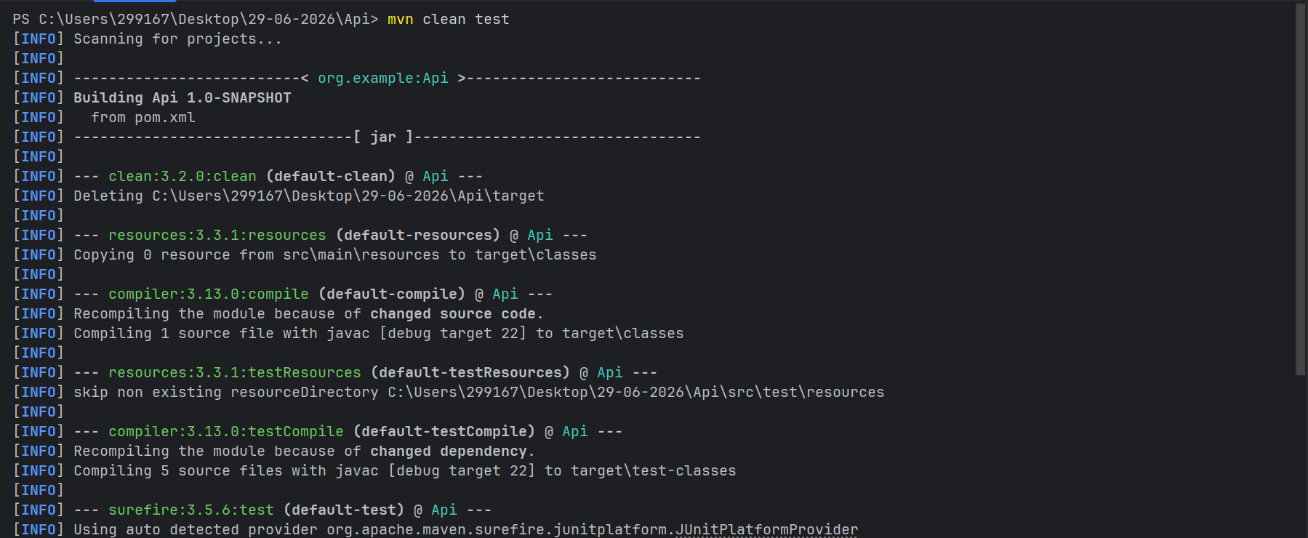
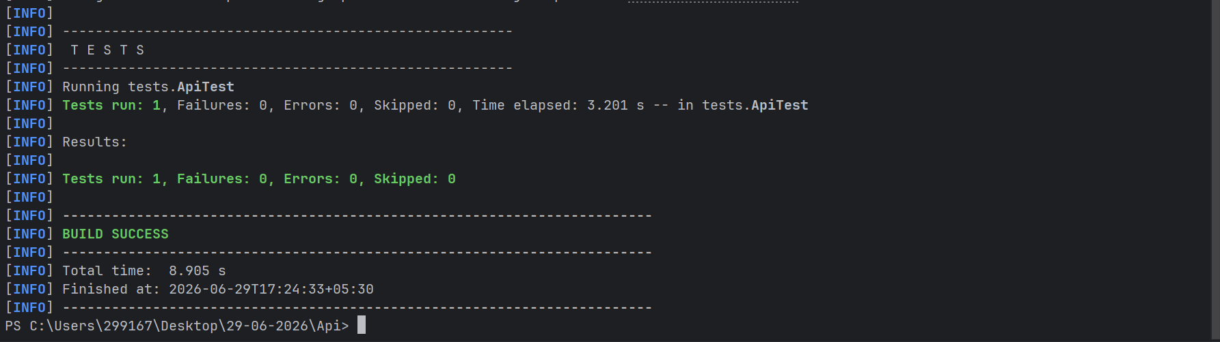
8. Conclusion
The Rest Assured API automation framework successfully validates the critical functionality of the application APIs.

