UI Automation Assessment Report
Project Information
Project Name: Selenium Ui Testing
Participant: Tetali Hemanth Venkata Reddy
Date: 29-06-2026
Branch: hemanth_qa_gate2
Assessment: UI Automation using Selenium WebDriver

1. Objective & User Story
Objective
The objective of this automation project is to validate the core user interface functionality of the application using Selenium WebDriver.
The automated test suite validates critical user workflows including navigation, authentication, product search, product selection, cart management, and checkout functionality.
The framework is designed to be scalable, maintainable, and reusable using modern UI automation best practices and the Page Object Model (POM) design pattern.

User Story
As a customer, I want to filter and sort products. So that I can quickly find products matching my preference.
2. Flow Under Test
Scenario – 1:
Search for ""T-Shirts"".
Apply Brand filter.
Verify all displayed products belong to selected brand.
Scenario – 2:
Apply Price filter.
Verify products fall within selected range.
Scenario – 3:
Sort by Price: Low to High.
Verify prices are sorted correctly.

3. Environment & Setup
Application Details
Item - Value
Application URL - Configured through Config.java
Framework - Selenium WebDriver
Language - Java 22
Build Tool - Maven
Test Runner - JUnit 5
Design Pattern - Page Object Model (POM)
Browser - Google Chrome
Driver Management - ChromeDriver
OS - Windows 11
Environment Configuration
Configured using:
System.getProperty("BaseURL")
System.getProperty("headless")
Example:
BaseURL=
headless=false

Execution Command
mvn clean test
Headless Execution:
mvn clean test -Dheadless=true

4. Framework Design
The framework follows reusable Selenium automation design principles.
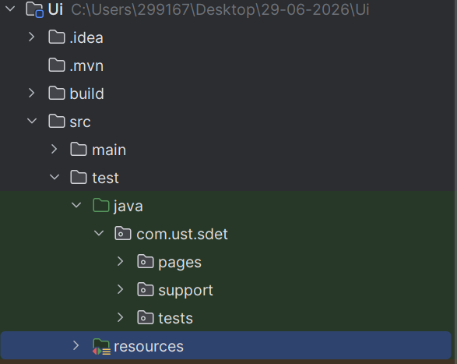
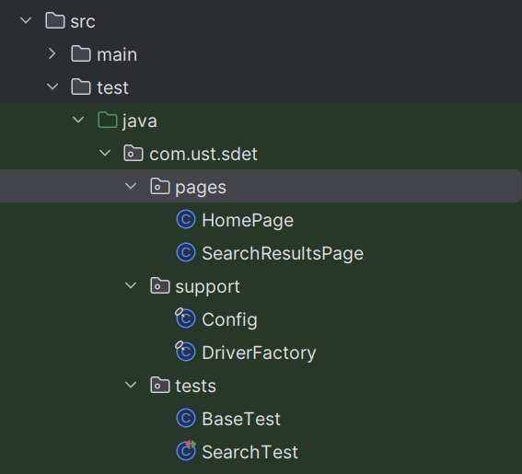

5. Test Scenarios Covered
Search for ""T-Shirts"".
Apply Brand filter.
Verify all displayed products belong to selected brand.
Apply Price filter.
Verify products fall within selected range.
Sort by Price: Low to High.
Verify prices are sorted correctly.

6. Automation Best Practices Used
- Selenium WebDriver
- JUnit 5
- Page Object Model (POM)
- Explicit Waits
- Centralized Configuration
- Reusable Driver Factory
- Headless Execution Support
- Clean Test Structure
- Encapsulated UI Actions
- Reusable Utility Methods
- Assertions for UI Elements
- Assertions for Business Flows
- Maven Dependency Management
- Maintainable Framework Design

7. Results
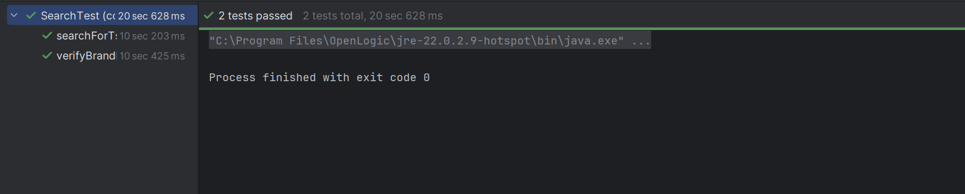

8. Conclusion
The Selenium UI automation framework successfully validates the critical user interface functionality of the application.

