Objective

Environment & Setup

Environment Setup Command:
npm init playwright@latest ------- initializes the playwright config and necessary files
npm install winston@latest ------ installs the Winston package for logging

Execution Command:
npx playwright test --headed

Playwright Config:-
import { defineConfig, devices } from '@playwright/test';

/**
* Read environment variables from file.
* https://github.com/motdotla/dotenv
*/
// import dotenv from 'dotenv';
// import path from 'path';
// dotenv.config({ path: path.resolve(__dirname, '.env') });

/**
* See https://playwright.dev/docs/test-configuration.
*/
export default defineConfig({
testDir: './tests',
/* Run tests in files in parallel */
fullyParallel: true,
/* Fail the build on CI if you accidentally left test.only in the source code. */
forbidOnly: !!process.env.CI,
/* Retry on CI only */
retries: process.env.CI ? 2 : 0,
/* Opt out of parallel tests on CI. */
workers: process.env.CI ? 1 : undefined,
/* Reporter to use. See https://playwright.dev/docs/test-reporters */
reporter: 'html',
/* Shared settings for all the projects below. See https://playwright.dev/docs/api/class-testoptions. */
use: {
/* Base URL to use in actions like `await page.goto('')`. */
// baseURL: 'http://localhost:3000',
baseURL: process.env.BASE_URL || "http://localhost:5173",

/* Collect trace when retrying the failed test. See https://playwright.dev/docs/trace-viewer */
trace: 'on',
screenshot:'on',
video:'on'
},

/* Configure projects for major browsers */
projects: [
{
name: 'chromium',
use: { ...devices['Desktop Chrome'] },
},

// {
// name: 'firefox',
// use: { ...devices['Desktop Firefox'] },
// },

// {
// name: 'webkit',
// use: { ...devices['Desktop Safari'] },
// },

/* Test against mobile viewports. */
// {
// name: 'Mobile Chrome',
// use: { ...devices['Pixel 5'] },
// },
// {
// name: 'Mobile Safari',
// use: { ...devices['iPhone 12'] },
// },

/* Test against branded browsers. */
// {
// name: 'Microsoft Edge',
// use: { ...devices['Desktop Edge'], channel: 'msedge' },
// },
// {
// name: 'Google Chrome',
// use: { ...devices['Desktop Chrome'], channel: 'chrome' },
// },
],

/* Run your local dev server before starting the tests */
// webServer: {
// command: 'npm run start',
// url: 'http://localhost:3000',
// reuseExistingServer: !process.env.CI,
// },
});

Tests Performed
Refund-tests-spec.ts
- Checking for full refund
- Creates an order using ‘/api/refund-lab/orders’ api (POST)
- Send a refund request for the entire quantity using ‘/api/refunds’ post request
- Verify the response is successful or not

- Checking for partial refund
- Creates an order using ‘/api/refund-lab/orders’ api (POST)
- Send a refund request for the entire quantity using ‘/api/refunds’ post request
- Verify the response is successful or not
- Testing for checking double refund
- Creates an order using ‘/api/refund-lab/orders’ api (POST)
- Send a refund request for the entire quantity using ‘/api/refunds’ post request using a created idempotence key
- Send another duplicate request using the same idempotence key.
Status :- Failing. The second request is still Refunding.

- Checking rejected refund scenarios (using forEach table)
- Over-refund :- trying to refund, more quantity than what is ordered
- Already-Refunded:- trying to refund an item that has already been refunded

Offline Resilience Test
- Rollback to an optimistic state when sync fails on server side.
- Browser set to Offline
- Item added to Queue
- The request is aborted. And the item is removed from the queue
- Sync queuing and resyncing when the network re-establishes after an outage
DiagnosticLoggingTest
- Creating a complete end to end flow from adding to cart to placing the order
- Applying coupon code ‘UST-10’. Checking value is correct

Folder Structure
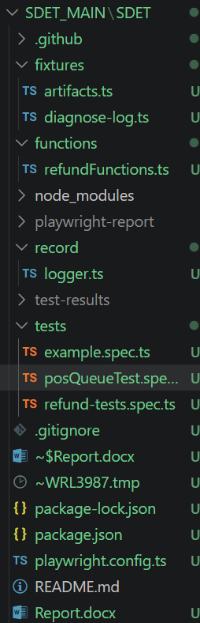
Logger.ts ------ contains the redaction functions and Winston custom structure
Diagnose-log.ts ----- containing the logging functions
Artifact.ts ----- contains the functions for storing the artifacts

Results:

1)
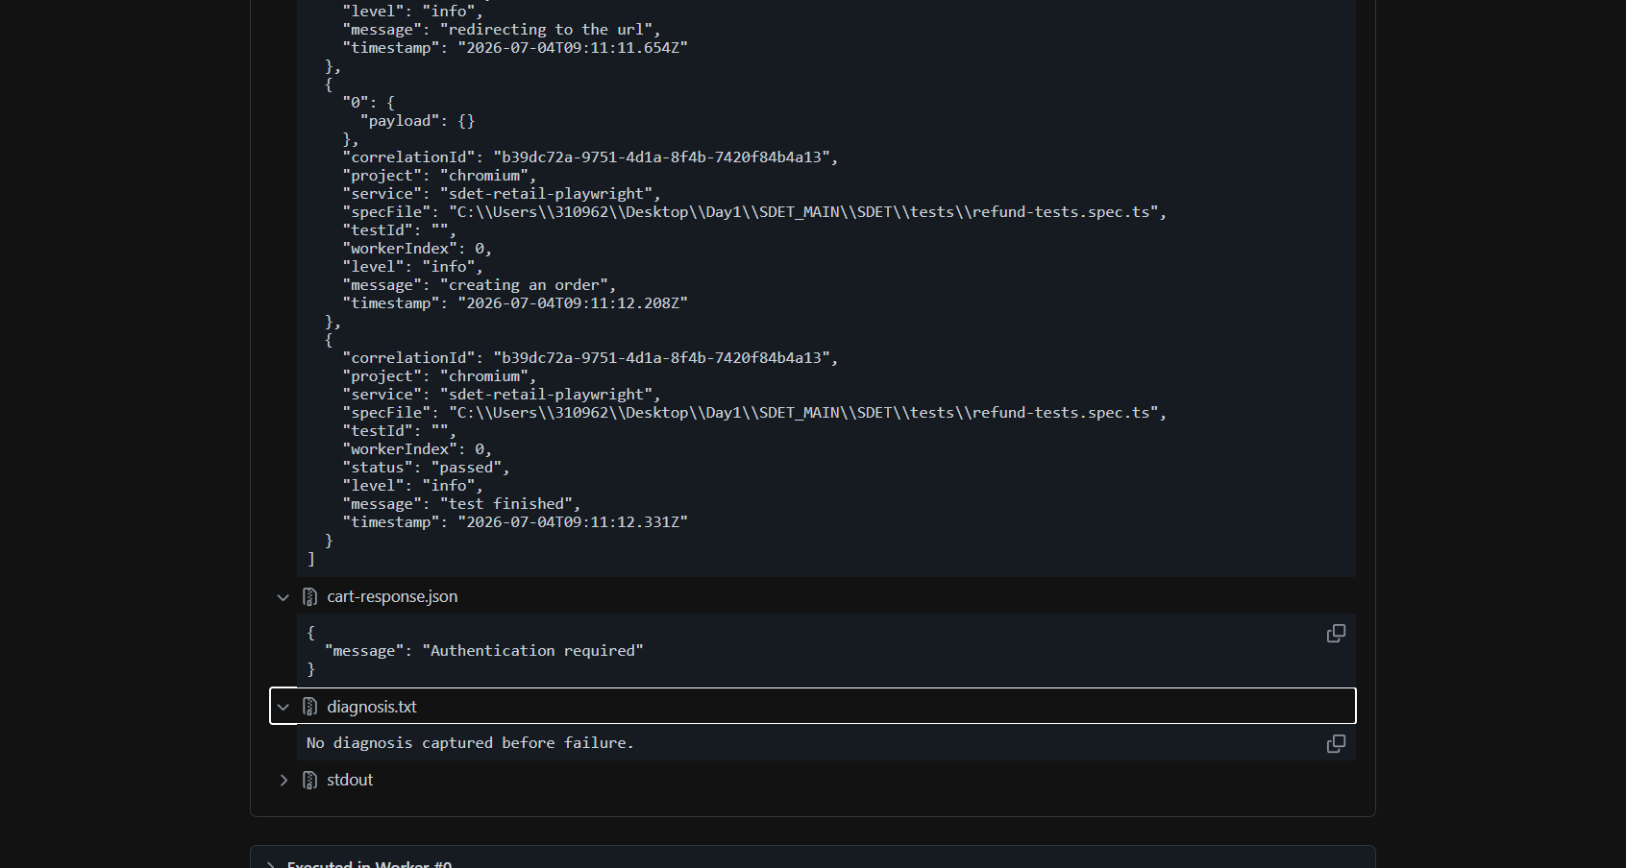
Authentication error with header. Modified the header params with Bearer type

2)
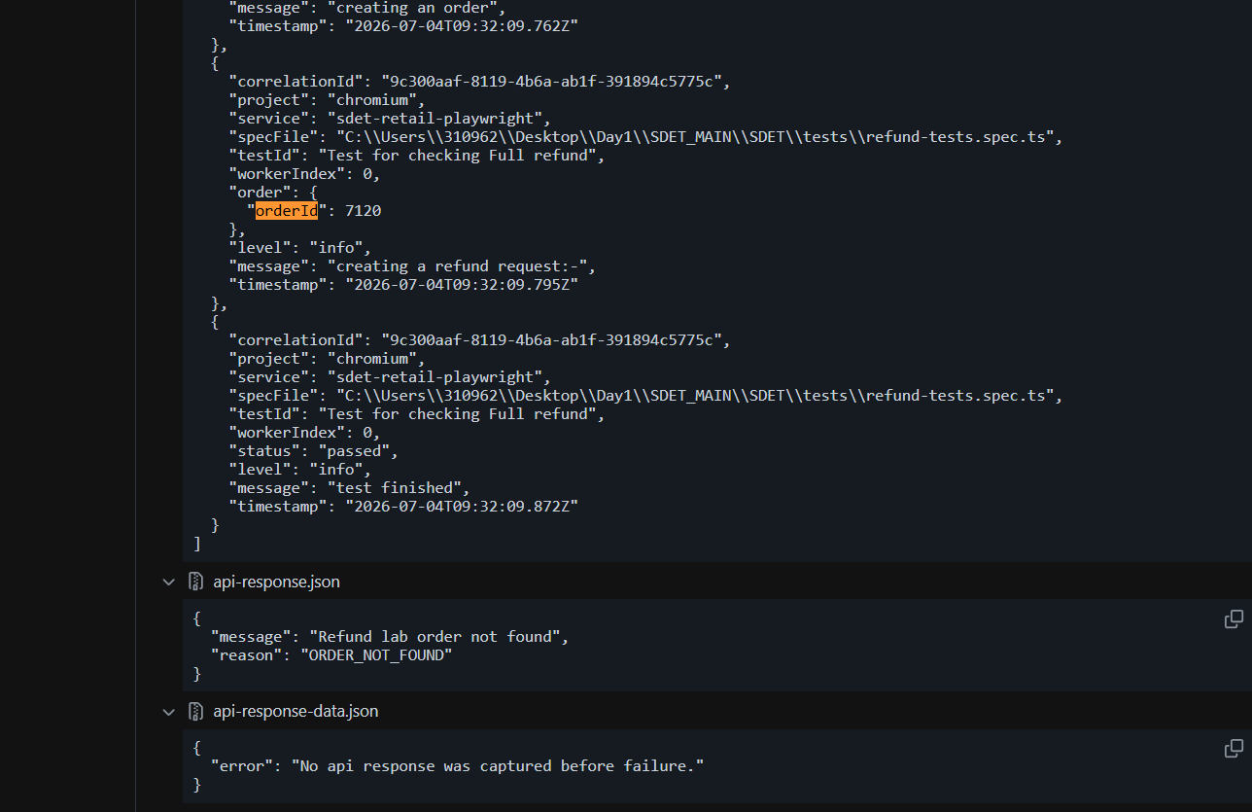
Incorrect payload given. Previous payload given instead of the correct payload
3)
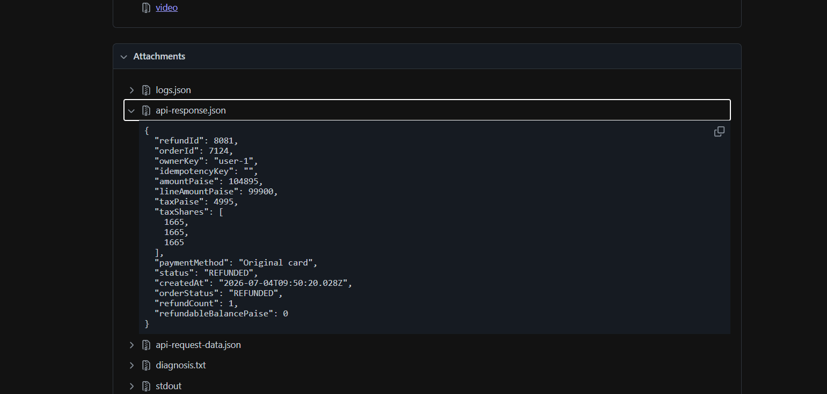
Full refund response
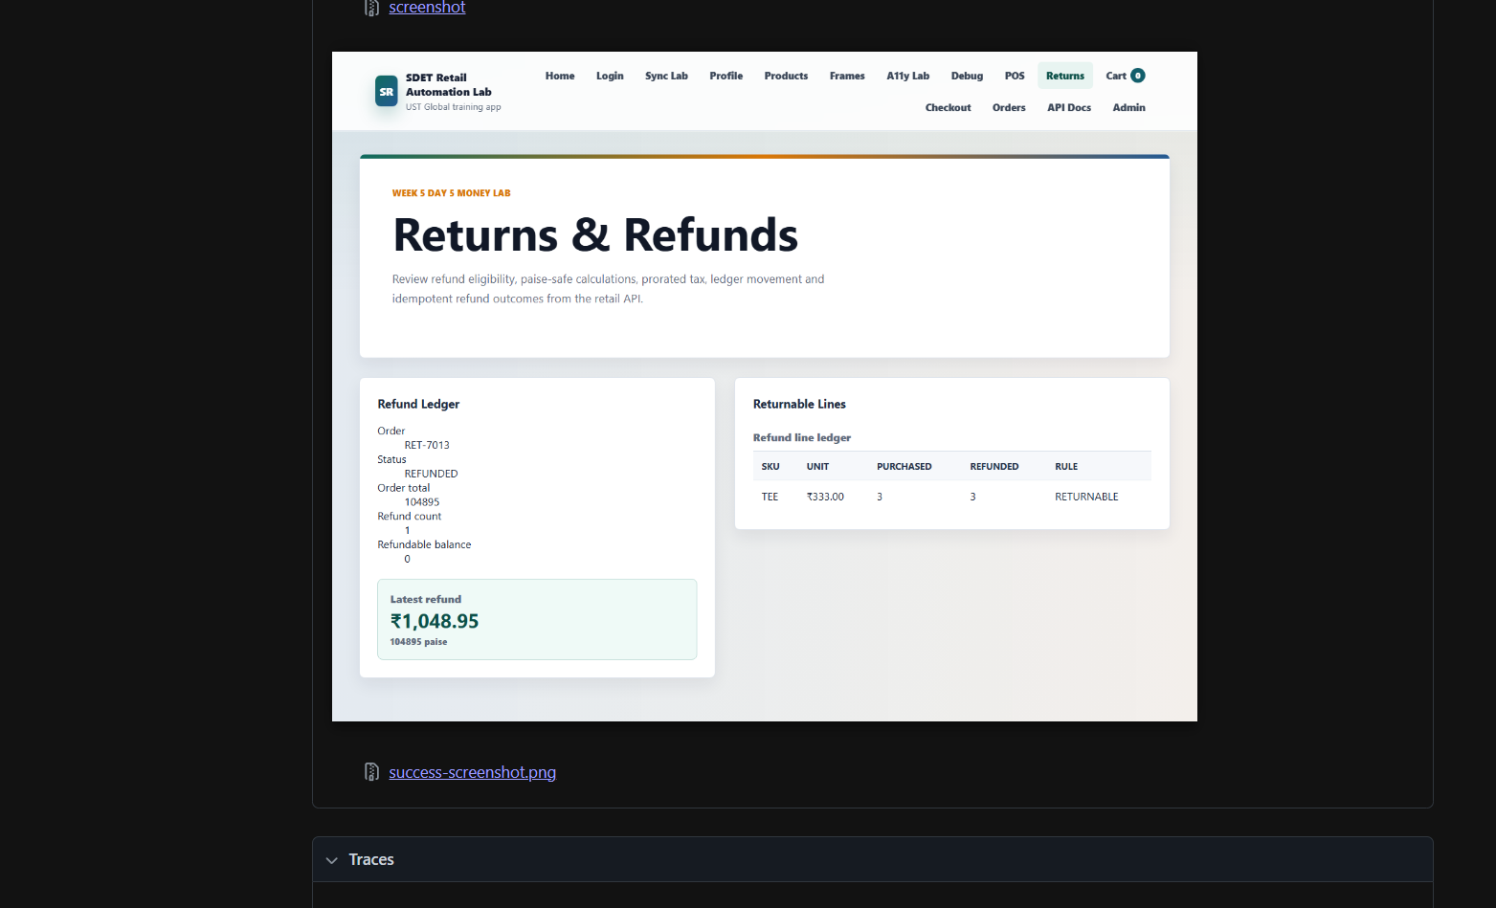
4)
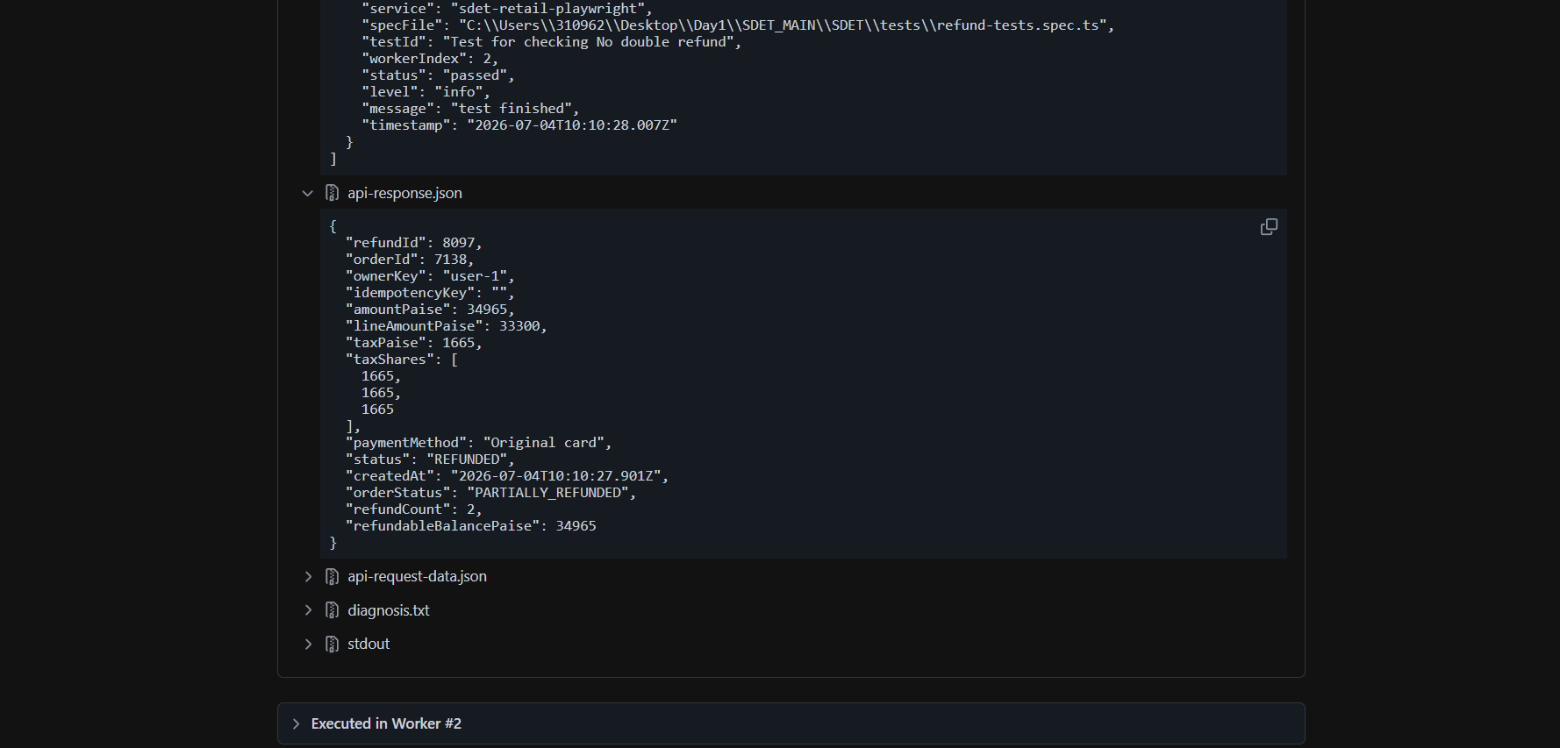
Refund count showing 2 for double request in same idempotent key.
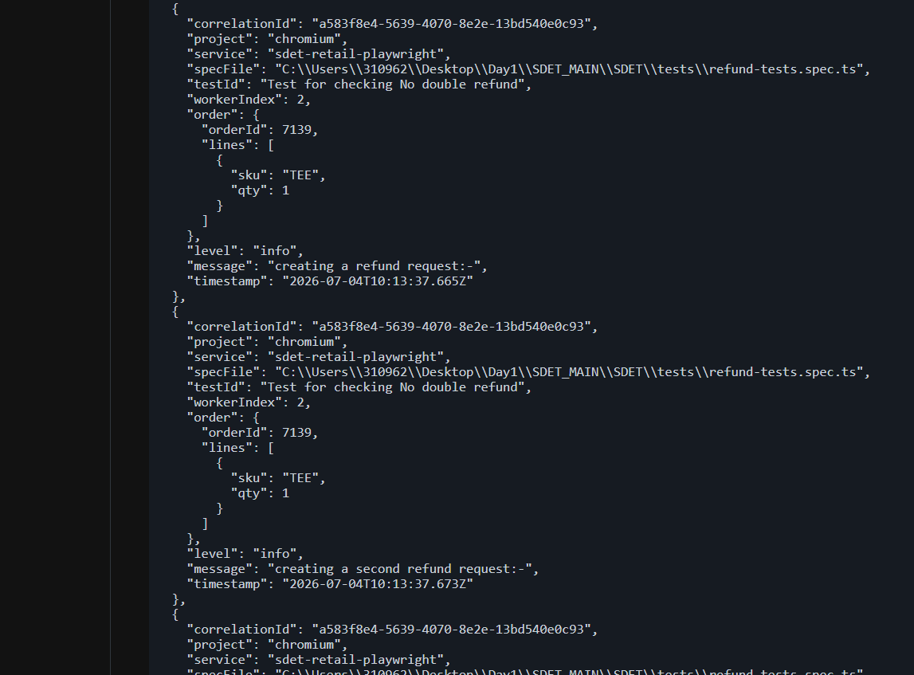
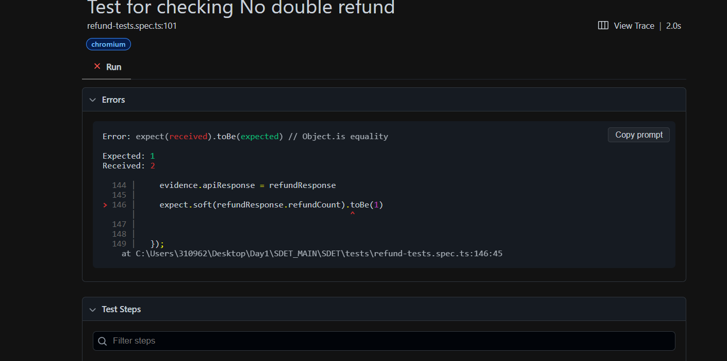
5)End to end flow screenshots
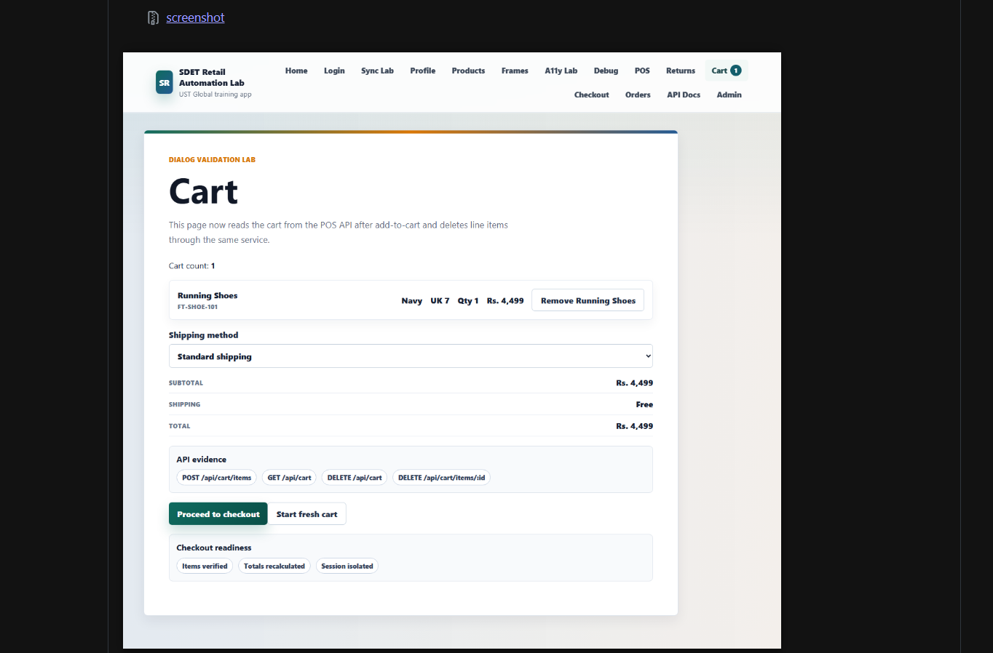
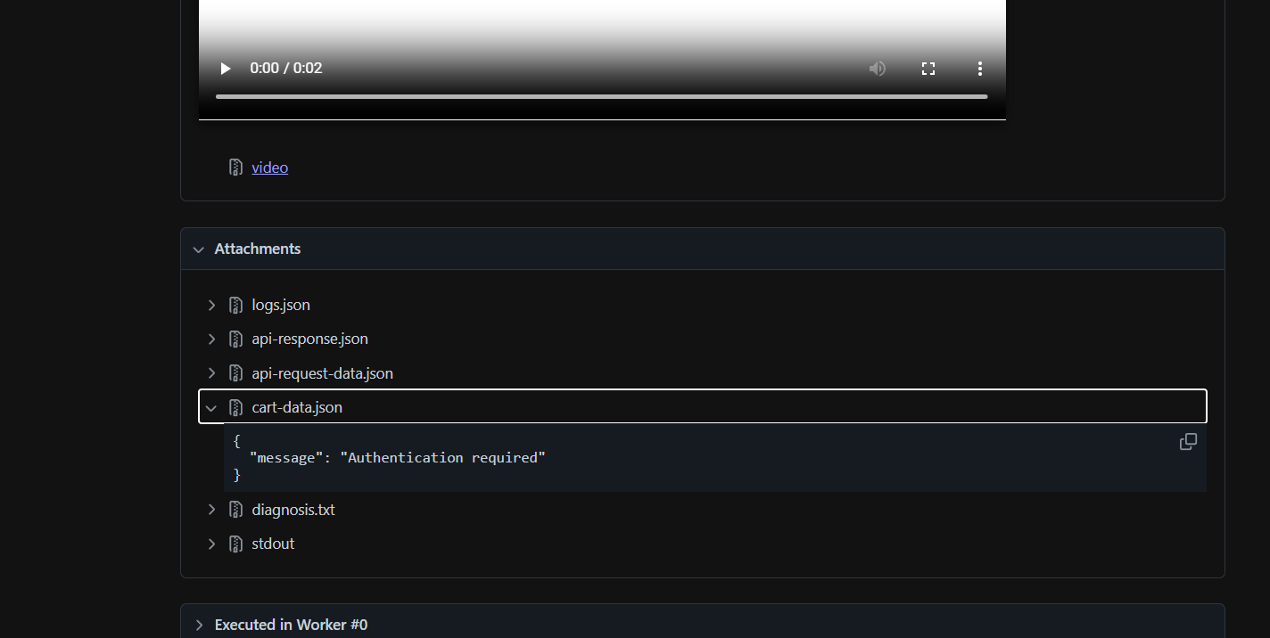
Authentication error:- Fixed the issue by fixing the headers with Authorization Bearer Token
