RETAIL APP TEST REPORT
User Story
As a shopper
I want to find products, add them to my cart, and complete an order
So that the retail purchase journey is covered in shared language
Scenarios
- Scenario: Buy a single product end to end
@smoke
When I search for "headphones"
And I add the first result to the cart
Then the cart badge shows 1
When I open the cart
Then the cart has 1 line item
When I place the order
Then the order is confirmed

- Scenario: cart badge reflects the number of items
@smoke
When I search for "headphones"
And I add the first result to the cart
Then the cart badge shows 1

- Scenario Outline: Buy "<product>" end to end
@regression
When I search for "<product>"
And I add the first result to the cart
Then the cart badge shows <count>
When I open the cart
Then the cart has <count> line item
When I place the order
Then the order is confirmed
Examples:
| product | count |
| headphones | 1 |
| shoes | 1 |
| lamp | 1 |

- Scenario: A fresh cart is empty
@regression
When I open the cart
Then the cart has 0 line items

- Scenario: deliberately failing scenario to demonstrate the failure screenshot
@negative
When I search for "headphones"
And I add the first result to the cart
Then the cart badge shows 0

In this scenario I am expecting the count to be 0 but actual count is 1, hence the test is failing.
CMD lines to run tests
- For all scenarios: mvn test -D cucumber.filter.tags="@smoke or @regression or @negative”
- For @smoke tests: mvn test -D cucumber.filter.tags="@smoke”
- For @regression tests: mvn test -D cucumber.filter.tags="@regression”
- For @negative tests: mvn test -D cucumber.filter.tags="@negative”
Reports
Command used to run the test for generating the report:
mvn test -D cucumber.filter.tags="@smoke or @regression or @negative”
Cucumber report
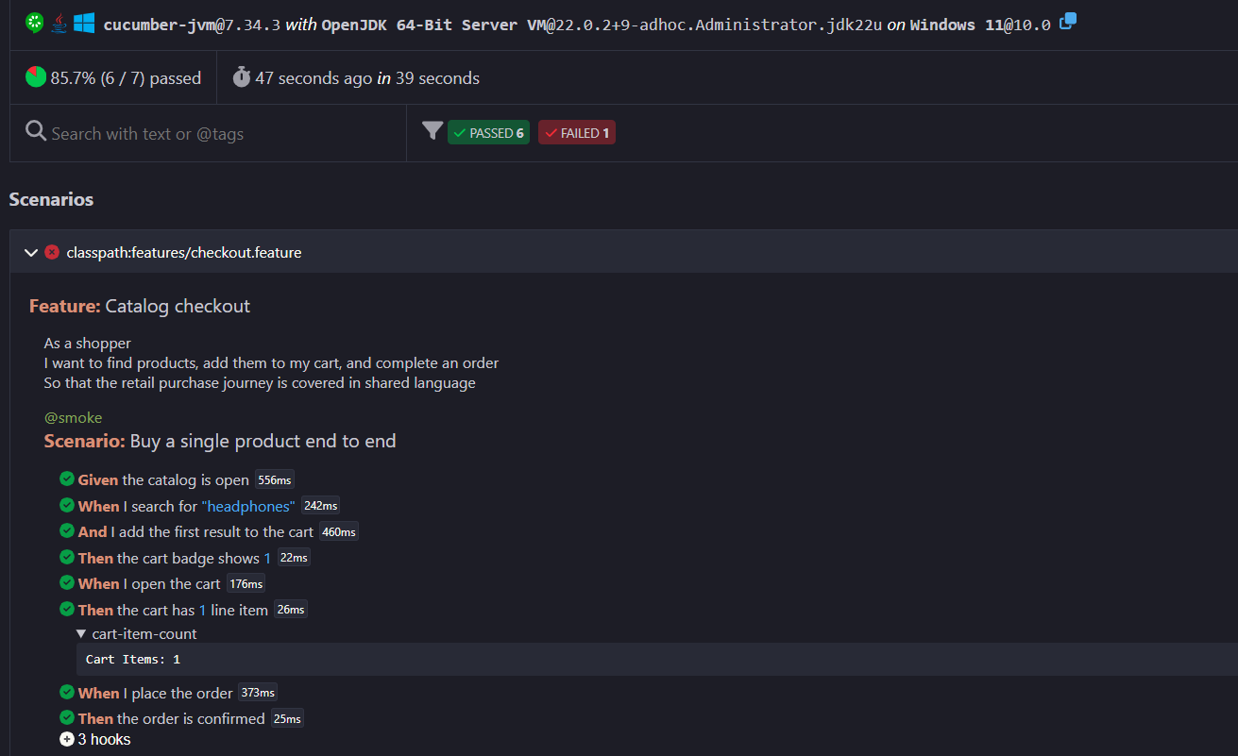
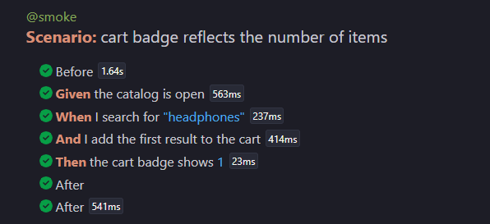
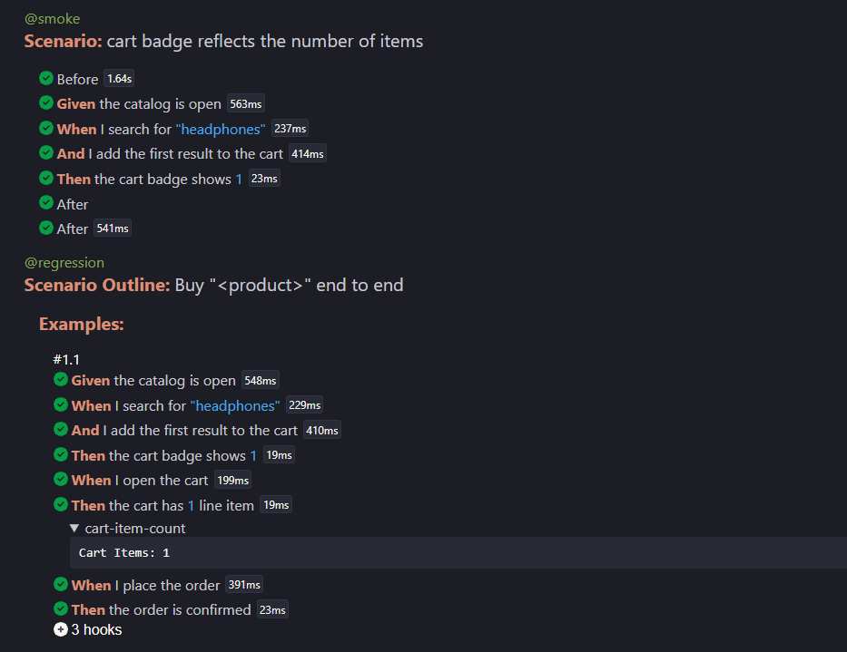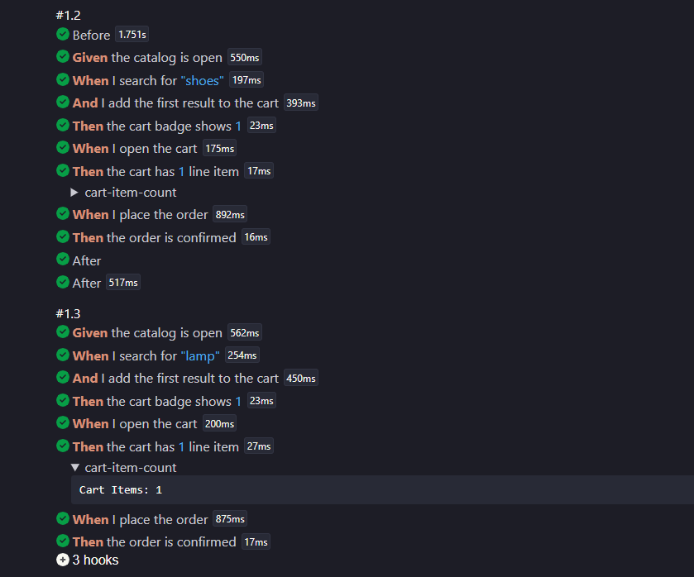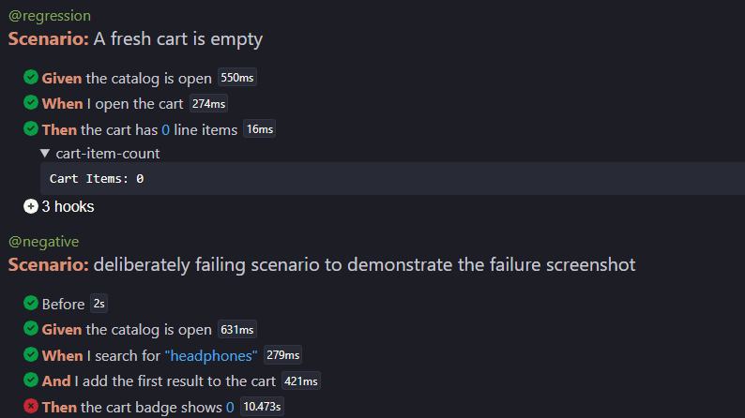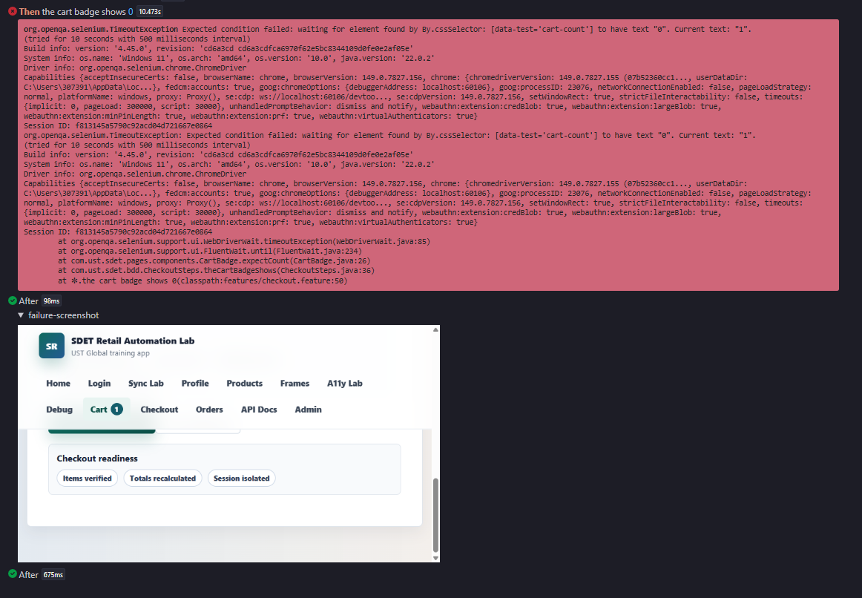

Spark (extent) report
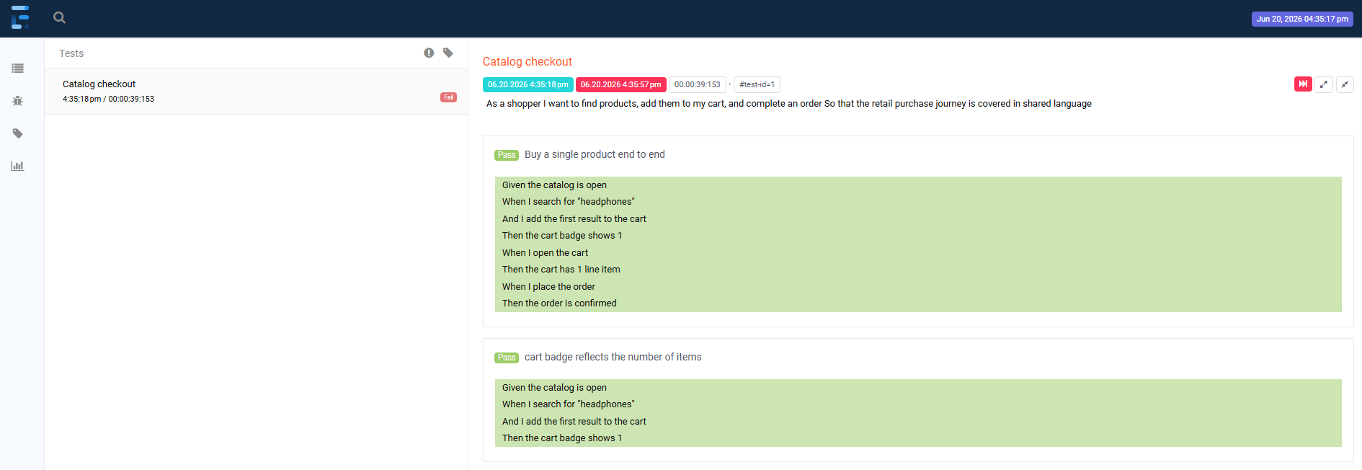
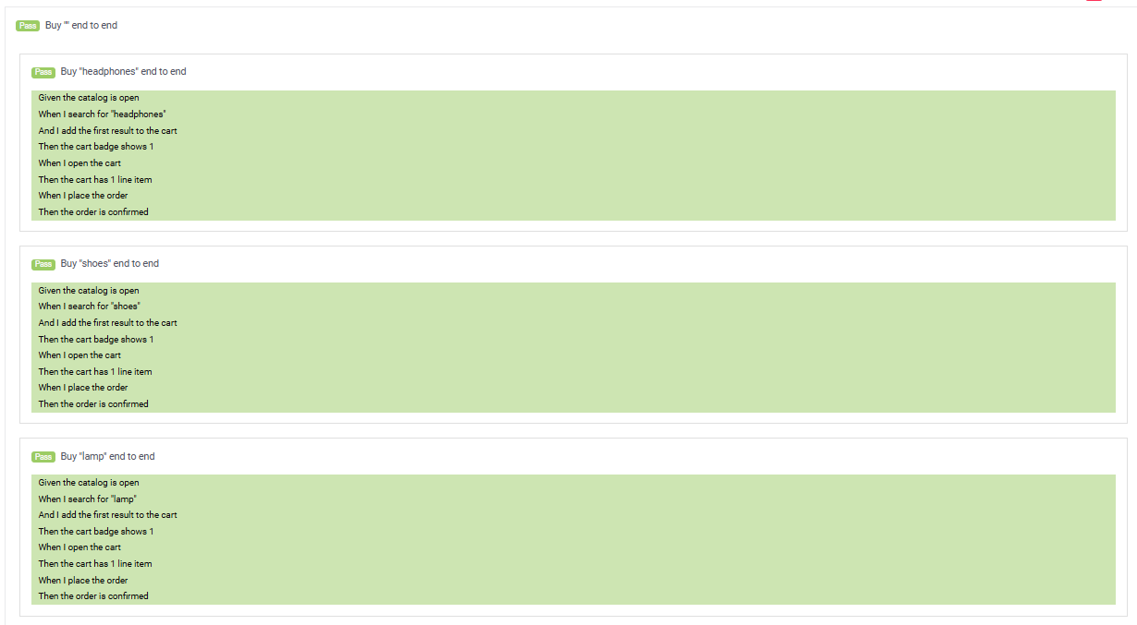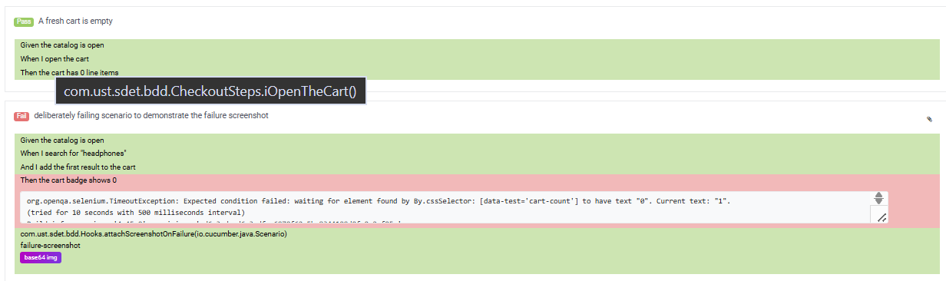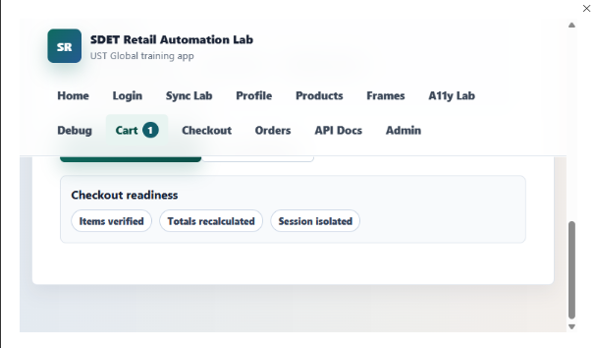

Allure report
Command to generate allure report
allure generate target/allure-results --clean -o target/allure-report

Command report
[INFO] Running com.ust.sdet.bdd.RunCucumberTest

@smoke
Scenario: Buy a single product end to end # classpath:features/checkout.feature:10
? Given the catalog is open # com.ust.sdet.bdd.CheckoutSteps.theCatalogIsOpen()
? When I search for "headphones" # com.ust.sdet.bdd.CheckoutSteps.iSearchFor(java.lang.String)
? And I add the first result to the cart # com.ust.sdet.bdd.CheckoutSteps.iAddTheFirstResultToTheCart()
? Then the cart badge shows 1 # com.ust.sdet.bdd.CheckoutSteps.theCartBadgeShows(int)
? When I open the cart # com.ust.sdet.bdd.CheckoutSteps.iOpenTheCart()

Embedding cart-item-count [text/plain 15 bytes]

? Then the cart has 1 line item # com.ust.sdet.bdd.CheckoutSteps.theCartHasLineItems(int)
? When I place the order # com.ust.sdet.bdd.CheckoutSteps.iPlaceTheOrder()
? Then the order is confirmed # com.ust.sdet.bdd.CheckoutSteps.theOrderIsConfirmed()

@smoke
Scenario: cart badge reflects the number of items # classpath:features/checkout.feature:20
? Given the catalog is open # com.ust.sdet.bdd.CheckoutSteps.theCatalogIsOpen()
? When I search for "headphones" # com.ust.sdet.bdd.CheckoutSteps.iSearchFor(java.lang.String)
? And I add the first result to the cart # com.ust.sdet.bdd.CheckoutSteps.iAddTheFirstResultToTheCart()
? Then the cart badge shows 1 # com.ust.sdet.bdd.CheckoutSteps.theCartBadgeShows(int)

@regression
Scenario Outline: Buy "headphones" end to end # classpath:features/checkout.feature:37
? Given the catalog is open # com.ust.sdet.bdd.CheckoutSteps.theCatalogIsOpen()
? When I search for "headphones" # com.ust.sdet.bdd.CheckoutSteps.iSearchFor(java.lang.String)
? And I add the first result to the cart # com.ust.sdet.bdd.CheckoutSteps.iAddTheFirstResultToTheCart()
? Then the cart badge shows 1 # com.ust.sdet.bdd.CheckoutSteps.theCartBadgeShows(int)
? When I open the cart # com.ust.sdet.bdd.CheckoutSteps.iOpenTheCart()

Embedding cart-item-count [text/plain 15 bytes]

? Then the cart has 1 line item # com.ust.sdet.bdd.CheckoutSteps.theCartHasLineItems(int)
? When I place the order # com.ust.sdet.bdd.CheckoutSteps.iPlaceTheOrder()
? Then the order is confirmed # com.ust.sdet.bdd.CheckoutSteps.theOrderIsConfirmed()

@regression
Scenario Outline: Buy "shoes" end to end # classpath:features/checkout.feature:38
? Given the catalog is open # com.ust.sdet.bdd.CheckoutSteps.theCatalogIsOpen()
? When I search for "shoes" # com.ust.sdet.bdd.CheckoutSteps.iSearchFor(java.lang.String)
? And I add the first result to the cart # com.ust.sdet.bdd.CheckoutSteps.iAddTheFirstResultToTheCart()
? Then the cart badge shows 1 # com.ust.sdet.bdd.CheckoutSteps.theCartBadgeShows(int)
? When I open the cart # com.ust.sdet.bdd.CheckoutSteps.iOpenTheCart()

Embedding cart-item-count [text/plain 15 bytes]

? Then the cart has 1 line item # com.ust.sdet.bdd.CheckoutSteps.theCartHasLineItems(int)
? When I place the order # com.ust.sdet.bdd.CheckoutSteps.iPlaceTheOrder()
? Then the order is confirmed # com.ust.sdet.bdd.CheckoutSteps.theOrderIsConfirmed()

@regression
Scenario Outline: Buy "lamp" end to end # classpath:features/checkout.feature:39
? Given the catalog is open # com.ust.sdet.bdd.CheckoutSteps.theCatalogIsOpen()
? When I search for "lamp" # com.ust.sdet.bdd.CheckoutSteps.iSearchFor(java.lang.String)
? And I add the first result to the cart # com.ust.sdet.bdd.CheckoutSteps.iAddTheFirstResultToTheCart()
? Then the cart badge shows 1 # com.ust.sdet.bdd.CheckoutSteps.theCartBadgeShows(int)
? When I open the cart # com.ust.sdet.bdd.CheckoutSteps.iOpenTheCart()

Embedding cart-item-count [text/plain 15 bytes]

? Then the cart has 1 line item # com.ust.sdet.bdd.CheckoutSteps.theCartHasLineItems(int)
? When I place the order # com.ust.sdet.bdd.CheckoutSteps.iPlaceTheOrder()
? Then the order is confirmed # com.ust.sdet.bdd.CheckoutSteps.theOrderIsConfirmed()

@regression
Scenario: A fresh cart is empty # classpath:features/checkout.feature:42
? Given the catalog is open # com.ust.sdet.bdd.CheckoutSteps.theCatalogIsOpen()
? When I open the cart # com.ust.sdet.bdd.CheckoutSteps.iOpenTheCart()

Embedding cart-item-count [text/plain 15 bytes]

? Then the cart has 0 line items # com.ust.sdet.bdd.CheckoutSteps.theCartHasLineItems(int)

@negative
Scenario: deliberately failing scenario to demonstrate the failure screenshot # classpath:features/checkout.feature:47
? Given the catalog is open # com.ust.sdet.bdd.CheckoutSteps.theCatalogIsOpen()
? When I search for "headphones" # com.ust.sdet.bdd.CheckoutSteps.iSearchFor(java.lang.String)
? And I add the first result to the cart # com.ust.sdet.bdd.CheckoutSteps.iAddTheFirstResultToTheCart()
? Then the cart badge shows 0 # com.ust.sdet.bdd.CheckoutSteps.theCartBadgeShows(int)
org.openqa.selenium.TimeoutException: Expected condition failed: waiting for element found by By.cssSelector: [data-test='cart-count'] to have text "0". Current text: "1".
(tried for 10 seconds with 500 milliseconds interval)
Build info: version: '4.45.0', revision: 'cd6a3cd cd6a3cdfca6970f62e5bc8344109d0fe0e2af05e'
System info: os.name: 'Windows 11', os.arch: 'amd64', os.version: '10.0', java.version: '22.0.2'
Driver info: org.openqa.selenium.chrome.ChromeDriver
Capabilities {acceptInsecureCerts: false, browserName: chrome, browserVersion: 149.0.7827.156, chrome: {chromedriverVersion: 149.0.7827.155 (07b52360cc1..., userDataDir: C:\Users\307391\AppData\Loc...}, fedcm:accounts: true, goog:chromeOptions: {debuggerAddress: localhost:60106}, goog:processID: 23076, networkConnectionEnabled: false, pageLoadStrategy: normal, platformName: windows, proxy: Proxy(), se:cdp: ws://localhost:60106/devtoo..., se:cdpVersion: 149.0.7827.156, setWindowRect: true, strictFileInteractability: false, timeouts: {implicit: 0, pageLoad: 300000, script: 30000}, unhandledPromptBehavior: dismiss and notify, webauthn:extension:credBlob: true, webauthn:extension:largeBlob: true, webauthn:extension:minPinLength: true, webauthn:extension:prf: true, webauthn:virtualAuthenticators: true}
Session ID: f813145a5790c92acd04d721667e0864
at org.openqa.selenium.support.ui.WebDriverWait.timeoutException(WebDriverWait.java:85)
at org.openqa.selenium.support.ui.FluentWait.until(FluentWait.java:234)
at com.ust.sdet.pages.components.CartBadge.expectCount(CartBadge.java:26)
at com.ust.sdet.bdd.CheckoutSteps.theCartBadgeShows(CheckoutSteps.java:36)
at ?.the cart badge shows 0(classpath:features/checkout.feature:50)

Embedding failure-screenshot [image/png 52014 bytes]

Attachments
Business data
Cart Items: 1

Failure-screenshot (@negative – scenario)
