Purpose:- To run sample testcases on https://www.shoppersstop.com/
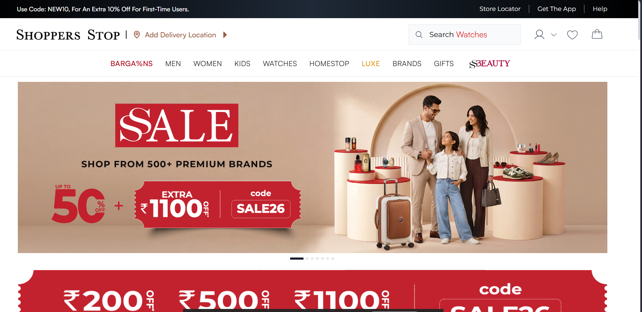
Folder Structure:-
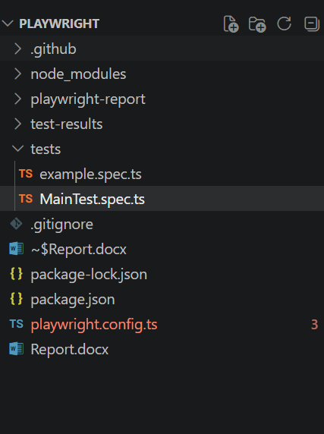

Setup:-
Npm init playwright@latest

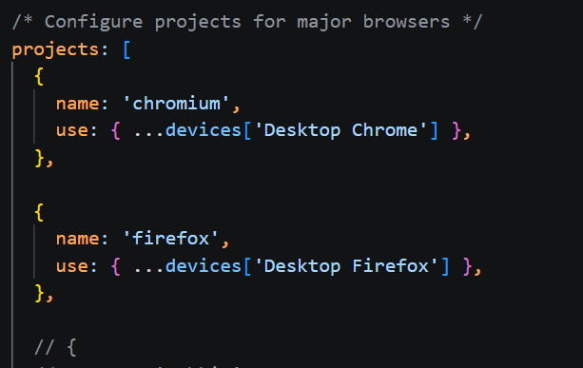

TestCases:-

- Negative case:- Visit a product page. Input an incorrect pincode (less than 6 digits). Assert that ‘please enter a valid pincode’ error is shown.
- Positive case:-

