Purpose:- To run sample testcases on https://petstore.swagger.io/ on the Pets apis
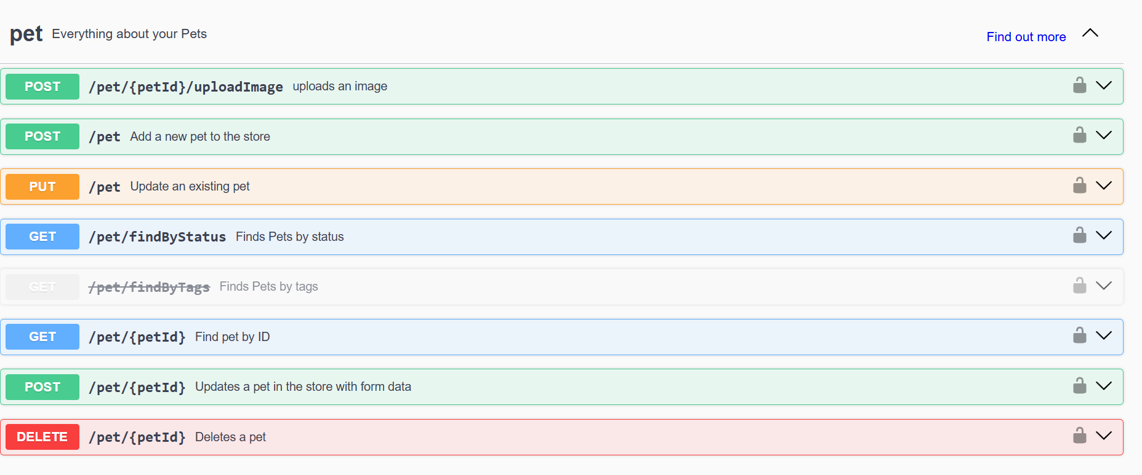
Folder Structure:-
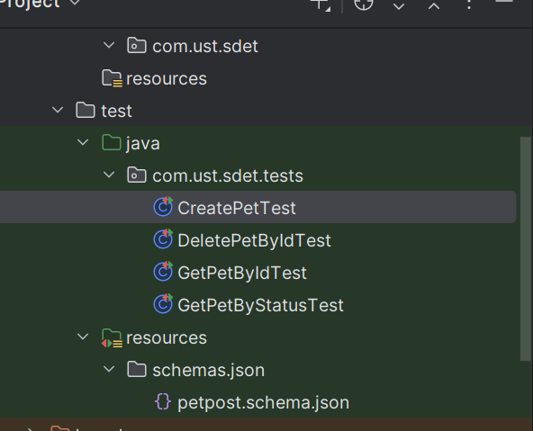

Setup:-
Packages required:-
1)Junit Jupiter @Test, @BeforeEach, @AfterAll
2)Rest-Assured given(), when(), then() functions
3) json-schema-validator for checking the json format of response

Schema

Petpost.schema.json
{
"$schema": "http://json-schema.org/draft-04/schema#",
"type": "object",
"required": ["id", "category", "name", "photoUrls", "tags", "status"],
"properties": {
"id": {
"type": "integer"
},
"category": {
"type": "object",
"required": ["id", "name"],
"properties": {
"id": {
"type": "integer",
"example": 0
},
"name": {
"type": "string",
}
}
},
"name": {
"type": "string"
},
"photoUrls": {
"type": "array",
"items": {
"type": "string"
}
},
"tags": {
"type": "array",
"items": {
"type": "object",
"required": ["id", "name"],
"properties": {
"id": {
"type": "integer"
},
"name": {
"type": "string"
}
}
}
},
"status": {
"type": "string",
"example": ["available"],
"enum": ["available","pending","sold"]
}
}
}

Sample Data

{id: 1234656,
category: {id: 0, name: test},
name: Doggo,
photoUrls: [unknown],
tags: [{id: 0, name: test}],
status: available}

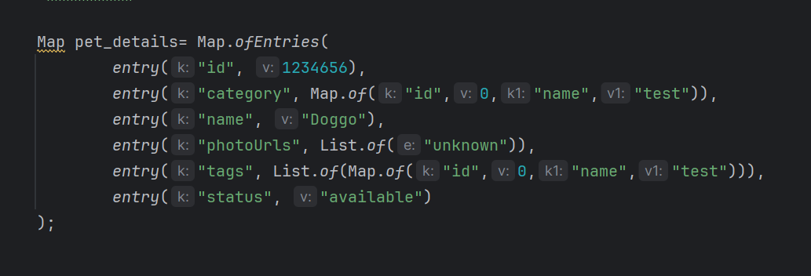

TestCases:-

1) CreatePetTest:- Create a pet using the sample data using the post request.
https://petstore.swagger.io/v2/pet -- POST

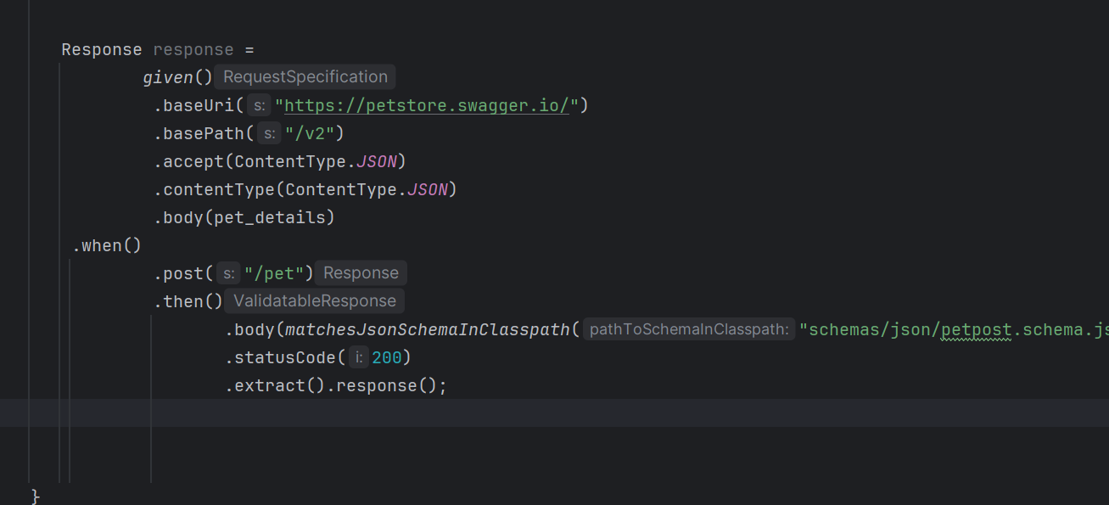
2)DeletePetByIdTest:- Delete a pet created using the post request. Verified by checking for 404 error during get by id.
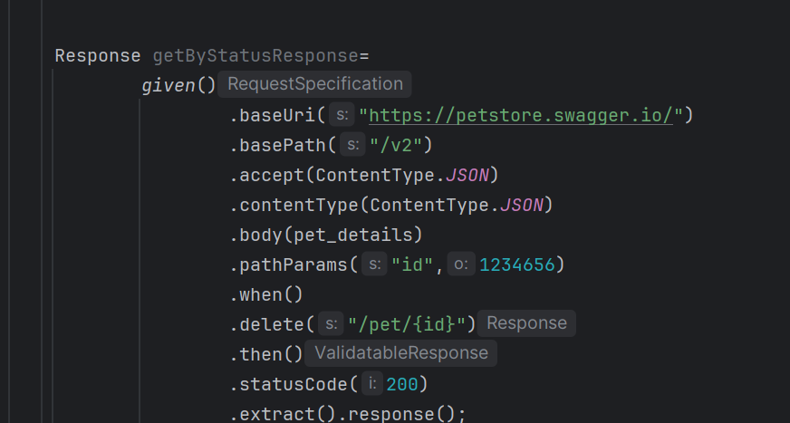
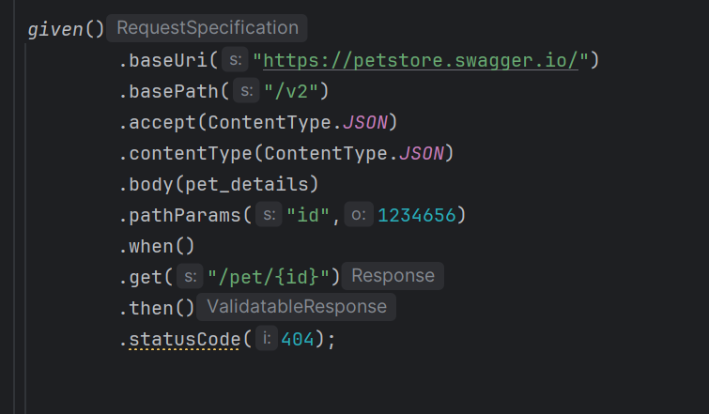
https://petstore.swagger.io/v2/pet ---- DELETE
3)GetPetByStatus :- Get all pets having a particular status(Here available used)
https://petstore.swagger.io/v2/pet/getByStatus/?status={status} ---GET
4)GetPetById:- Get the created pet having particular id
https://petstore.swagger.io/v2/pet/{id} ---GET
Validation done on each response using
