Demo report
  - Athuldev U
27-06-2026

OBJECTIVE
This module validates API contracts between a consumer application named storefront and a provider service named catalog and do the ui testing with selenide and verify the product stock count is visible or not.

PROJECT STRUCTURE
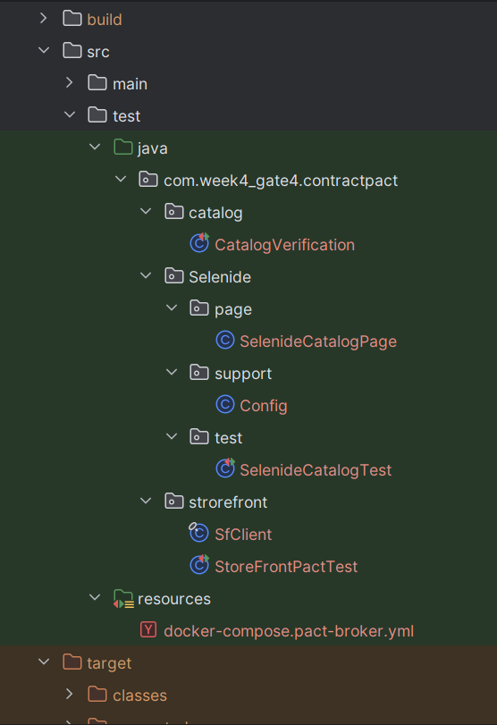

USER STORY
Go to the catalog page and search for the product running shoes and verified it is visible and do the necessary assertion
The Pact tests depend on a local Pact Broker and WireMock stubs for provider verification.In storefront and catalog contain the necessary file to run the pact test
Consumer and Provider are the Storefront and catalog
Storefront contain the StorefrontPact contain the pact test and the the SfClient are used to verify the pact.The provider side verification are done in Catalog verification page.
To run the PactTest
mvn clean -Dtest=StoreFrontPactTest
To check if the Provider Test is working in local
run : mvn clean -Dtest=CatalogVerification
(with out the Pact Broker snippet and to run in ci we have to give the pactbroker )

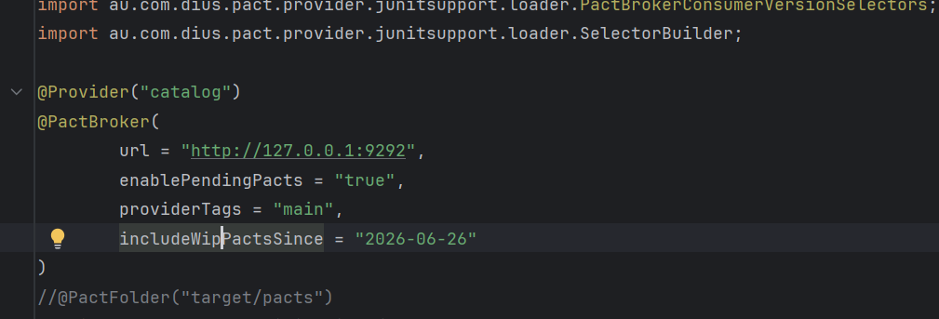
this is the pact json file that is created while we run the pactg test
{
"consumer": {
"name": "storefront"
},
"interactions": [
{
"comments": {
"testname": "com.week4_gate4.contractpact.strorefront.StoreFrontPactTest.testGetOrder(MockServer)",
"text": [
]
},
"description": "a request for RunningShoe",
"key": "94ba8c35",
"pending": false,
"providerStates": [
{
"name": "Product RunningShoe is in catalogPage"
}
],
"request": {
"method": "GET",
"path": "/product/106"
},
"response": {
"body": {
"content": {
"id": 106,
"status": "in_stock",
"total": 4500
},
"contentType": "application/json",
"encoded": false
},
"headers": {
"Content-Type": [
"application/json"
]
above is sample of the code that will genreate

The selenide test
