Report
Participant: Shahbaz Ahmad
Date: 04-07-2026
Branch: shahbaz-week05-gate5
Assessment: Week 5 Gate 5

Github Link
My Branch name is shahbaz-week05-gate5 and link is
Objective:
Validate the reliability, resilience, and correctness of the Returns & Refund and Offline POS workflows by verifying refund calculations, business rules, idempotency, offline queue synchronization, rollback mechanisms, network resilience, and evidence collection under both normal and failure scenarios.

Topic:
1. Stabilization (Test Stabilization)
- Process of making automated tests reliable and consistent.
- Removes flaky behavior by fixing waits, locators, test data, and environment issues.
- Goal: Same test should pass every time if the application works correctly.

2. Artifact
- Files generated during test execution for reporting and debugging.
- Common artifacts:
  - HTML Report
  - Screenshots
  - Videos
  - Trace files
  - Logs
3. Log
- Records everything that happens during test execution.
- Helps understand the execution flow and identify failures.
- Examples:
  - Console logs
  - Browser logs
  - API request/response logs
  - Server logs
  - Playwright execution logs

4. Evidence
- Proof that a test was executed and its result is valid.
- Used during reviews, audits, or bug reporting.
- Examples:
  - Screenshot of failure
  - Video recording
  - Trace file
  - HTML report
  - API response

5. Debug
- Process of identifying, analyzing, and fixing the root cause of failures.
- Steps:
  - Reproduce the issue
  - Inspect logs and reports
  - Use breakpoints or Playwright Inspector
  - Fix the issue and rerun tests

6.Flaky Test
- A test that passes sometimes and fails sometimes without any code changes.
- They should be fixed or quarantined until stabilized.

Environment Setup
- Tools: Node.js, Playwright Test Runner, TypeScript/JavaScript, VS Code
- Reporting Tools: HTML Reporter,

Install Commands:
- npm init playwright@latest gate5Assessment
- npx playwright install
- npm install winston

Workflow
- Test Initialization
- Test Setup
- Execute Test
- API & UI Validation
- Assertions
- Logging
- Evidence Collection
- Error Handling
- Report Generation
- Test Completion

Folder Structure
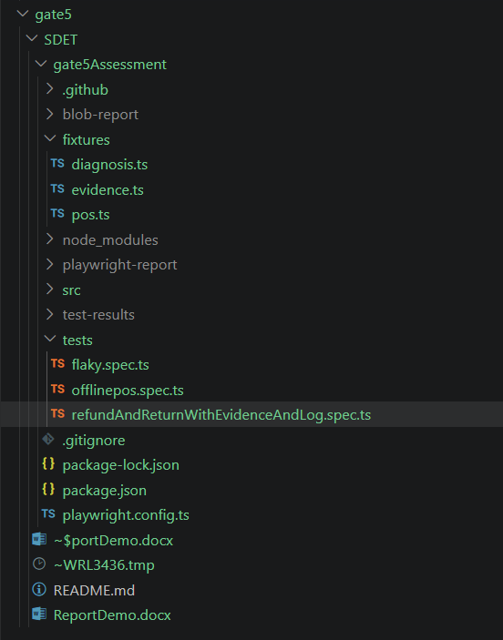

Fixtures Usage
Implemented custom Playwright fixtures to provide reusable logging, evidence collection, and correlation ID generation across all test cases, reducing duplicate code and improving test maintainability.
Added structured diagnostic logging with multiple log levels (info, warn, error, http, and debug) to record detailed execution steps, making it easier to trace failures and debug issues.
Generated a unique Correlation ID for every test execution and included it in HTTP request headers to enable end-to-end request tracking between the test framework and backend services.
Automated evidence collection by capturing API responses, request failures, ledger data, screenshots, and other test artifacts, then attaching them to the Playwright test report for easier analysis.
mproved failure diagnosis by automatically generating diagnostic log files and execution timelines whenever a test fails, providing sufficient information for root cause analysis without rerunning the test.

Code –
Diagnosis.ts
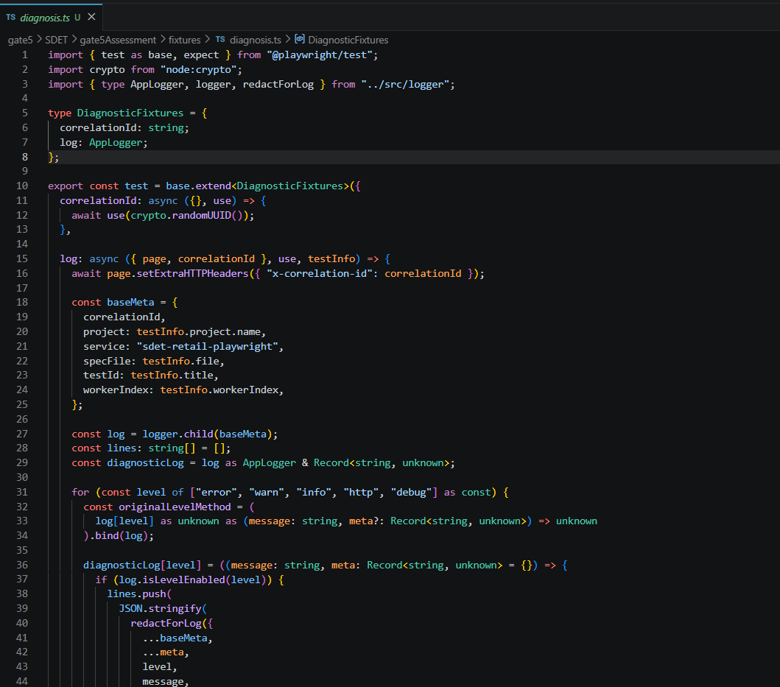
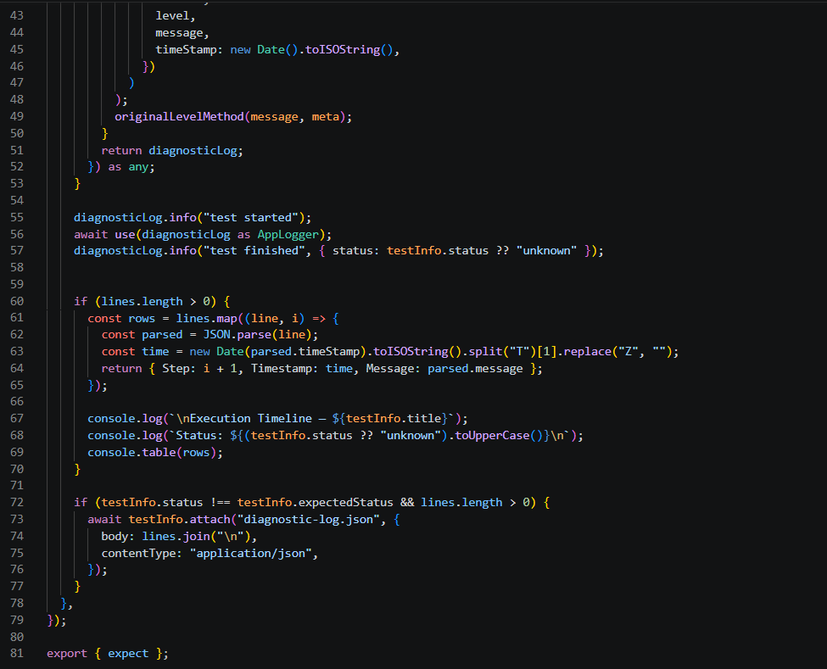

evidence.ts
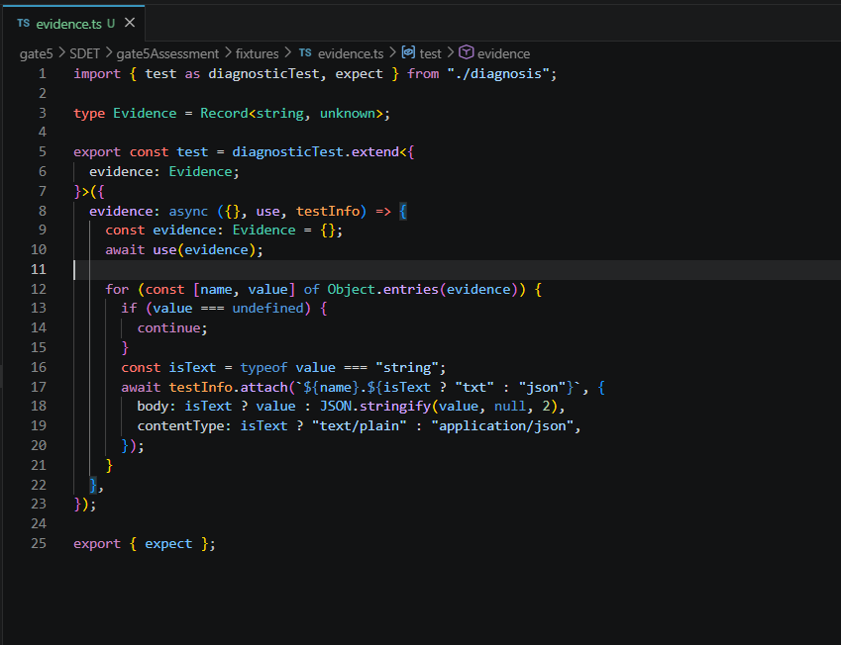

pos.ts
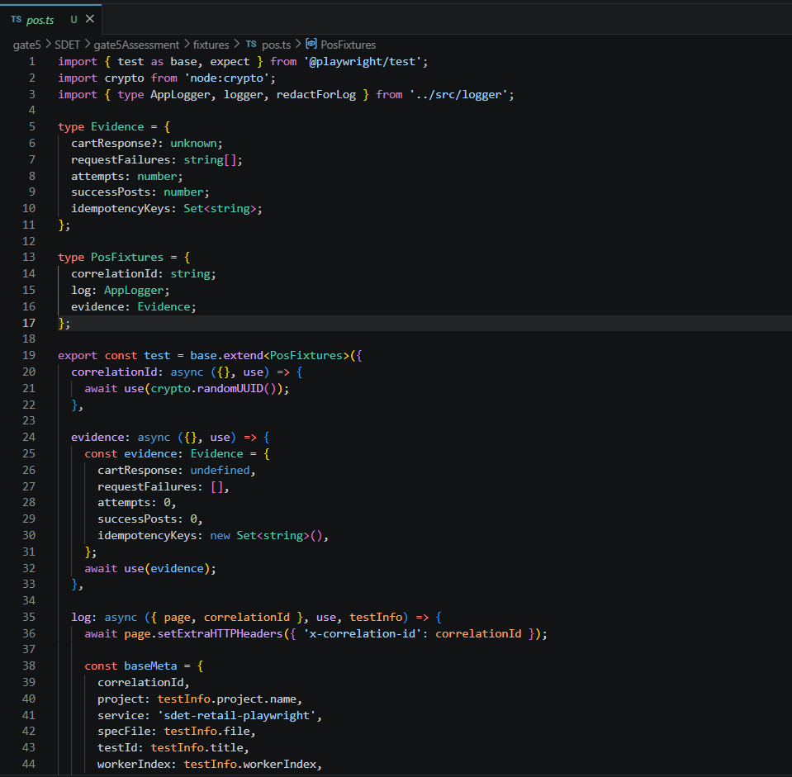
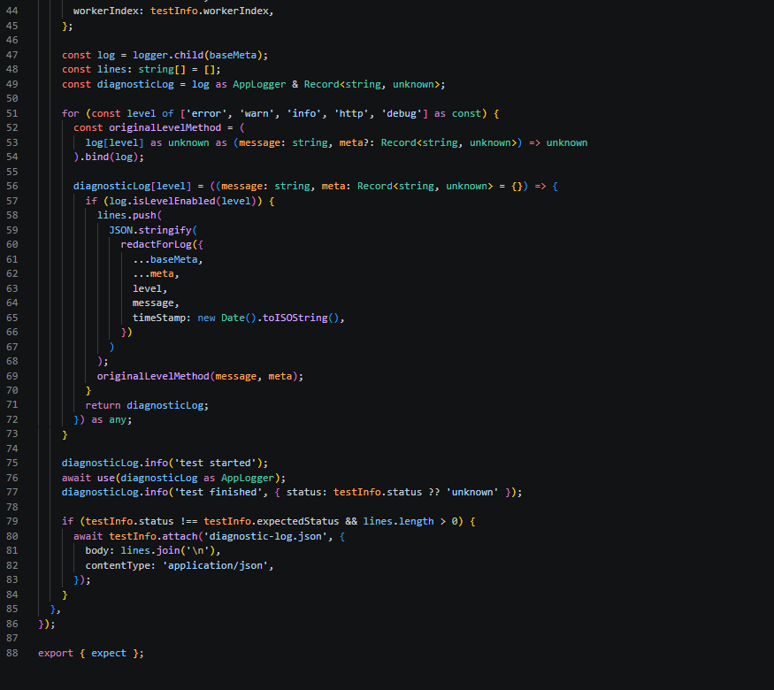

refund.api.ts
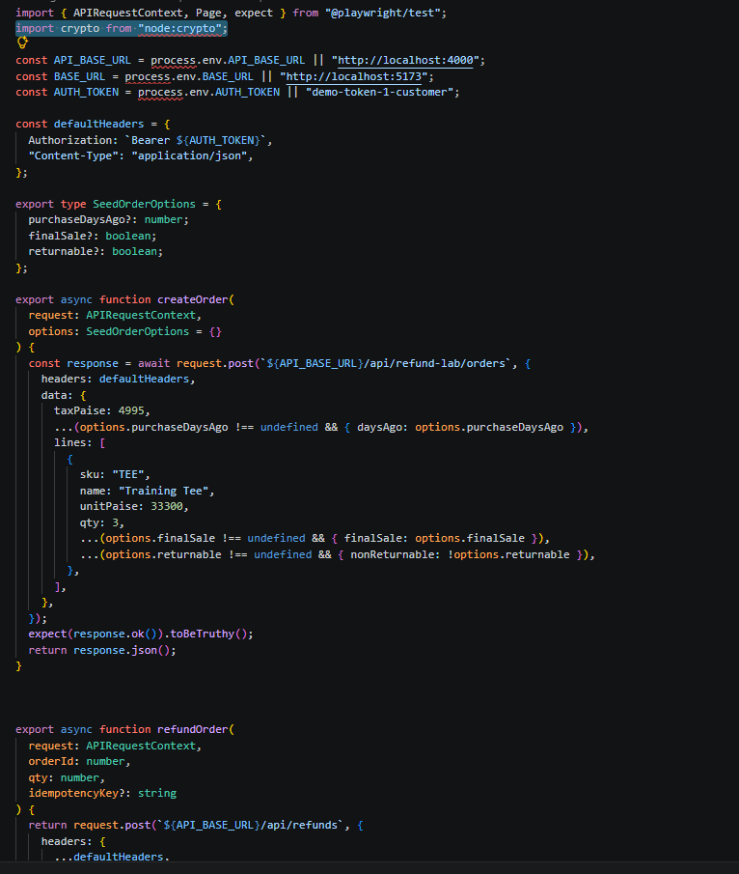
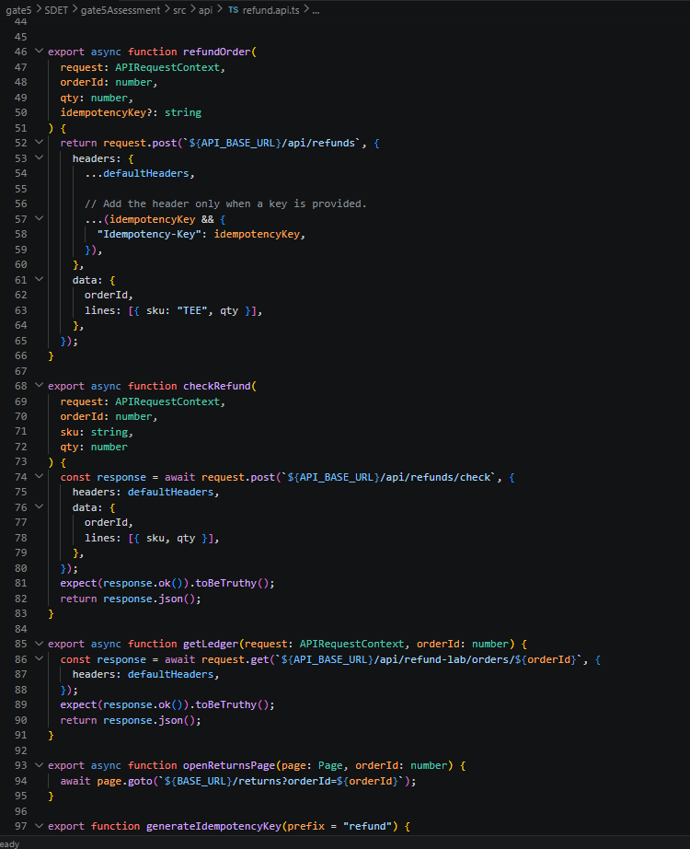
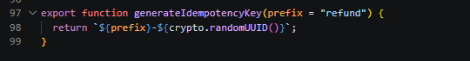

logger.ts
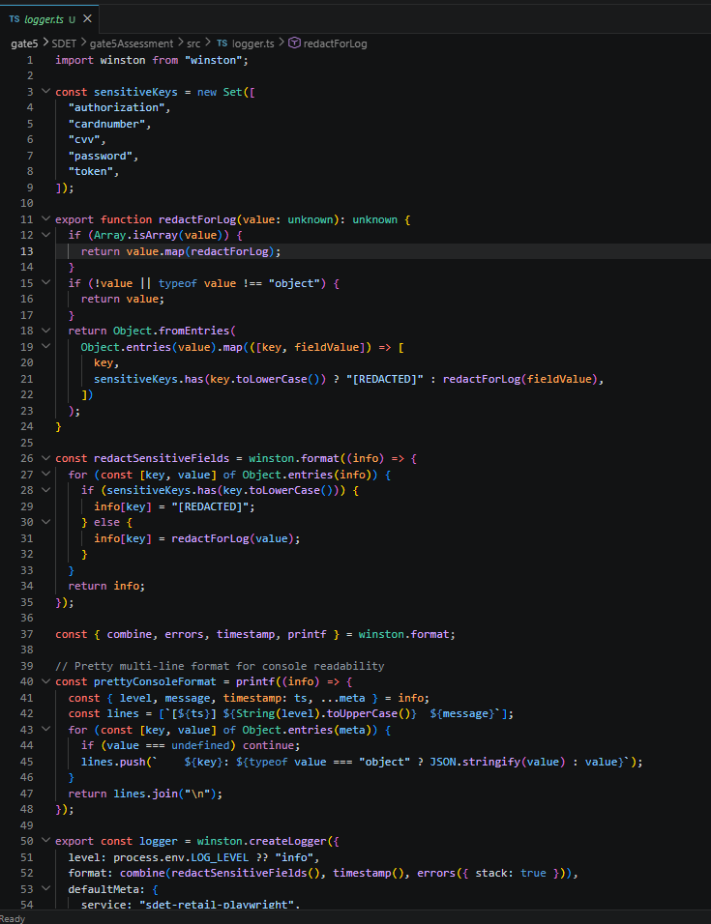
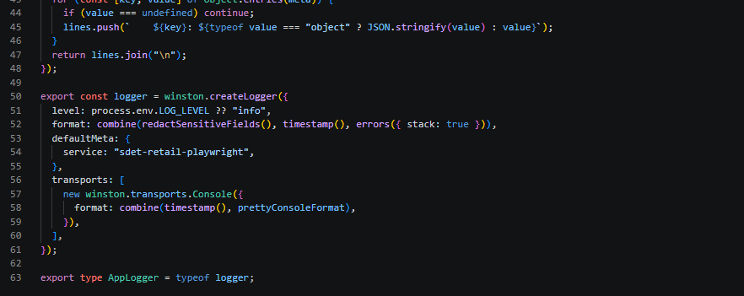

flaky.spec.ts
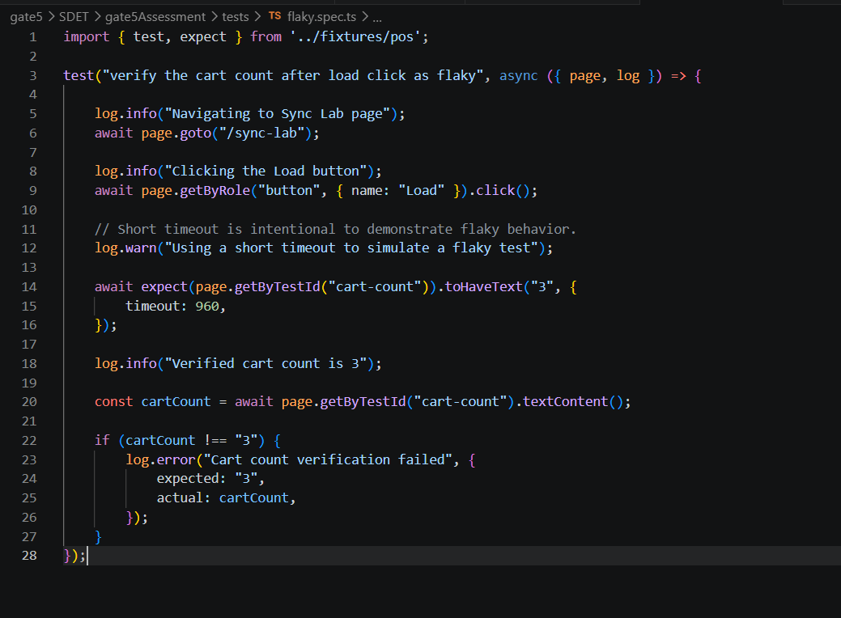

offlinepos.spec.ts
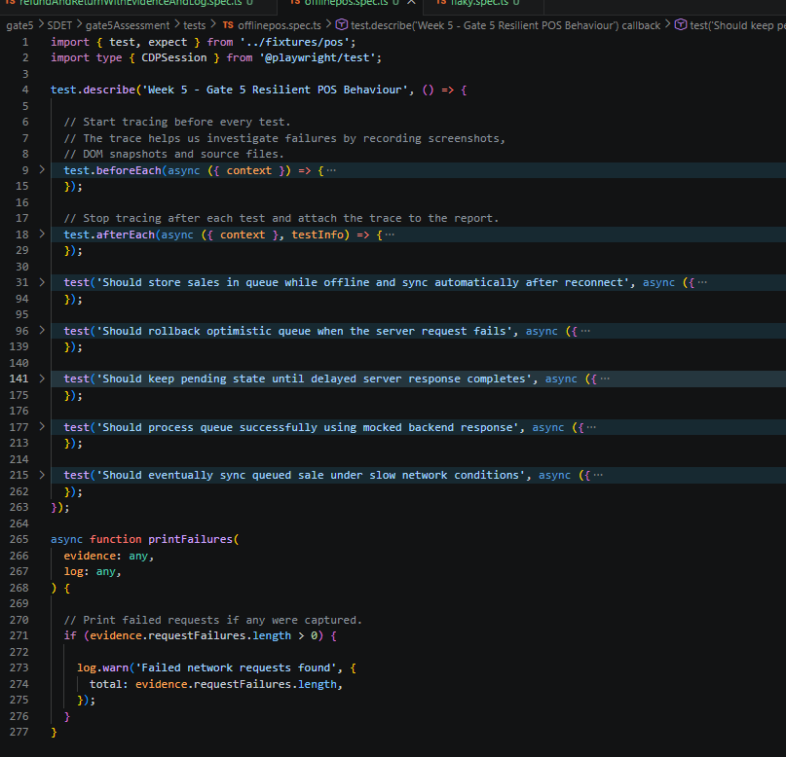

refundAndReturnWithEvidenceAndLog.spec.ts
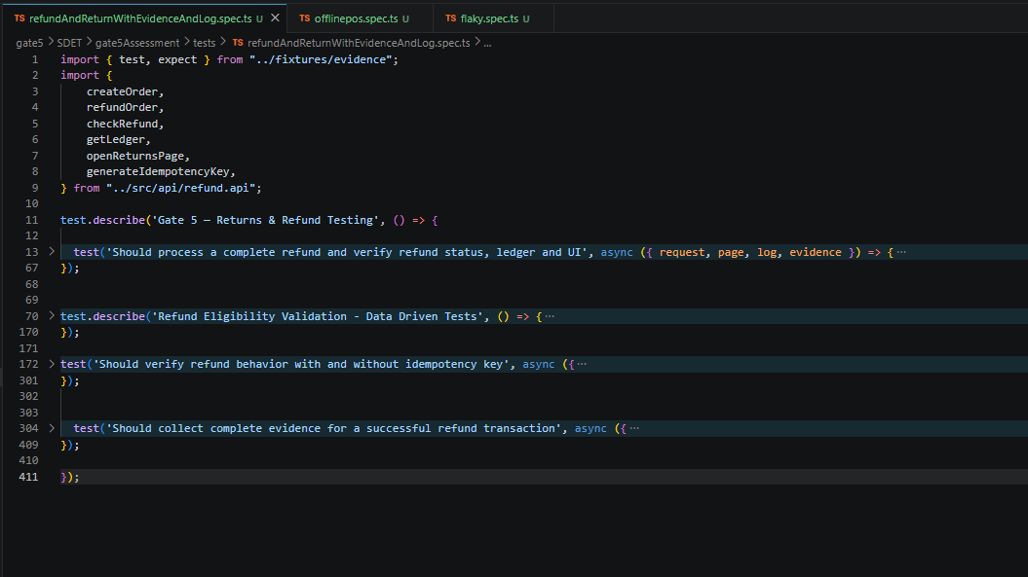

Command line –
npx playwright test
npx playwright test flaky.spec.ts --repeat-each=50
npx playwright test offlinepos.spec.ts
npx playwright test refundAndReturnWithEvidenceAndLog.spec.ts
npx playwright show-report

Result Evidence
Attach screenshots, videos, and trace files generated during execution.
flaky.spec.ts
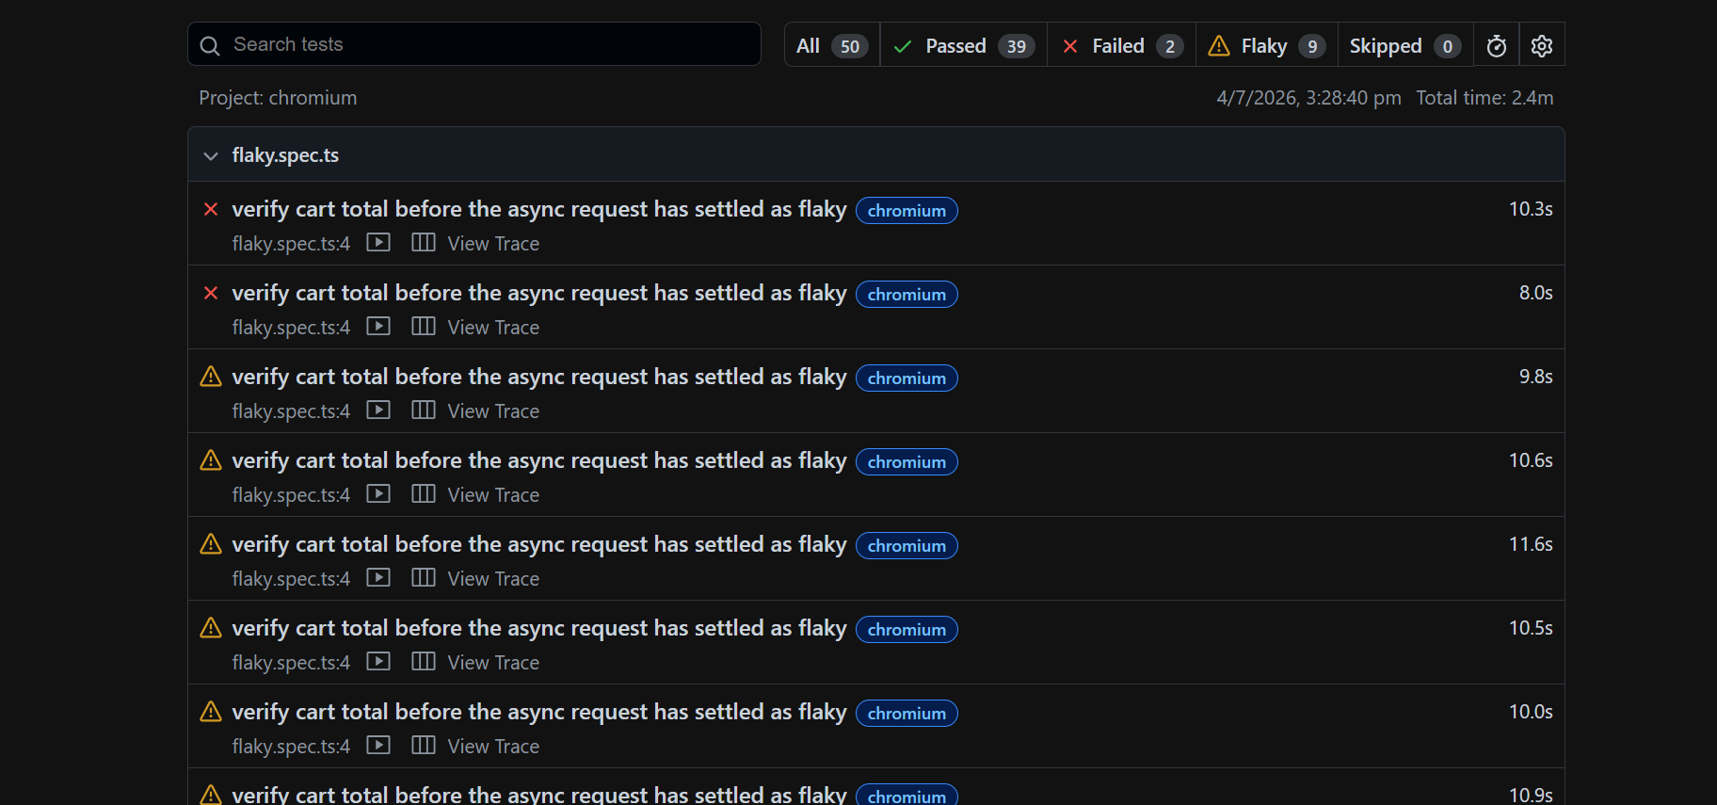

offlinepos.spec.ts
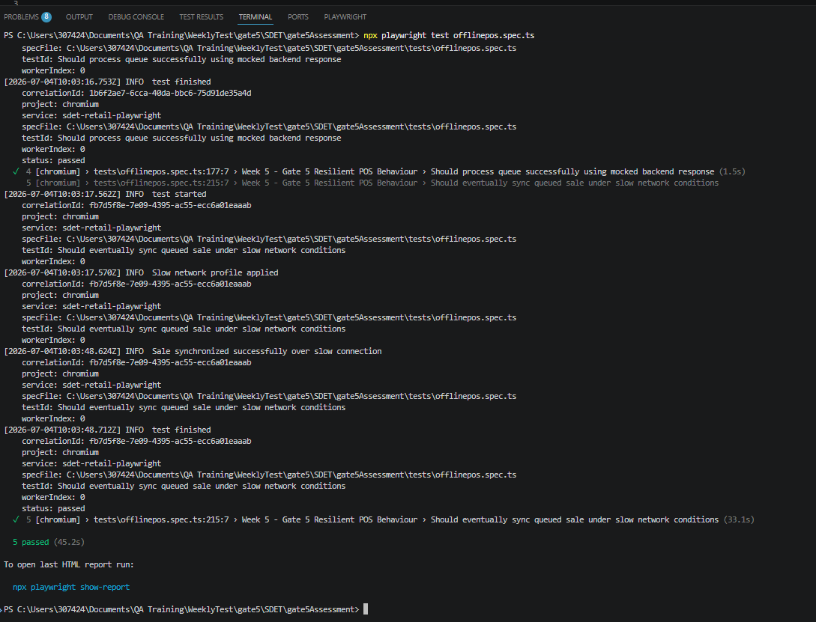
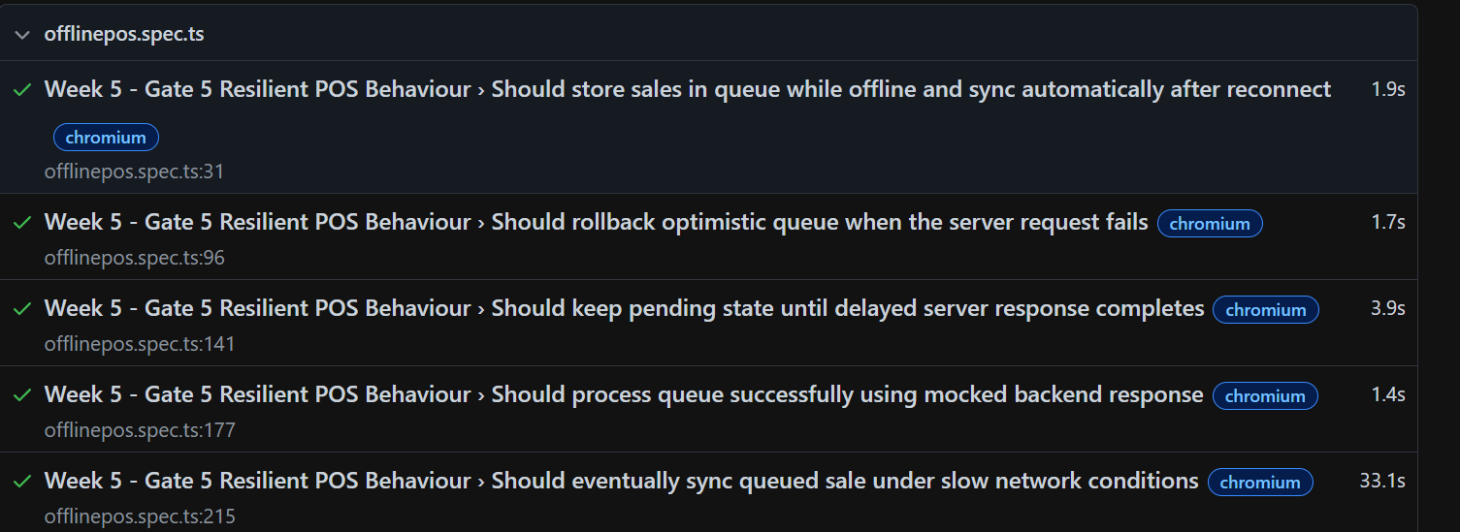
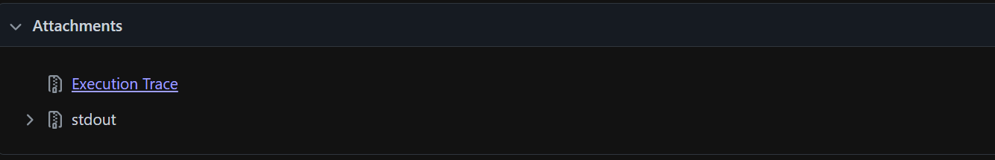
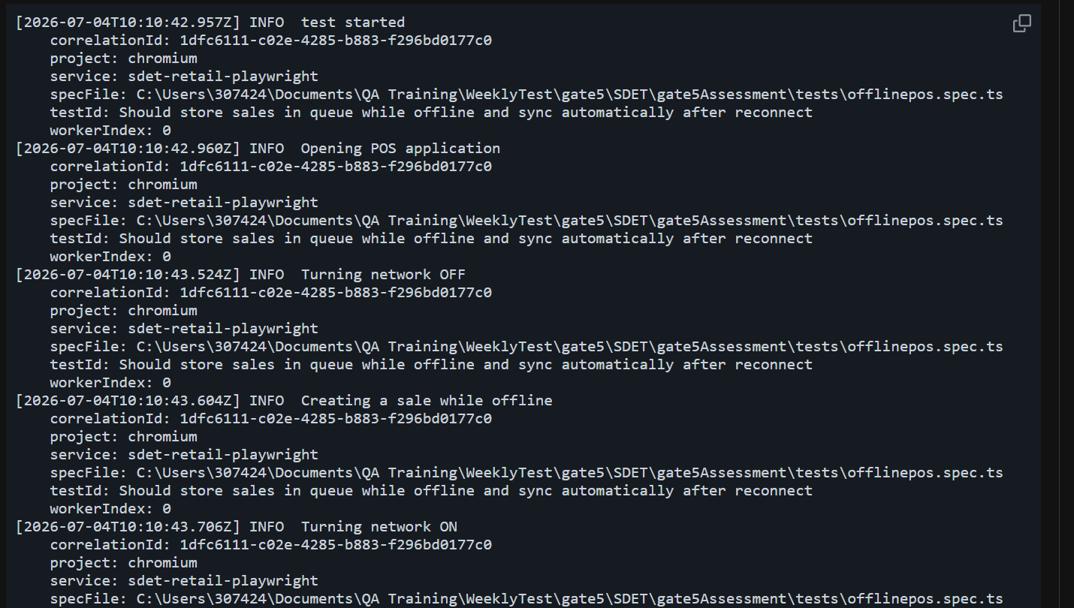
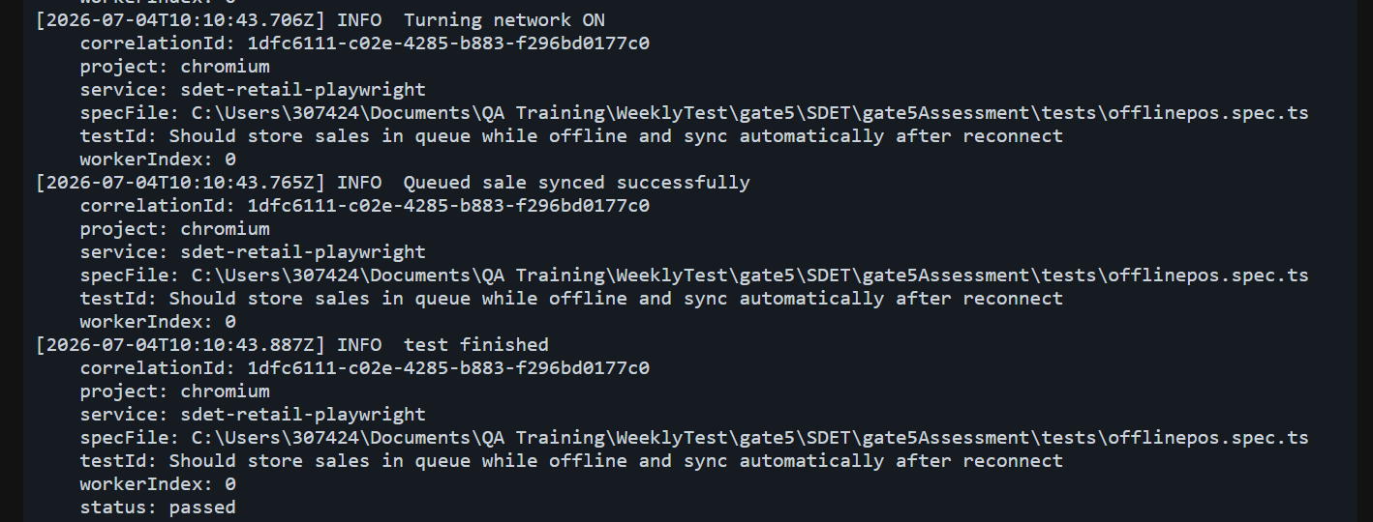

refundAndReturnWithEvidenceAndLog.spec.ts
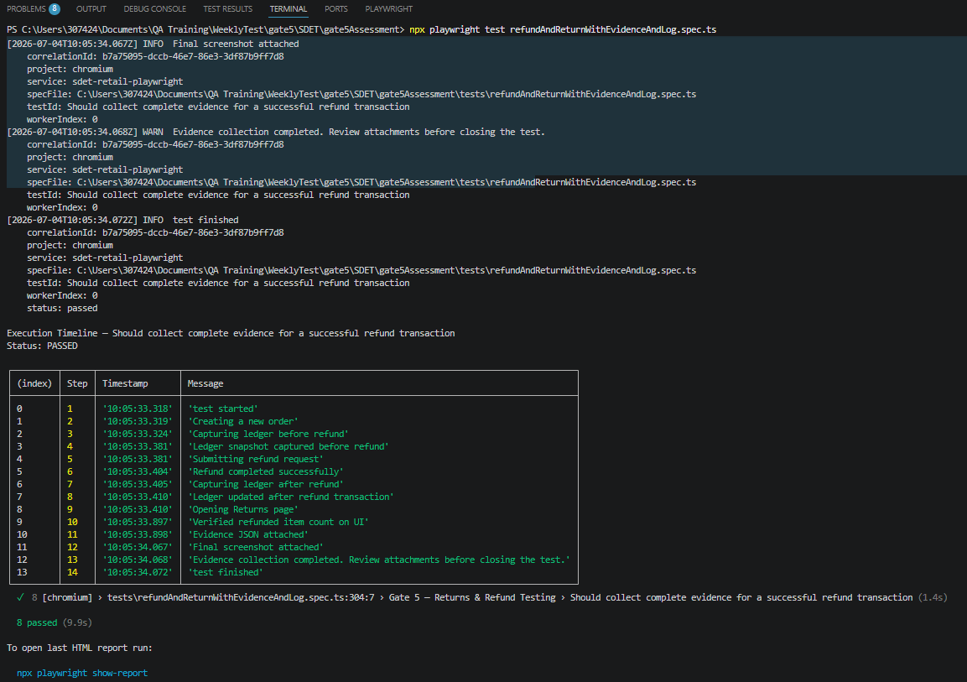
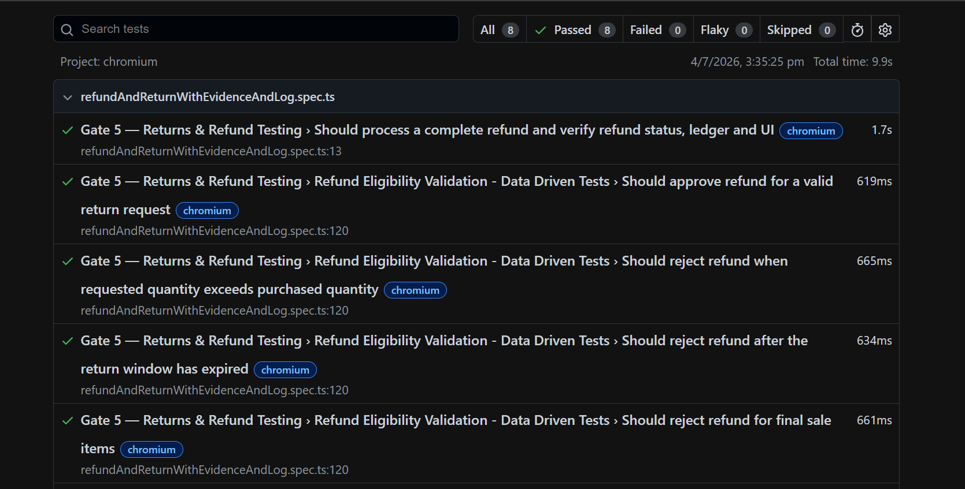
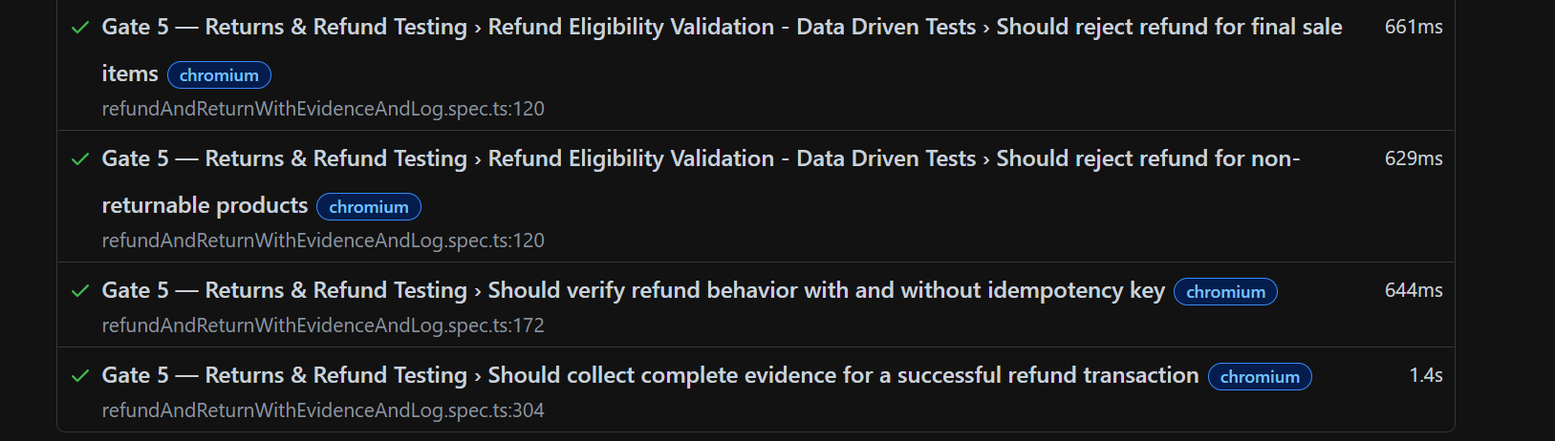
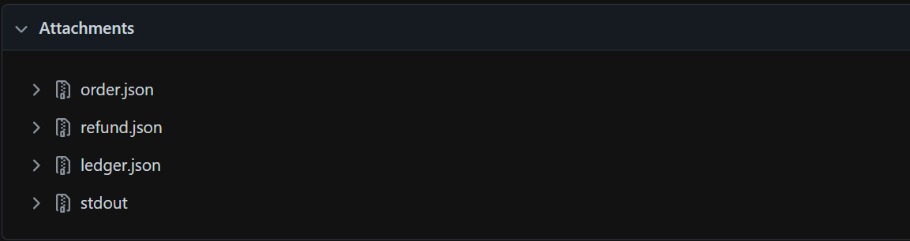
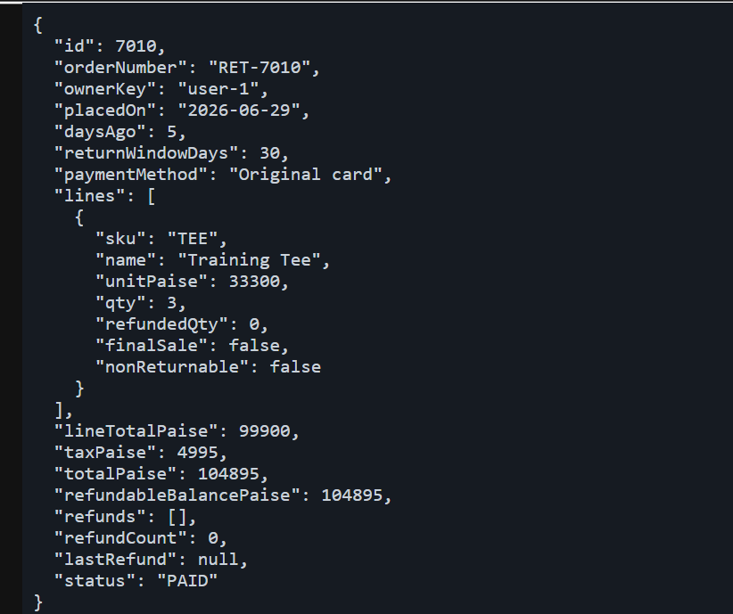
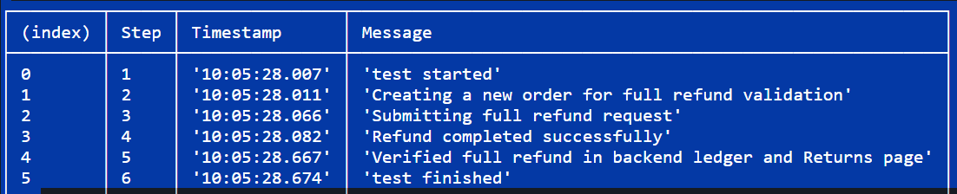

How to Solve Issues
Offline Queue and Reconnect
Failure Reason
- Network connection is intentionally disabled using context.setOffline(true).
- The application cannot send the sale request to the server.
- The sale is stored in the local outbox (queue) for later synchronization.
Recovery Steps
- Enable the network using context.setOffline(false).
- Wait for the application to detect the restored connection.
- Verify the network banner changes from Offline to Online.
- Verify the queued sale is synchronized automatically.
- Confirm the outbox count changes from 1 to 0.
Expected Result
- Queued sale is synchronized successfully after reconnection.
- No data is lost during the offline period.
- The queue is cleared automatically.

Rollback on Failed Request
Failure Reason
- The API request is intentionally aborted using route.abort('failed').
- The request does not reach the server.
- The optimistic UI temporarily shows the sale before the failure is detected.
Recovery Steps
- Detect the failed network request.
- Remove the optimistic queue entry from the UI.
- Verify the outbox count becomes 0.
- Confirm the failed request is captured in the logs or evidence.
- Ensure the application returns to a consistent state.
Expected Result
- Failed sale is removed from the queue.
- UI remains consistent with the server state.
- Failure is recorded for debugging.

Delayed Network Request
Failure Reason
- The request is intentionally delayed using setTimeout().
- The server takes longer than normal to respond.
- The sale remains in the pending state during the delay.
Recovery Steps
- Keep the request in the pending state while waiting.
- Allow the delayed request to continue.
- Wait for the server response.
- Verify the outbox count becomes 0 after synchronization.
- Confirm the pending status is removed.
Expected Result
- Application waits without errors.
- Sale is synchronized after the delayed response.
- Queue is cleared successfully.

Mocked Server Response
Failure Reason
- The real backend is replaced using route.fulfill().
- A mocked successful response is returned.
- This scenario validates UI behavior without depending on the real server.
Recovery Steps
- Return a mocked success response.
- Verify the application accepts the response.
- Verify the queued sale is processed.
- Confirm the outbox count becomes 0.
Expected Result
- Application behaves as if the real server responded successfully.
- Queue is cleared.
- UI displays successful processing.

Slow Network (CDP Throttling)
Failure Reason
- Network speed is intentionally reduced using Network.emulateNetworkConditions.
- Requests take significantly longer to complete.
- The application remains in the pending state until the response arrives.
Recovery Steps
- Keep the request in the pending state during slow network conditions.
- Wait for the delayed server response.
- Verify the request completes successfully.
- Confirm the outbox count becomes 0 after synchronization.
- Ensure the pending status disappears.
Expected Result
- Application remains responsive during slow network conditions.
- Sale is synchronized successfully after the response.
- Queue is cleared without data loss.

Without Idempotency Key
- Create Order
- Send First Refund Request
- Send Second Refund Request
- Two Different Refunds Are Created
- Ledger Shows Two Refund Records
With Idempotency Key
- Create Order
- Generate Idempotency-Key
- Send First Refund Request
- Retry Using Same Idempotency-Key
- Backend Returns Existing Refund
- Ledger Shows Only One Refund Record

Conclusion
The Gate 5 assessment successfully validated the reliability and quality of flaky , Returns & Refund and Offline POS workflows under normal and failure conditions. The test suite verified accurate refund calculations, business rule enforcement, idempotency handling, offline queue synchronization, rollback mechanisms, network resilience, and evidence collection.
By combining UI testing, API validation, logging, diagnostics, and automated evidence capture, the framework was able to detect potential issues such as duplicate refunds, over-refunds, network failures, and synchronization problems while ensuring the application recovered correctly. The use of structured logging, correlation IDs, screenshots, traces, and evidence attachments also improved debugging and simplified root cause analysis.
Overall, the implemented test automation framework demonstrates that the application behaves reliably, maintains data integrity, and provides consistent user experience across various real-world scenarios, making it well-suited for production-quality validation.

