Week-04 Assessment Report

1. PactFlow Implementation
Implemented contract testing using PactFlow by configuring the Consumer and Provider projects. Created a PactFlow account, generated the Broker URL and API token, updated the Maven configuration, and modified the GitHub Actions workflows to integrate with PactFlow.

Activities Completed
- Created a PactFlow account and generated the Broker URL and API token.
- Configured the Consumer project to generate and publish Pact contracts.
- Configured the Provider project to verify contracts from PactFlow.
- Updated Consumer and Provider GitHub Actions workflows.
- Verified the PactFlow Broker URL and API token using PowerShell.
- Investigated publishing and provider verification issues using GitHub Actions logs.

Screenshots to Add
Activity | Command / Output | Screenshot
Consumer Test | mvn -Dtest=PosOmsConsumerPactTest test | GitHub Actions - Successful consumer test
Publish Contract | mvn au.com.dius.pact.provider:maven:publish | GitHub Actions - Publish step
Broker Verification | Invoke-WebRequest / irm command | PowerShell output showing HAL (_links) response
Provider Verification | mvn -Dtest=OmsProviderVerificationTest test | GitHub Actions - Provider verification output

2. Selenide Automation Project
Developed a UI automation framework using Selenide with the Page Object Model (POM). The framework separates page classes from test classes, making the project modular, reusable, and easy to maintain.
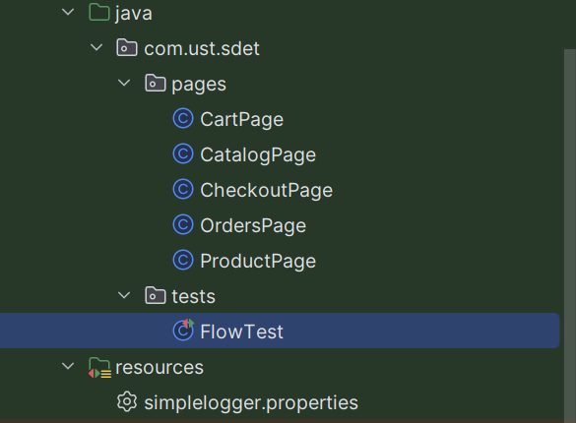
Figure: Selenide project structure

Framework Structure
• pages package: Contains Page Object classes such as CatalogPage, ProductPage, CartPage, CheckoutPage and OrdersPage.
• tests package: Contains FlowTest, which executes the complete end-to-end user journey.
• resources: Stores project configuration files such as simplelogger.properties.

End-to-End Test Flow
The automation validates a complete purchase flow:
1. Open the Catalog page.
2. Select a product.
3. Add the product to the Cart.
4. Proceed to Checkout.
5. Place the order.
6. Navigate to the Orders page and verify that the order is displayed.

Assertions Performed
Assertions are added throughout the flow to verify page navigation, product details, cart contents, checkout completion, and successful order creation. This ensures both functional correctness and end-to-end validation.

Current Status
• PactFlow integration is configured and under verification.
• Selenide automation framework is implemented and the complete purchase flow is automated with assertions.

