Report for week3_gate3

Project Overview
Automate the retail purchase flow using Selenium, Cucumber, JUnit 5, PicoContainer, Allure, and Extent Reports.
Flow:
Catalog → Search Product → Add to Cart → Cart → Checkout → Order Confirmation

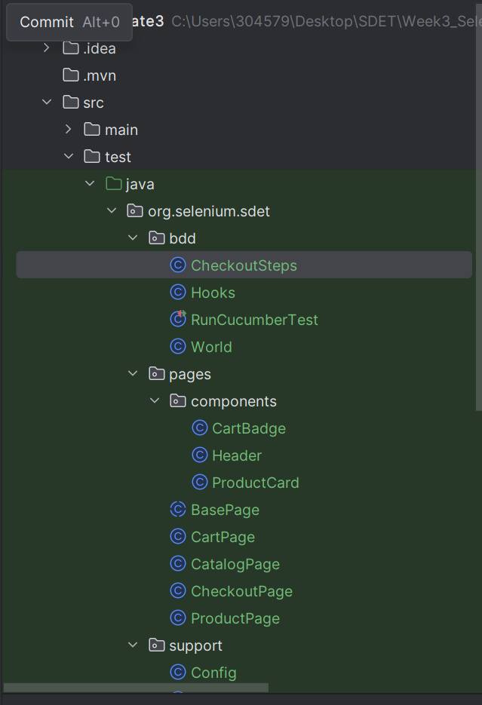
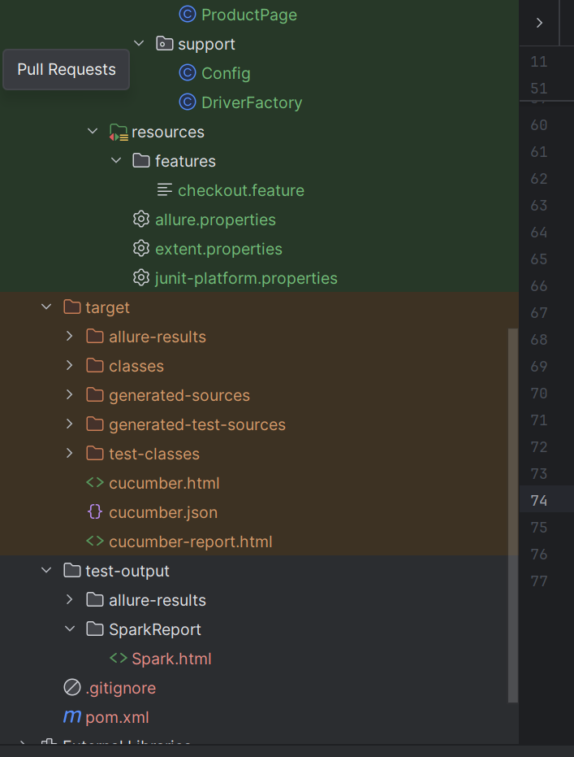
Folder Structure

Implemented Scenarios
Buy a single product end to end | @smoke
Cart badge reflects number of items added | @smoke
Buy products using Scenario Outline | @regression
Fresh Cart is empty | @regression
Deliberate failure for screenshot evidence | @negative

Framework Requirements (POM)
The framework is designed using the Page Object Model (POM) pattern.
- BasePage contains a shared WebDriverWait and reusable helper methods such as visible(), click(), type(), text(), and elements().
- Separate page classes are created for CatalogPage, ProductPage, CartPage, and CheckoutPage.
- Reusable components such as Header, CartBadge, and ProductCard are implemented to improve maintainability.
- Fluent navigation is used where page methods return the next page object after successful navigation.
- Locators are stored as private By objects and elements are always re-located when needed.
- Assertions are implemented only in the step definitions, while page objects are responsible only for page interactions and state retrieval.
BDD Implementation (Cucumber)
The framework uses Cucumber for Behaviour Driven Development (BDD).
- A checkout.feature file contains all required scenarios and a Scenario Outline with multiple example rows.
- Step definitions are thin wrappers over page object methods and do not contain Selenium WebDriver code.
- Cucumber expressions such as {string} and {int} are used.
- Hooks are implemented using @Before and @After annotations.
- A new WebDriver instance is created before each scenario and closed after execution.
- PicoContainer is used to share state through a World object.
- Scenarios are categorized using @smoke, @regression, and @negative tags.
- Tag-based execution is supported through the JUnit Platform runner.
Reporting and Evidence
The framework provides execution evidence through Allure and Extent Reports.
- Allure and Extent Reports are configured as Cucumber plugins.
- Screenshots are automatically captured and attached when a scenario fails.
- Business data attachments are included in the reports for traceability.
- Environment details such as browser, execution mode, and build information are available in both reports.
- The framework supports headless execution and report results accurately match the executed scenarios.

POM Design
- BasePage
- CatalogPage
- ProductPage
- CartPage
- CheckoutPage
Reusable Components
- Header
- CartBadge
- ProductCard

Command to Run

- Clean and Run All Tests
– mvn clean test

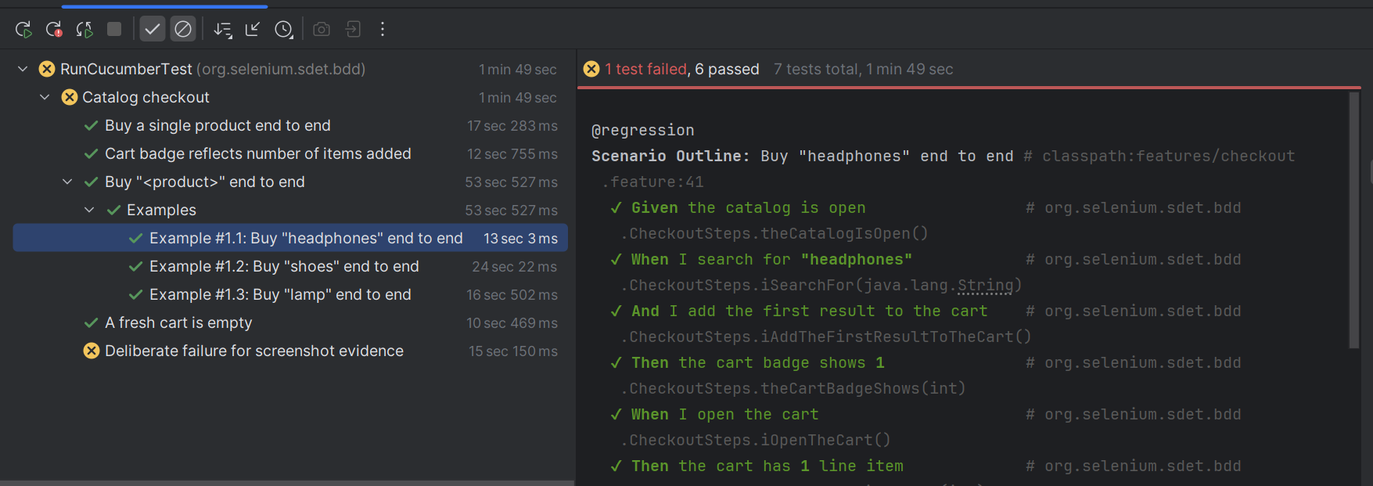
- Run Headless
– mvn clean test -Dheadless=true(this will run the commands headless)


- Run Headed
– mvn clean test -Dheadless=false(this will run the commands headed)
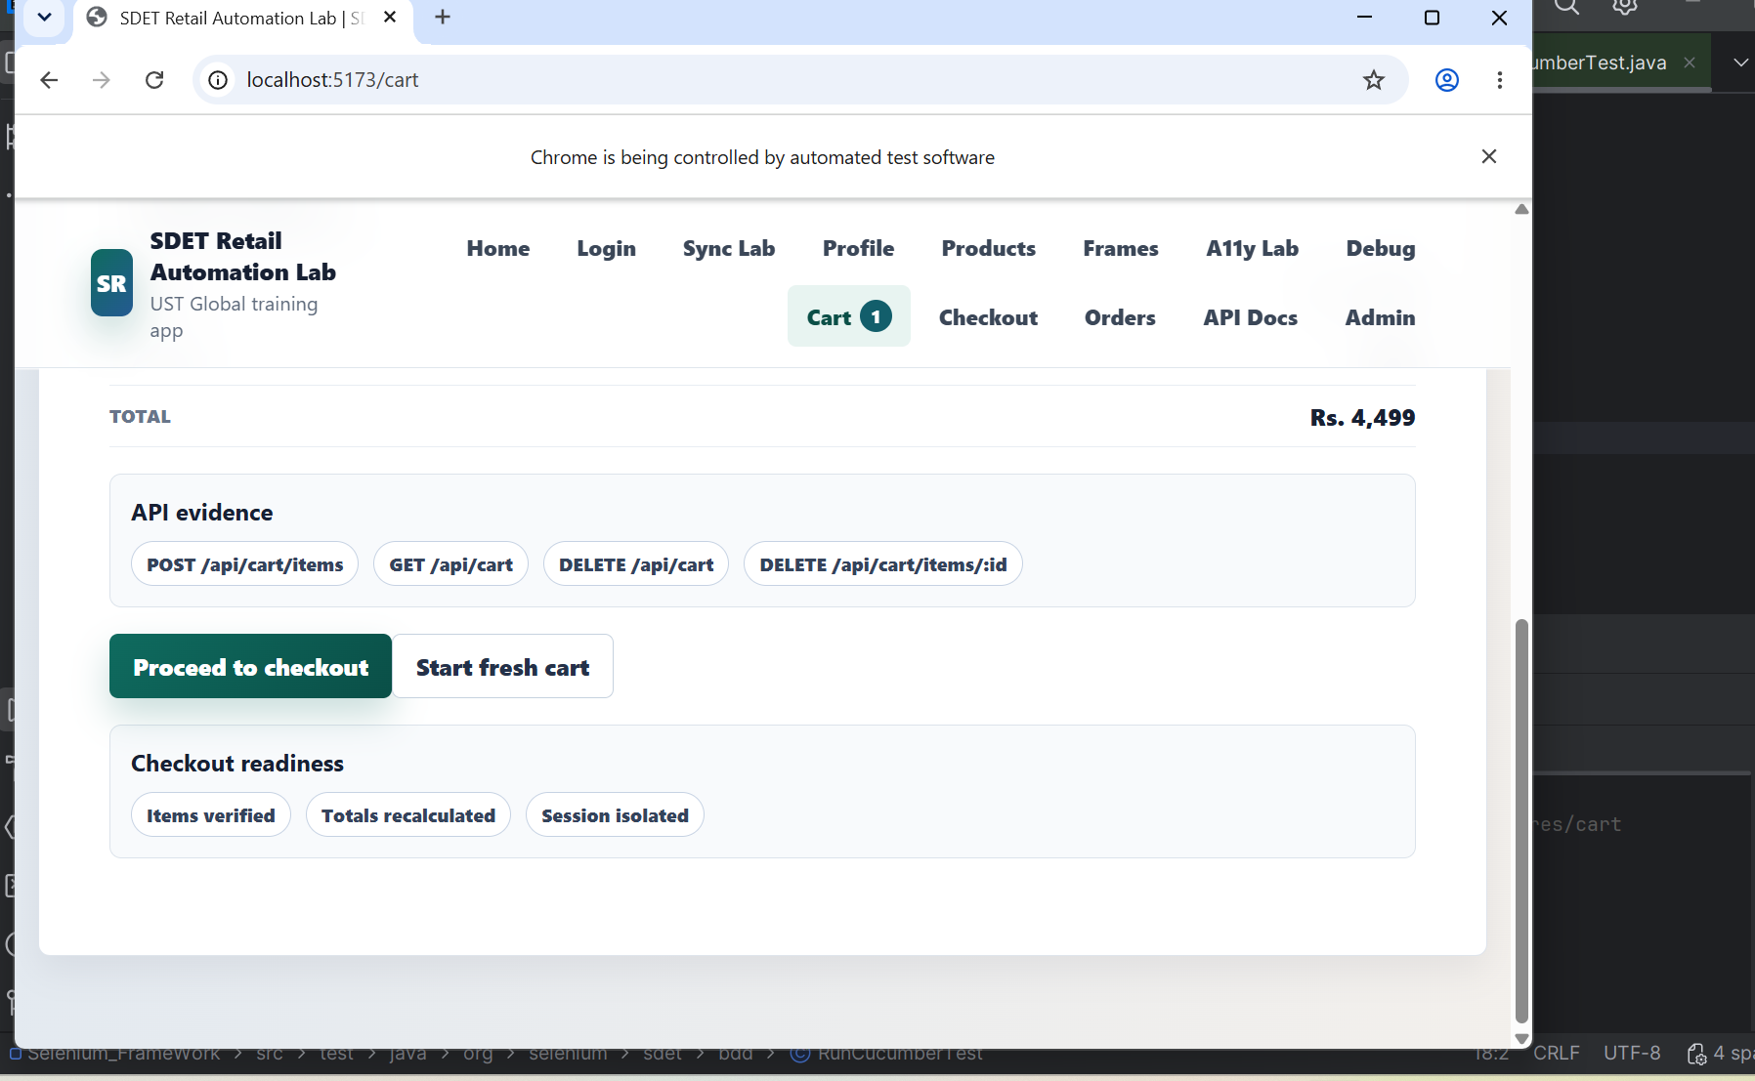
- Run Only Smoke Tests
– mvn clean test -Dcucumber.filter.tags=”@smoke”

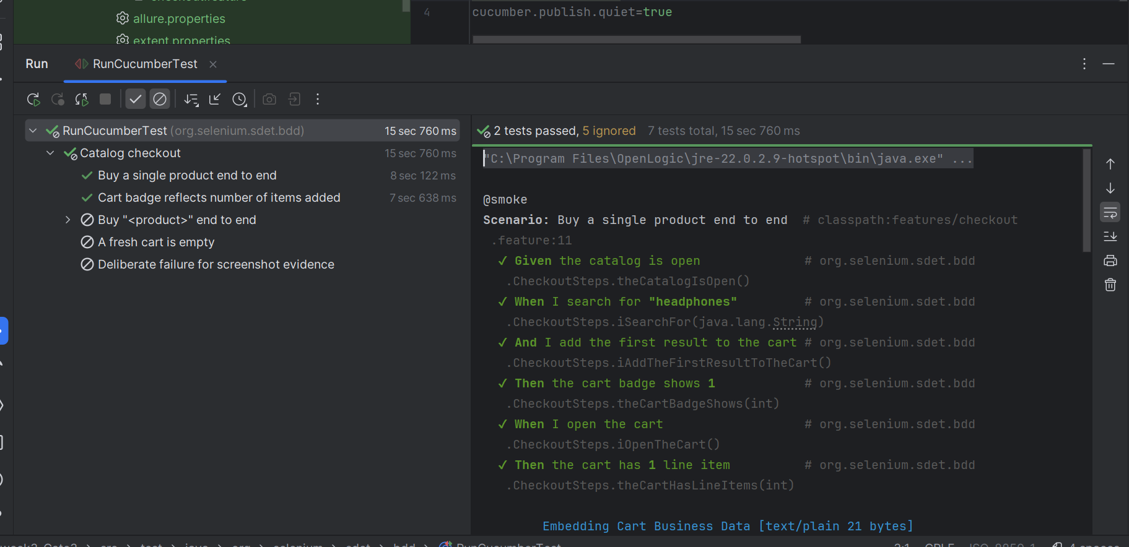
- Run Only Regression Tests
– mvn clean test -Dcucumber.filter.tags=”@regression”

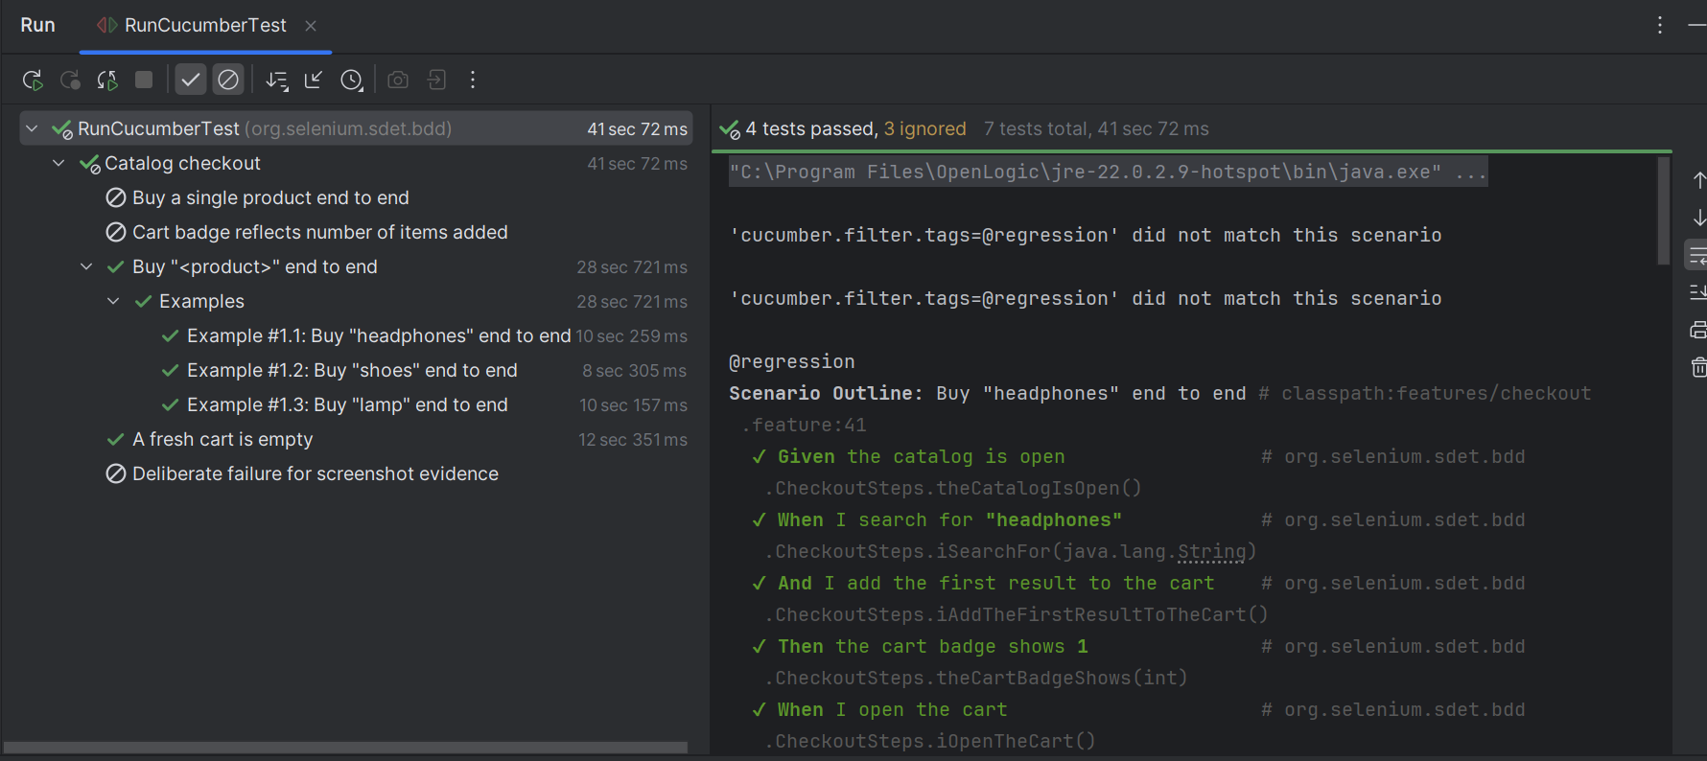
- Run Only Negative Tests
– mvn clean test -Dcucumber.filter.tags=”@negative”

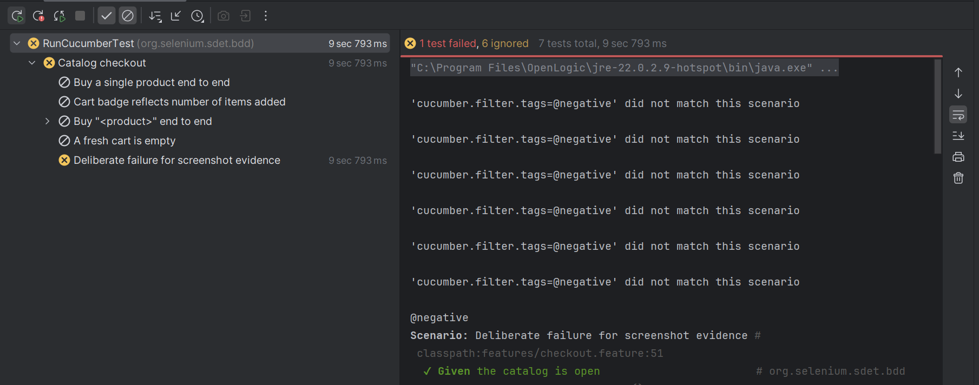

This test is mean to be failed – negative test

- allure generate allure-results --clean -o allure-report
this will generate a allure-results which contains json

In my system mvn is not working so im unable to run these commands

