Week 4 – Gate 4 Assessment Report
Project Overview
This assessment consists of 2 projects
- Pact Consumer Provider Testing
- Selenide UI Automation
Project 1: Pact Consumer Provider Testing
Objective
To validate API contracts between the Consumer and Provider using Pact Contract Testing.
Technologies Used
- Java
- Maven
- Junit 5
- Pact JVM
- WireMock
- Docker
- GitHub Actions
Project Structure
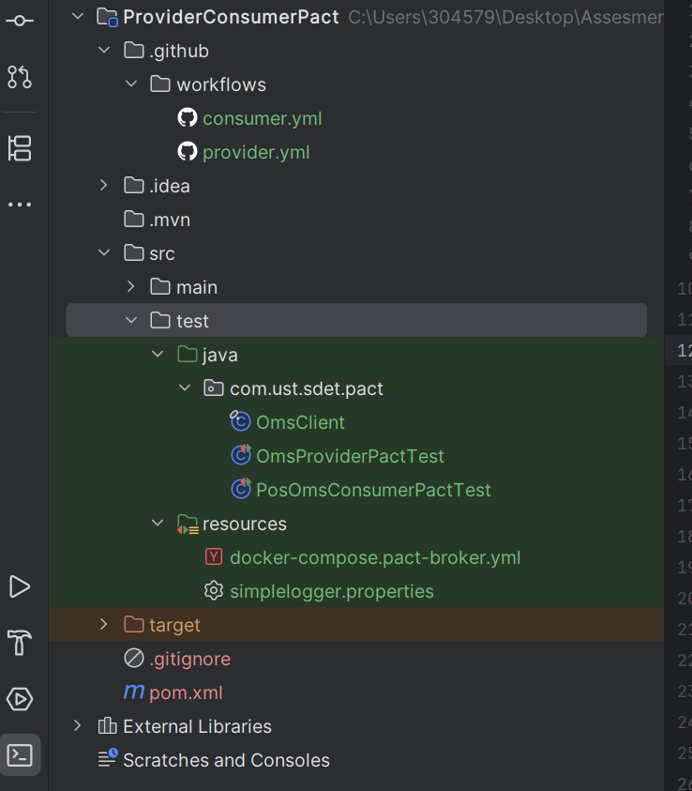
Test Scenarios
- Get Order
- Create Order
- Get Inventory
Consumer
- Generate Pact contract
- Publishes contract
- Runs Consumer tests
Provider
- Verifies Pact contract
- Uses WireMock with State Handlers
- Runs Provider verification
Commands
Run All Tests
- mvn clean test
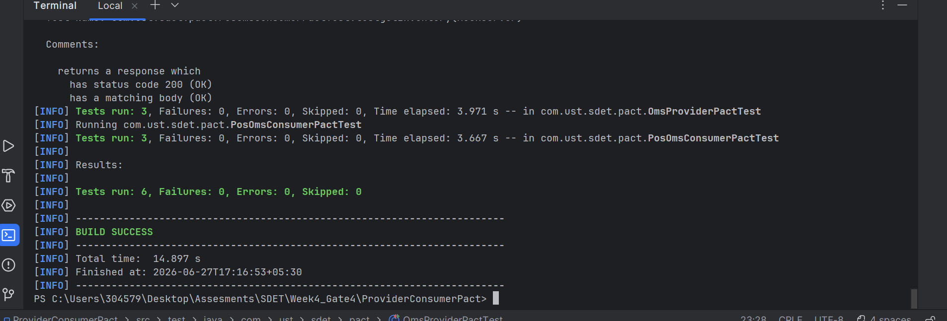
Run Consumer Tests
- mvn -Dtest=PosOmsConsumerPactTest test
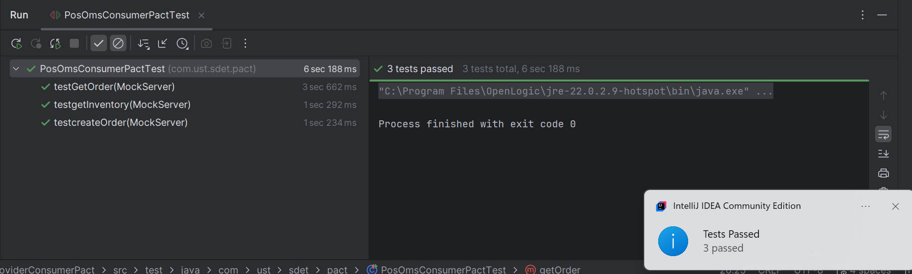
Run Provider Tests
- mvn -Dtest=OmsProviderPactTest test
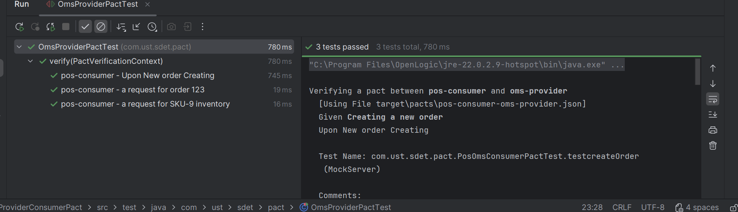

Conclusion
The Pact Consumer-Provider project successfully validates API contracts between the Consumer and Provider applications. Consumer tests generates contract files, while Provider verification ensures that the API implementation matches the agreed contract. WireMock is used to simulate provider responses, and GitHub Actions automate the Consumer and Provider pipelines, enabling reliable contract testing and continuous integration.

Project 2 : Selenide UI Automation
Objective
To automate the Retail application using Selenide and verify that the selected product is available
Tools Used
- Java
- Maven
- Selenide
- Selenium
- Junit 5
Project Structure
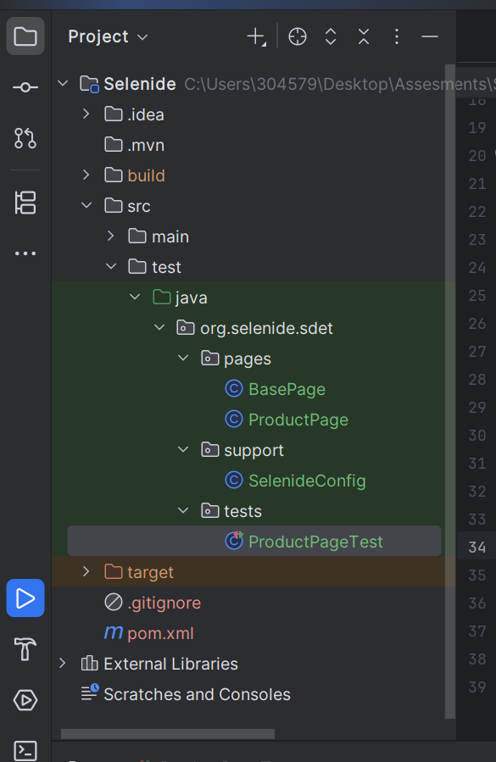

Test Scenario
Verify Product Availability
Steps
- Launch the browser.
- Open the Retail application.
- Navigate to the Catalog page.
- Open the first product.
- Verify the Product page is displayed.
- Verify the Product name is visible.
- Verify the Availability status is “In Stock”.
Expected Results
The product details page should display
Availability : In stock
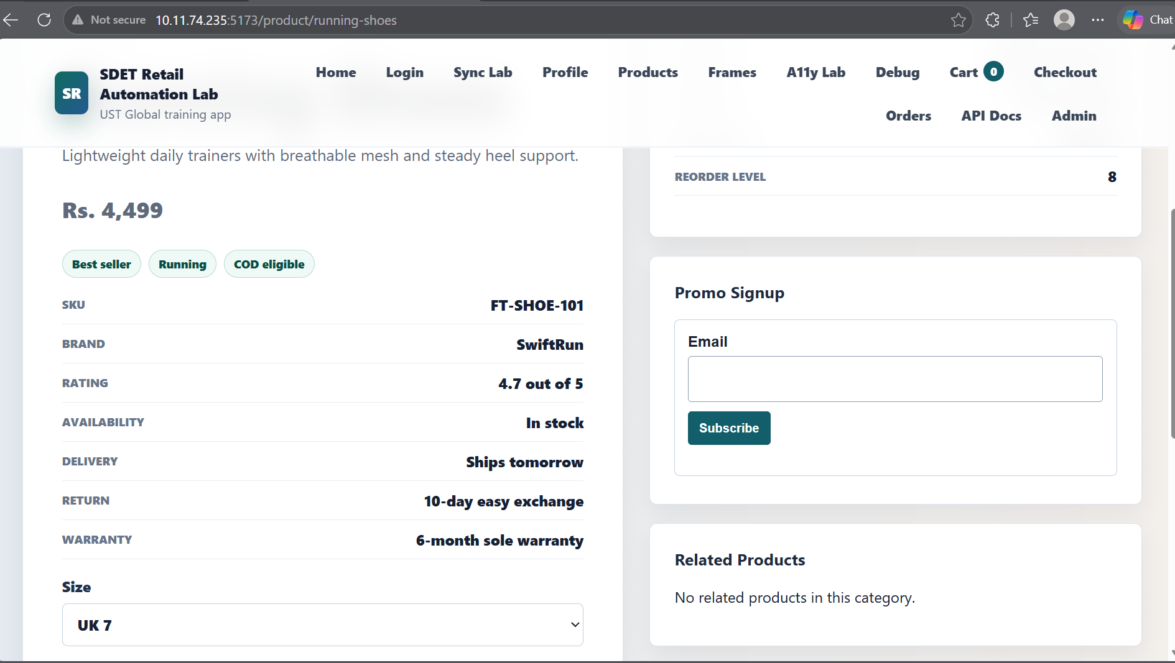
Design Pattern
- Page Object Model(POM)
Features
- Selenide Auto Wait
- Page Object Model
- Reusable Page Classes
- Simple and Maintainable Framework
Commands
Run all tests
- mvn clean test
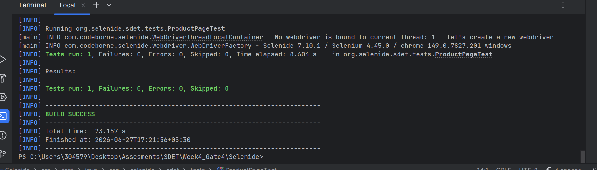
Run Product Page Test
- mvn -Dtest=ProductPageTest test
Run in Headless Mode
- mvn clean test -Dheadless=true
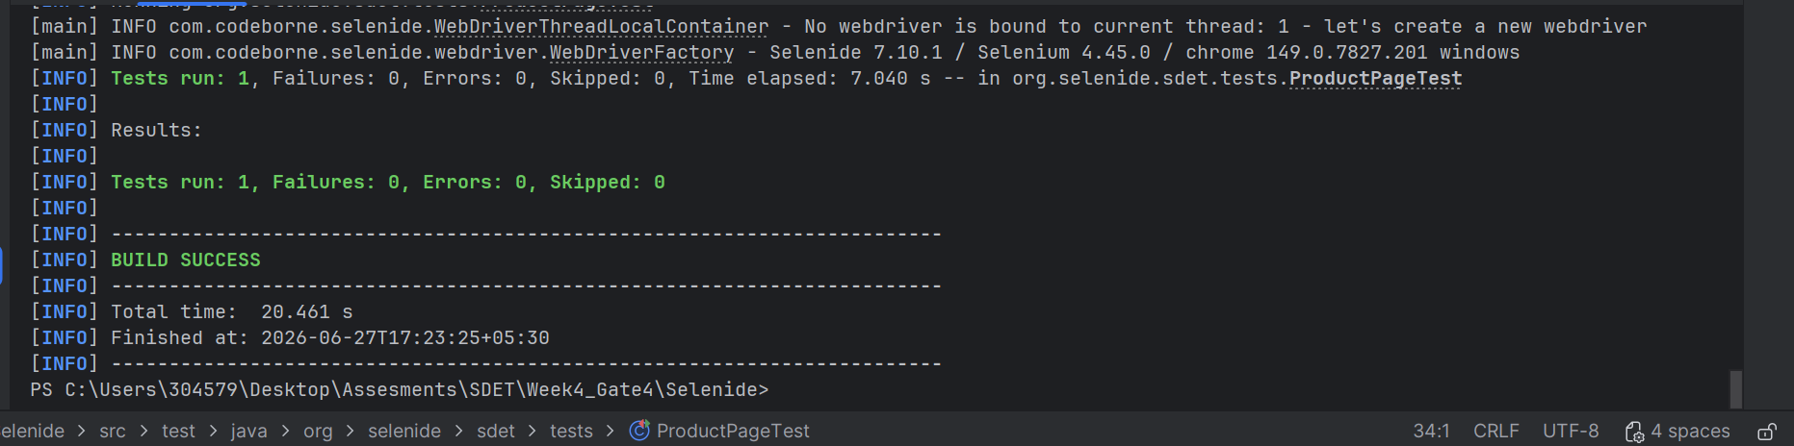
Run Headed Mode
- mvn clean test -Dheadless=false
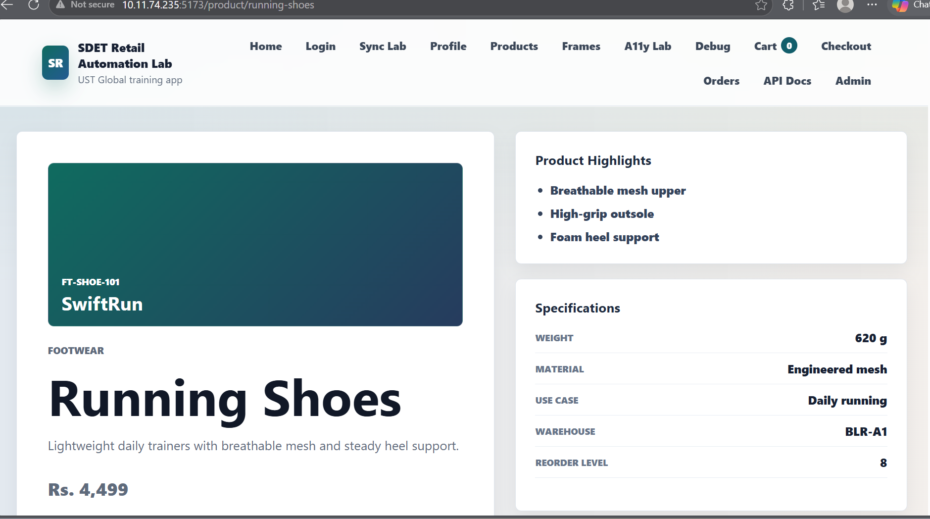

Conclusion
The Selenide framework successfully verifies that the selected product is available by checking that the Availability field displays “In stock”. The project follows the Page Object Model, making the test simple, reusable, and easy to maintain.

