Name: J. Ragumaan
Date: 27 June 2026
Project1:
Consumer-Driven Contract Testing using WireMock, Pact and Pact Broker
Aim
To implement Consumer-Driven Contract Testing using WireMock, Pact, and Pact Broker, and automate consumer contract publishing and provider verification using GitHub Actions CI/CD workflows.
Objectives
- To understand the concept of Consumer-Driven Contract Testing (CDCT).
- To implement WireMock for mocking provider APIs during consumer development.
- To create consumer contract tests using Pact.
- To publish generated Pact contracts to the Pact Broker.
- To verify the provider implementation against published contracts.
- To automate contract testing using GitHub Actions.
- To understand the purpose of the can-i-deploy command in deployment validation.
Tools and Technologies Used
- Java 22
- Maven
- JUnit 5
- Rest Assured
- WireMock
- Pact JVM
- Pact Broker
- Docker & Docker Compose
- GitHub Actions
- Git & GitHub

Procedure
- Created a Maven project for demonstrating Consumer-Driven Contract Testing.
- Organized the test code into separate consumer and provider packages.
- Implemented OmsClient to use the OMS API from the consumer side.
- Developed PosOmsConsumerPactTest to define consumer expectations and automatically generate Pact contracts.
- Used WireMock to mock provider API responses, allowing consumer testing without depending on a live provider.For demo we are using it for now it is aim is to demonstrate like real world project
- Configured a Pact Broker using Docker Compose to store generated contracts and verification results.
- Published the generated Pact contracts to the Pact Broker using the Pact CLI.
- Implemented OmsProviderVerification to verify the real provider API against the published consumer contracts.
- Created separate GitHub Actions workflows:
|--consumer.yml for executing consumer contract tests and publishing contracts.
|--provider.yml for executing provider verification and deployment compatibility checks.
- Executed the can-i-deploy command to verify contract compatibility before deployment.
Project Structure
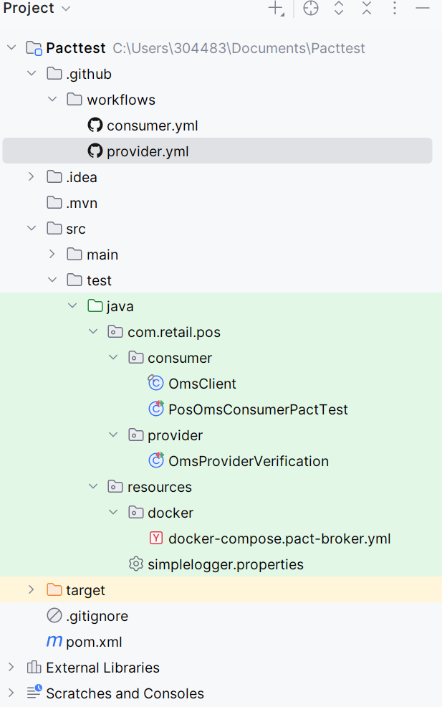
Local run output evidence:
OmsProviderVerification:
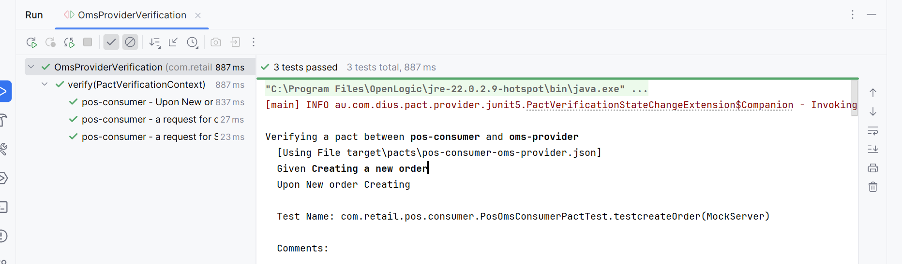
PosOmsConsumerpactTest:
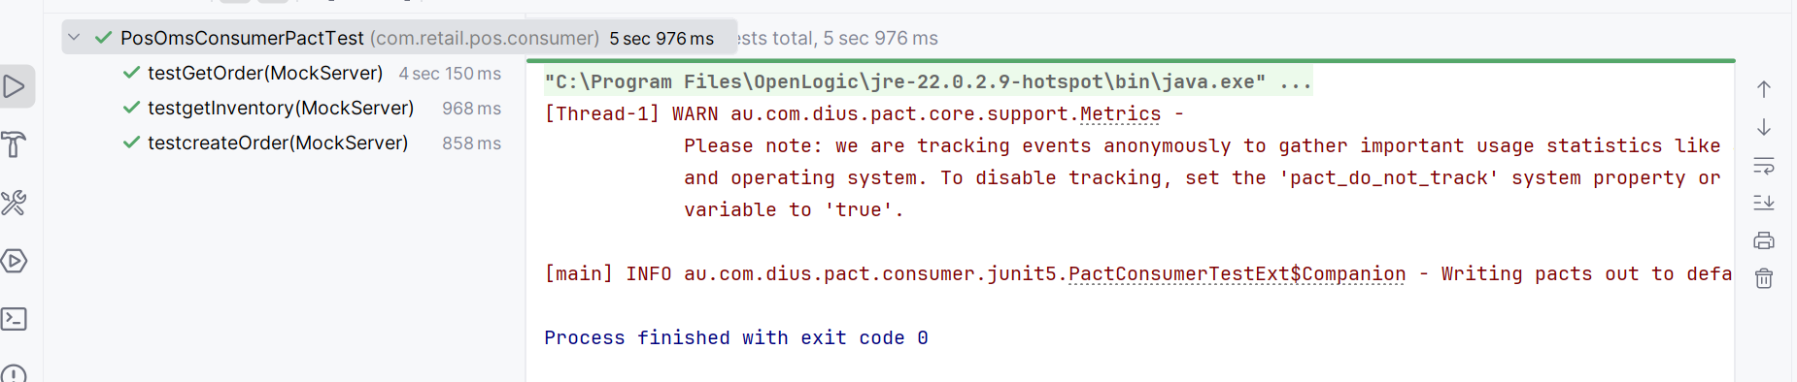

Target\pact-pos-consumer-oms-provider.json is generated
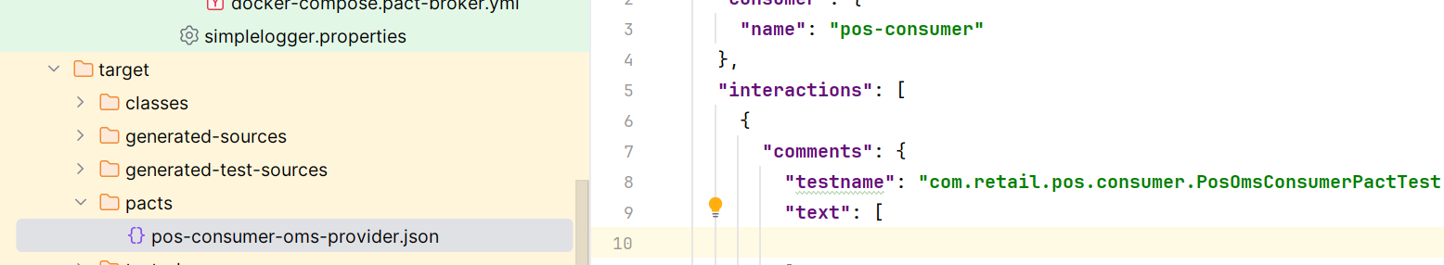

Workflow
Consumer Application
|
WireMock Mock Server
|
Pact Consumer Test
|
Generate Pact Contract
|
Publish Contract to Pact Broker
|
Provider Verification
|
Publish Verification Result
|
can-i-deploy
|
Deployment Decision
Observations
- WireMock enabled consumer testing without requiring the actual provider service.
- Pact automatically generated API contracts based on consumer expectations.
- Pact Broker centrally stored contracts and provider verification results.
- Provider verification validated that the real provider implementation satisfied the published consumer contract.
- Separate GitHub Actions workflows automated consumer contract publishing and provider verification.
- The can-i-deploy command acted as a deployment safety check by confirming compatibility before deployment.
Result
Successfully implemented a Consumer-Driven Contract Testing solution using WireMock, Pact, and Pact Broker. Automated the generation, publication, verification, and compatibility validation of contracts through GitHub Actions.
Conclusion
Finally Consumer-Driven Contract Testing using WireMock, Pact and Pact Broker implemented successfully.

Project-2
Selenide Page Object Model – Product Page Test
Aim
To automate the Product Page functionality of a web application using the Selenide Page Object Model (POM) by opening a product, validating that the product page is displayed correctly, and verifying product availability.

Objective
- Configure Selenide for browser automation.
- Implement the Page Object Model design pattern.
- Navigate from the product catalog to the product details page.
- Verify that the product page loads successfully.
- Validate product information.
- Check product availability status.

Project Structure
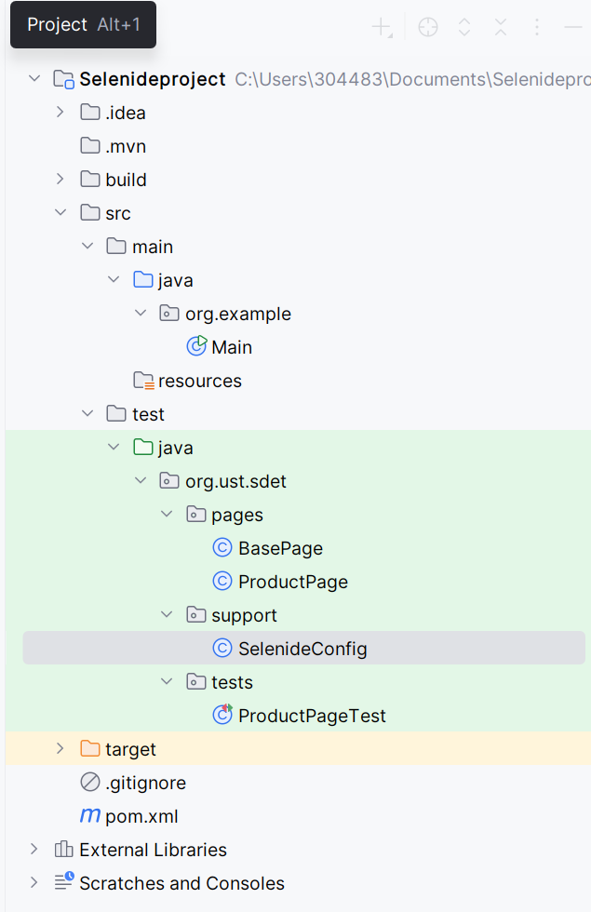
Implementation
1. BasePage.java
The BasePage class have the reusable code of all the pages.
2. ProductPage.java
Represents the Product Details Page.
3. SelenideConfig.java
Contains global configuration for Selenide.
Configuration
Property | Value
Base URL | http://localhost:5173
Browser | Chrome
Headless | False
Browser Size | 1440 × 900
Timeout | 10 Seconds
Configuration is loaded before executing tests.

4. ProductPageTest.java
This class verifies Product Page functionality.
Test Flow
Start
│

Launch Browser
│

Open /catalog
│

Locate First Product
│

Click Product
│

Open Product Page
│

Verify Product Name
│

Verify Availability
│

Test Passed
Evidence
Test Code:
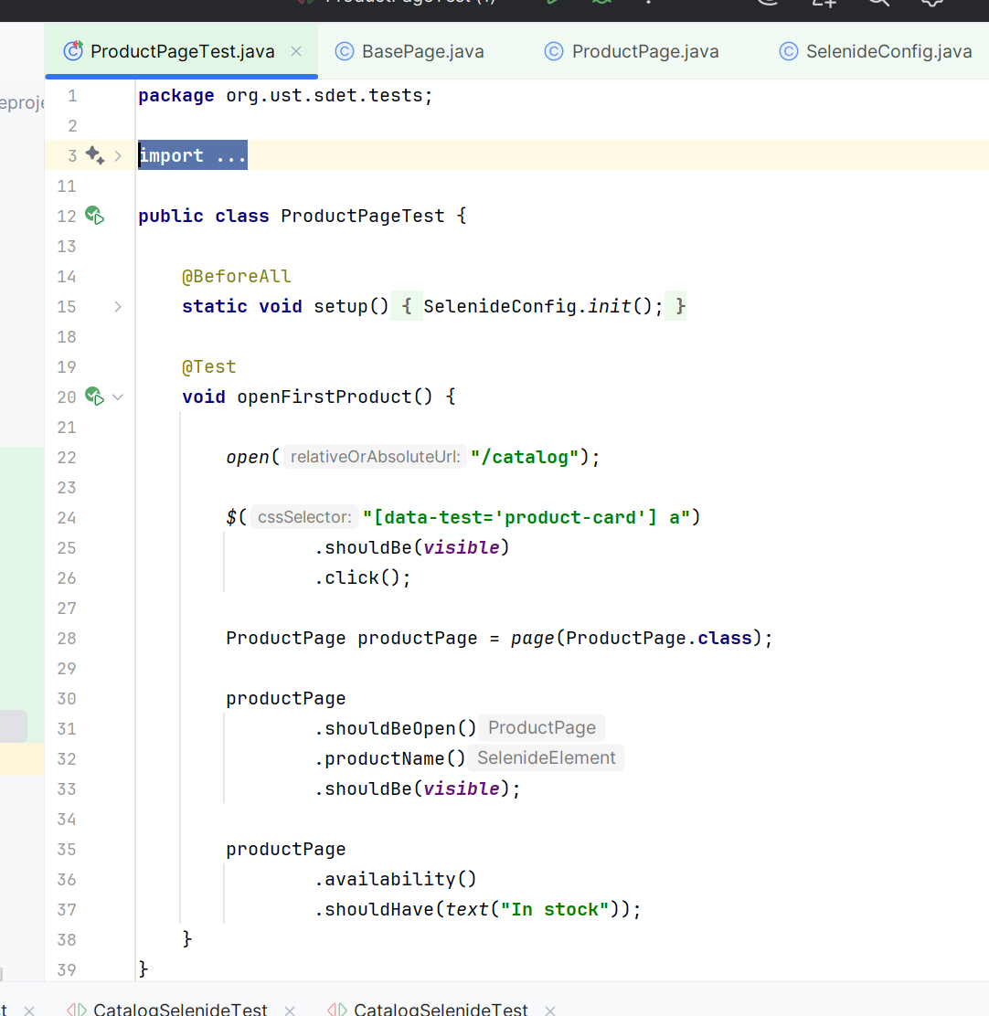
Output:
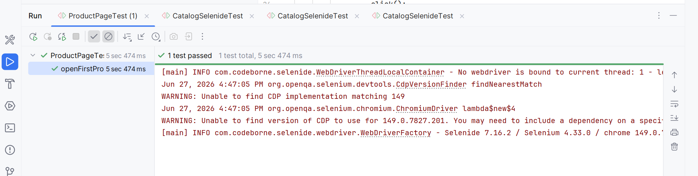

Expected Result
- Browser launches successfully.
- Catalog page opens.
- First product is selected.
- Product Details page loads successfully.
- Product name is displayed.
- Availability badge displays "In stock".
- Test executes successfully without failures.

Technologies Used
- Java
- Selenide
- JUnit 5
- Maven
- Chrome Browser

Advantages of Using Selenide
- Built-in automatic waits.
- Minimal boilerplate code.
- Cleaner and more readable syntax.
- Easy Page Object Model implementation.
- Faster and more stable UI tests.
- Better maintainability compared to raw Selenium.
Conclusion
The Product Page automation was successfully implemented using the Selenide Page Object Model.

