DEMO REPORT
WEEK03-GATE03

- Introduction
This project tests a shopping catalog system using Cucumber (BDD) and Selenium.
The main goal is to check whether a user can:
- Search products
- Add items to cart
- View cart
- Place an order
2. Tools Used
- Java
- Selenium WebDriver
- Cucumber (BDD)
- JUnit
- Chrome Browser

3. Test Scenarios
Scenario 1: Buy a single product end to end
Test: @smoke
Steps:
- Open Catalog
- Search for a product
- Add first product
- Check cart badge
- Open cart
- Verify 1 item
- Place order
- Confirm order
Expected Output:
- Product added successfully into cart
- Cart shows 1 item
- Cart Badge shows 1 item
- Order confirmed

Scenario 2: Cart Badge reflects the number of items added
Test: @smoke
Steps:
- Open Catalog
- Search for a product
- Add first product
- Check badge
Expected Output:
- Cart badge should show correct count
- Product added successfully into cart

Scenario 3: Multiple product checkout
Test: @regression
Products tested:
Product | Expected Count
Headphones 1 | 1
Shoes | 1

Steps:
- Search each product
- Add to cart
- Check cart
- Place order
Expected Output:
- Each product should be added correctly
- Order should be confirmed

Scenario 4: Empty cart validation
Test: @regression
Steps:
- Open cart
Expected Output:
- Cart badge shows 0
- No items in cart

Scenario 5: Negative test (Failure case)
Test: @negative
Steps:
- Add product
- Check wrong count
Expected Output:
- Test should FAIL
- Screenshot should be captured

4. Happy Path and Negative Path
Happy Path
- Buy product end-to-end
- Cart badge update
- Multiple product checkout
- Empty cart

Negative Path
- Checking for Wrong cart count

5. Commands Used
mvn test
Output:
- All scenarios executed
- Pass/Fail status shown
mvn -Dtest=RunCucumberTest -Dcucumber.filter.tags=@smoke test
Output:
- Only smoke scenarios executed
mvn -Dtest=RunCucumberTest -Dcucumber.filter.tags=@regression test
Output:
- Only regression scenarios executed

mvn -Dtest=RunCucumberTest -Dcucumber.filter.tags=@negative test
Output:
- Only negative scenarios executed

6. Test Result
Scenario | Result
Buy product | PASS
Cart badge | PASS
Multiple products | PASS
Empty cart | PASS
Negative scenario | FAIL

7. Different Test Types Used
1.Smoke Test
2.Regression Test
3.Negative Test

8.Screenshots
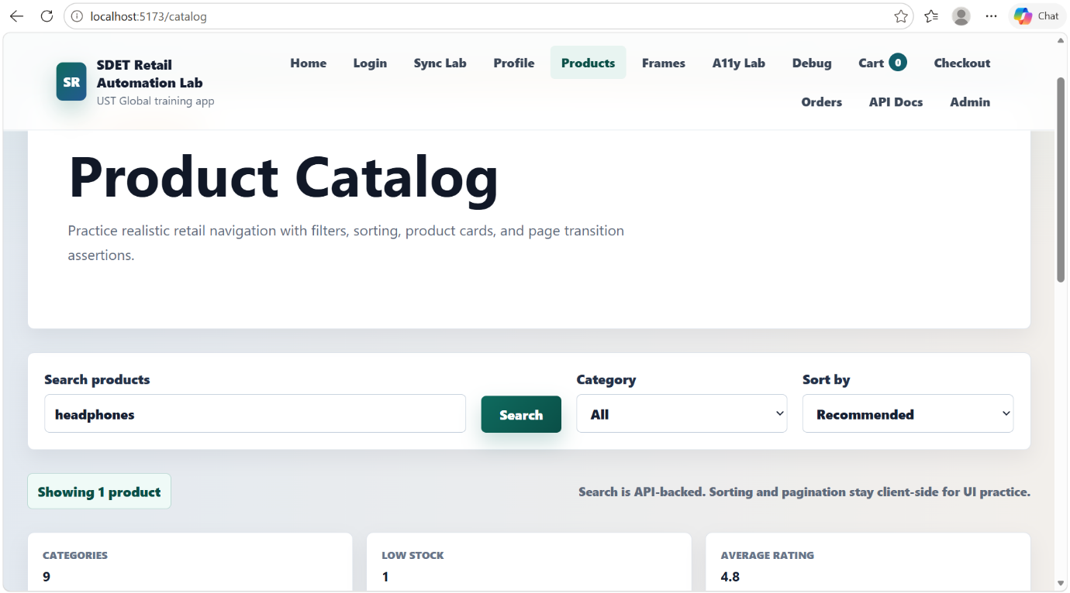

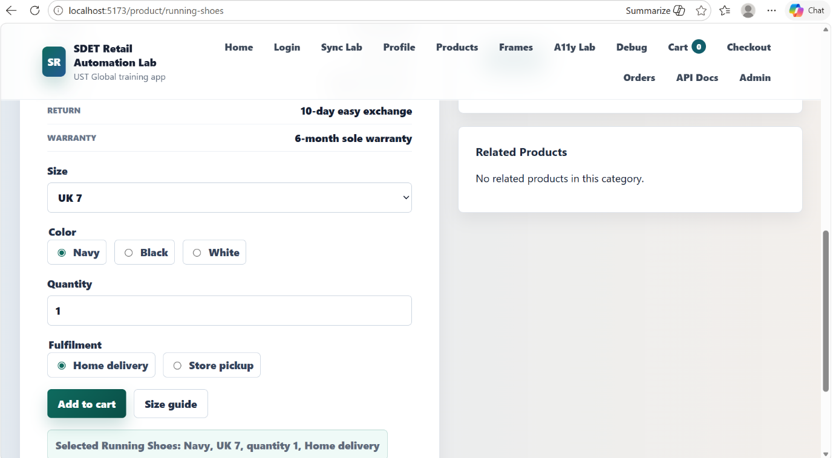

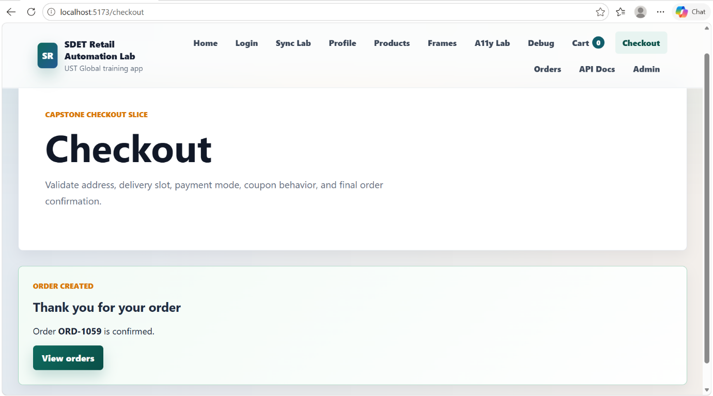

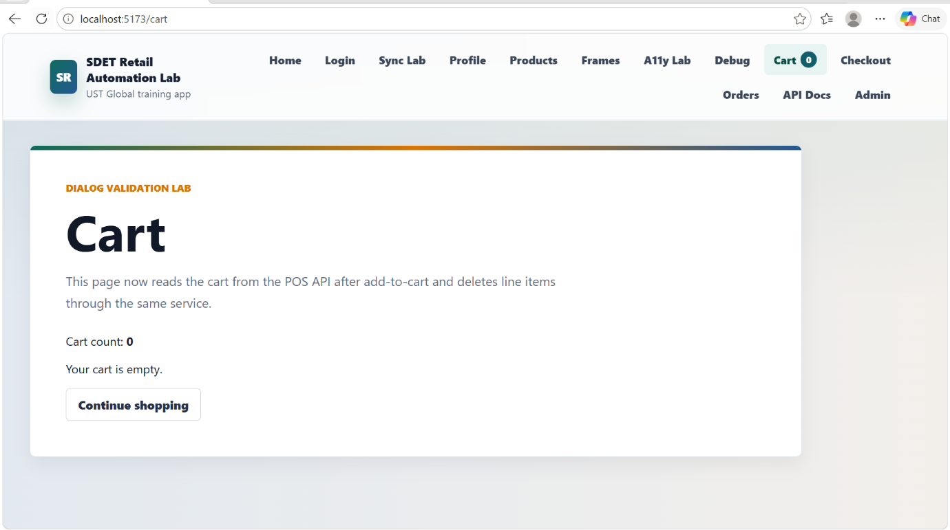
mvn -Dtest=RunCucumberTest -Dcucumber.filter.tags=@regression test
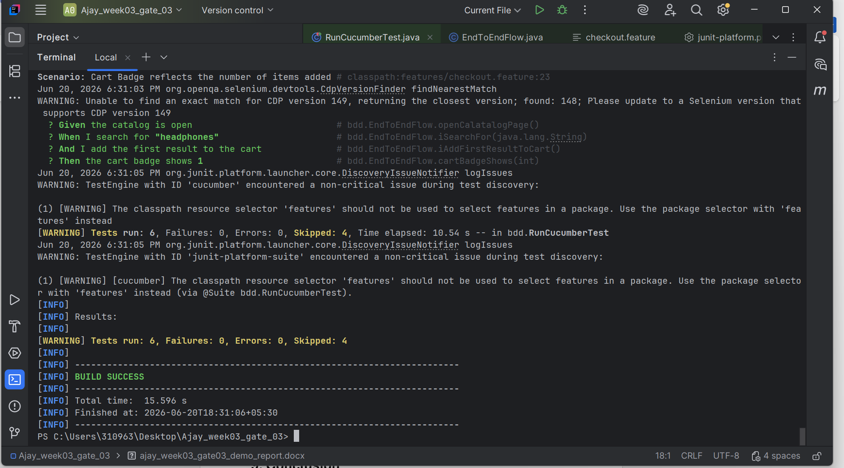

mvn -Dtest=RunCucumberTest -Dcucumber.filter.tags=@smoke test

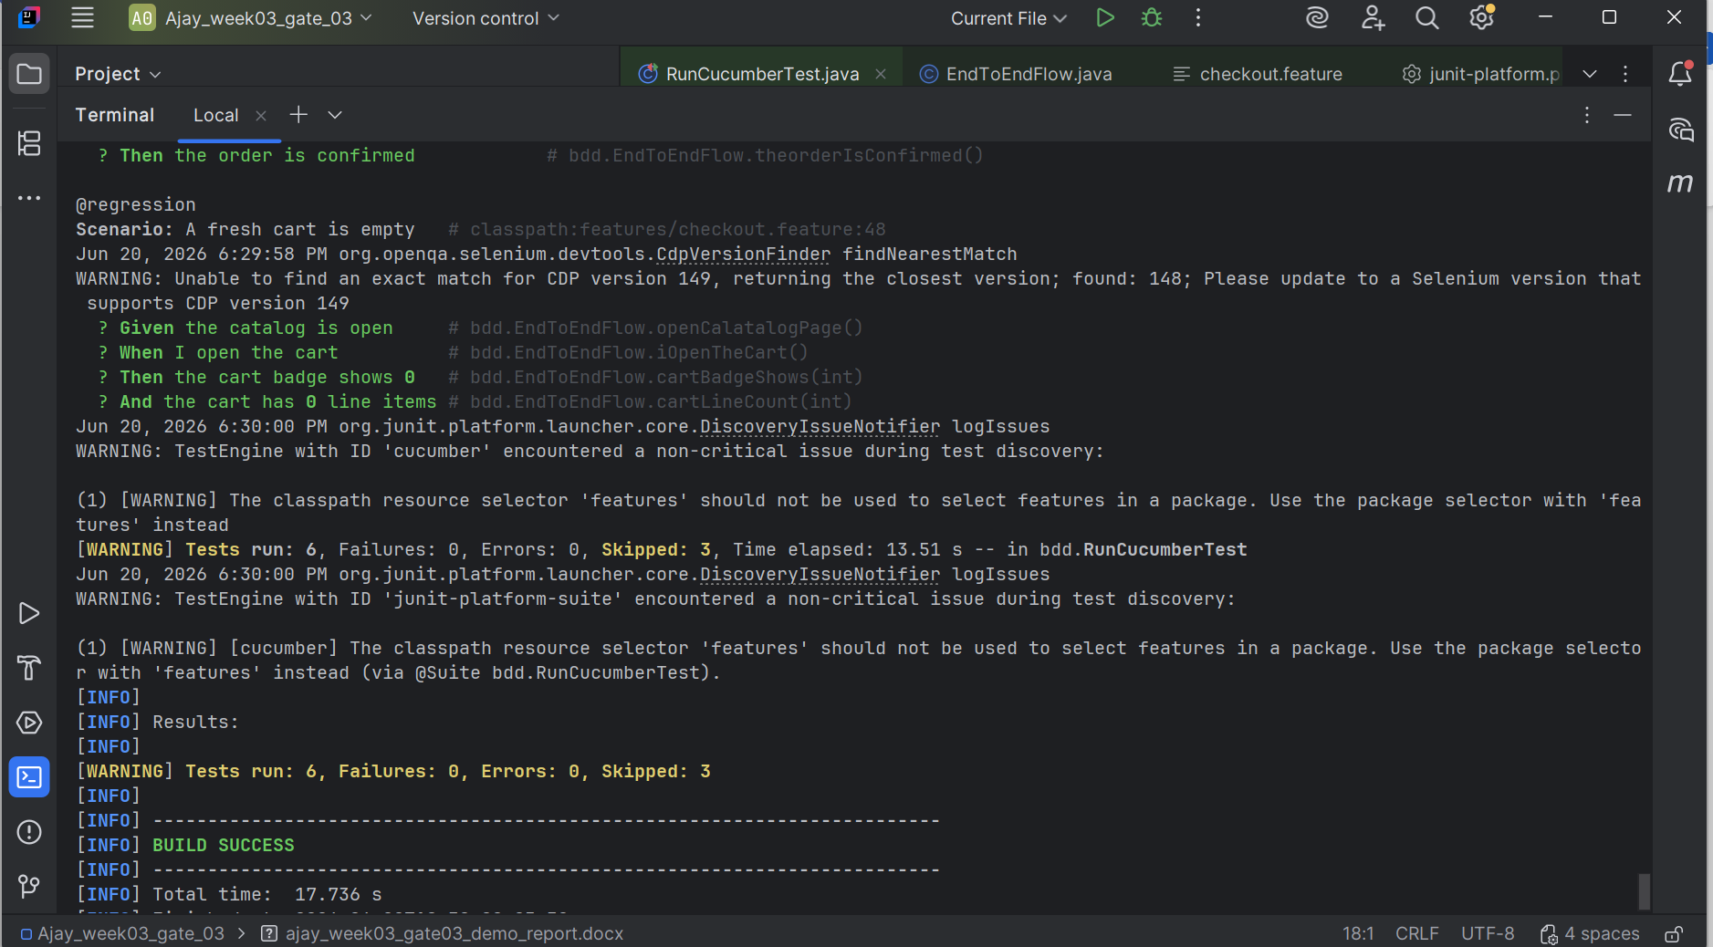

mvn -Dtest=RunCucumberTest -Dcucumber.filter.tags=@negative test
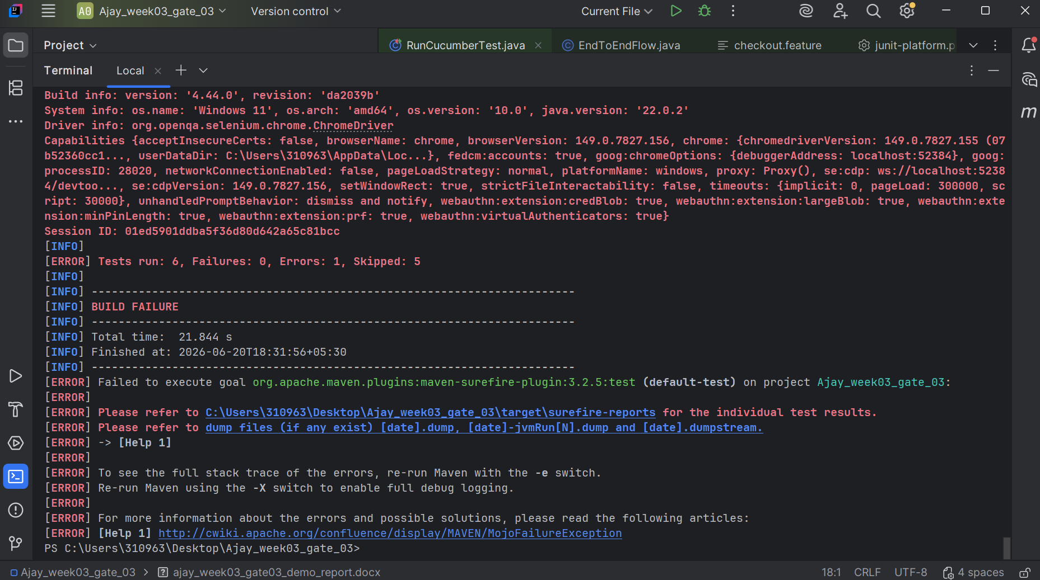

9. Conclusion
Project goes through the full Shop catalog system and different Scenarios are tested using smoke, regression and negative test
- All test passes except negative test
- Both positive and negative test cases are tested
- Went through the full end to end flow

