Selenium Automation Framework

Prepared by: Salman Benny Kaliboina
Date: 29 June 2026
Overview
This document captures the setup, design decisions, and test results for the Selenium-based automation framework we built to cover end-to-end testing of the “add to cart” feature of amazon application using Chrome Webdriver.
We went with the Page Object Model because it keeps tests readable and means you only have to update one place when the UI changes. Most of the boilerplate — driver setup, waits, reporting, screenshots is handled by the base classes so test methods stay focused on what they're actually testing.

How the layers fit together
There are four main layers. Tests call into page objects, which handle all the browser interaction. Utility classes deal with waits, screenshots, and reading test data. Config is kept in properties files so the same tests canun against dev, QA, or staging without touching any code

Tech Stack
The choices below are fairly standard for a Java/Selenium project. A few notes on why we landed where we did are underneath the table.

Category | Technology | Version | Notes
Language | Java | 17 LTS | Long-term support release, good library coverage
WebDriver | Selenium WebDriver | 4.18.x | W3C protocol, no vendor shims needed
Test runner | TestNG | 7.8.x | Grouping, parallel runs, retry built in
Build | Maven | 3.9.x | Dependency management and test runner
Reports | Extent Reports | 5.x | Rich HTML, thread-safe, embeds screenshots
Logging | Log4j2 | 2.x | Structured logs per test run
CI/CD | GitHub Actions + Jenkins | Latest | PR checks and scheduled regression
Version control | Git / GitHub | Latest | Feature branches, PR review flow

Folder Structure
The project follows standard Maven layout. Everything under src/main is framework code; everything under src/test is the actual tests and test resources.
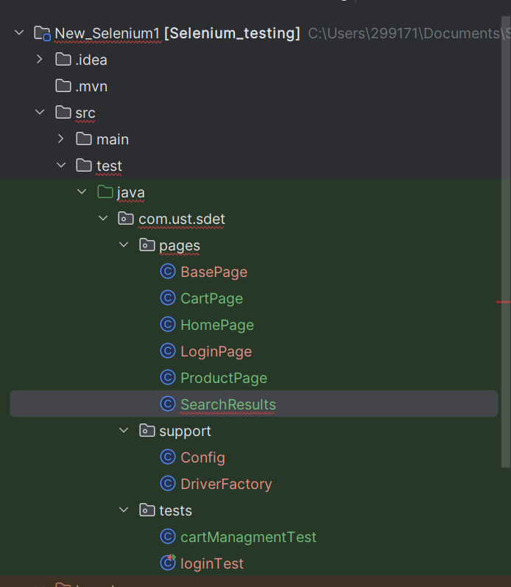

Test Results:

Screenshots
Screenshots below were captured automatically by the TestListener on step failure The test cases has the complete per-test logs alongside these.

Running the Tests

Prerequisites
- Java 17+ (JDK)
- Maven 3.9+
- Chrome, Firefox, or Edge installed locally
- Git

Commands:
mvn clean test

Reports
After any run you'll find the HTML report at reports/ExtentReport.html. Logs are in logs/test-execution.log.

