ASSESSMENT - WEEK 5
REPORT
Objective
To produce artifact and log for test cases and debug the flaky test using those artifacts.
PROJECT STRUCTURE
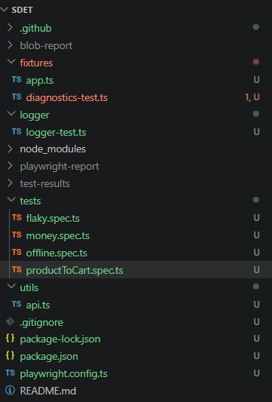
SCENARIOS COVERED
Scenario 1: Adding product to cart flow – included logging
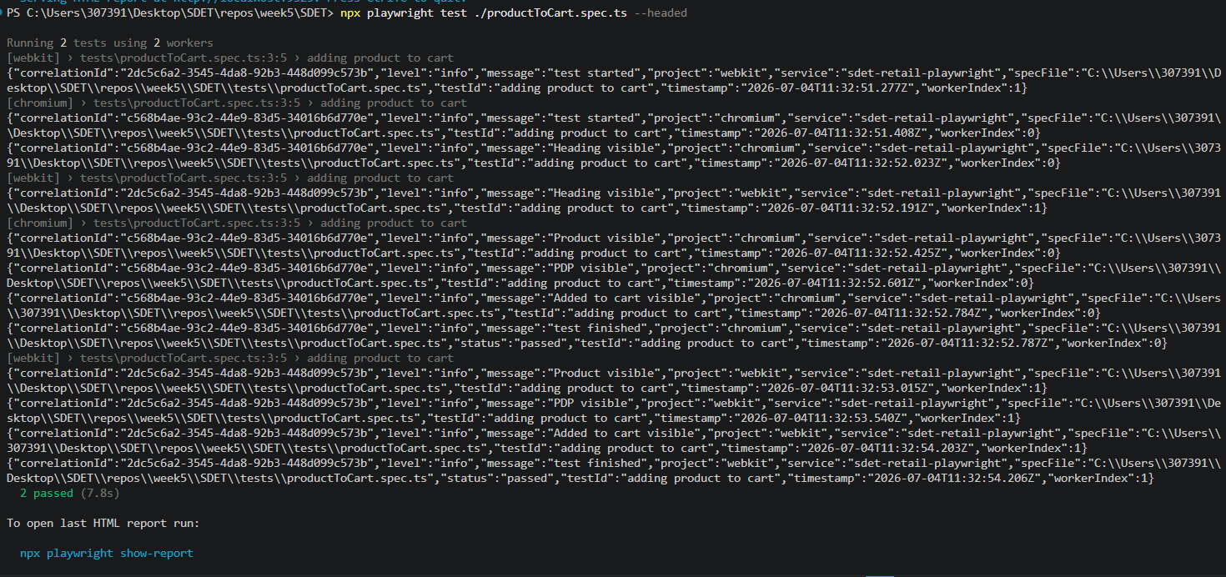

Scenario 2: Sync test hangs on WebKit - Offline set before load - Load first, then offline - Cross-browser green
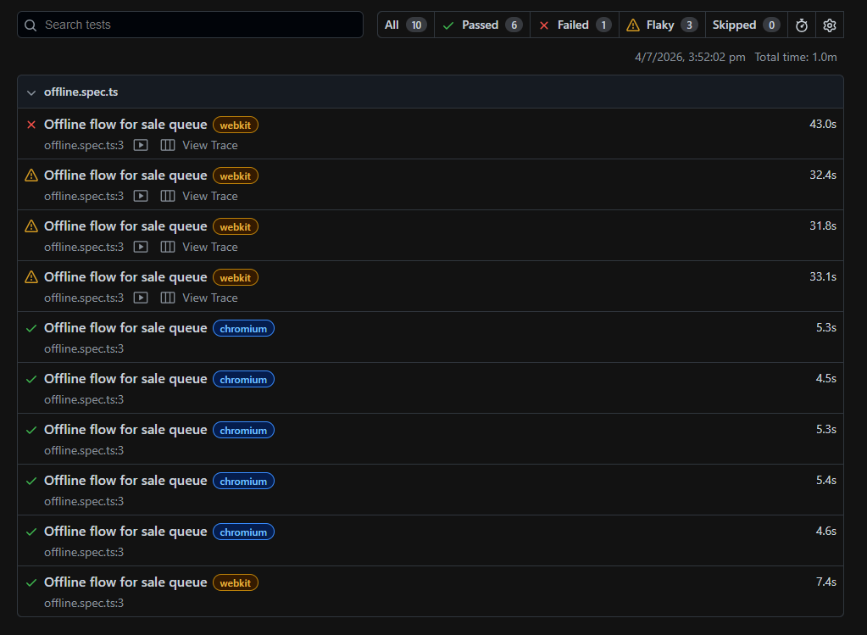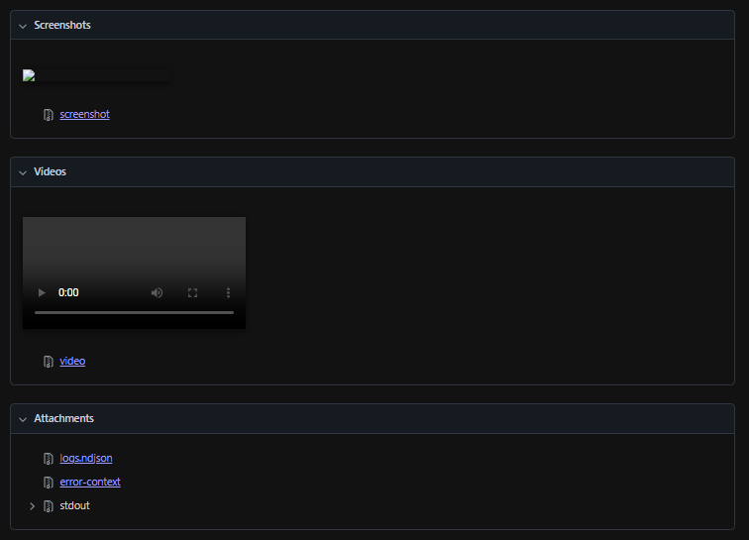
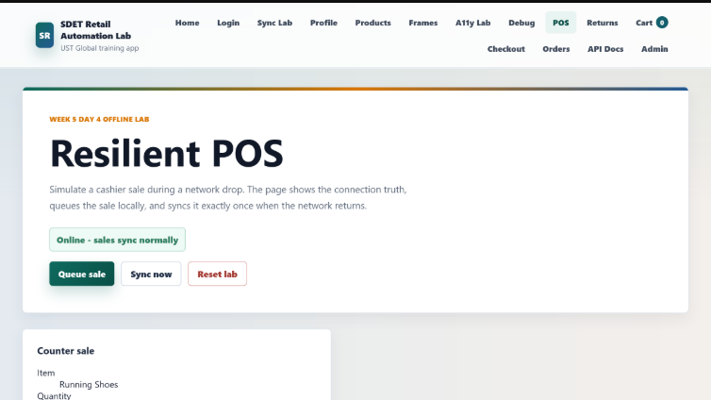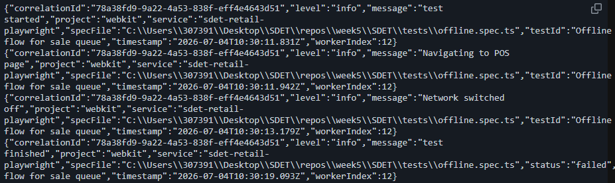
Issue: WebKit is slow while rendering the page.
Fix: Replaced the assertion to check the banner with the assertion to verify the outbox count is incrementing.
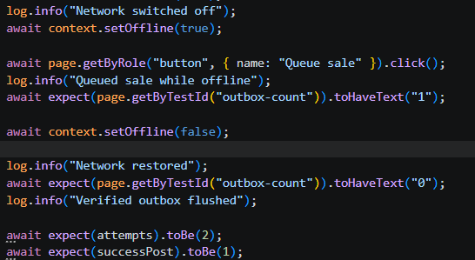
Execution after fix: npx playwright test ./offline.spec.ts –repeat-each=50
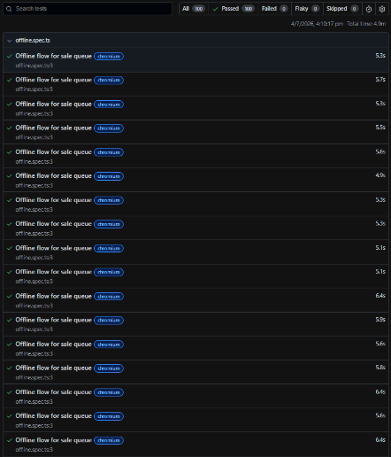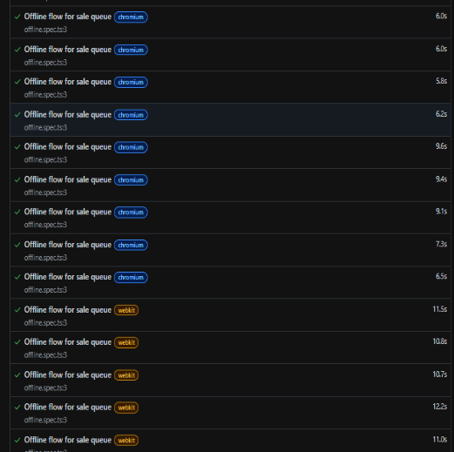

Scenario 3: Refund posts twice - No idempotency key - Idempotency-Key + ledger - refundCount === 1
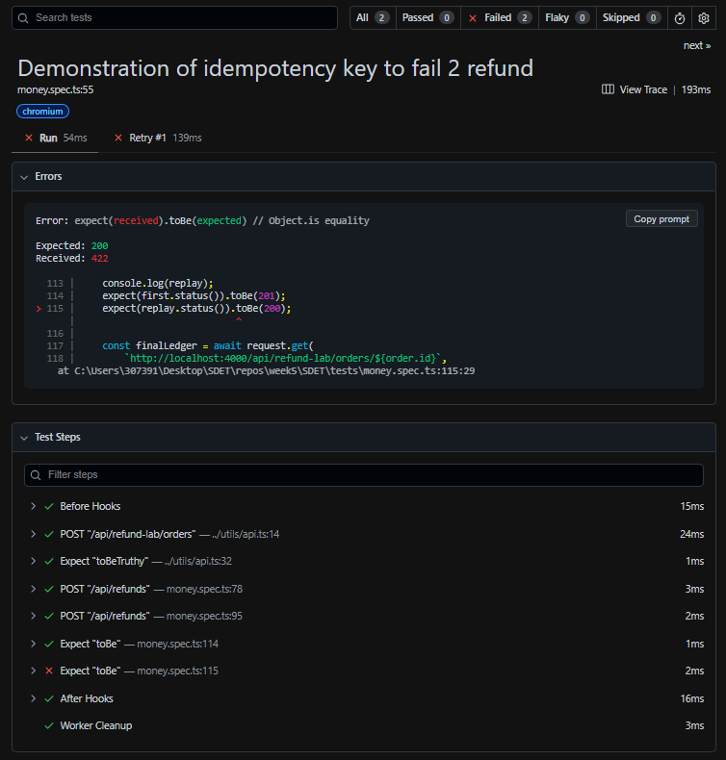
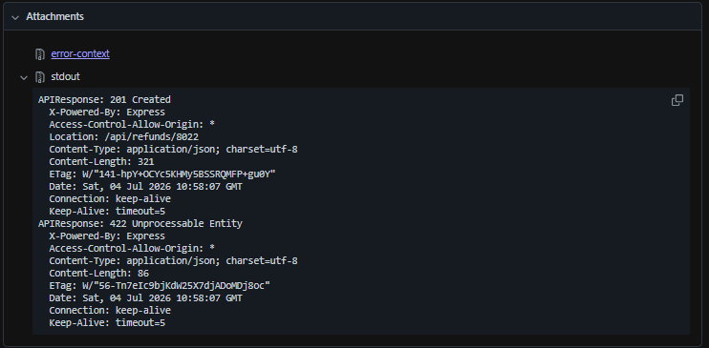
Issue: Without idempotency key the request cannot be fulfilled.
Fix: add the same idempotency key to the header
After FIX:
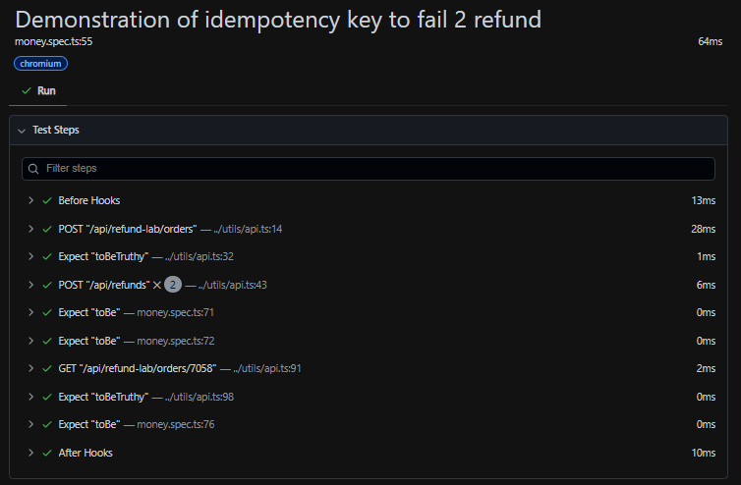
Scenario 4: Valid refund, Partial Refund, Over refund handled properly.
Added the evidence, log to success test also.
