Selenium Cucumber Assessment Report
1. Objective
To automate the end-to-end shopping flow using Selenium WebDriver, Cucumber, Page Object Model (POM), Allure Reporting, and Extent Reporting.

2. User Story
As a shopper, I want to search the catalog, add a product to my cart, and complete checkout so that I can buy products successfully.

3. Framework Design
Technologies Used
- Java
- Maven
- Selenium WebDriver
- Cucumber
- PicoContainer
- JUnit 5
- Allure Reports
- Extent Reports
Framework Structure
- BasePage
- LoginPage
- HomePage
- CatalogPage
- ProductPage
- CartPage
- CheckoutPage
Reusable Components
- Header
- CartBadge
- ProductCard
Hooks
- Browser initialization using @Before
- Screenshot capture on failure using @After
- Browser cleanup using @After

4. Scenarios Implemented
Smoke
- Buy a single product end-to-end
- Cart badge reflects number of items added
Regression
- Buy products using Scenario Outline
- Verify fresh cart is empty
Negative
- Login with invalid credentials
Failure Demonstration
- Intentional failing scenario for screenshot capture verification

5. Execution Evidence
Command
mvn test

Output: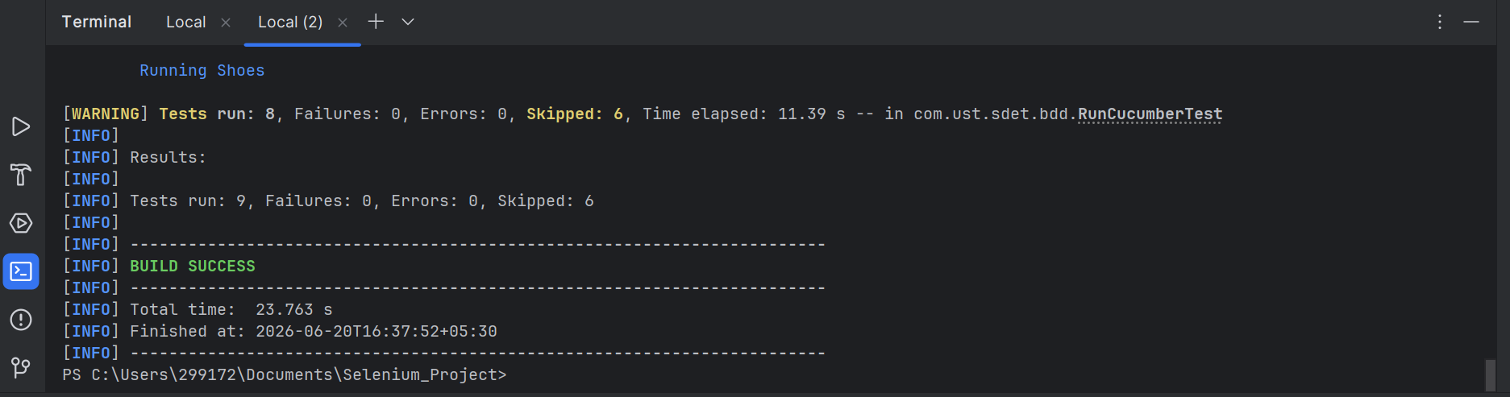
What It Proves
Framework executed successfully and scenarios were triggered through Cucumber.

6. Headless Execution
Command
mvn test -Dheadless=true
Output
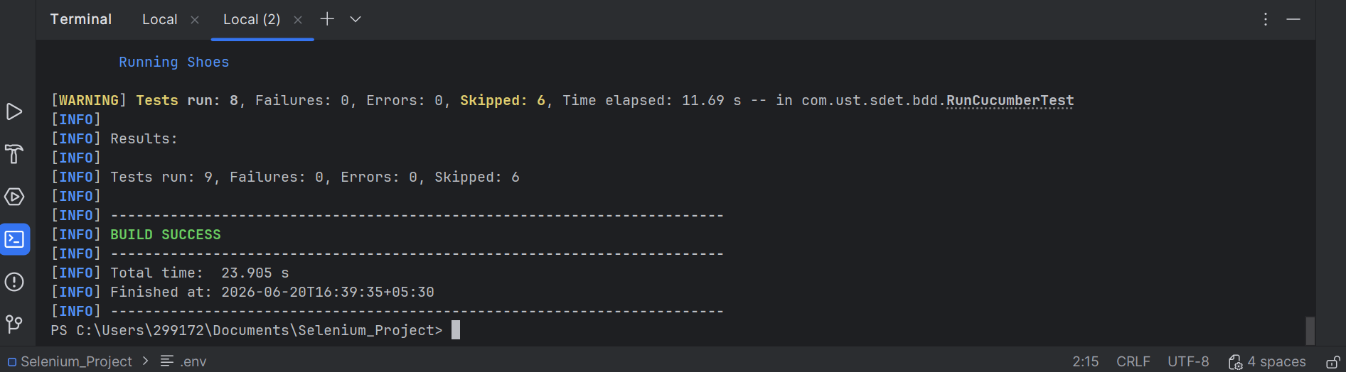
What It Proves
Framework executes successfully without launching the browser UI.

7. Allure Report
Command
allure generate allure-results --clean -o allure-report
What It Proves
Allure report was generated successfully.

8. Extent Report
Command
mvn test
Output
Extent Spark report generated.
Proof
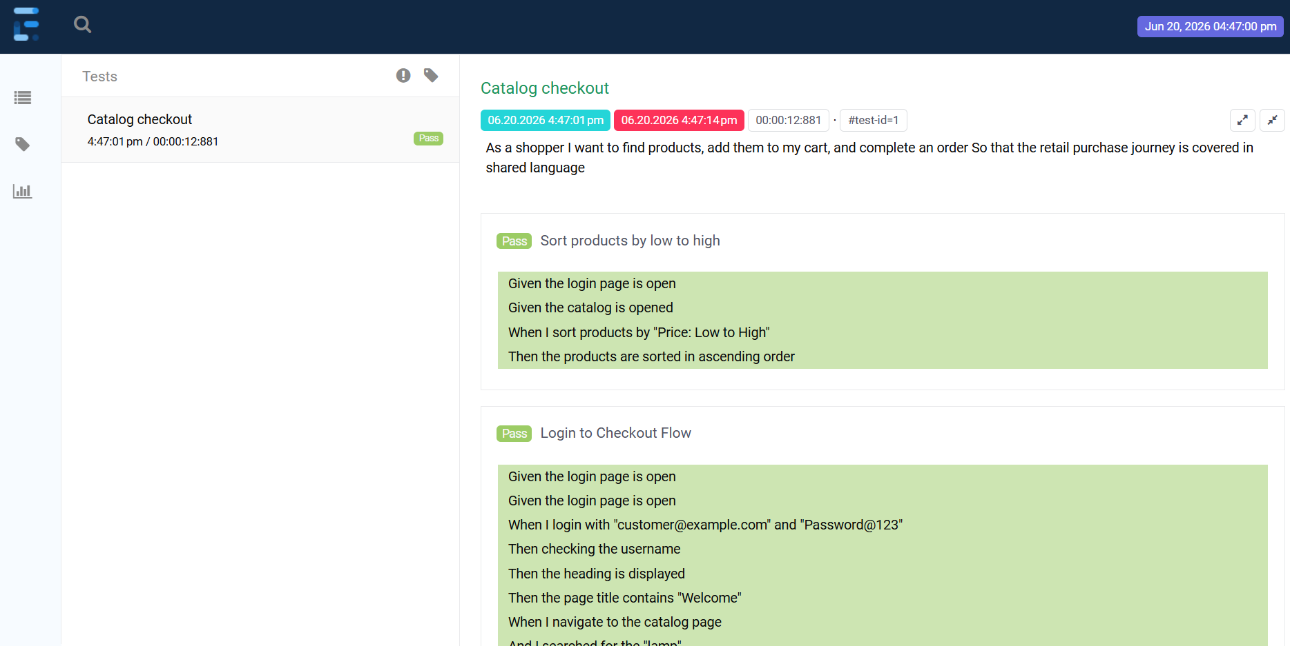
What It Proves
Extent report was generated successfully.

9. Screenshot Capture Verification
Scenario
Intentional failing scenario (changing the selector for the catalog page)

Proof
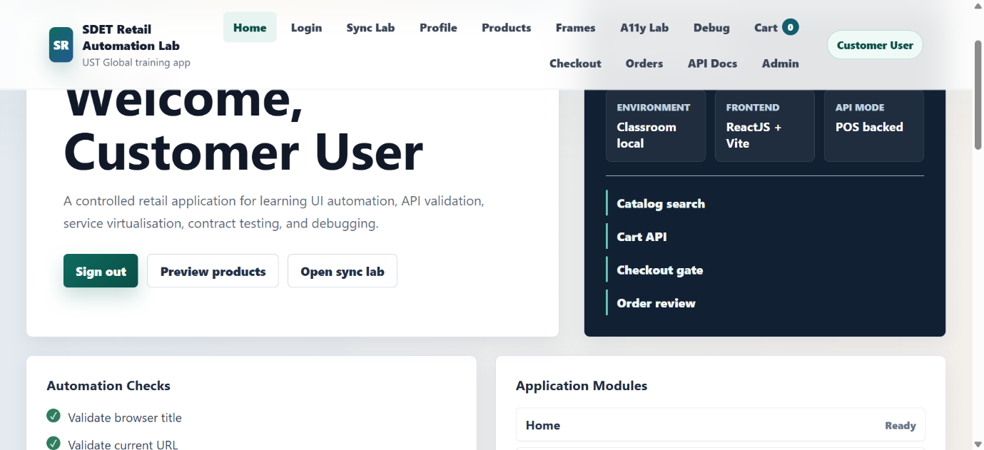
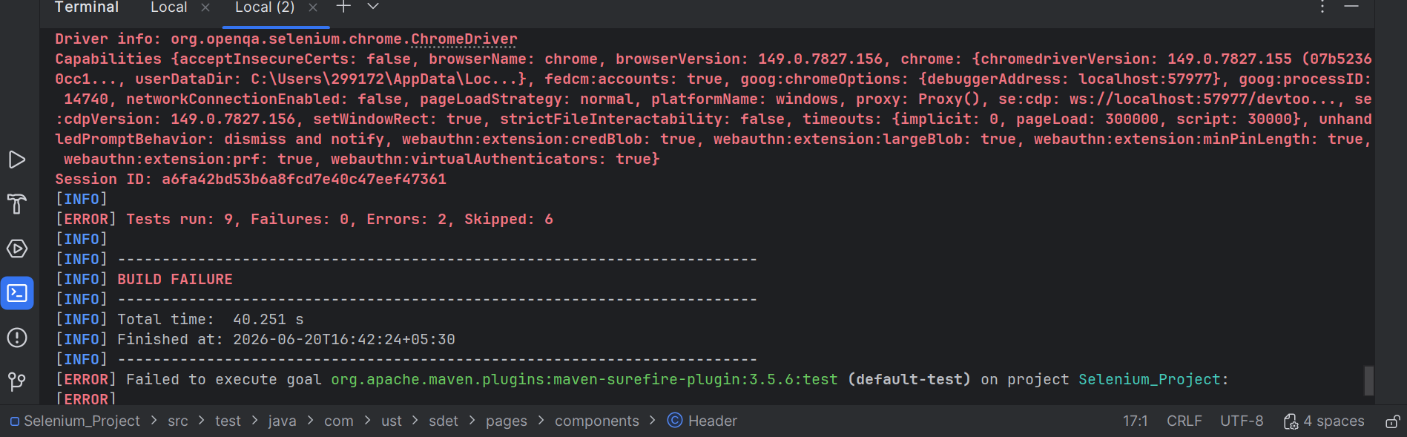
What It Proves
Screenshot is automatically captured and attached when a scenario fails.

10. Business Data Attachment
Attached Data
Selected Product Name
Example:
Product: Headphones
What It Proves
Business data is captured and attached to reports.

11. Environment Information
Allure Environment
Environment details such as Browser, Base URL, Java Version, and Operating System can be configured through environment.properties.
Extent System Information
Execution details such as Browser, Framework, Java Version, and Operating System can be configured through Extent System Information.
What It Proves
The framework supports capturing and displaying execution environment details in both reporting tools.

12. Test Results Summary
Type | Count
Passed | 09
Failed | 00
Skipped | 06
Total | 15
Verification
The execution count matches:
- Terminal output
- Allure report
- Extent report
14. Cucumber Tag Execution
Execute All Scenarios
Command
mvn test

Expected Output
- Smoke scenarios executed
- Regression scenarios executed
- Negative scenarios executed
Proof

What It Proves
All scenarios are discovered and executed successfully.

Execute Smoke Scenarios Only
Command
mvn -Dtest=RunCucumberTest "-Dcucumber.filter.tags=@smoke" test
Expected Output
- Only smoke scenarios run
- Regression and negative scenarios are skipped
Proof
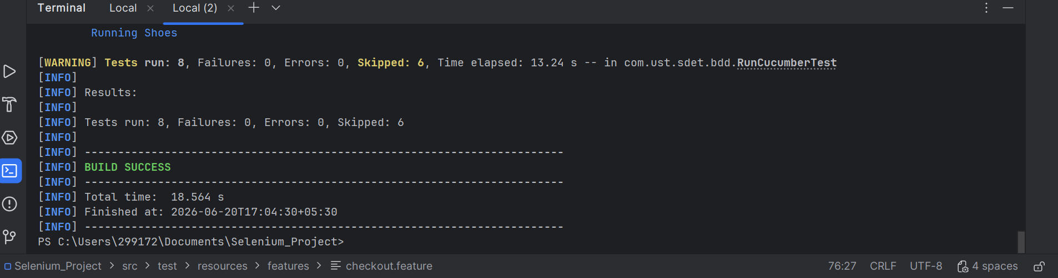
What It Proves
Cucumber tag filtering works correctly for smoke testing.

Execute Regression Scenarios Only
Command
mvn -Dtest=RunCucumberTest "-Dcucumber.filter.tags=@regression" test
Expected Output
- Only regression scenarios run
- Scenario Outline examples execute separately
Example:
Buy "headphones" end to end
Buy "shoes" end to end
Buy "lamp" end to end
Proof
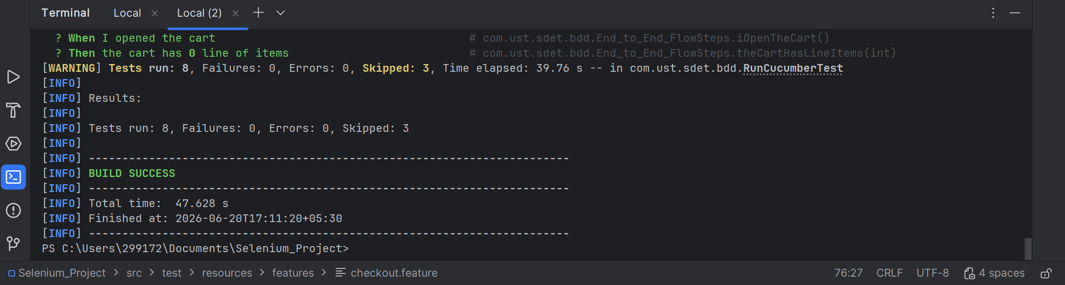
What It Proves
Regression suite can be executed independently.

Command
mvn test -Dcucumber.filter.tags="@smoke or @regression"
Expected Output
- Smoke scenarios execute
- Regression scenarios execute
- Negative scenarios are skipped
Example:
Smoke:
- Buy a single product end-to-end
- Cart badge reflects the number of items added
Regression:
- Buy "headphones" end to end
- Buy "shoes" end to end
- Buy "lamp" end to end
- Fresh cart is empty
Proof
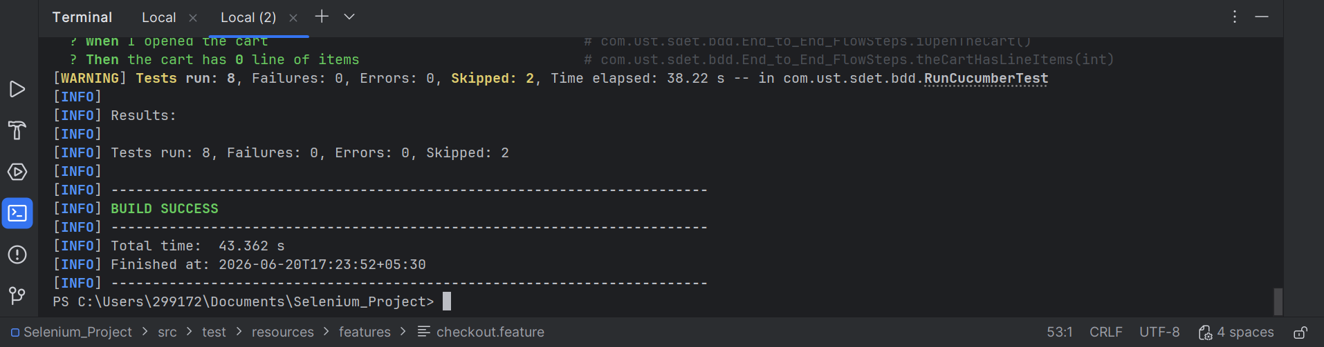
What It Proves
Smoke and Regression suites can be executed together while excluding Negative scenarios.

Execute Negative Scenarios Only
Command
mvn test -Dcucumber.filter.tags="@negative"
Expected Output
- Invalid login scenario executes
- Intentional failure scenario fails
Example:
Passed: Login with invalid credentials
Failed: Demonstrate screenshot capture on failure

Proof
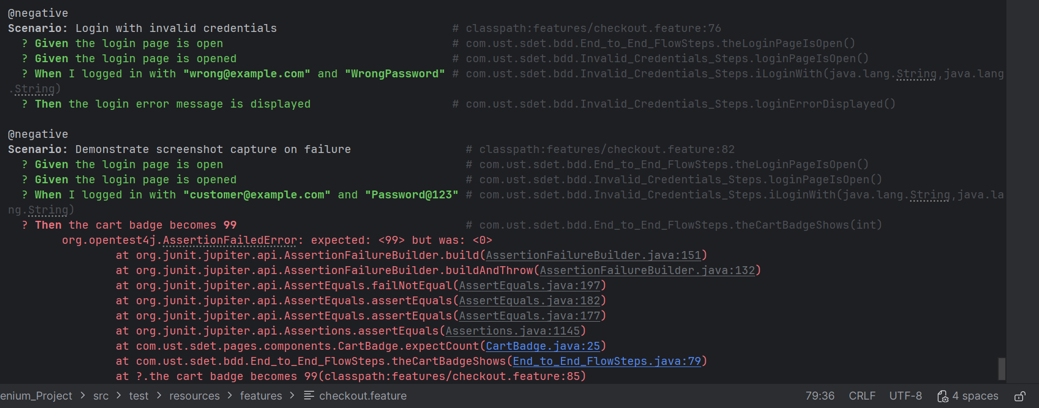
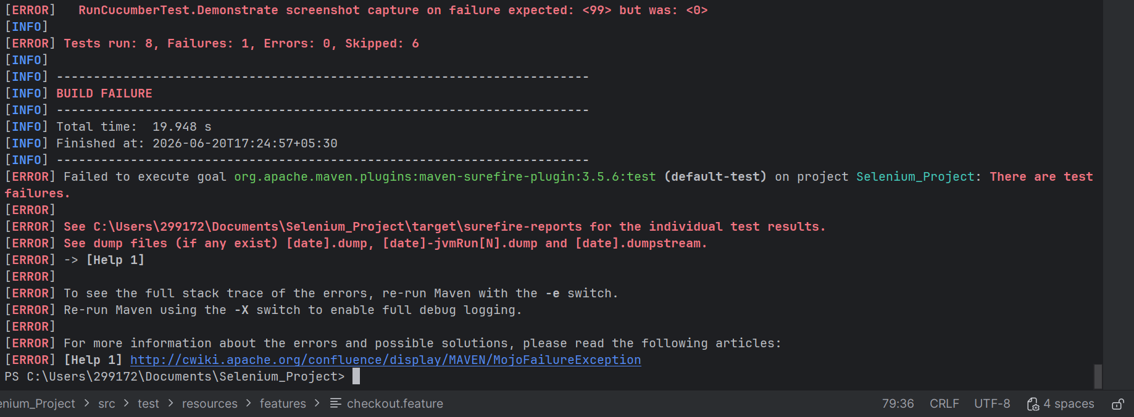
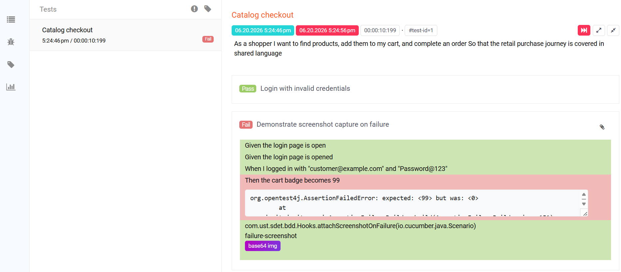
What It Proves
The framework correctly handles failures and automatically captures screenshots when a scenario fails.

Conclusion
The Selenium-Cucumber automation framework was successfully implemented using the Page Object Model (POM) design pattern. Smoke, Regression, and Negative scenarios were executed using Cucumber tag filtering.
The framework supports:
- End-to-end test execution
- Headless execution
- Allure and Extent reporting
- Screenshot capture on failure
- Environment configuration
- Reusable Page Objects and Components
An intentionally failing negative scenario was executed to verify automatic screenshot capture and attachment in both Allure and Extent reports.
The execution results and reports confirm that the framework is functioning as expected.

