Playwright UI Automation Test Report
Project Name:
Participant: Shahbaz Ahmad
Date: 24-06-2026
Branch:
Assessment: Playwright UI Automation

Question NO 2

Objective
The objective of this automation project is to validate the core functionality of the application using Playwright.
The automated test suite verifies critical user workflows and ensures that the application behaves as expected across supported browsers. The framework is designed to provide reliable, maintainable, and scalable UI automation.

Github Link
My Branch name is Shahbaz_QA_gate1 and link is
ust-sdet-training/SDET at shahbaz-QA-gate1

User Story
As a user, I want to perform the application workflow successfully so that I can complete my task without errors and receive the expected results from the system.

Environment Setup
- Tools: Node.js, Playwright Test Runner, TypeScript/JavaScript, VS Code
Install Commands:
- npm init playwright@latest
- npx playwright install
- Reporting Tools: HTML Reporter, Allure

Framework Architecture
The framework is built using:
- Page Object Model (for UI abstraction)
- Fixtures (for reusable setup like login, credentials)
- Test files (business scenarios)
- Config file (playwright.config.ts)

Workflow
1. Start test execution
2. Load fixtures (credentials, page, browser)
3. Navigate using page.goto()
4. Use Page Object methods
5. Execute assertions
6. Generate report

Folder Structure
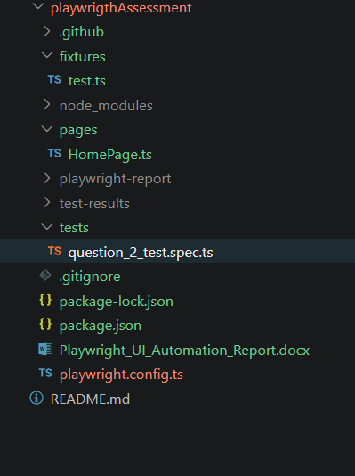

Page Object Model
Each UI page is represented as a class containing locators and methods. This improves maintainability and avoids duplication.
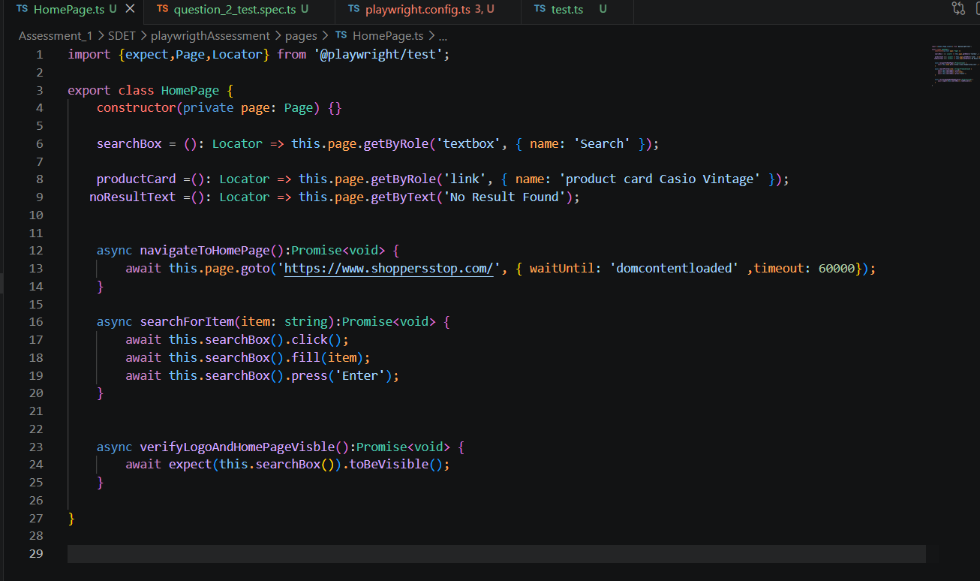

Fixtures Usage
Fixtures are used to provide reusable resources like page, browser, login session, and credentials. All user credentials are stored in fixtures for centralized management.
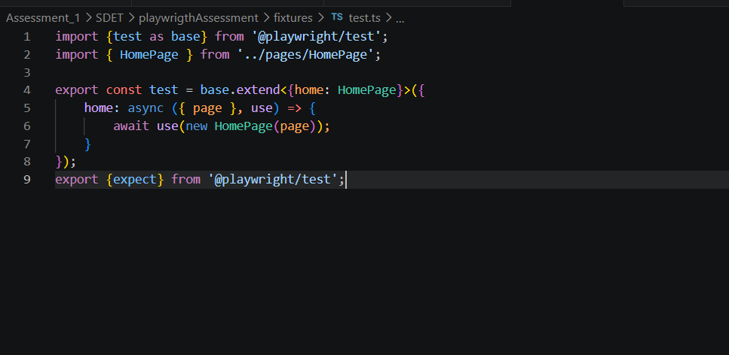

Code – Home Page with Search for happy and negative
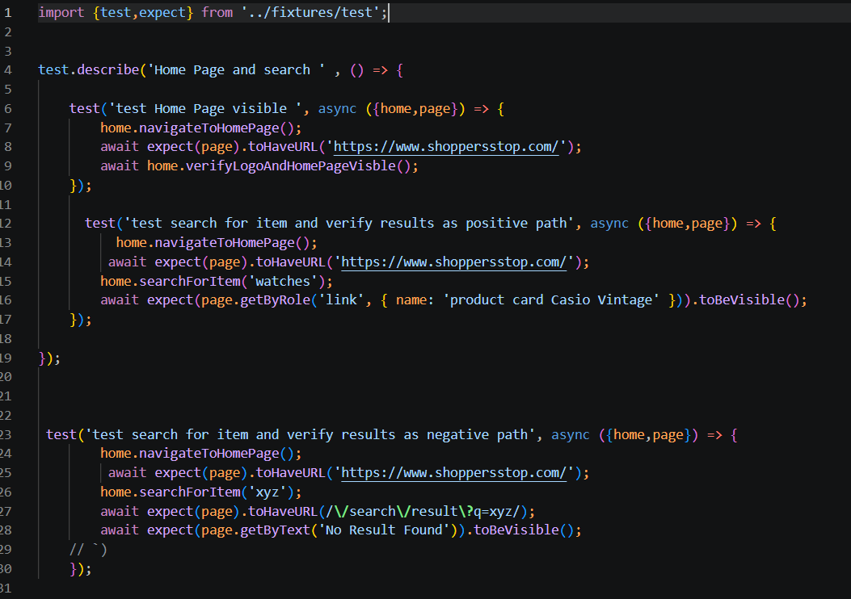

Test Case ID | Description | Status
TC_001 | Verify Home Page | Passed
TC_002 | Verify Valid Product Search | Passed
TC_003 | Verify Search Result Visibility | Passed
Negative Scenarios
Test Case ID | Description | Status
TC_004 | Verify Invalid Product Search | Passed
TC_005 | Verify Empty Search Validation | Passed

Commands
- npx playwright test
- npx playwright show-report

Result Evidence
Attach screenshots, videos, and trace files generated during execution.
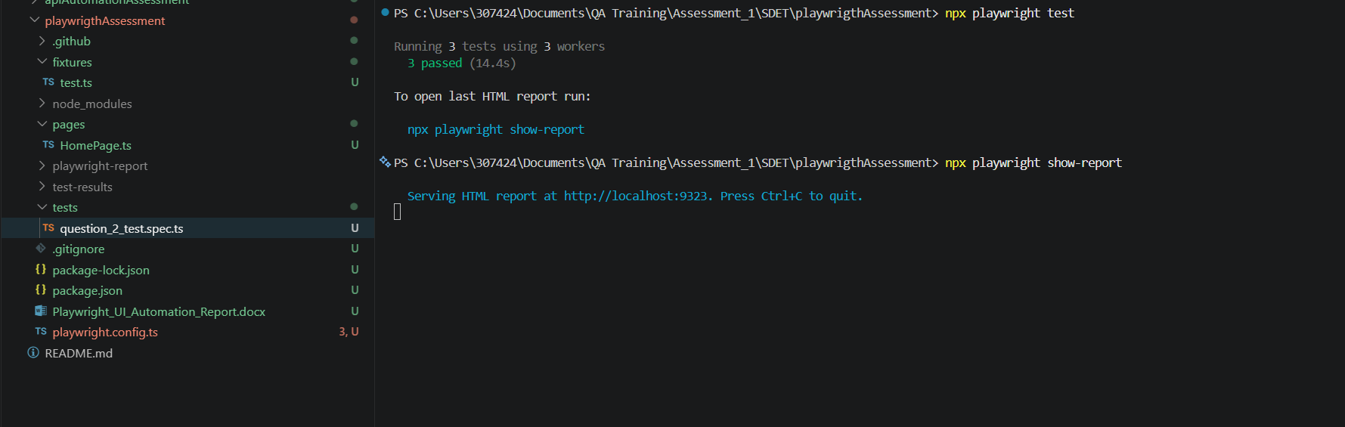

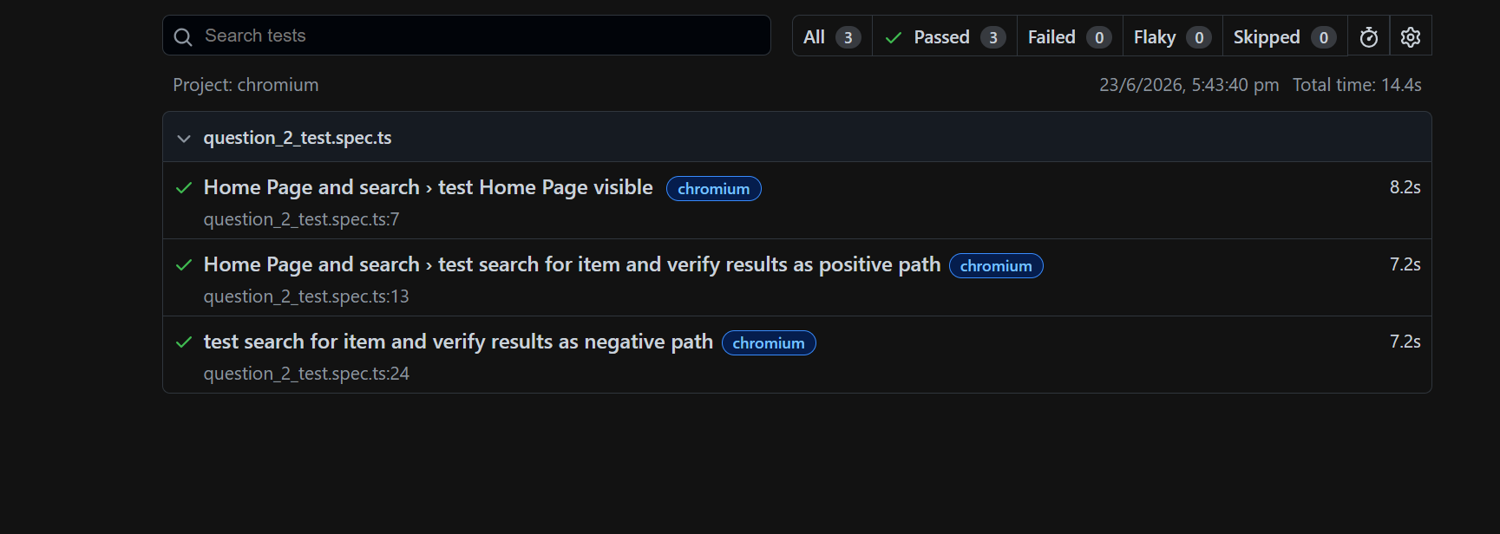
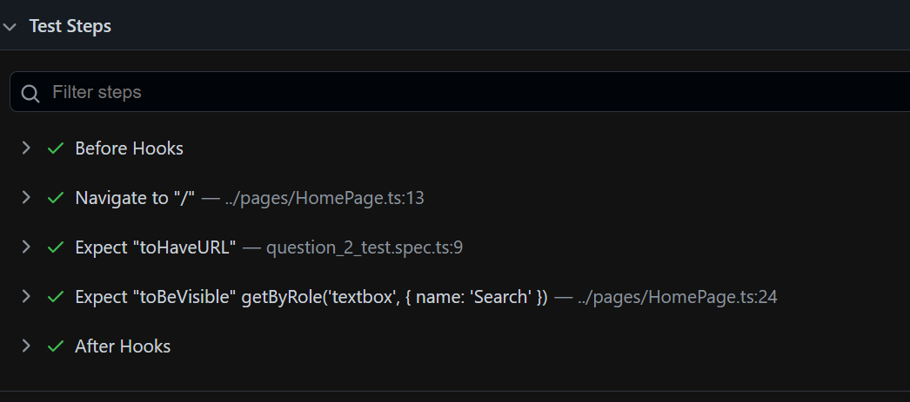

How to Solve Issues
Check locators,
wait strategies,
fixture setup,
test data, and
network conditions.

Limitations
Dependent on UI stability, network speed, and environment configuration.

Conclusion
Playwright framework ensures scalable, maintainable, and fast UI automation using modern testing practices.

