WEEK 5 GATE 5 REPORT
Project Name - Stabilisation

A simple overview of the project and the test cases in it.

Project Overview:

This project is a Playwright-based test automation setup. It is used to test a POS and a refunds workflow. The main goal is to check that the application behaves correctly in normal, offline modes.

Project Structure

- tests/ - Contains the main Playwright test files.

- fixtures/ - Holds shared test fixtures

- utils/ - Contains helper code such as the logger.

- playwright.config.ts - Main Playwright configuration file.

- package.json - Project dependencies and scripts.

Test Cases

Refund Flow Tests

These tests check that refund requests are handled correctly. They cover full refunds, partial refunds, invalid refunds, and repeated refund requests using the same idempotency key.
Screenshots:
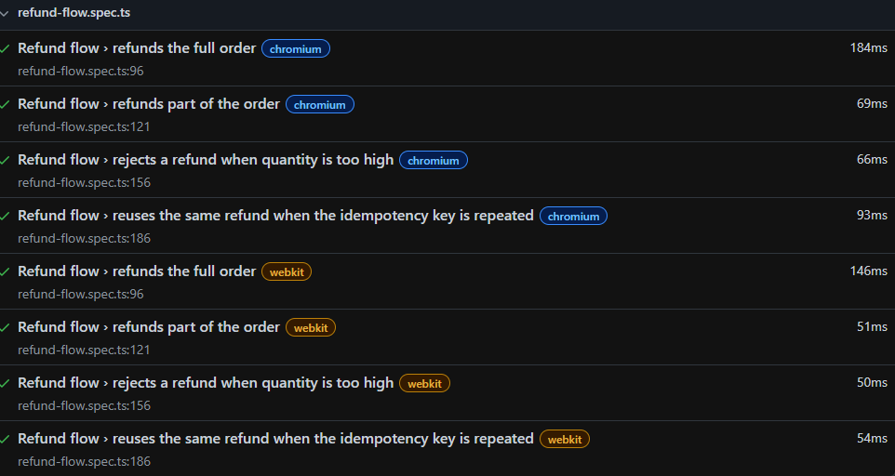

Attached logs Screenshot:
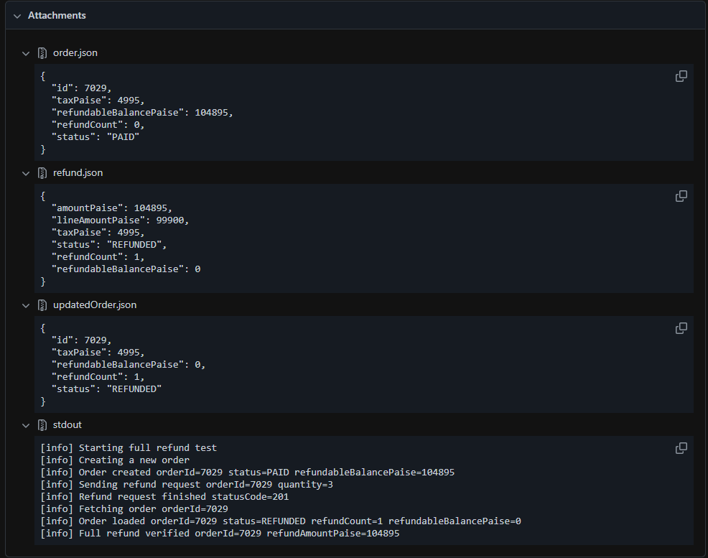

Offline Flow Test

This test checks that the application can handle offline mode. It verifies that sales are queued while offline and then synced when the connection is restored.
Screenshots:


Flaky Login Tests

These tests look at a login flow that can be unstable. One version shows the flaky behavior, while the other version checks the button state before clicking to make the flow more reliable.

flaky login test – This is flaky it tries to click the Sign In button immediately after filling the form, with an small timeout of 100 ms. Depending on how quickly the page finished enabling the button, the test would sometimes pass and sometimes fail.

Before fix –
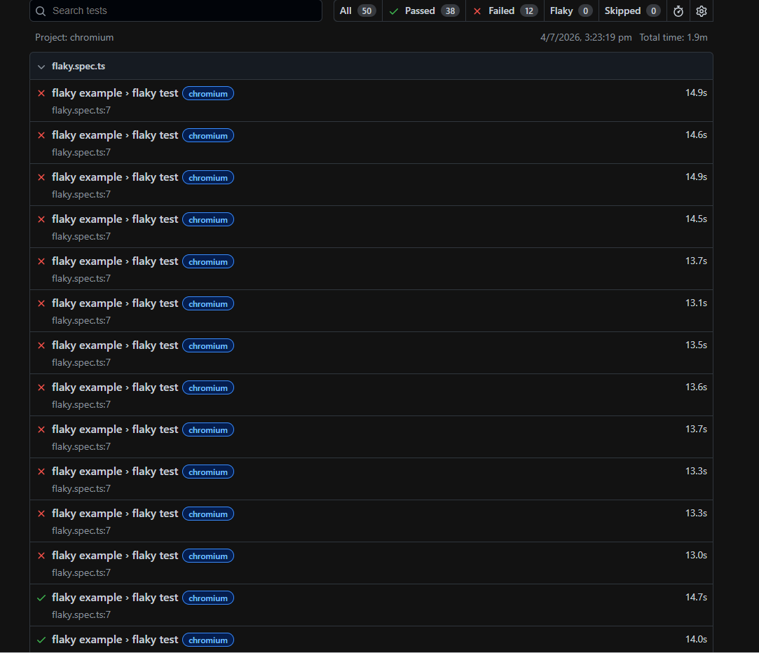
Ran 50 times – Passed 38 , Failed 12.
Since the test failed it stored screenshots, videos and trace.
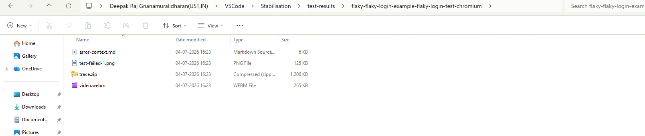

trace.zip:
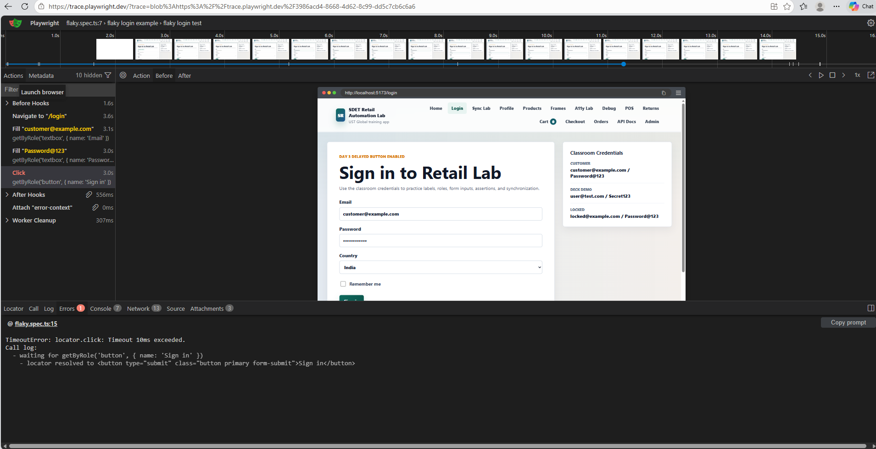

After fix:
Flaky login test - fix - I fixed it by adding a Playwright web-first assertion, await expect(button).toBeEnabled(), which automatically waits until the button becomes interactable before clicking it. This removes the timing race and makes the test less flaky.
ALL 50 TIMES THE TEST CASE PASSED AFTER FIX
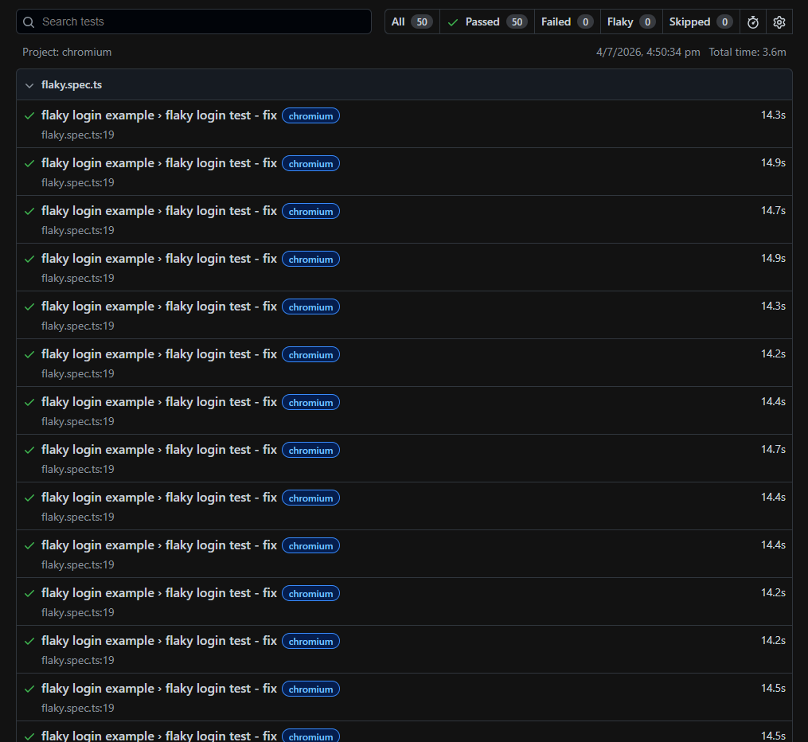

Float Math Tests:
This test shows why floating-point numbers should not be used for financial calculations. In the first test, multiplying decimal values can produce precision errors because JavaScript stores decimals in binary. In the second test, I use integer paise instead of rupees. Integer arithmetic is exact, so calculations like totals and taxes remain accurate, which is the standard approach used in payment systems and banking applications.

Sync Webkit tests:
This file verifies that the POS application:
- Detects when it goes offline and informs the user.
- Rolls back optimistic UI changes if syncing a sale fails.
- Queues sales while offline, retries synchronization after reconnecting, and uses the same Idempotency Key so the sale is synchronized exactly once without creating duplicates.

Logging and Reporting

The project uses a simple logger to record important steps during tests. These logs help with debugging and make it easier to understand what happened during a failed run.

