SELENIUM-CUCUMBER ASSESSMENT REPORT

Feature: Catalog Checkout Test
@smoke
Scenario: Buy a product login to Checkout
As a user I opened a product called “headphones.”
After, I decided to add it to the cart.
As soon as the item was added, the Cart Badge immediately updated and displayed 1, indicating that one item was now in the cart.
I opened the cart then found one cart line, showing the added headphones.
After that I proceeded to place the order.
then a confirmation message appeared, letting that the order had been successfully placed.
@smoke
Scenario: Cart Badge display
As a user,I opened a product called “shoes.”
After that ,I decided to add it to the cart
As soon as the item was added, the Cart Badge immediately updated and displayed 1, indicating that one item was now in the cart.

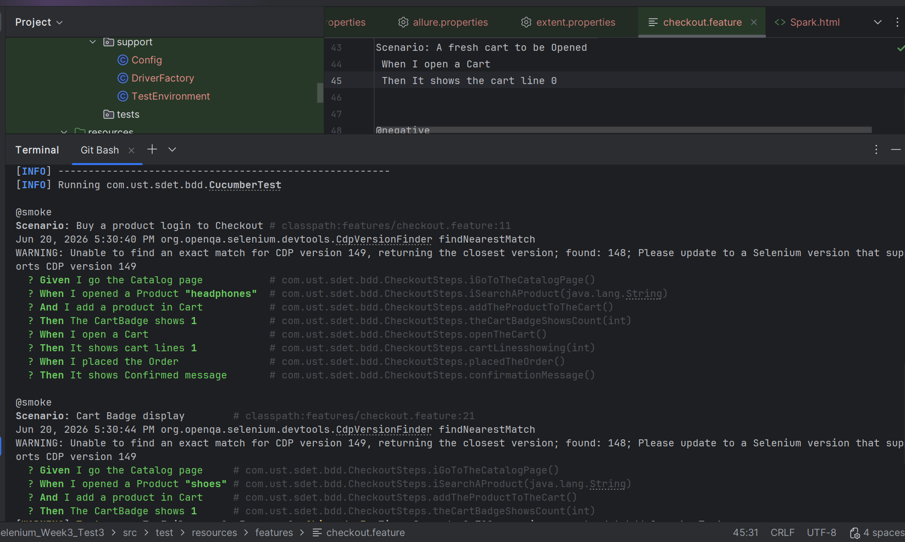

@regression
Scenario Outline: Buy a product "<product>"
As a user I opened a product
After, I decided to add it to the cart.
As soon as the item was added, the Cart Badge immediately updated and displayed count, indicating that one item was now in the cart.
I opened the cart then found the cart line, showing the added product.
After that I proceeded to place the order.
then a confirmation message appeared, letting that the order had been successfully placed.
Test Data:
|product| count|
|water | 1 |
|skin | 1 |
|shoes | 1 |

@regression
Scenario: A fresh cart to be Opened
As a User, I opened a Cart then I check the cart Line shows that It is empty

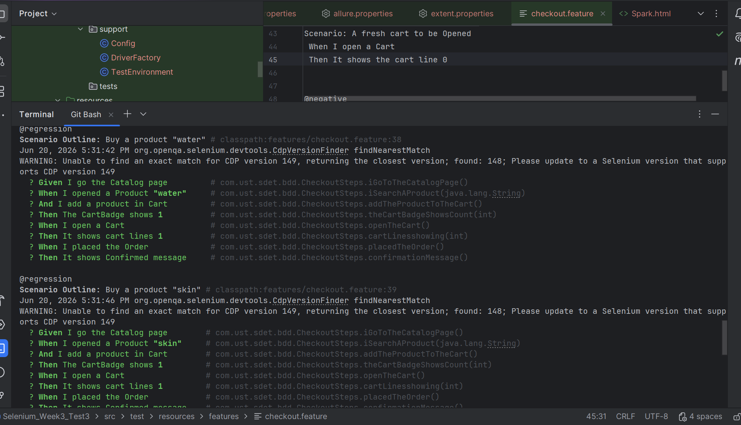

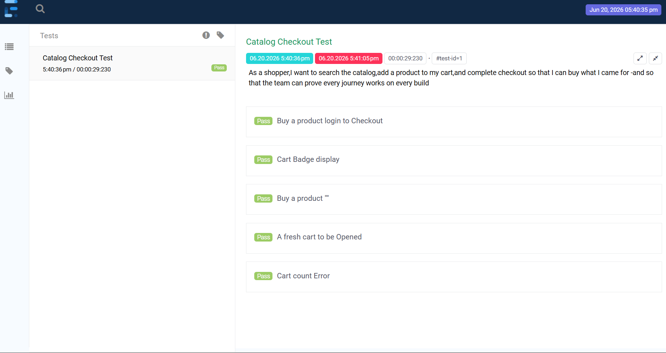
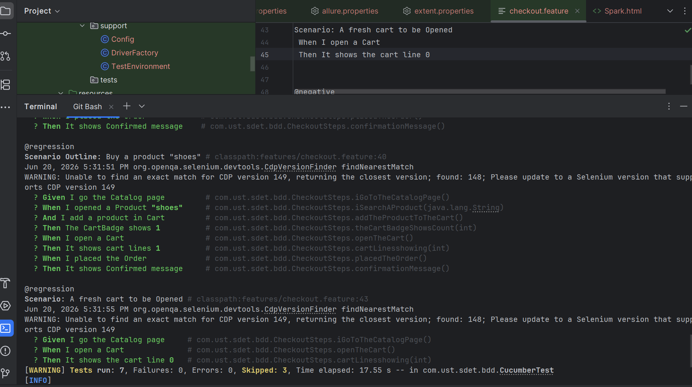

@negative
Scenario: Cart Count Error
As a user,I selected a product “headphones.”After,that I added that into the cart
As soon as I added that into the cart,it shows Cart Badge as 1 indicating that one item was Added.
After that I again go the Catalog Page and add another item to the Cart ,but in assertion I validates with 1 instead on 2.
So it leads to me in an Error,that I attached a Screenshot

After that I corrected the assertion validation as 2 It passes the execution.

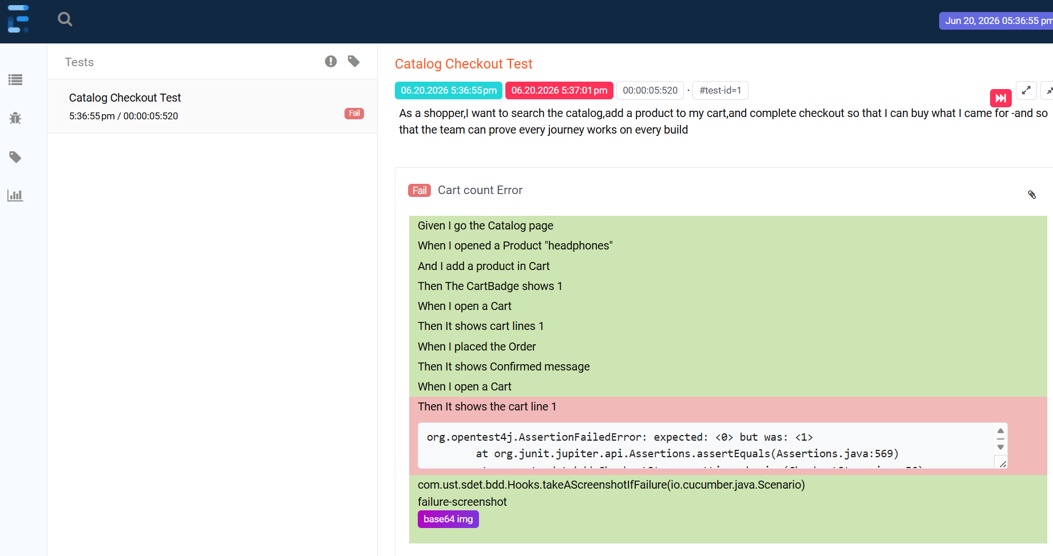
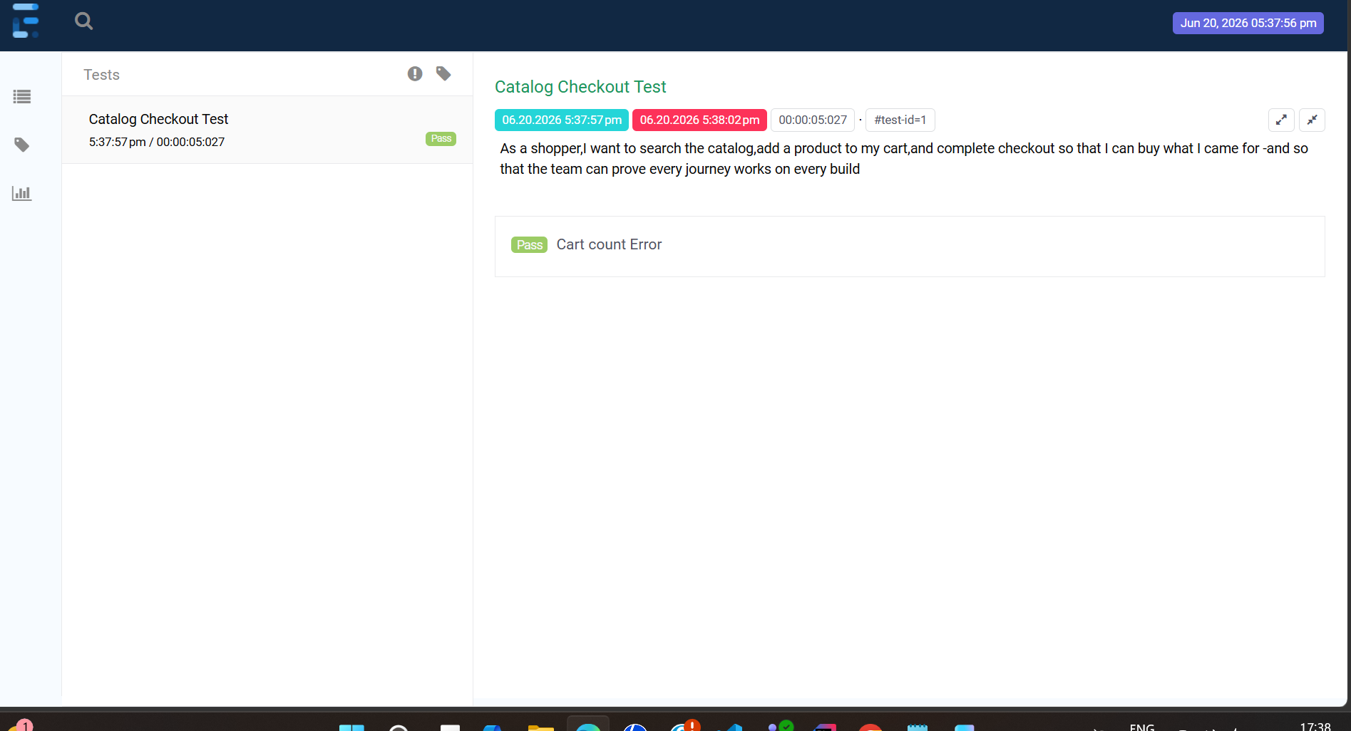
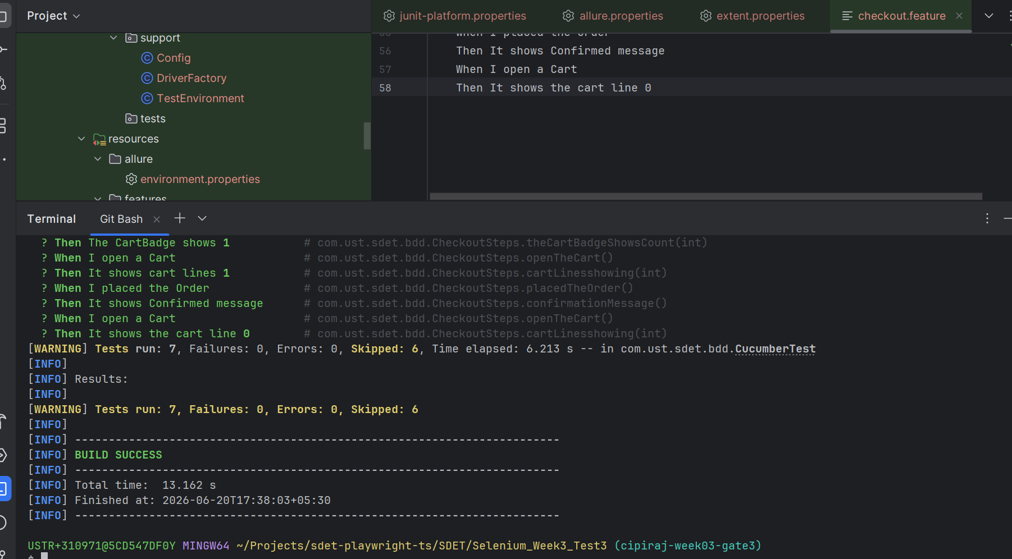

Business Logic data:
Here The products are get displayed before adding into the Cart
