REPORT
Feature: E2E flow from Catalog to Checkout
As a shopper, I want to find products, add them to my cart, and complete an order. So that the retail purchase journey is covered in shared language.

Scenarios:
- Buy a single producr end to end.
Steps:
- Open Catalog page.
- Search for "headphones".
- Add the first product to cart.
- Verify the cart badge count.
- Open cart.
- Verify that cart contains one item.
- Verify that price > 0.
- Place the order.
- Verify order confirmation.

Expected Result:
- Cart should contain one item.
- Valid price should displayed.
- Order is successfully placed.
Evidence: 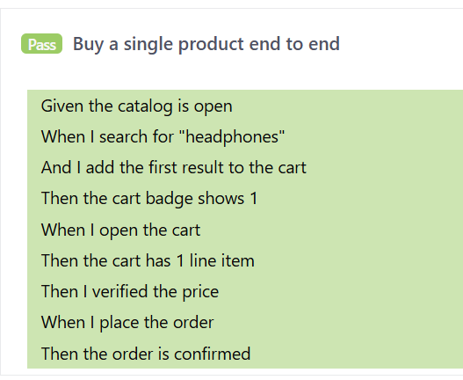
Scenario 2: Cart Badge Validation
Steps:
- Search for "shoes".
- Add the first result to cart.
- Verify that cart badge displays 1.
Expected Result:
- Cart badge reflects number of added items.
Evidence: 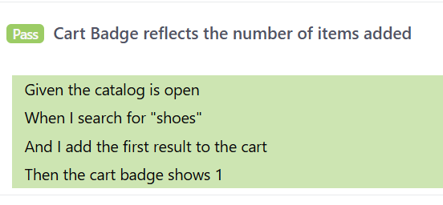

Scenario Outline: Buy Multiple Products in one go
Products Tested:
- Headphones
- Shoes
- Lamp
Steps:
- Search product.
- Add the first result to cart.
- Verify that cart badge count.
- Verify the cart line items.
- Place the order.
- Verify the order confirmation for each product.
Expected Result:
- Order successfully placed for each product.
Evidence: 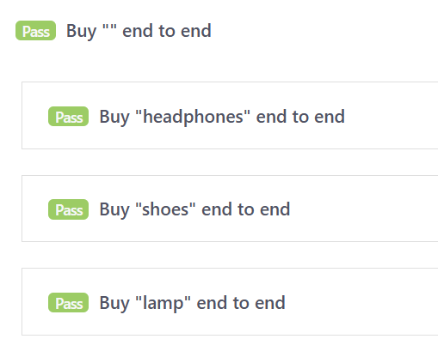

Scenario: Fresh Cart Validation
Steps:
- Open the cart.
- Verify that cart is empty.
Expected Result:
- Cart contains 0 line items.
Evidence: 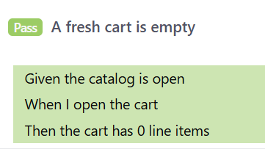

Negative Scenario
Scenario: Fresh Cart is Not Empty
Steps:
- Open the cart.
- Verify that cart contains items.
Expected Result:
- Test should fail because a new cart is expected to be empty.
Purpose:
- To check how it the report shows for negative cases.
Evidence:
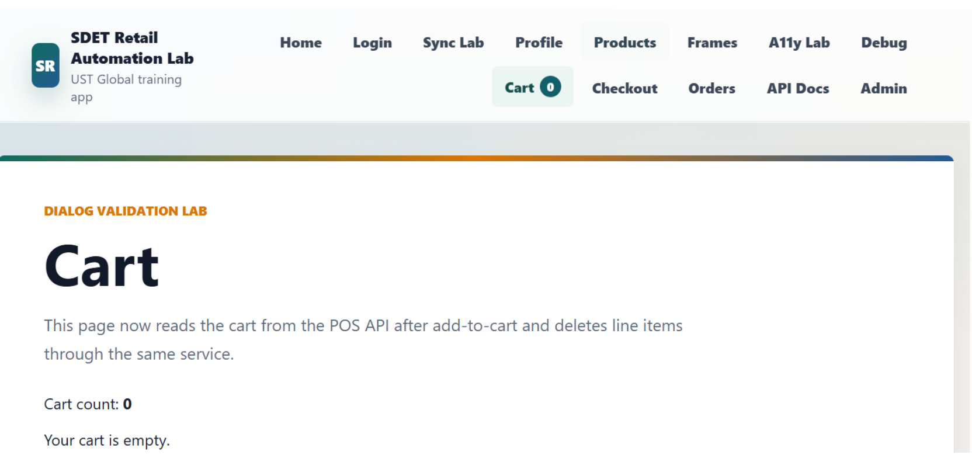

Allure commands are not running in my machine
Command: allure generate target/allure-reports --clean -o target/allure-report
Expected: It should generate a folder which contains test report with json files, screenshots, teststeps.

