Week 5 – Gate 5
PLAYWRIGHT ADVANCED

Assessment: Playwright Testing on a Realtime Web Application
URL: localhost:5173/catalog
Framework: Playwright Test Runner
IDE: Visual Studio Code
Execution Mode: Headed
Design Pattern: Page Object Model (POM)
Overall Status: All Tests Passed

Purpose of this Document
This document serves as a reference demo report that covers every point required by the assessment gate for Playwright testing on a Retail web application covering test scenarios, test results, including the artifacts

Scope covered
- Flakiness covered(Causes to Solution)
- Offline banner visibility check
- Offline queuing of products in the cart

Environment & Setup
Language: TypeScript
Test Framework: @playwright/test
IDE: Visual Studio Code
Package Manager: npm (node_modules)
Browser(s): Chromium (headed mode)
Wait Strategy: Explicit waits via Locator auto-waiting + waitFor()

playwright.config.ts settings

import { defineConfig, devices } from "@playwright/test";

import process from "node:process";

const CI = !!process.env.CI;

export default defineConfig({

testDir: "./tests",

timeout: 30_000,

fullyParallel: true,

retries: CI ? 2 : 0,

reporter: CI

? [["list"],["blob"], ["html", { open: "never" }],]: [ ["html"],],

use: {

baseURL: process.env.BASE_URL || "http://localhost:5173",

screenshot: CI ? "only-on-failure" : "off",

trace: CI ? "on-first-retry" : "off",

video: CI ? "retain-on-failure" : "off",

},

projects: [

{

name: "chromium",

use: {

...devices["Desktop Chrome"],

},

},

],

});

Project Structure
The project follows the decent structure which includes a separate fixatures folder for evidence collection and diagnostics (Artifacts, screen shots, videos)
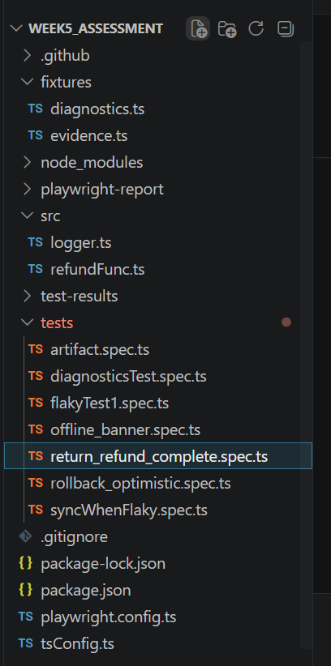

5. Test Cases

5.1 flakyTest
Contains two test scenarios which might causes flakiness
We need to run the flaky test for 50 times to detect the flakiness.
In this scenario, the user gets into the login page and fills the details, the test gets explicitly failed due to less timeout.
Test case 1: flakyTest1.spec.ts
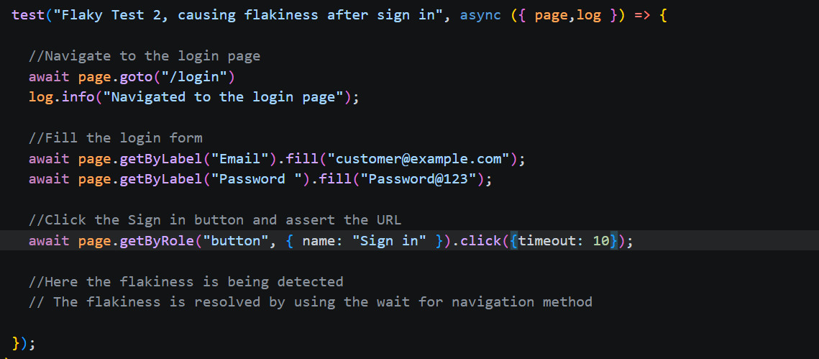

Artifact:
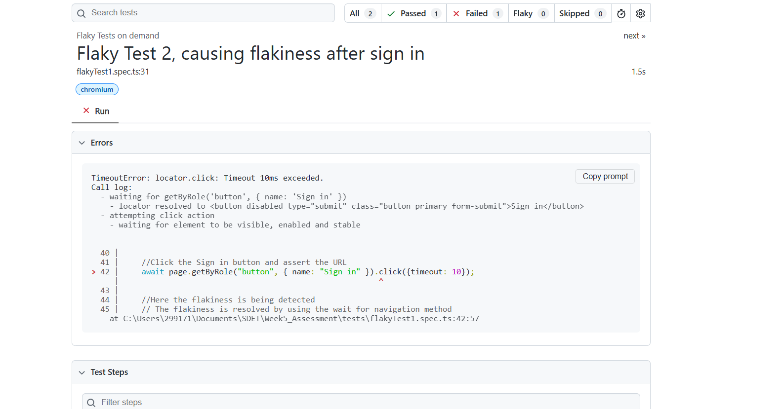

Solution: Increase the timeout from 10 to 10000 or more, or never to make the timeout in this scenario

After Fix:
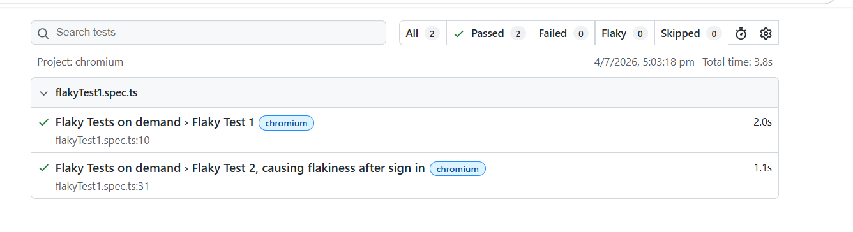
Test Result:
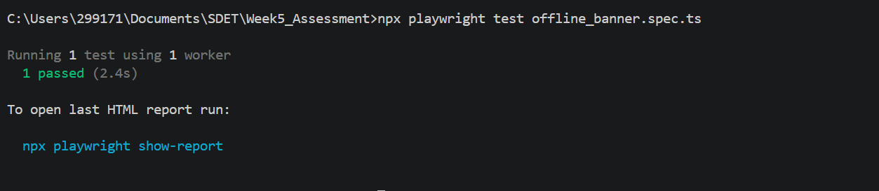

5.2 Offline Banner Validation
This scenario explains that when the user goes to the POS page, when the network is turned off or lost connection, the user can able to see the network banner as “Offline”, similarly when the network is online the user can able to see the “Online”
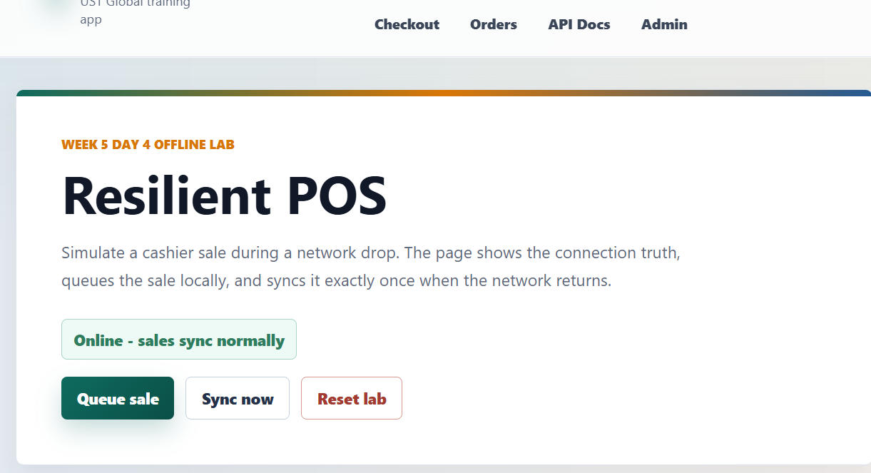


Artifact:
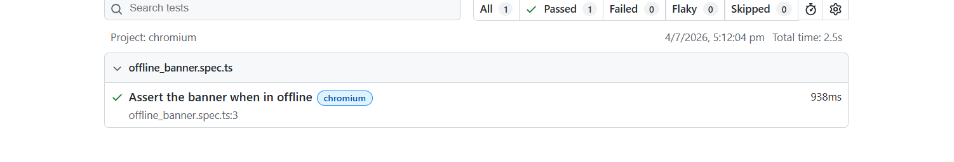
Test Result:

5.3 Return the refund (Prorating partial Refund, Full Refund, verifying over-refund, under refund and money leaks)

Here, create an order, raise a refund and assert the refund values,

Scenario1: Refund only the partial items.

Scenario 2: Make a full refund by creating an order, refunding it, and verifying the ledger and UI reflect the full refund.

Scenario 3: Create for individual refund scenarios (Over Refund, Approved)

Run multiple refund verdict scenarios for valid and over-refund cases

Scenario 4: Verify that invalid refund attempts are rejected and idempotent retries do not leak money using idempotency key

Artifacts:

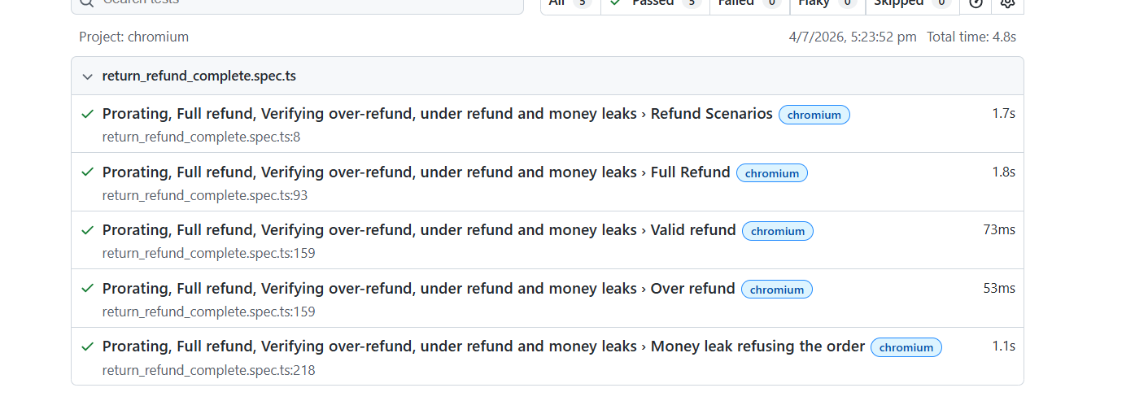

Attachment:
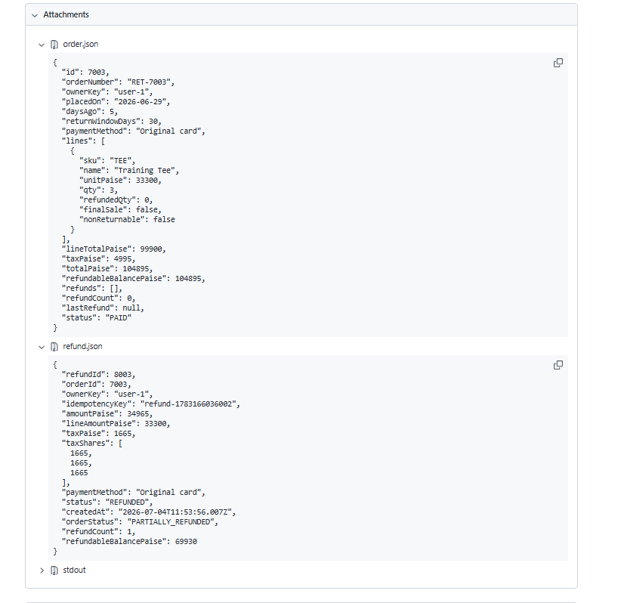
Attachment2:
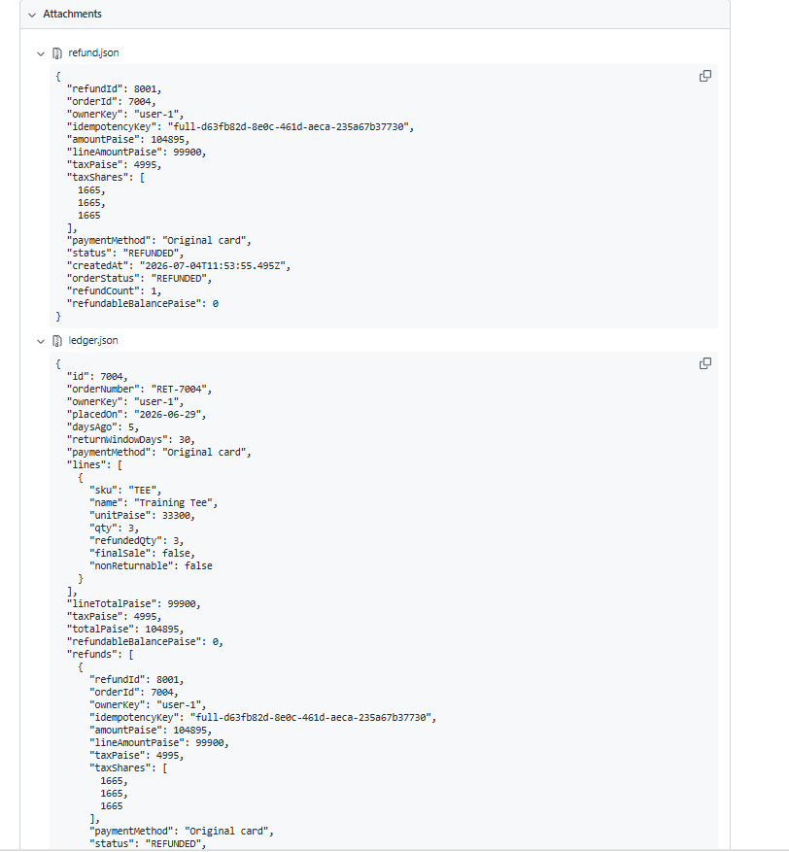

Attachment3:
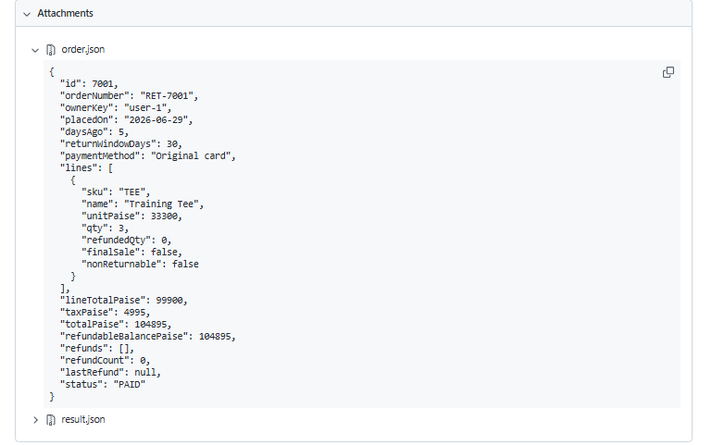

Attachment4:
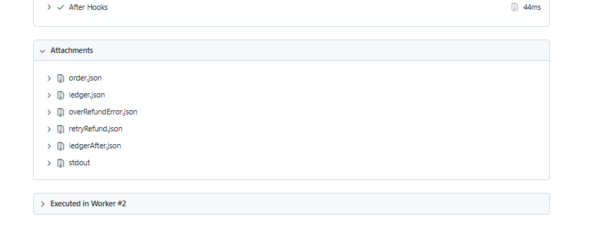
Test Result:
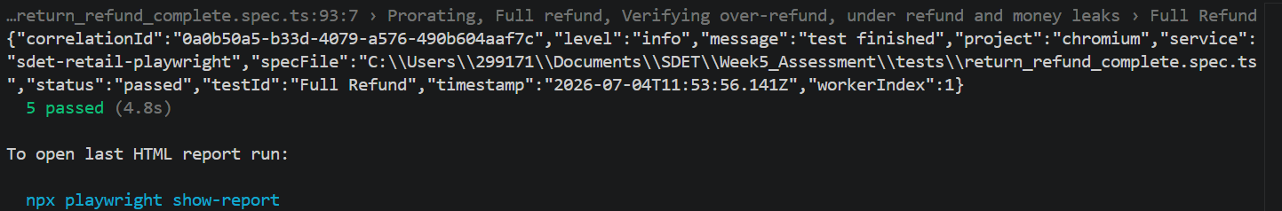

5.4 To ensure that queued sales are synced exactly once, even when the network connection is flaky and causes retries.

Verify that when the network is off the items are queued, when online again the items are synced

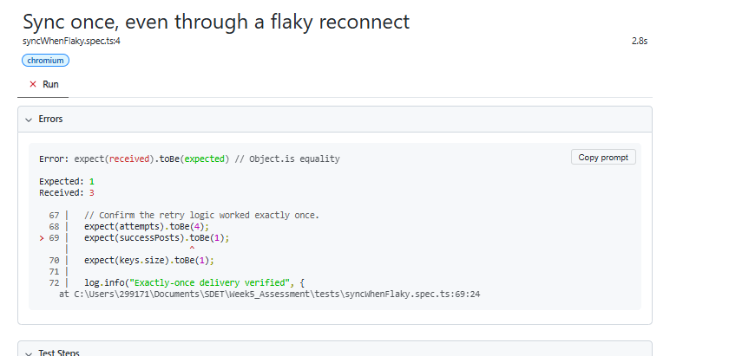

Attachments:
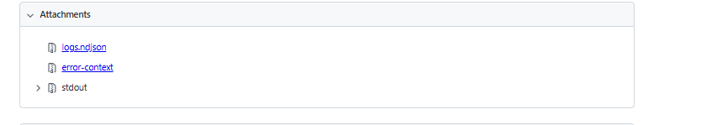

How to Run a test

Step 1 — Install Playwright
npm init playwright@latest

Step 2 — Install project/node packages
npm install

Step 3 — Run all tests
npx playwright test

Step 4 — Run a specific spec file
npx playwright test network_offline.spec.ts

Step 5 — View the HTML report
npx playwright show-report

8. Test Results Summary

Overall Status: All tests passed in headed mode using Chromium, with explicit waits ensuring stable and flake-free execution
Used Logs, evidences to verify the steps involved along with video and screen shot traces,

9. Overall Summary
- Locators are written using resilient partial-class and attribute selectors since Retail application DOM uses dynamically generated CSS class names; these should be revisited if the site's markup changes.
- Explicit waits (waitFor, waitForLoadState) are used instead of hard-coded sleeps to keep the suite stable and fast.

