Playwright Automation Framework – Shoppers Stop Test Report
1. Project Title
UI Automation Testing Framework using Playwright – Search Functionality Validation
GitHub Repo: ust-sdet-training/SDET at ManiPrasad-QA-gate1
Branch: ManiPrasad-QA-gate1
2. Objective
The objective of this project is to design and implement a scalable UI automation framework using Playwright and TypeScript to validate search functionality for a web application.
Target Website:
Shoppers Stop End of Season Sale | Up to 50% Off Across Categories

3. User Story
User Story 1 – Valid product Search
Searching Watches

Acceptance Criteria:
- User goes to home page
- User enters Watches in search bar
- User clicks enter
- User is redirected to product page

User Story 2 – Non-existing product search
Searching Mobikes
Acceptance Criteria:
- User goes to home page
- User enters Watches in search bar
- User clicks enter
- User is redirected to product page shows “No result Found”

4. Environment & Setup
Software
Component | Version
Node.js | Latest LTS
Playwright | Latest
TypeScript | Latest
VS Code | Latest
Browser | Chromium

5. Framework Design
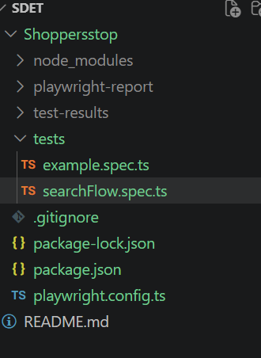
Test Layer
Responsible for:
- Test orchestration
- Assertions
File:
tests/searchFlow.spec.ts

6. Scenarios Covered
Scenario 1 – Valid Product search
Input:
Search for “Watches”
Expected:
- Watches visible in products page
Status:
PASS

Scenario 2 – Non-existing product search
Input:
Search for “Mobikes”
Expected:
- Page displayed with “No Result Found”
Status:
PASS

7. Execution Steps
Install dependencies:
npm install
Install browsers:
npx playwright install
Execute tests:
npx playwright test --headed
Open report:
npx playwright show-report

8. Test Results
Execution Summary:
Total Tests: 2
Passed: 1
Failed: 1
Execution Mode:
Chromium Browser
Execution Duration:
~21 seconds

9. Evidence
Execution Output:
Running 2 tests using 2 workers
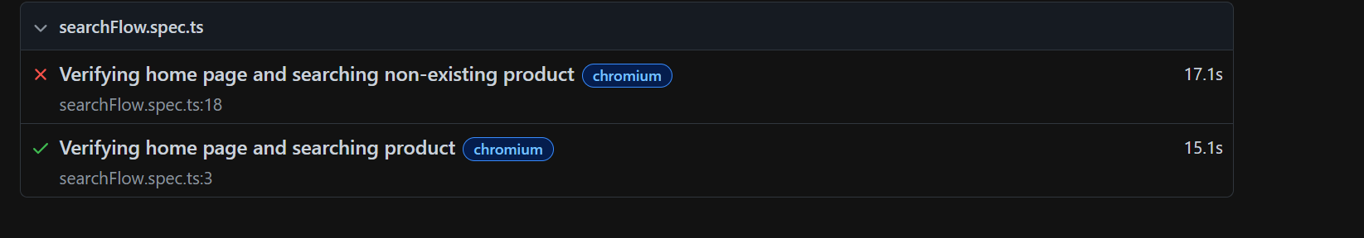
HTML Report Generated Successfully
Screenshots:
Stored under:
test-results/

12. Issues Encountered
Issue 1:
ERR_ABORTED – Frame Detached
Cause:
Asynchronous execution without await
Resolution:
Implemented await for flow methods

Issue 2:
Incorrect Locator Strategy
Cause:
Invalid role and label selection
Resolution:
Updated locator methods

13. Limitations
- Dependent on external website availability
- Execution affected by network speed
- Limited browser coverage
- Public site introduces flakiness

14. Conclusion
The Playwright automation framework was successfully implemented.

