PLAYWRIGHT WEEK5 DEMO REPORT

Purpose of this document: This document explains the project structure, framework components, test scenarios executed, logging and evidence collection mechanisms, and the results obtained from validating refund processing, offline synchronization, and stability-related scenarios.

Prepared By : V Ajay Krishnan

1.Objective

The objective of this project is to automate and validate important retail application workflows using Playwright.
The automation focuses on:
- Refund processing
- Refund validation checks
- Full refund and partial refund scenarios
- Over-refund prevention
- Idempotency validation
- Offline sale queue and synchronization
- Logging and evidence collection
- Flaky test scenarios

2.Environment & setup

Language Used: TypeScript
Framework : Playwright
Operating System : Windows
FrontEnd Url : http://localhost:5173
BackendEnd Url : http://localhost:4000

Configuration:
projects: [
{
name: "chromium",
use: { ...devices["Desktop Chrome"] }
}
]

baseURL: http://localhost:5173

Artifacts:
screenshot: "on"
trace: "on"
video: "on"

3.Framework design
The framework is built using reusable fixtures and API helper methods.
Fixtures
app.fixture.ts
Used for:
- Evidence collection
- Attaching JSON and text artifacts to reports
diagnostic-test.ts
Used for:
- Correlation ID generation
- Structured logging
- Log attachment generation

API Helpers
refund.api.ts
Contains reusable methods such as:
seedOrder()
refundOrder()
checkRefund()
getLedger()
openReturnsPage()
generateIdempotencyKey()

logger.ts
Used to:
- Generate structured logs
- Mask sensitive information
- Create log artifacts for debugging

4.Project structure

fixtures
- app.fixture.ts
- diagnostic-test.ts

src
- api
refund.api.ts
- logger.ts

tests
- artifactFlow.spec.ts
- flackyTest.spec.ts
Screenshots has been given below:
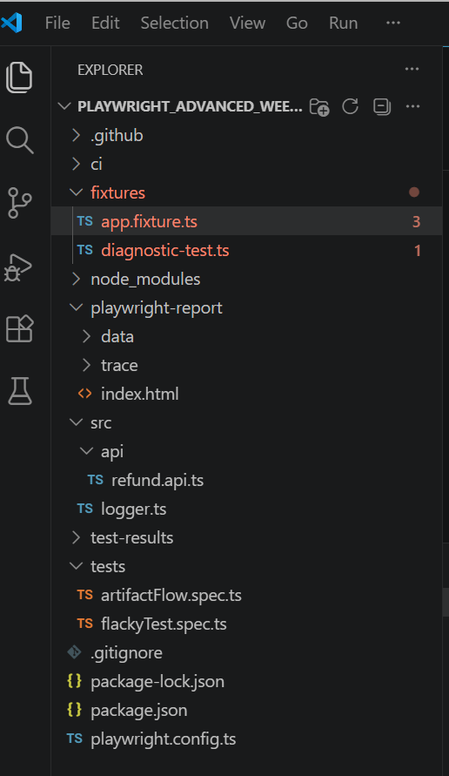

5. Different TetsCases:

Refund Flow Tests
1. Partial Refund
Validates:
- Order creation
- Partial refund for one item
- Refund calculation
- Tax calculation
- Ledger updates
- UI updates after refund

2. Full Refund
Validates:
- Complete refund of all items
- Refund amount calculation
- Ledger updates
- Refunded status
- Returns page updates

3. Valid Refund
Validates:
- Refund eligibility check
Expected Result: APPROVED

4. Over Refund
Validates:
- Refund quantity greater than purchased quantity
Expected Result: OVER_REFUND

5. Duplicate Refund Prevention
Validates:
- Same refund request submitted twice
- Same idempotency key used
- Duplicate refund is not created

6. Offline Queue Synchronization
Validates:
- Sales request while offline
- Queued request storage
- Network recovery handling
- Retry mechanism
- Idempotency check

7. Flacky Test
Validates:
- Navigation to POS page
- Visibility of the Queue Sale button
- Demonstration of an intentionally unstable test scenario
Expected Result:
Queue Sale button is visible when the test passes.
The test may fail randomly due to the intentional failure condition.

6.How to Run Commands
For artifactFlow.spec.ts:
npx playwright test artifactFlow.spec.ts : is used to run the test
npx playwright test artifactFlow.spec.ts :--headed : is used to get the headed result
npx playwright test artifactFlow.spec.ts : --headless: is used to get the headless result
npx playwright show-report: To get the test report

For flackyTest.spec.ts:
npx playwright test flackyTest.pec.ts : is used to run the test
npx playwright test flackyTest.pec.ts : --headed : is used to get the headed result
npx playwright test flackyTest.pec.ts : --headless: is used to get the headless result
npx playwright show-report: To get the test report

7.STEPS PERFORMED
Partial Refund
- Created a new order.
- Opened the Returns page.
- Submitted a partial refund.
- Verified refund amount and tax values.
- Verified ledger and UI updates.

Full Refund
- Created a new order.
- Submitted a full refund.
- Verified refund details.
- Verified ledger status and balance.
- Verified updated values on the Returns page.

Valid Refund
- Created a new order.
- Checked refund eligibility.
- Verified the result as “APPROVED”.

Over Refund
- Created a new order.
- Requested refund beyond purchased quantity.
- Verified the result as “OVER_REFUND”.

Duplicate Refund Prevention
- Created a new order.
- Submitted a refund request.
- Sent the same request again using the same idempotency key.
- Verified only one refund was recorded.

Offline Queue Synchronization
- Opened the POS page.
- Switched the application to offline mode.
- Queued a sale.
- Restored network connection.
- Verified the queued sale was synced successfully.
Flaky Test
- Opened the POS page.
- Executed an intentionally flaky scenario.
- Verified the Queue Sale button visibility.
- Observed random pass/fail behavior for demonstration purposes.

9.Result
Total Test Cases: 7
Passed: 7
Test Cases Executed:
- Partial Refund
- Full Refund
- Valid Refund
- Over Refund
- Duplicate Refund Prevention
- Offline Queue Synchronization
- Flaky Test

10.Issues Faced :

Issue I faced was I didn’t add header which made my testcase failed.
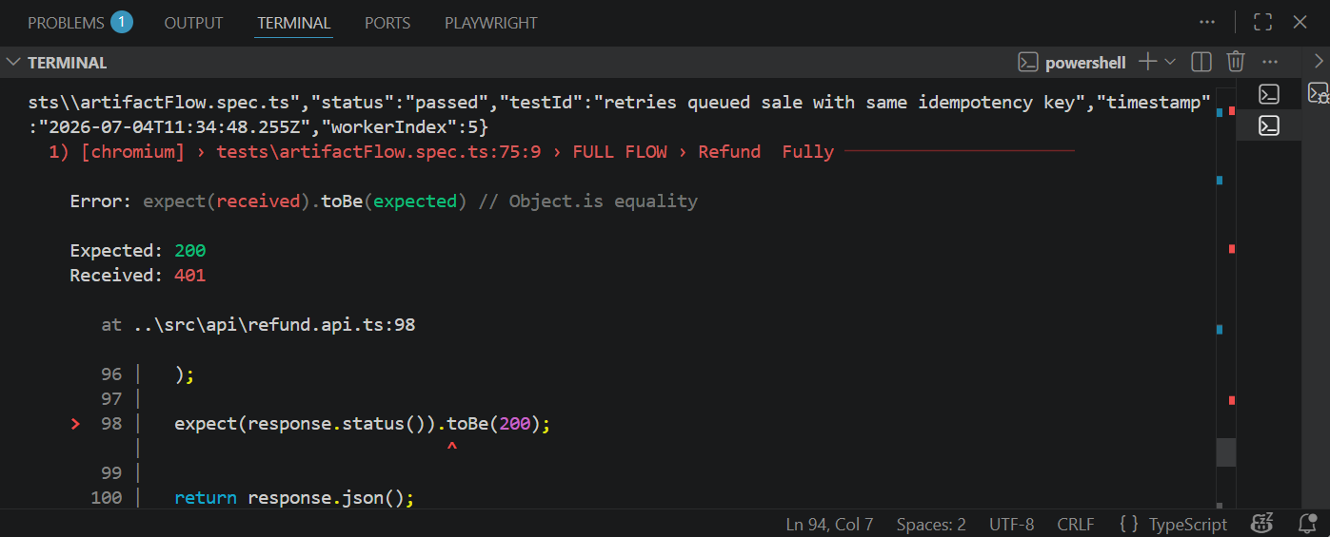
Here header was missing which made me fail the test.
Later I found out the mistake and fixed it by adding the header
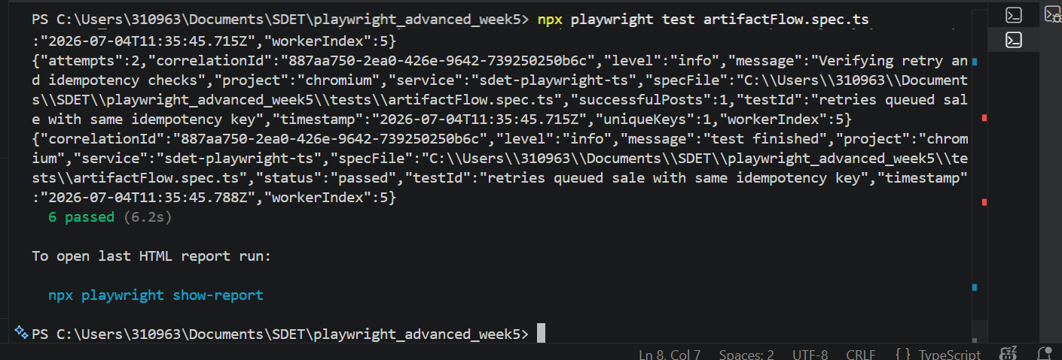
Here as u can see I fixed the code by adding header to the post and get.
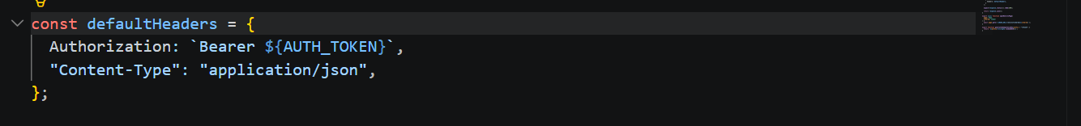

11.Flacky Test
In ran the test 50 times to check if there is any flacky is occurring or not .
COMMAND USED : npx playwright test flackyTest.spec.ts –repeat-each=50

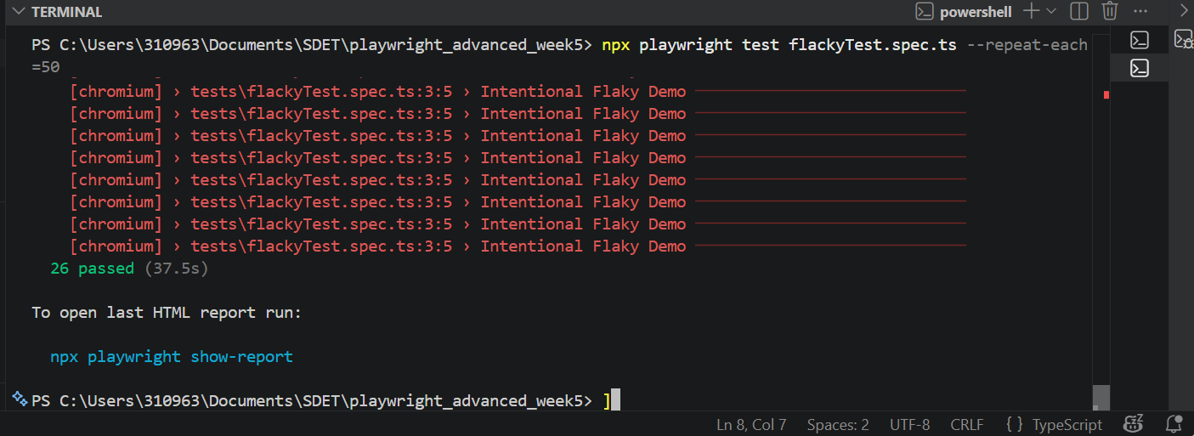
Here as u can see I ran the test 50 times and 26 passed and rest failed , showing flacky is occurring in the test I wrote.
12.Conclusion
The Playwright automation framework successfully covers key retail application scenarios including refund processing, refund validation, duplicate refund prevention, and offline synchronization behavior.
The framework uses reusable fixtures and helper methods to reduce code duplication while providing detailed logs and evidence artifacts.
The generated traces, videos, screenshots, and evidence files help simplify debugging and provide clear proof of test execution.

9.Evidence

Screenshots attached separately showing:
- Successful test execution

I ran the test 50 times to check if all the 50 times the test is passing or not and no flacky is occurring.
All the 50 times the tests are passing and the evidence is given below:

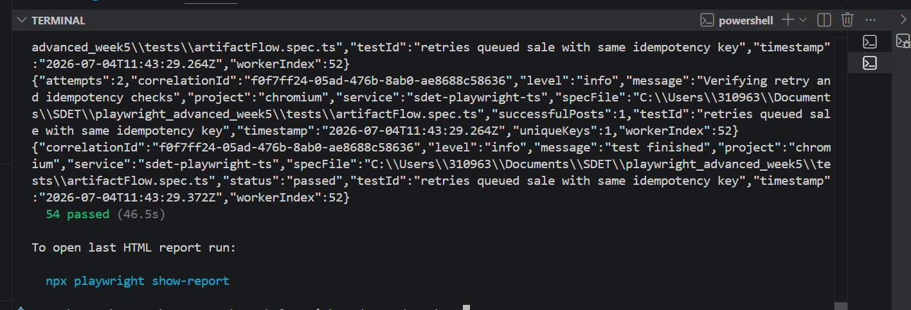

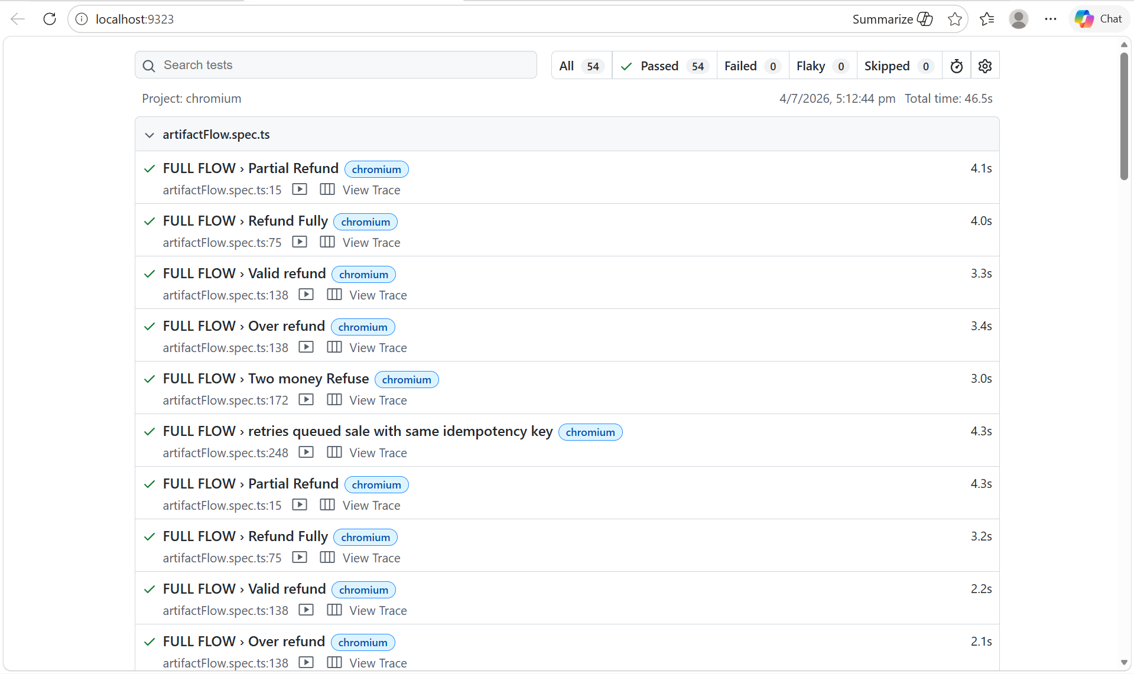

Test case passed : artifactFlow.spec.ts
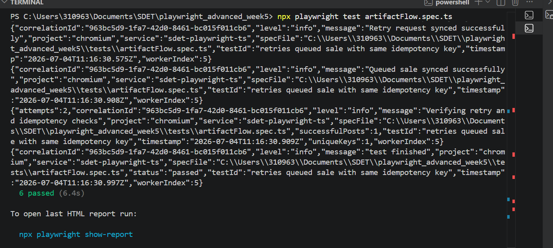

All the 6 TestCases has been Passed.
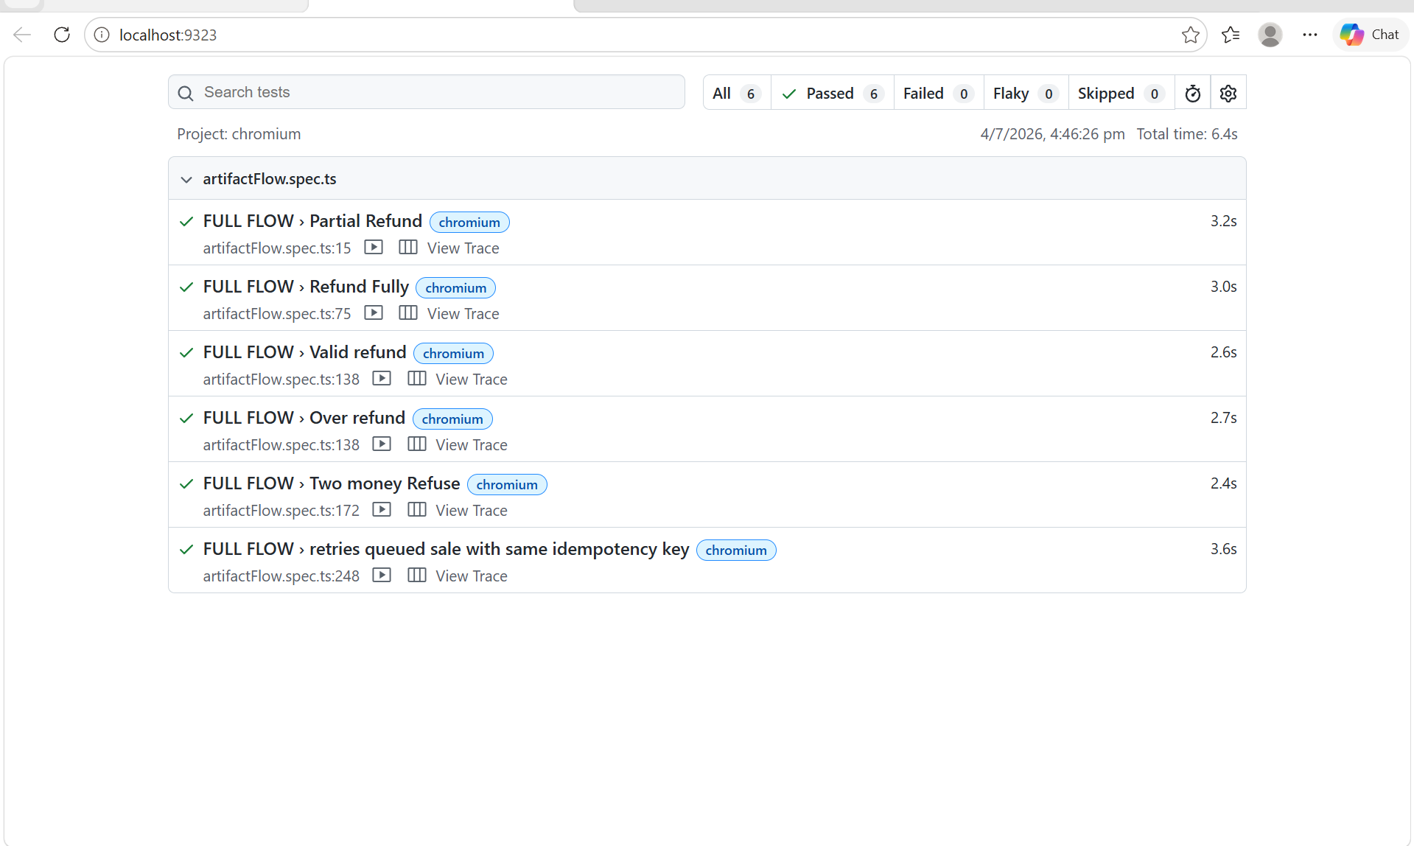
Report of all TestCases Passed.
Screenshots, Videos and Traces:
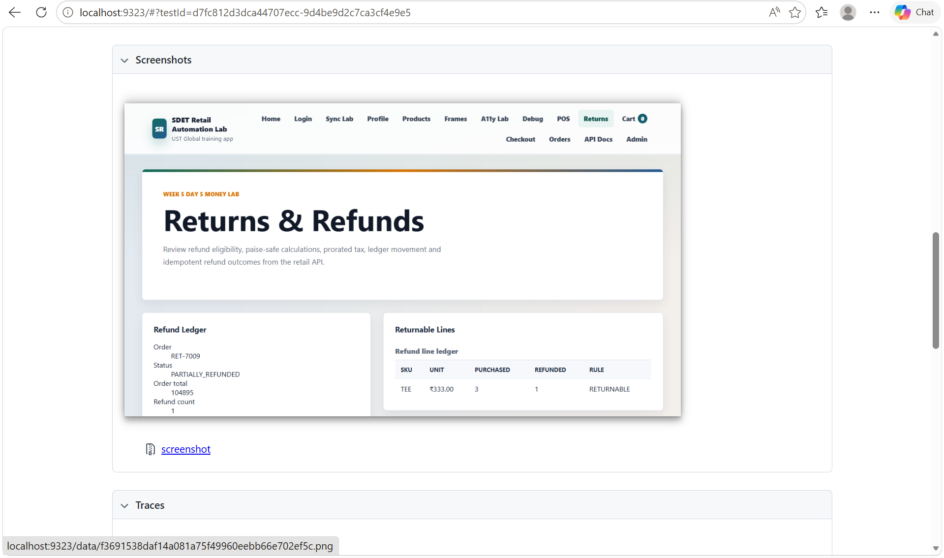

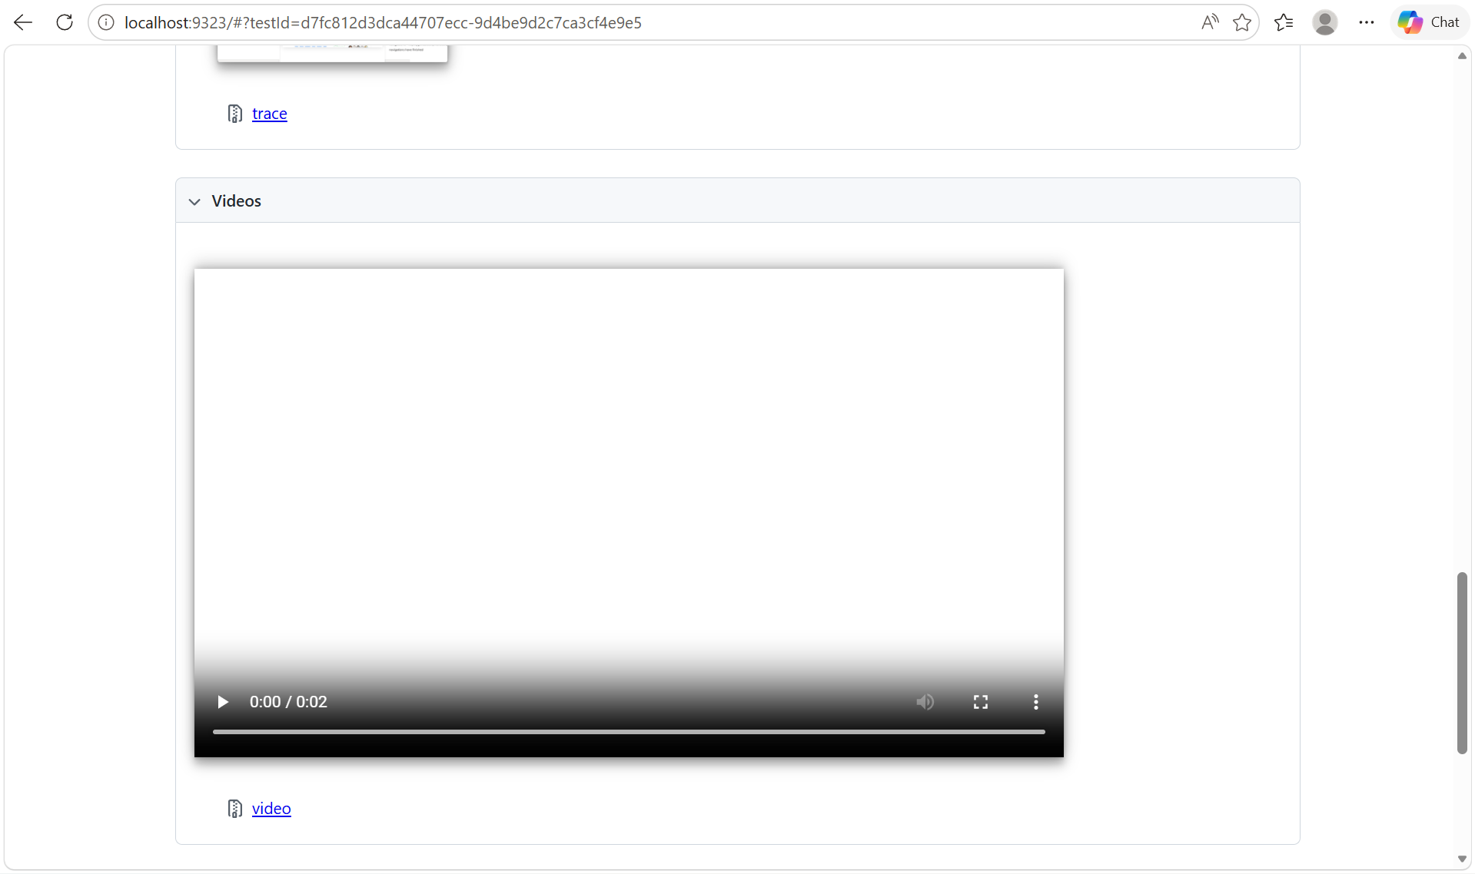

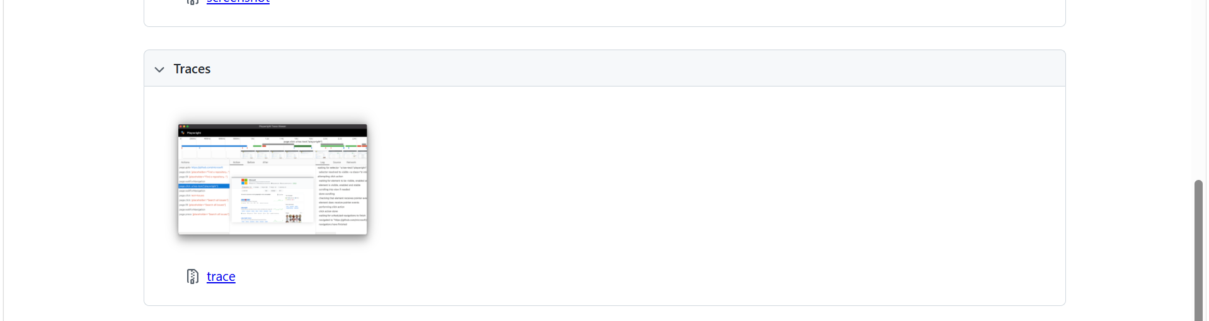
Json Response:
