Week 04 – Gate 4 demo report
Selenide:
Using Selenide, we want to check the availability of a product using the ‘availability badge’. Two page objects are created, one for the CatalogPage and one for the ProductPage.
CatalogPage contains a method to search for a product and a method to click on the ‘View’ button of the product card which returns an instance of the ProductPage object. ProductPage allows us to check the availability badge of the product card.
A single test called SelenideTest.java is created to test the flow. First, a CatalogPage instance is created and the test searches for “headphones”. The click product method is called on the CatalogPage instance and a new instance of ProductPage is returned. From this instance of ProductPage we assert that the availability badge of the selected product contains the test “In stock”.
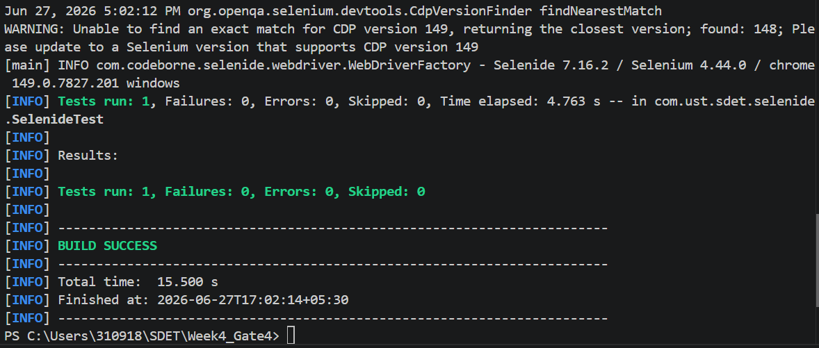
Contract Testing
Two files are created, PosOmsConsumerPactTest.java is used to create the consumer side pacts to publish to the pact broker. A pact is created to get an order of id = 123 and receive a response of orderId = 123, status = “CONFIRMED” and total = 42.0 with a status code of 200.
The pact broker is to be hosted on http://localhost:9292.
The second file is PosOmsVerificationTest.java which verifies the pacts published by the consumer to the pact broker. Wiremock runs on http://localhost:4010 and requests are sent here.

The pact broker is set up and run with the help of a docker-compose.pact-broker.yml file.
Separate .yml files are created for consumer and producer. Consumer.yml is used to run the consumer test, create the pacts and publish them to the broker.
Provider.yml is used to run the verification tests and verify the requests against the pacts published to the broker by the consumer.

