Documentation Report (Week03_Gate03_Selenium)

This is a Selenium automation project for a retail-app shopping website flow. It is written in Java and uses Cucumber to describe test scenarios in plain language.
What this project does :
The tests automate a shopping journey from the catalog to checkout:
- Open the catalog page
- Search for a product
- Add the first product to the shopping cart
- Open the cart
- Proceed to checkout and place the order
- Confirm that the order is completed

The project also shows:
- reporting with Cucumber and Allure
- page object structure for web automation
- a failure screenshot capture step

Main technologies used :
- Java 22
- Maven for build and dependencies
- Selenium WebDriver for browser automation
- Cucumber for writing behavior-driven tests
- JUnit Platform to run the tests
- Allure and Extent Reports for test reports

Tags / Annotations used in the feature:
- @smoke: marks the quick smoke scenario for a single-product purchase.
- @regression: marks scenario outlines and regression checks.
- @negative: marks a failing/negative example used to demonstrate screenshot capture.
- Background: common step "Given the catalog is open" runs before every scenario.

Scenarios (brief):
- Complete purchase of a single product (smoke):
Search for "headphones", add first result, verify cart badge is 1, open cart, check 1 item, proceed to checkout, and expect order confirmation.
- Purchase different products successfully (regression, Scenario Outline):
Runs the same happy path for multiple example products (headphones, shoes, lamp).
- Verify a newly opened cart is empty (regression):
Opens cart and asserts it contains zero line items.
- Demonstrate failure screenshot capture (negative):
A deliberately failing assertion to show screenshot attachment on failure.

Evidence:

Command used to run the tests:
mvn test -Dtest=ApplicationRunnerTest

Note:
- I am not able to run this Maven command myself right now, because my laptop does not have the SSL certificate set up.
- To generate a nicer Allure report, the command is:
allure generate allure-results --clean -o allure-report
- However, Allure is not installed on my laptop, and due to company policy we are not allowed to download and install it. So this command will not work in my setup.
- The screenshots below were taken from the IDE’s own test runner and the Extent Report instead, since those work without needing Maven downloads or the Allure tool.

Complete purchase of a single product (smoke)

Junit-platform.properties:
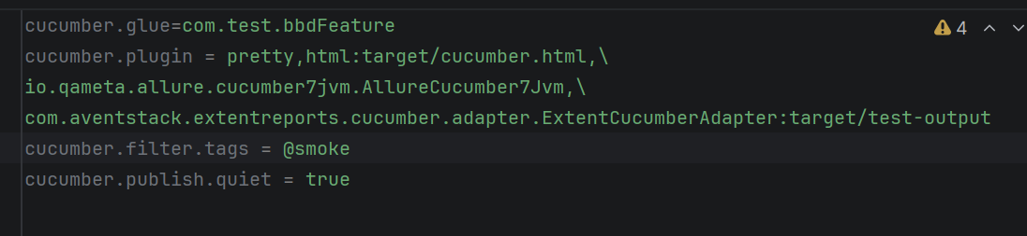

Screenshot:
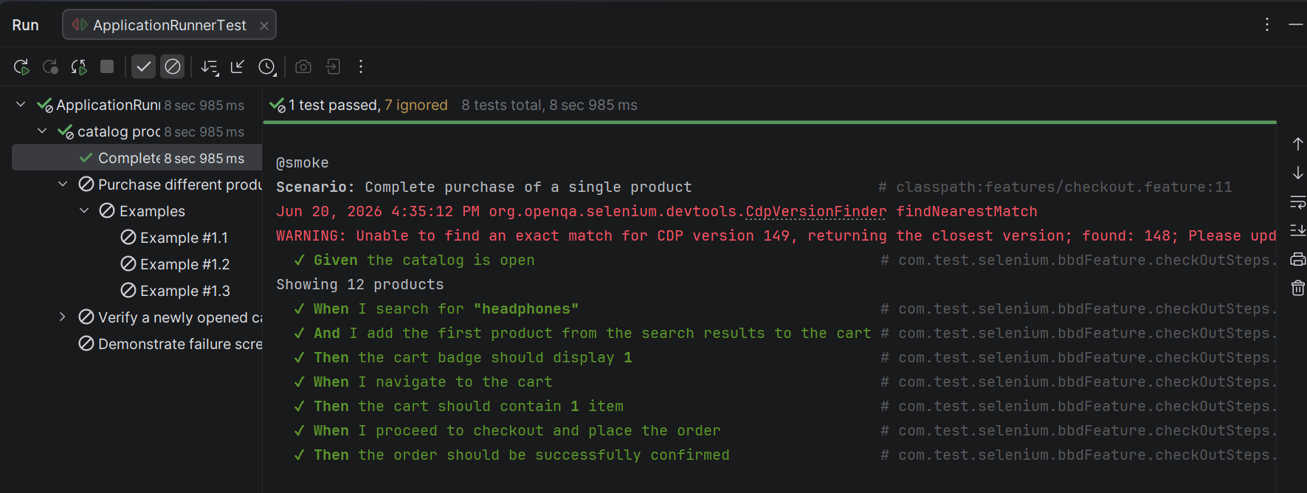
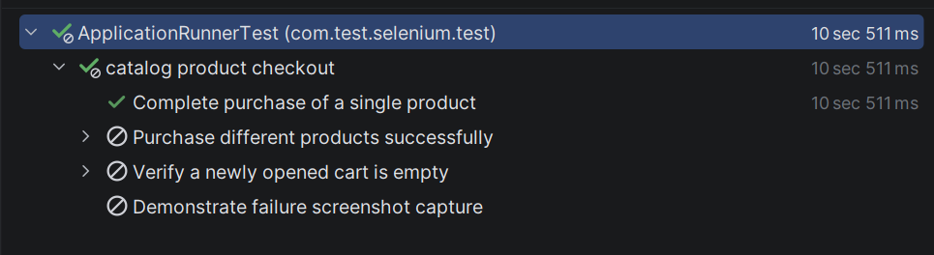

Key points:
- The first picture shows the settings file telling Cucumber to run only the tests tagged @smoke.
- The second picture shows the test running in the IDE. Every Given/When/Then line has a green tick, which means each step worked as expected.
- The third picture is the final results tree. The green checkmark on “Complete purchase of a single product” confirms the smoke test passed.

Purchase different products successfully (regression, Scenario Outline):
Junit-platform.properties:
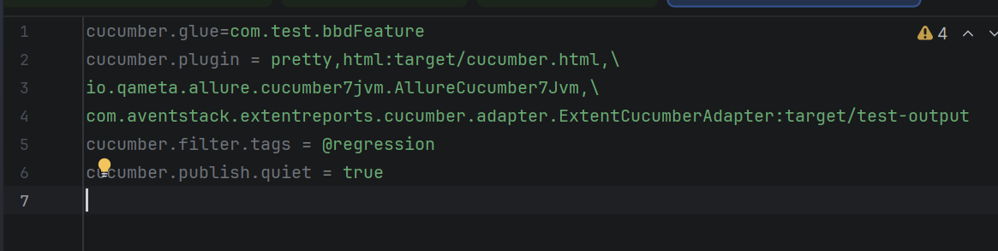

Screenshot:
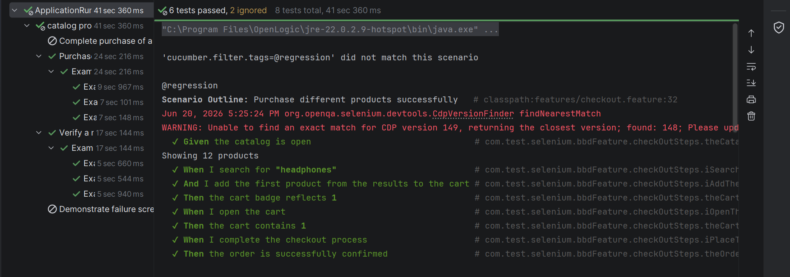
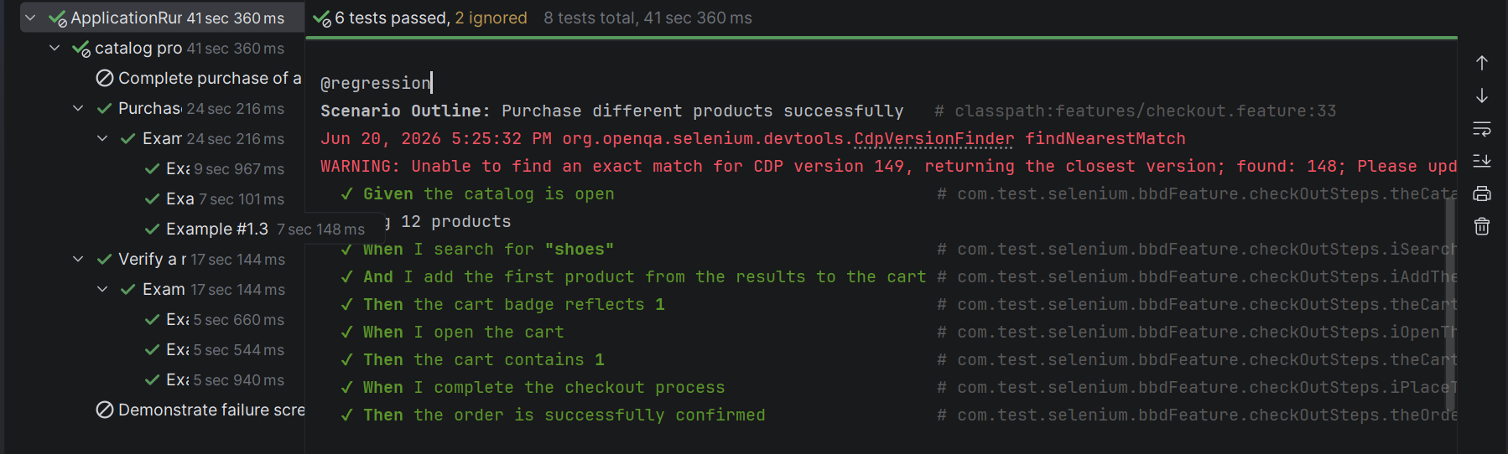
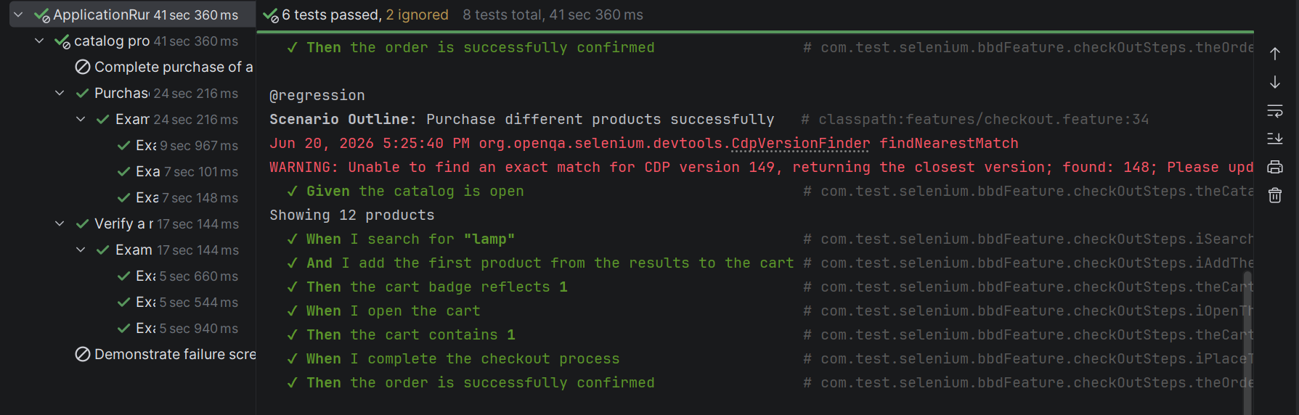
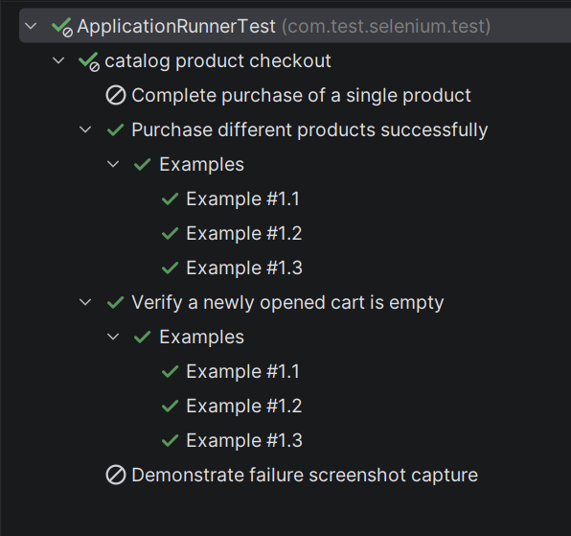
Key points:
- This time the file filters by @regression instead of @smoke.
- A Scenario Outline lets one set of steps run multiple times with different data. Here the same purchase steps run for “headphones”, “shoes”, and “lamp” one after another.
- Each of the three runs (Example #1.1, #1.2, #1.3) shows all steps passing, and the final tree confirms 6 tests passed in total.
Verify a newly opened cart is empty (regression):
Screenshot:
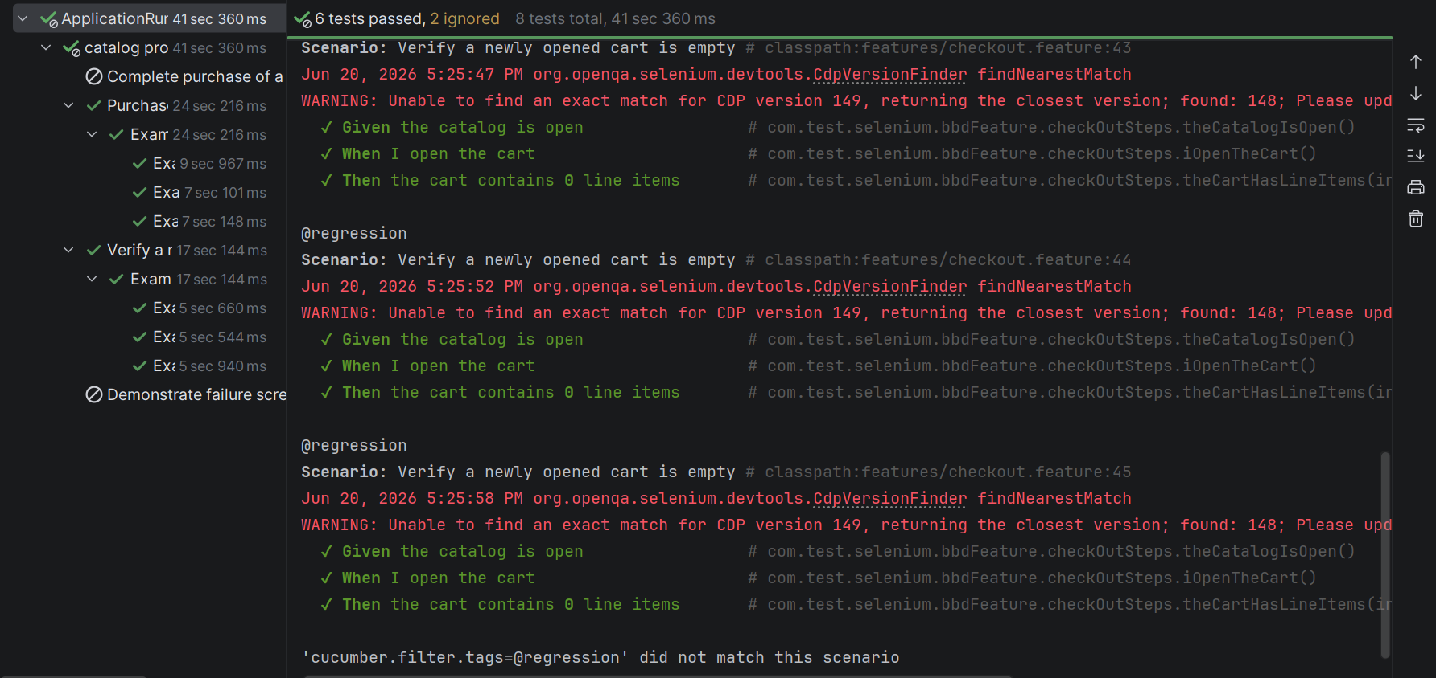
Key points:
- This check makes sure the cart starts empty. It opens the cart without adding anything first.
- The “Then the cart contains 0 line items” step has a green tick, which confirms the cart was truly empty.
- This run repeats three times because it is also a Scenario Outline, just like the previous test.
Demonstrate failure screenshot capture (negative):
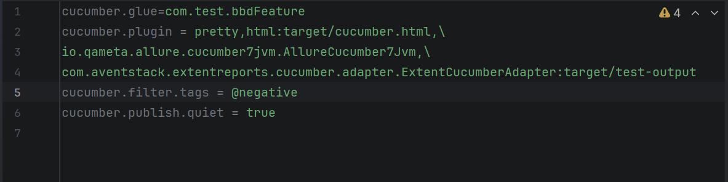

Screenshot:
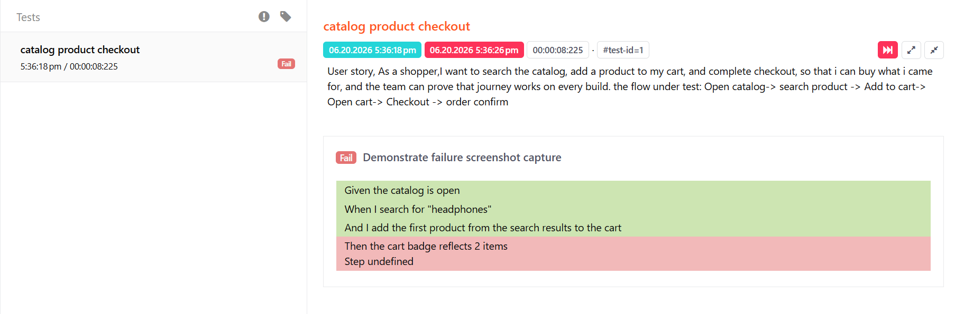
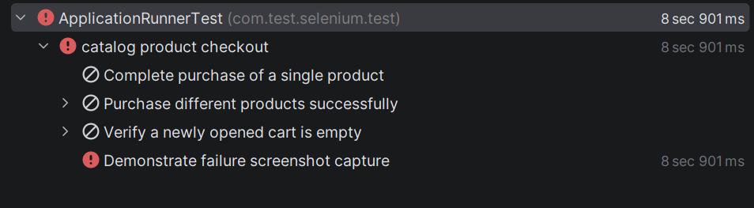
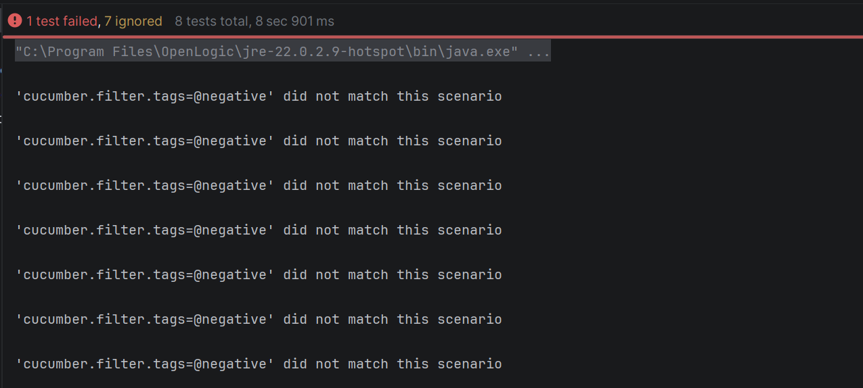
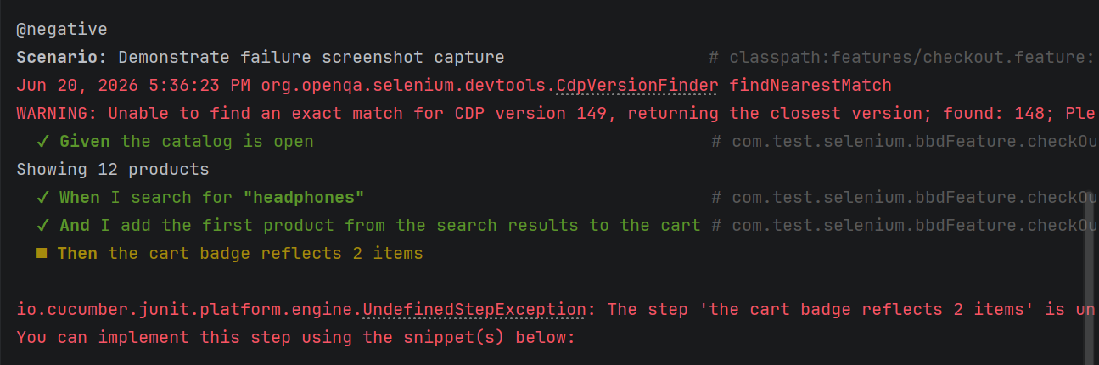
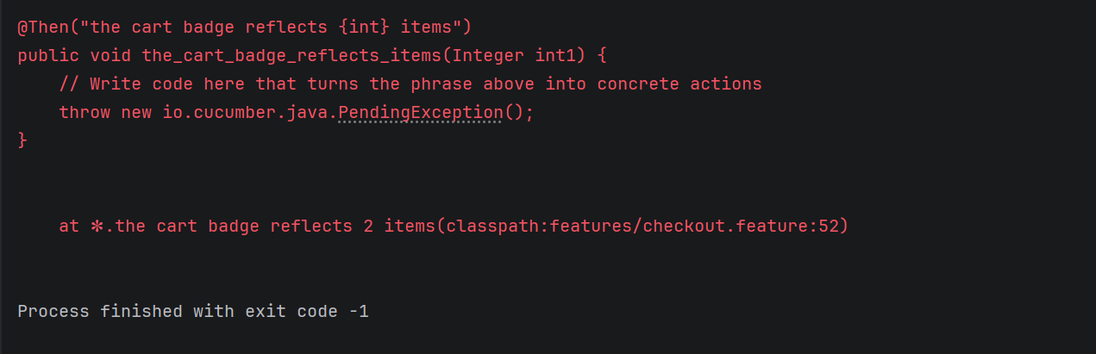
Key points:
- This test is written to fail on purpose. It checks for “2 items” in the cart when only 1 item was actually added.

