Demo_Report

Scenario: Shopper sees cart count increase when adding multiple items
When I look for "Ceramic Dinner Set"
And I add the first available product to the cart
And I look for "bottle"

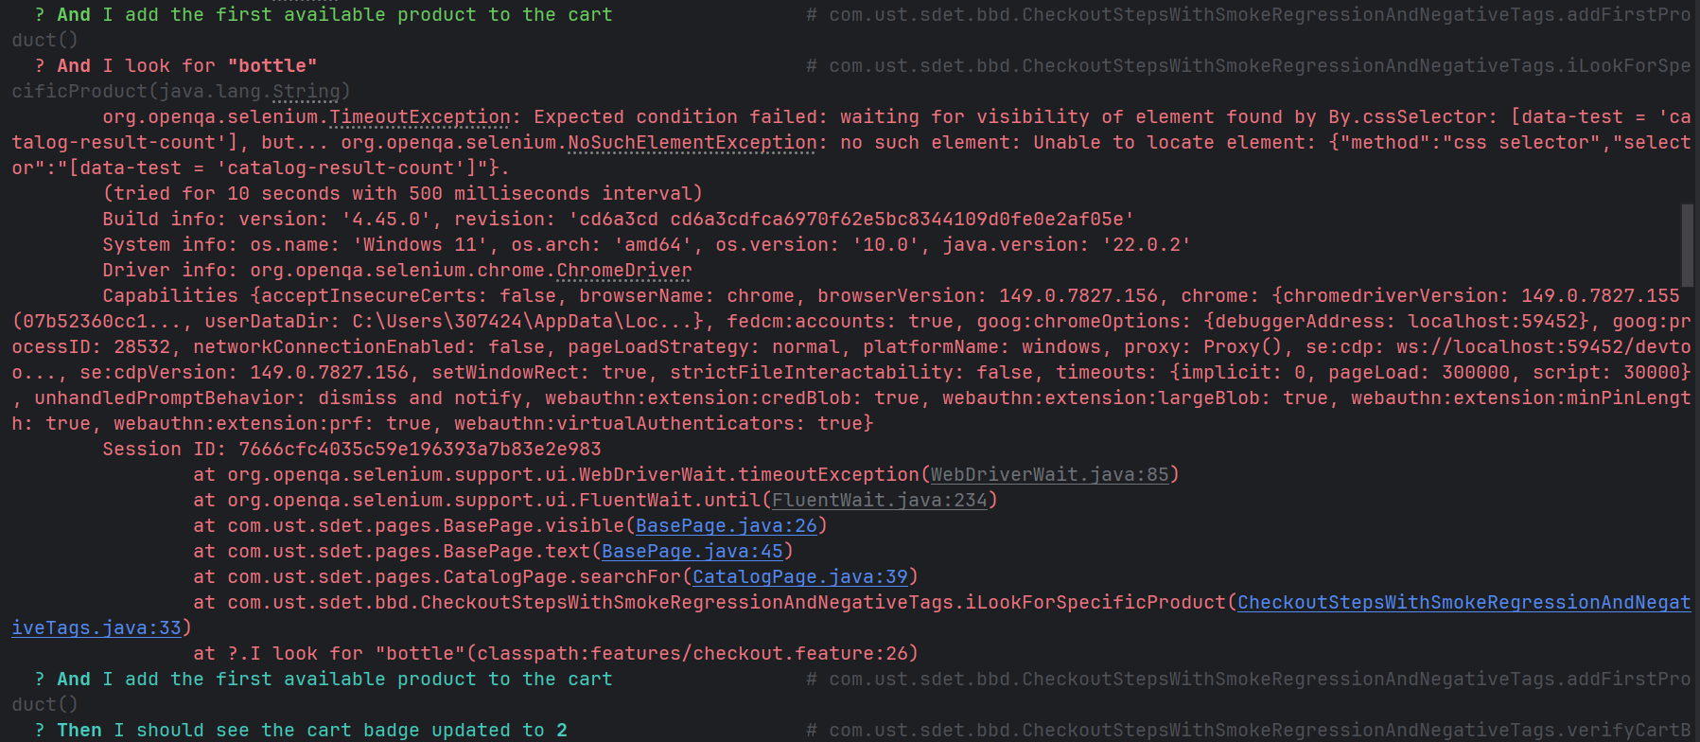
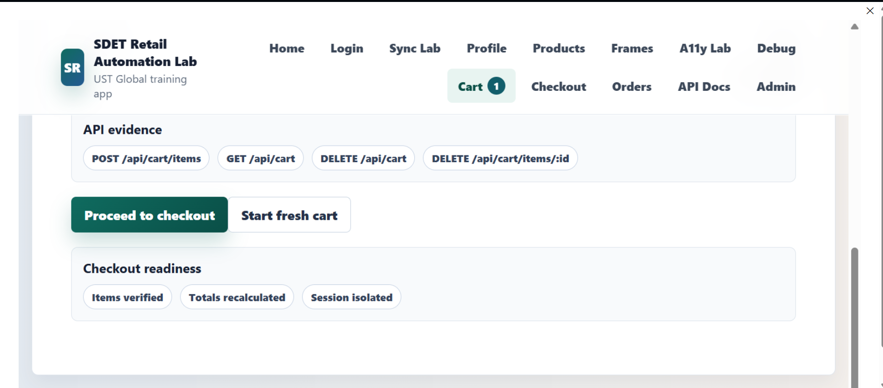
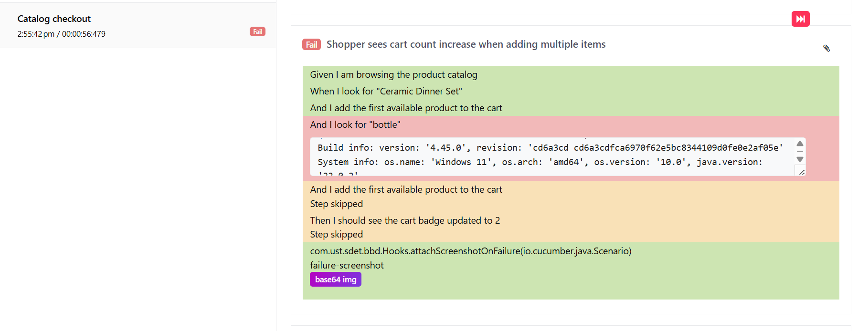
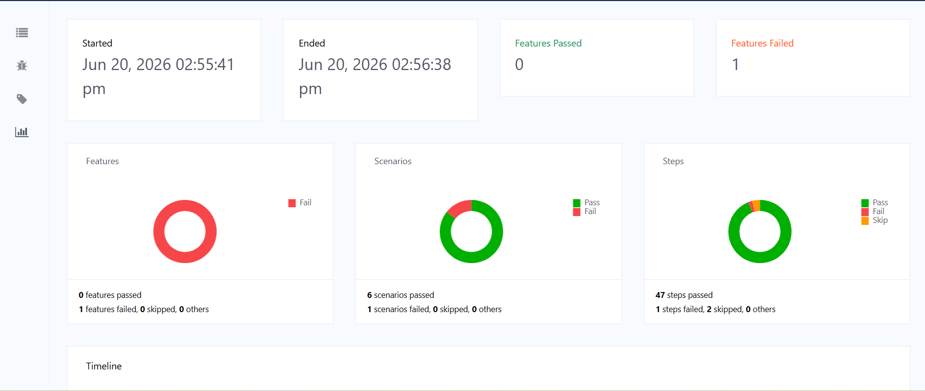
And I add the first available product to the cart
Then I should see the cart badge updated to 2

Solutions:
When I add first item to the cart and go to the cart to verify at that point is passed and page is change but at the time I check another product so at so it give me error . So I solve this problem when ever I check another product first check the the page is catalog, then I search and add to cart

@When("I look for {string}") public void iLookForSpecificProduct(String product) {
world.catalog = new CatalogPage(world.driver).open();
world.catalog.searchFor(product);
}
So this solve my problem.

@negative
Scenario: Shopper sees incorrect cart badge count (intentional failure)
When I look for "headphones"
And I add the first available product to the cart
Then I should see the cart badge updated to 2
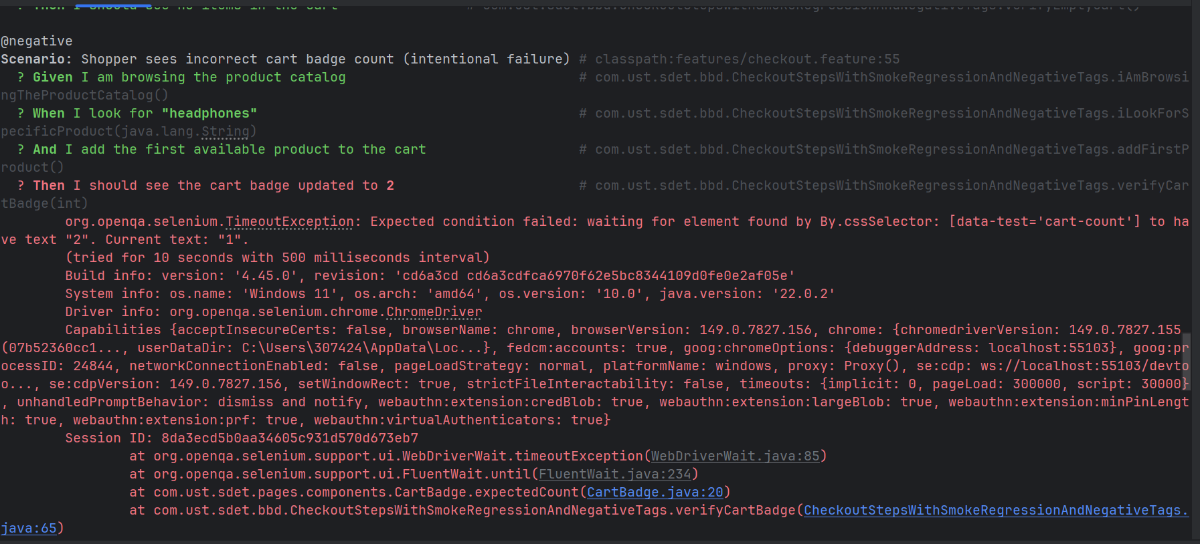
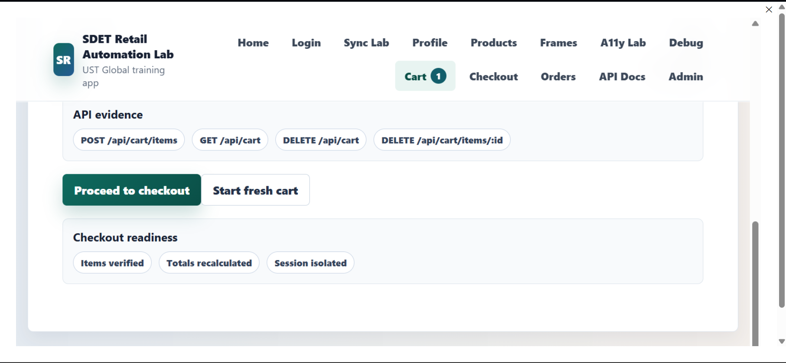
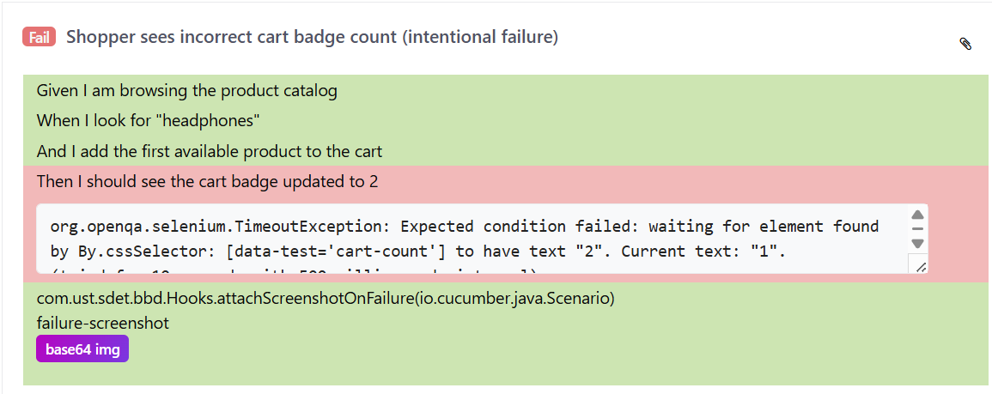
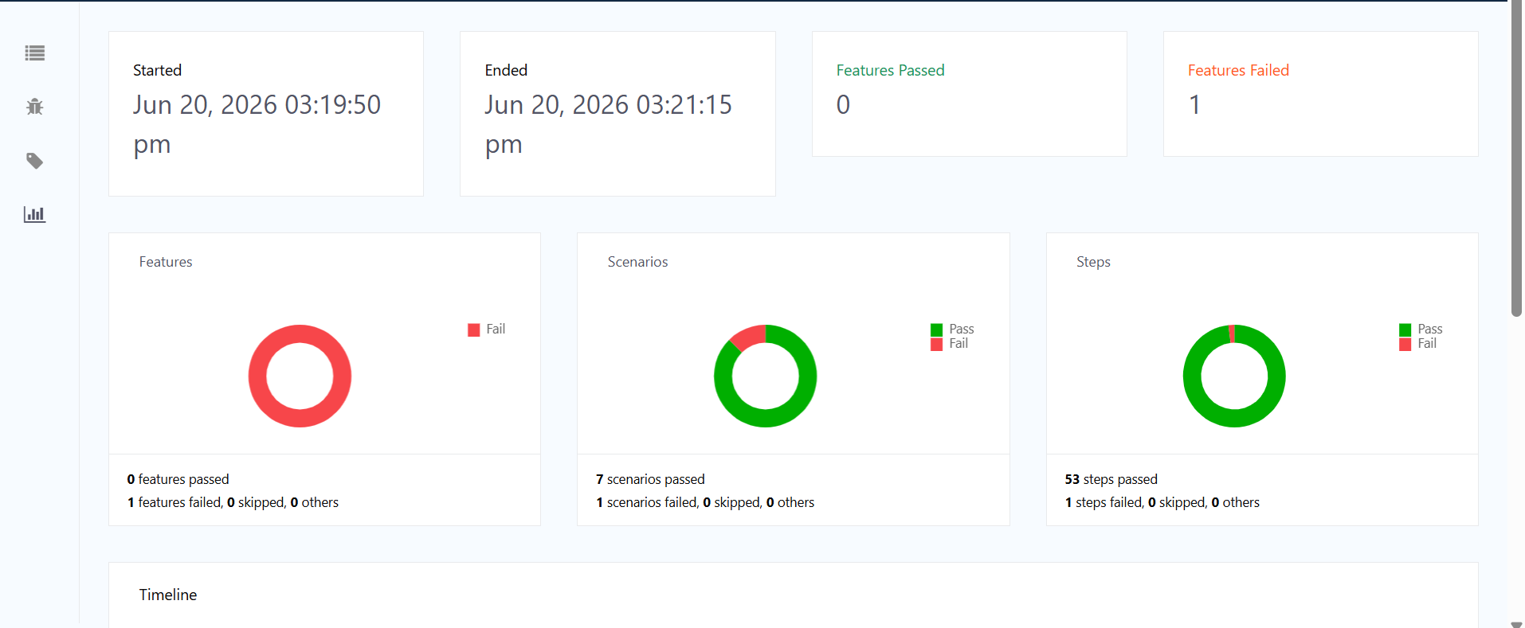

Solution:
I intentionally created an incorrect validation by adding one product but verifying the count as two.
That give error (refers to above pictures). This give me expected results (as fails) . To solve this problem
I have changed the negative scenario’ part as “Then I should see the cart badge updated to 1”. By modify this the error is solved.

Explanations:
In Support folder
- TestEnvironment: In this I have define required method that reads value from .env file

- Cofing: In this I have define baseUrl,catalog and headless and all value is coming from .env file through TestEnvironment;

- DriverFactory: In this class, I define the crome driver with arguments like headless=new and some prefs add to option so that it cant struct like enter credentials and web driver helps to interact with web page ;

In page folder,
- BasePage:
In this class I use webdriver and instantiate webDriverWait for wait and I set up wait times to 10 seconds and define six method like header(),visible for showing element ,visibleElements() for list of elements ,elements() for single element fetch, click() for click events and type() to type in input and last is text() for getting text.

- CatalogPage:
In this I define open method for open the url of catalog,searchFor() searching specific products,card() for getting list of products as card,openFirstProduct() to get into first product page and many more.
- ProductPage: for product web page and respective method like name(),addToCart()
- CartPage: in this I define linecount(),total and proceed() this is for checkout
- CheckoutPage: In this I define placeorder() and conformationText() successfully order .
Components folder :
In this use CartBadge,Header,ProductCard as compents because we use this many times

Bdd folder:
- World: here we define properties that we need to across whole journey driver,catalog,product,cart,checkout,scenario

- Hooks: in here I use setup I create driver and scenario before each test, and after each test screenshotonFailure,and close the driver after each test.

- CheckoutStepsWithSmokeRegressionAndNegativeTags:
In this I write step definitions for the catalog checkout flow using Cucumber. It handles user actions such as searching, adding products, navigating the cart, and completing checkout. It also validates cart and order behavior using assertions, and captures business data (cart total) as an attachment before checkout.

- RunCucumberTest:
In this I use suite,engines,resources path and parameter that run the cucumber test.

In Resource folder:
- In feature folder: I define the scenario with different tags @smoke, @regression, @negative
- There are extent.properties for allure extent reports
- Allure.properties ,in this I define configuration for allure and in this I cant able to run because this is outer library and it is not allow in this laptop ,but can we can use command line to run allure file to generate report
- target/allure-results
- allure generate target/allure-results --clean -o target/allure-report
- allure serve target/allure-results

