Name: Student number:

- (a) Given the hyperplane w^{T} x+c = 0, write out the distance formula of a point x to the hyperplane. Note: distance is a positive number. (5 points)
(b) Suppose x = (1,2,3,4,5) is a 5-dimensional vector and we want to map it to a 2-dimensional sub-space. Design an orthonormal base for a 2-dimensional subspace and calculate the representation of x in the subspace. (7 points)

- Given the training dataset X = {(x₁,y₁),··· ,(x_{N},y_{N})}, where x_{i} ∈ R^{d} and y_{i} ∈ R. Fit the data with a linear regression model with the projection parameter w (omit the bias term).
  - Write out the loss function with the “least square loss” and a regularizer onlyapplied to the first element of w, i.e., Ω(w) 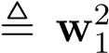, where the weight of the
regularizer is λ. (5 points)
  - Derive the optimal solution for w. (10 points)

3. When building a decision tree for the following data, assume at the current node we only have two options to split the data, as indicated by the two dash vertical lines in Figure 1. With the information gain ration criterion, which split is better? And
why? (15 points)
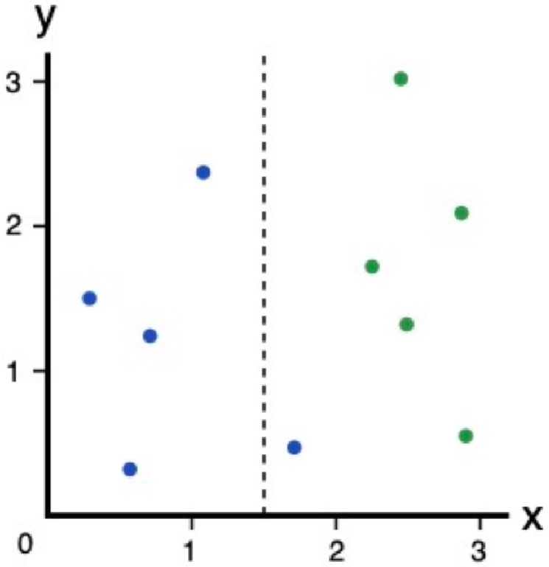

Split 1
Split 2
Figure 1: Two options to split the tree.

4. For the FNN illustrated in Figure 2, defined as a^{(k)} = W^{T} h^{(k−1)} +b^{(k)}, and h^{(k)} = σ(a^{(k)}), where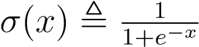 is the sigmoid function. Assume 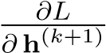 is given. What is the expression for 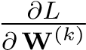? You can use the fact that σ(x)′ = σ(x)(1 − σ(x)) if
needed.(13 points)
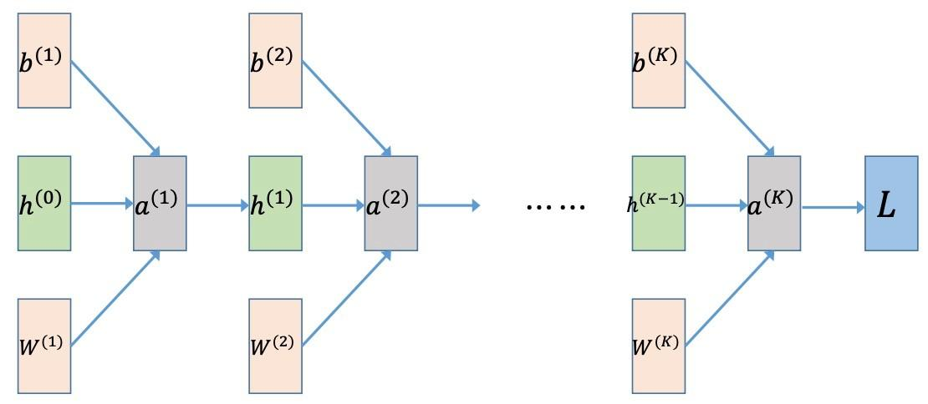
Figure 2: The feedforward neural network

5. There are two training points x₁,y₁ = (2,3),−1; x₂,y₂ = (−1,2),+1. Use kernel
SVM with kernel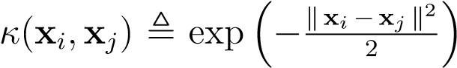, where we denote the feature mapping as ϕ(x). Thus, we can write out the prediction function for a data point x in the feature space as: f(x) = w^{T} ϕ(x) + b. Simplify f(x) using all known information.
(15 points)

- For the HMM illustrated in Figure 4. Calculate p(x₂ = 1|x₀ = 1). Your answer
should be rounded to two decimal places. (15 points)
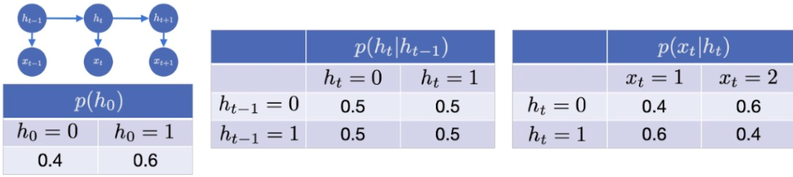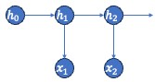

0
1
Figure 5: HMM.
Figure 4: HMM.

