**SQL实验报告**

**姓名：陈鸿绪 学号：PB21000224 日期：5.1**

1. 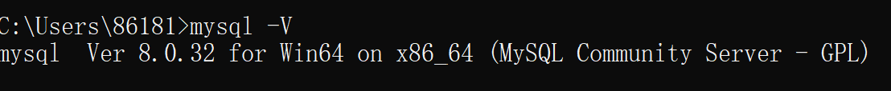MySQL配置结果：版本显示

b) 数据库中基本表的建立：

create table course(CNO char(8) primary key,

NAME VARCHAR(40) NOT NULL,

TNO CHAR(7) NOT NULL)

create table student(SNO char(11) primary key,

NAME varchar(4) not null,

GENDER char(6) not null,

BIRTHDAY datetime not null,

DEPART int not null);create table teacher(TNO CHAR(7) primary key,

NAME VARCHAR(4) not null,

GENDER char(6) not null,

BIRTHDAY datetime not null,

POSITION char(25) not null,

DEPART INT not null)

create table score(SNO char(11) not null,

CNO char(8) not null,

DEGREE int)

create table score(SNO char(11),

CNO char(8) ,

DEGREE int,

foreign key(SNO) references student(SNO),

foreign key(CNO) references course(CNO))

c) 数据导入表中：

LOAD DATA INFILE 'Course.csv'

INTO TABLE course

FIELDS TERMINATED BY ',';

LOAD DATA INFILE 'Student.csv'

INTO TABLE student

FIELDS TERMINATED BY ',';

LOAD DATA INFILE 'Score.csv'

INTO TABLE score

FIELDS TERMINATED BY ',';

LOAD DATA INFILE 'Teacher.csv'

INTO TABLE teacher

FIELDS TERMINATED BY ',';

1. alter table lab01.student add AGE int not null;





1. update student

set AGE=2023-year(BIRTHDAY);





1. update student

set AGE=AGE+2;





1. alter table student

modify AGE CHAR(2);



1. alter table student

drop AGE;





1. create table teacher_course(TNO CHAR(7),

NUM_COURSE INT);



1. alter table teacher_course

add primary key(TNO);





1. insert into teacher_course(TNO,NUM_COURSE)

select teacher.TNO,temp.NUM_COURSE

from teacher left outer join

(select TNO,count(CNO) from course group by TNO) as temp(TNO,NUM_COURSE)

on teacher.TNO=temp.TNO;



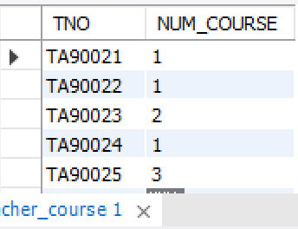

1. delete from teacher_course where NUM_COURSE is null;



1. drop table teacher_course;



1. insert into student(SNO,NAME,GENDER,BIRTHDAY,DEPART)

values('PB21000224','CHX','male','2004-2-24 00:00:00',229)

insert into student(SNO,NAME,GENDER,BIRTHDAY,DEPART)

values('PB21000227','jjy','male','2004-3-3 00:00:00',229)

insert into student(SNO,NAME,GENDER,BIRTHDAY,DEPART)

values('PB21000211','py','male','2004-12-24 00:00:00',229)

insert into score(SNO,CNO,DEGREE)

values('PB21000224','20230402',95);

insert into score(SNO,CNO,DEGREE)

values('PB21000224','20230410',97);

insert into score(SNO,CNO,DEGREE)

values('PB21000224','20230412',99);









1. delete from score

where score.SNO='PB21000224' and

score.DEGREE<=ALL(select temp.DEGREE

from (select DEGREE

from score

where SNO='PB21000224')

as temp(DEGREE));



1. create index NAME_INDEX ON course(NAME);



1. create unique index TNO_INDEX ON teacher(TNO);



1. create index RECORD_INDEX on score(SNO DESC,DEGREE ASC)



1. show index from score;

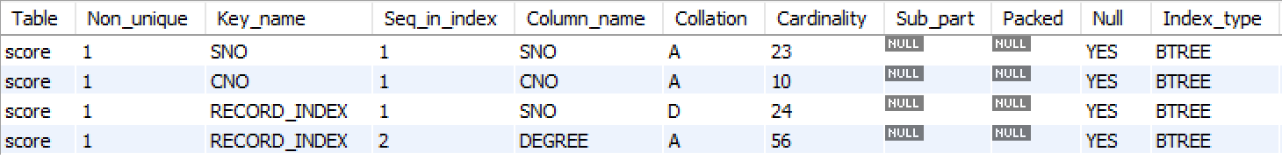

1. drop index TNO_INDEX on teacher;



1. select SNO,NAME

from student

where DEPART=

(select DEPART

from student

where SNO='PB21000224')

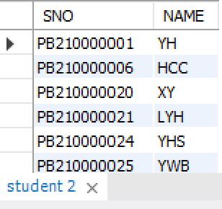

1. select SNO,NAME

from student

where DEPART=

(select DEPART

from student

where SNO='PB21000224')

and SNO<>'PB21000224';

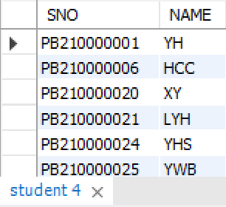

1. select SNO,NAME

from student

where DEPART=

(select DEPART

from student

where NAME='jjy');

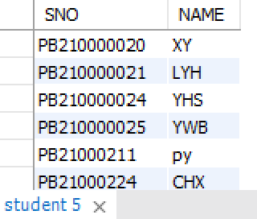

1. select SNO,NAME

from student

where DEPART not in

(select DEPART

from student

where SNO='PB21000227' or SNO='PB21000211')

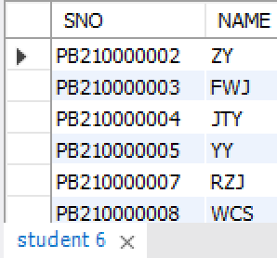

1. select TNO,NAME

from teacher

where TNO in

(select TNO

from course

where CNO in

(select CNO

from score

where SNO='PB21000224'));

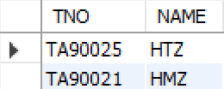

1. select count(*)

from (select TNO

from teacher

where DEPART=11 or DEPART=229) as temp(TNO);

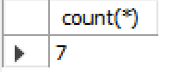

1. select score.SNO,NAME,DEGREE

from score,student

where CNO in

(select CNO from course where NAME='DB_Design')

and DEGREE>=89 and score.SNO=student.SNO;

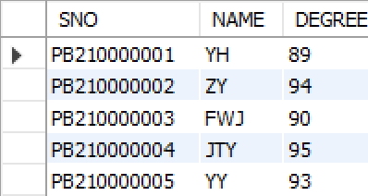

1. select distinct student.SNO,NAME

from student,score

where (score.CNO in

(select CNO

from teacher

where NAME='ZDH')

and score.SNO=student.SNO);

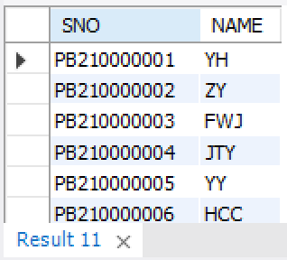

1. select SNO, DEGREE

from score

where CNO in

(select CNO

from course

where NAME='operating_system')

order by DEGREE desc;

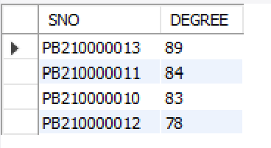

1. select course.CNO,NAME,avg(DEGREE)

from course left join score on(course.CNO=score.CNO)

group by CNO;

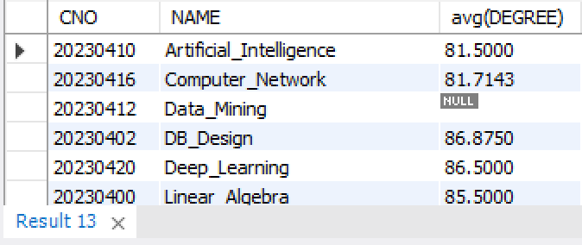

1. select course.CNO,NAME,max(DEGREE),min(DEGREE),max(DEGREE)-min(DEGREE)

from course,score

where course.CNO=score.CNO

group by CNO;

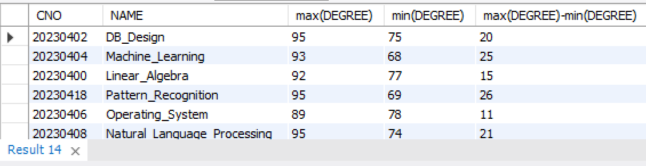

1. select distinct teacher.TNO,teacher.NAME

from teacher,score,course

where course.CNO=score.CNO and DEGREE<72 and course.TNO=teacher.TNO;

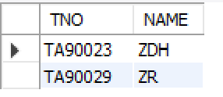

1. select student.SNO,NAME

from student,score

where student.SNO=score.SNO

group by SNO

having count(CNO)>=2

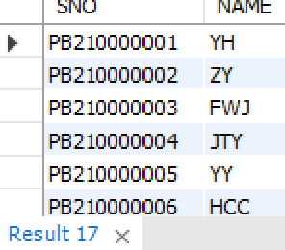

1. select temp.SNO,avg(temp.DEGREE)

from (select student.SNO,DEGREE

from student left join score on(student.SNO=score.SNO)) as temp(SNO,DEGREE)

group by temp.SNO;

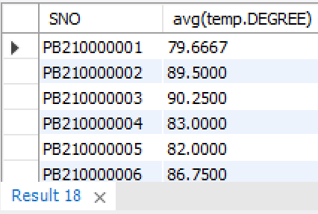

1. select temps.DEPART,count(temps.SNO),avg(temps.DEGREE)

from (select temp.DEPART,temp.SNO,avg(temp.DEGREE)

from (select DEPART,student.SNO,DEGREE

from student left join score on(student.SNO=score.SNO)) as temp(DEPART,SNO,DEGREE)

group by temp.SNO) as temps(DEPART,SNO,DEGREE)

group by DEPART

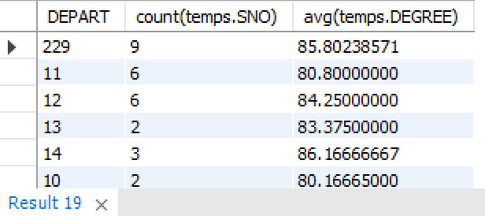

1. select NAME

from student x

where not exists(

select *

from score

where score.SNO=x.SNO and score.CNO in(

select CNO

from course

where NAME='Data_Mining'))

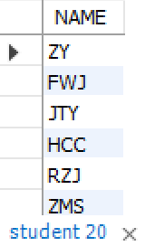

1. select course.NAME,avg(2023-year(student.BIRTHDAY))

from course left join score on(score.CNO=course.CNO)

left join student on(score.SNO=student.SNO)

group by course.NAME

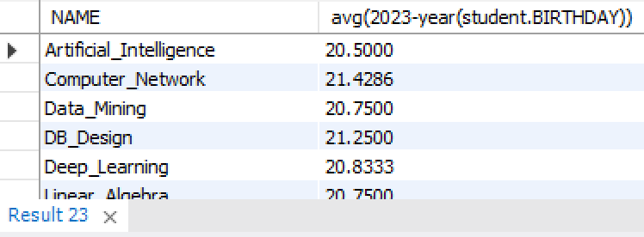

1. select student.SNO,student.NAME

from student,score

where student.SNO=score.SNO and score.CNO in (

select CNO

from course

where NAME like "%Computer%");

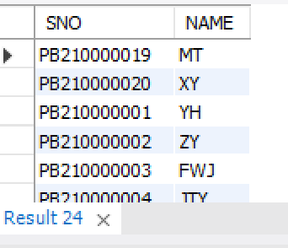

1. select SNO,CNO,DEGREE

from score x

where x.DEGREE-12 >

(select avg(DEGREE) from score y where y.CNO=x.CNO group by CNO) ;

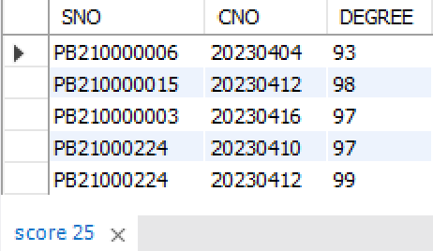

1. create view db_female_student(SNO,NAME,GENDER,BIRTHDAY,DEPART)

as select * from student where GENDER='female'

with check option



1. update db_female_student

set NAME='CHX'

where SNO='PB210000016'



1. select SNO,NAME

from db_female_student

where 2023-year(BIRTHDAY)<21;

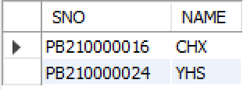

1. insert into db_female_student

values('SA210110021',' QXY','female','1997-07-27 00:00:00','12');

select * from db_female_student

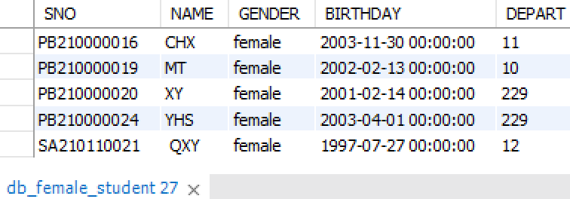

1. insert into db_female_student

values('SA210110023',' DPC','male','1997-04-27 00:00:00','11');



1. drop view db_female_student



1. create table teacher_salary(

TNO char(7) primary key,

SAL float)



1. DELIMITER //

create trigger TS_T1

BEFORE insert on teacher_salary

for each row

if new.TNO not in (select TNO from teacher) then

SIGNAL SQLSTATE '45000'

SET MESSAGE_TEXT = "have no such TNO";

END IF//

DELIMITER ;

DELIMITER //

create trigger TS_T2

BEFORE update on teacher_salary

for each row

if new.TNO not in (select TNO from teacher) then

SIGNAL SQLSTATE '45000'

SET MESSAGE_TEXT = "have no such TNO";

END IF//

DELIMITER ;



insert into teacher_salary

values("TA9002",7000);

insert into teacher_salary

values("TA90022",7000);

update teacher_salary

set TNO="TA9002"

where TNO="TA90022"







1. DELIMITER //

create trigger TS_T3

BEFORE update on teacher_salary

for each row

if (new.SAL < 4000 and (select position from teacher where new.TNO=teacher.TNO)="Instructor") or

(new.SAL < 5000 and (select position from teacher where new.TNO=teacher.TNO)="Associate Professor") or

(new.SAL < 6000 and (select position from teacher where new.TNO=teacher.TNO)="Professor") then

SIGNAL SQLSTATE '45000'

SET MESSAGE_TEXT = "the salary is not correct";

END IF//

DELIMITER ;

DELIMITER //

create trigger TS_T4

BEFORE insert on teacher_salary

for each row

if (new.SAL < 4000 and (select position from teacher where new.TNO=teacher.TNO)="Instructor") or

(new.SAL < 5000 and (select position from teacher where new.TNO=teacher.TNO)="Associate Professor") or

(new.SAL < 6000 and (select position from teacher where new.TNO=teacher.TNO)="Professor") then

SIGNAL SQLSTATE '45000'

SET MESSAGE_TEXT = "the salary is not correct";

END IF//

DELIMITER ;



insert into teacher_salary

values("TA90023",2000)



insert into teacher_salary

values("TA90023",5000);



update teacher_salary

set SAL="1000"

where TNO="TA90023"



1. drop trigger TS_T1;

drop trigger TS_T2;

drop trigger TS_T3;

drop trigger TS_T4;

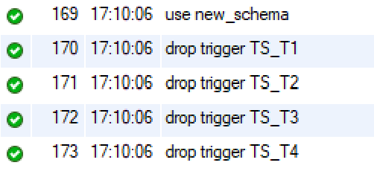

1. update score

set DEGREE=NULL

where CNO in

(select CNO from course where score.CNO=course.CNO and course.NAME="Data_Mining");



select SNO,DEGREE

from score

order by DEGREE ASC;

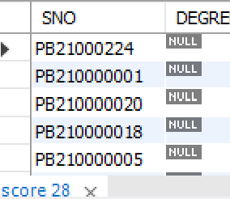

null不参与比较大小，但是在数据排序的时候默认排在最小值的前面

1. 查看比DB_DESIGN课程平均分高的人

select student.NAME

from score x,student

where student.SNO=x.SNO and

(x.DEGREE > (select avg(DEGREE) from score y,course where course.NAME="DB_DESIGN" and course.CNO=y.CNO))

and (x.CNO in (select course.CNO from score z,course where course.NAME="DB_DESIGN" and course.CNO=z.CNO));

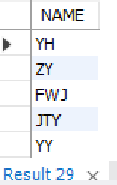

1. 将DB_DESIGN课程的成绩由高到低排出一个试图，随后删除

create view DB_DESIGN_SCORE(SNO,DEGREE)

as

select score.SNO, score.DEGREE

from score,course

where score.CNO=course.CNO and course.NAME="DB_DESIGN"

order by score.DEGREE desc;

drop view DB_DESIGN_SCORE



1. 求出所有有成绩的同学平均成绩排序,只显示学号和平均成绩

select SNO,avg(score.DEGREE) avg_degree

from score

group by SNO

order by avg_degree desc

