**IP实验**

**姓名：陈鸿绪 学号：PB21000224 日期：11.24.2023**

修改发送数据包大小：

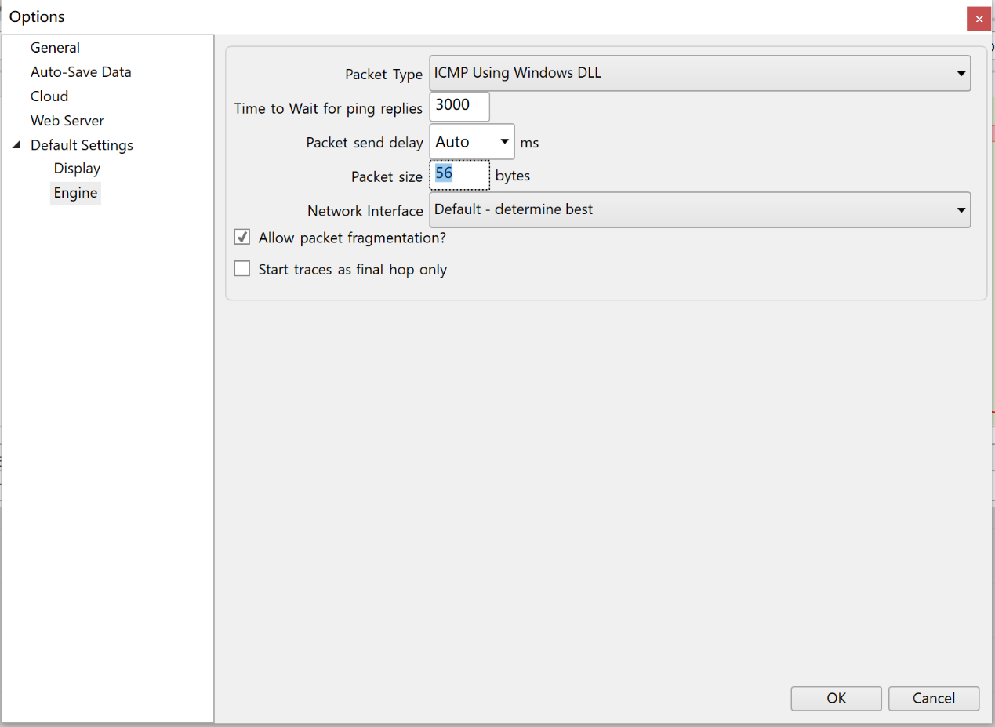

1. Select the first ICMP Echo Request message sent by your computer, and expand the Internet Protocol part of the packet in the packet details window. What is the IP address of your computer?

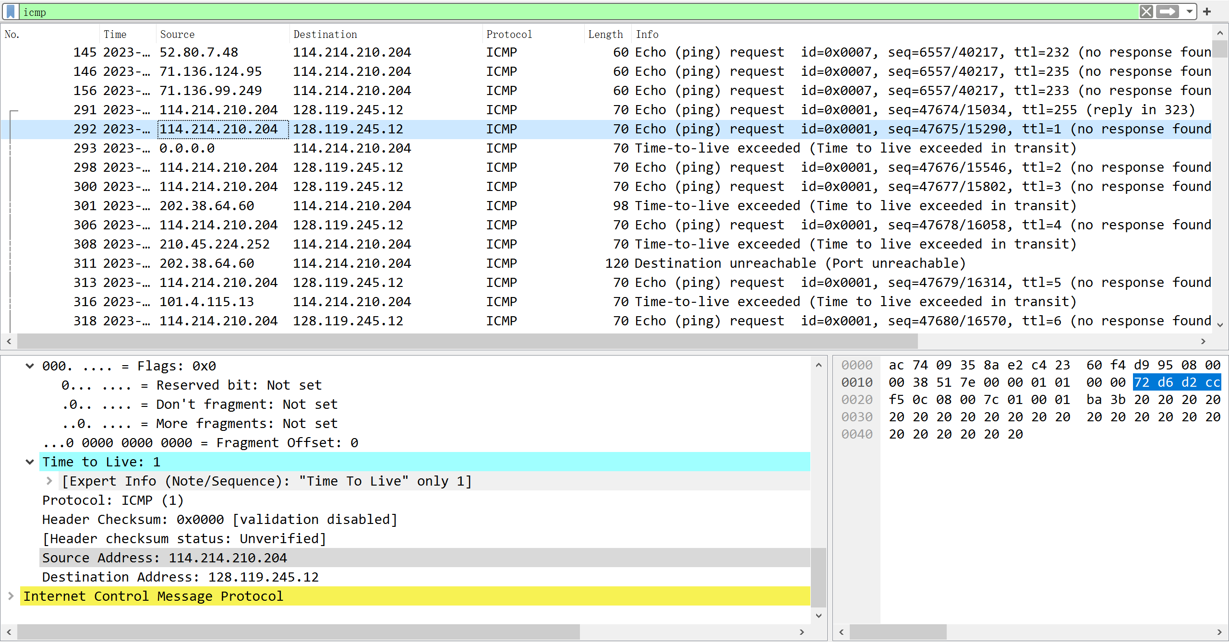

IP：114.214.210.204

1. Within the IP packet header, what is the value in the upper layer protocol field?

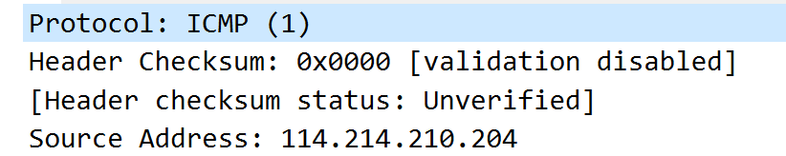

ICMP为上层协议

1. How many bytes are in the IP header? How many bytes are in the payload of the IP datagram? Explain how you determined the number of payload bytes.

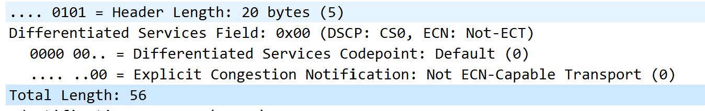

Header：20 总长度：56 有效负载：36

1. Has this IP datagram been fragmented? Explain how you determined whether or not the datagram has been fragmented

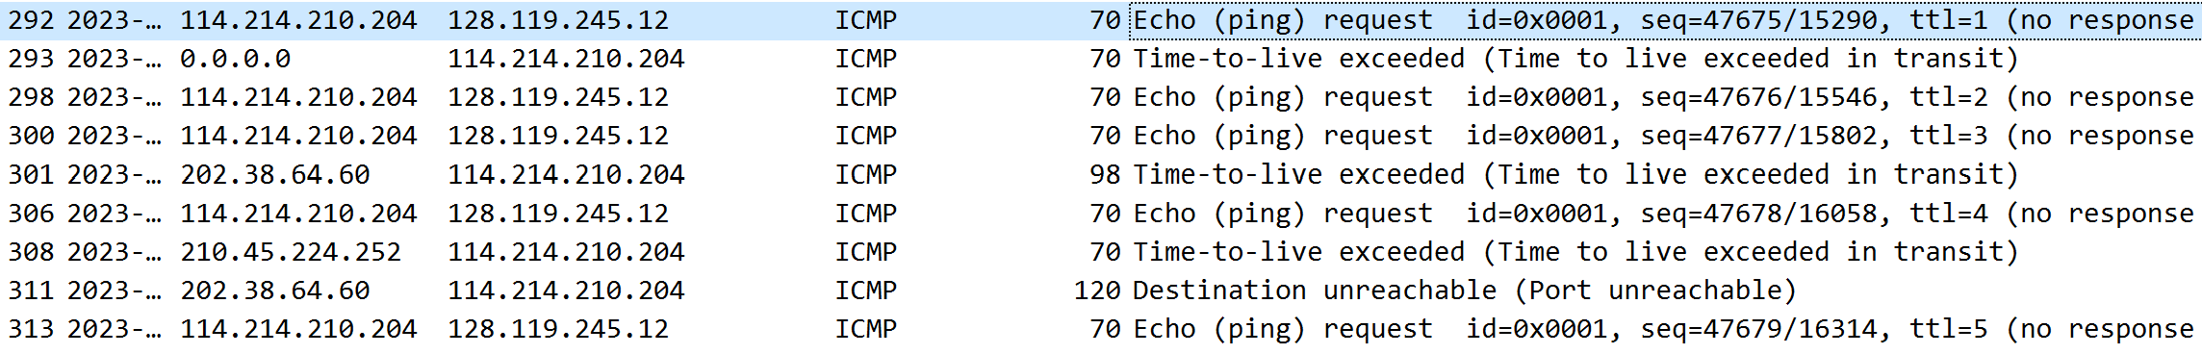

没有发现多个相同的TTL，所以并没有分割

1. Which fields in the IP datagram always change from one datagram to the next within this series of ICMP messages sent by your computer?

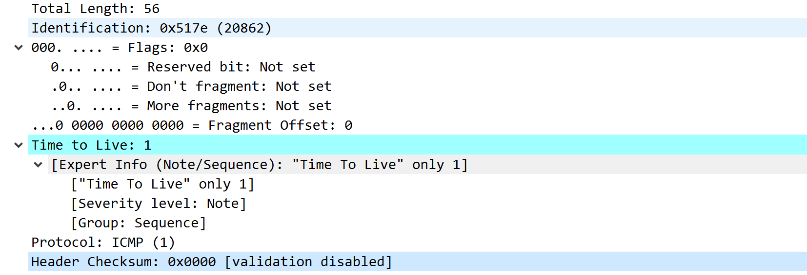

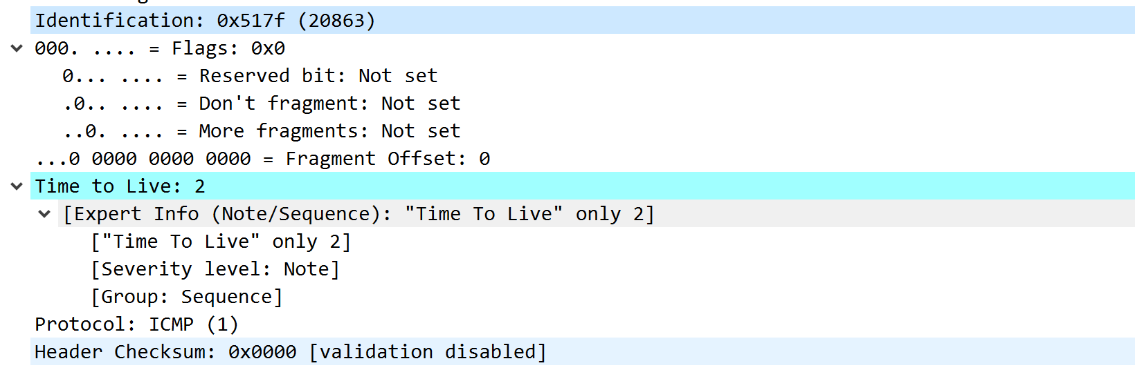

可以发现Time to live、Identification是不一样的（理论上Header Checksum也是会变，不知道为什么这里直接取0）

1. Which fields stay constant? Which of the fields must stay constant? Which fields must change? Why?

保持不变：显式拥塞通告(ECN)、全长、标志、分片偏移(fragment offset)、源地址(Source)、目的地址、选项。以上下次可能会改变。

必须保持不变：版本、首部长度(Internet Header Length)、区分服务(Differentiated Services)、协议。

必须更改：标识符、存活时间、首部检验和、负载数据

1. Describe the pattern you see in the values in the Identification field of the IP datagram

Next(with the packets still sorted by source address) find the series of ICMP TTLexceeded replies sent to your computer by the nearest (first hop) router.

根据观察不同报文Identification不一样。标识符主要用来标识一个报文的所有分片，因此对于不同报文就需要改变该值。



1. What is the value in the Identification field and the TTL field?

如下图所示：

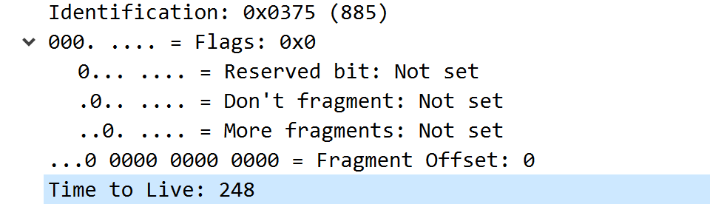

1. Do these values remain unchanged for all of the ICMP TTL-exceeded replies sent to your computer by the nearest (first hop) router? Why?

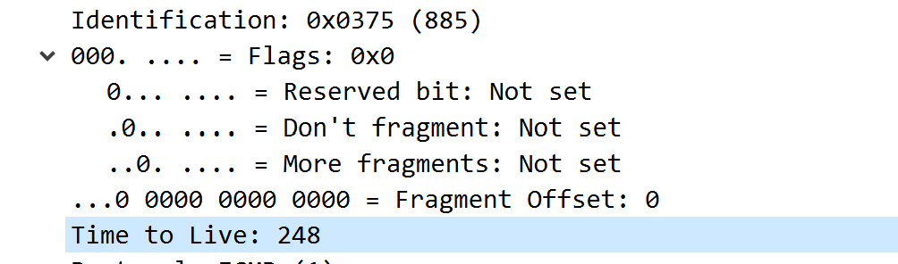

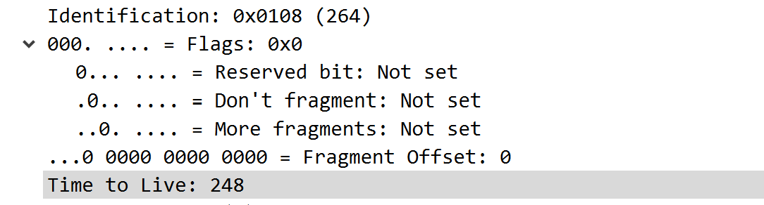

Identification有改变，TTL不变。因为一个路由中的数据包具有相同的寿命，而除分段的数据其他数据包都会有唯一的标识，标识相同表示他们来自同一个数据包的分片。

1. Find the first ICMP Echo Request message that was sent by your computer after you changed the Packet Size in pingplotter to be 2000. Has that message been fragmented across more than one IP datagram?

**本人的实验过程中并没有分片。从第十题开始，所以采用实验提供的数据。**



可以发现第一个ICMP Echo请求确实分片了。分成了以上两片。

1. Print out the first fragment of the fragmented IP datagram. What information in the IP header indicates that the datagram been fragmented? What information in the IP header indicates whether this is the first fragment versus a latter fragment? How long is this IP datagram



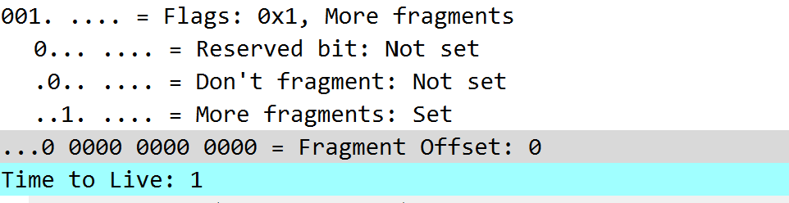

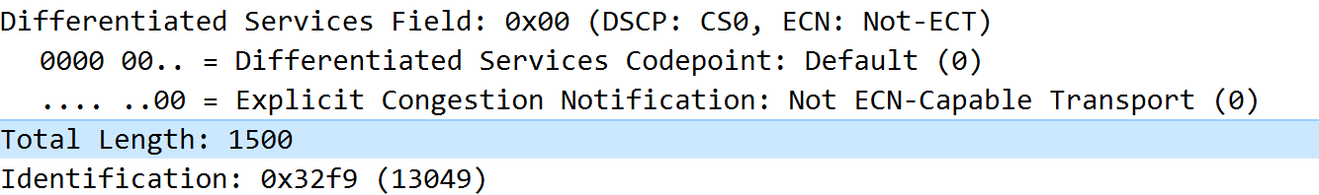

More fragments指示有分割，fragment offset为0表示偏移量为0，即为第一个数据报片段，总长度为1500。

1. Print out the second fragment of the fragmented IP datagram. What information in the IP header indicates that this is not the first datagram fragment? Are the more fragments? How can you tell?

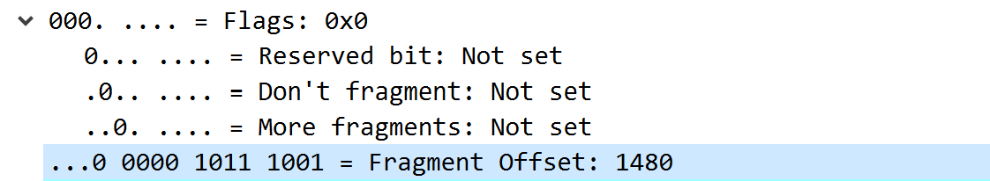

More fragment:Not set表示数据报不再被分段，Fragment Offset:1480表示其偏移1480，为第二个分段。

1. What fields change in the IP header between the first and second fragment

total Length、Flags、Header Checksum均发生了改变

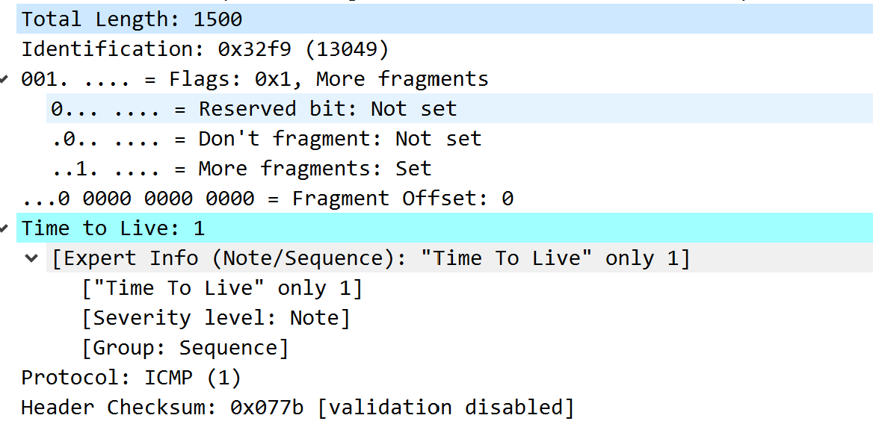

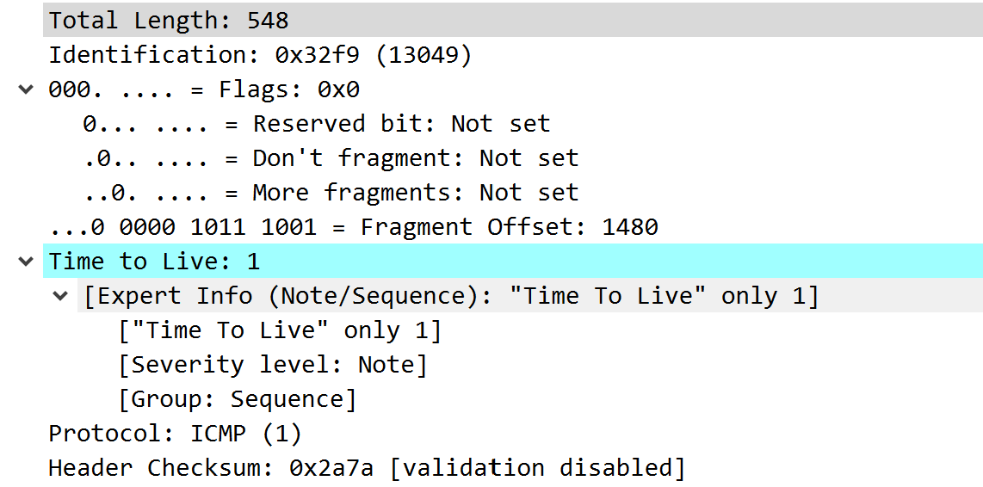

total Length：1500和548

Flags：0x0和0x1

Header Checksum：0x077b和0x2a7a

1. How many fragments were created from the original datagram?

3个fragments



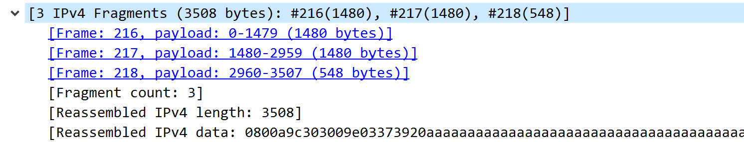

1. What fields change in the IP header among the fragments?

分片1

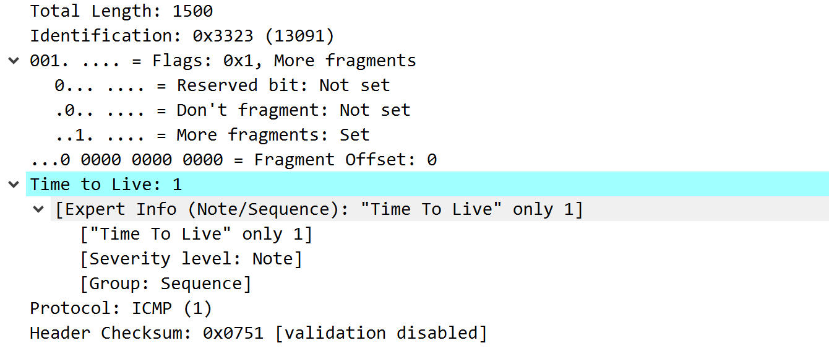

分片2

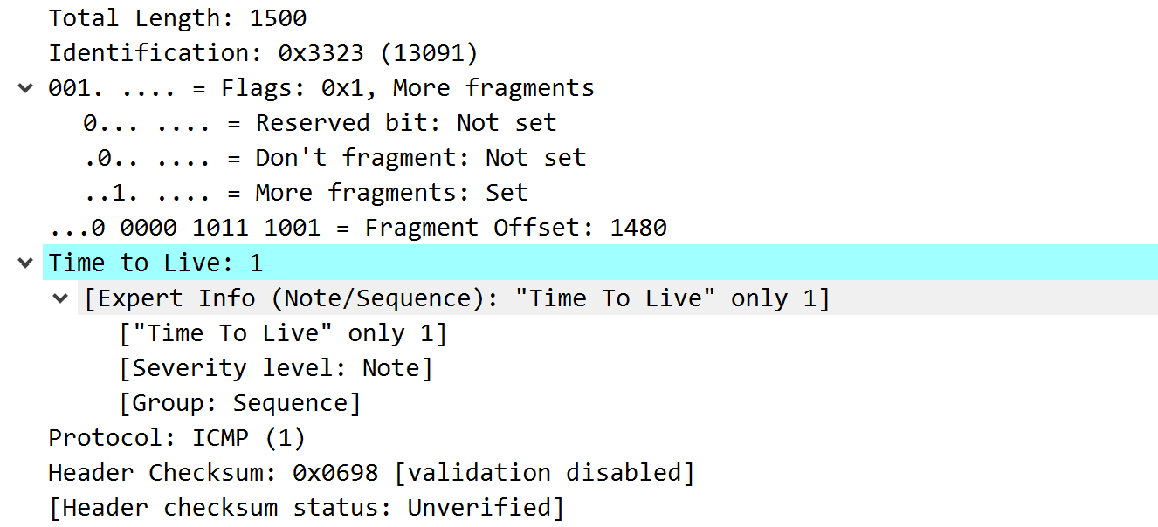

分片3

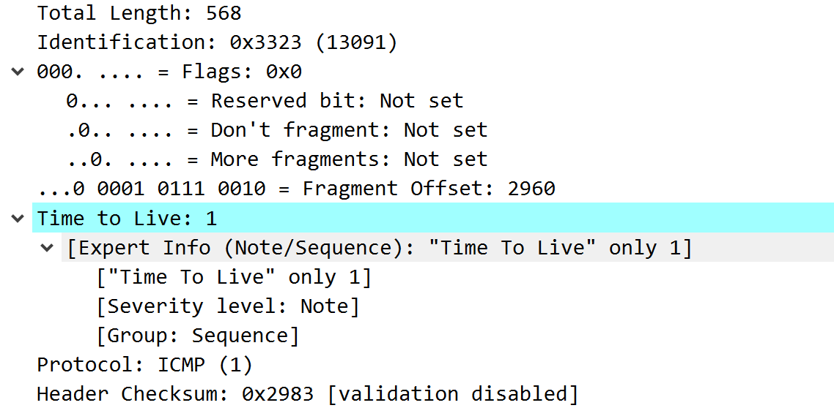

有图可以发现total length、Identification、flags、header checksum均有改变