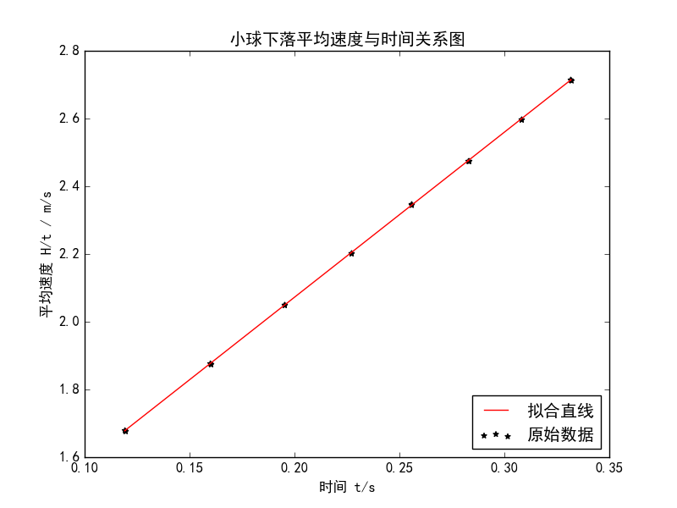

linear regression:   
 slope: 4.87328   
 intercept: 1.09774   
 r-value: 0.999993   
 p-value: 8.31738e-55   
 std-err: 0.00392303   
 r-squared: 0.999986   
 斜率标准差: 0.00392303   
 截距标准差: 0.000960499