大物实验数据 古宜民 2018/04/05

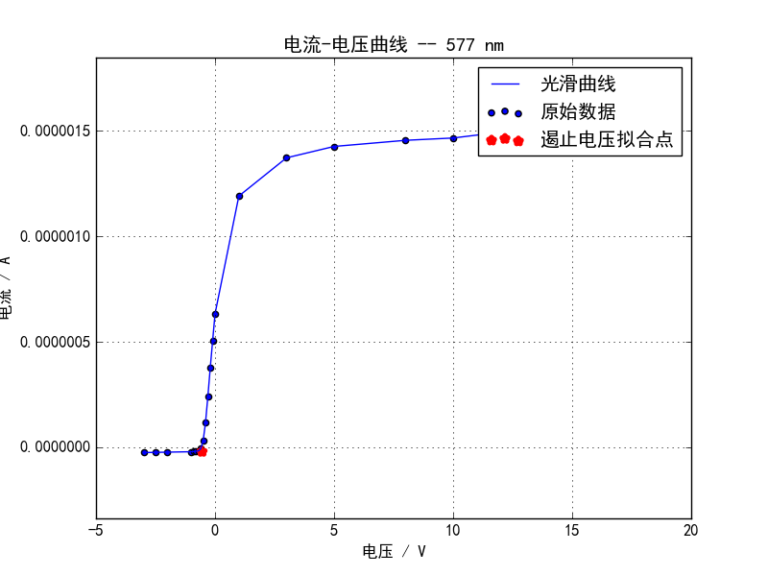

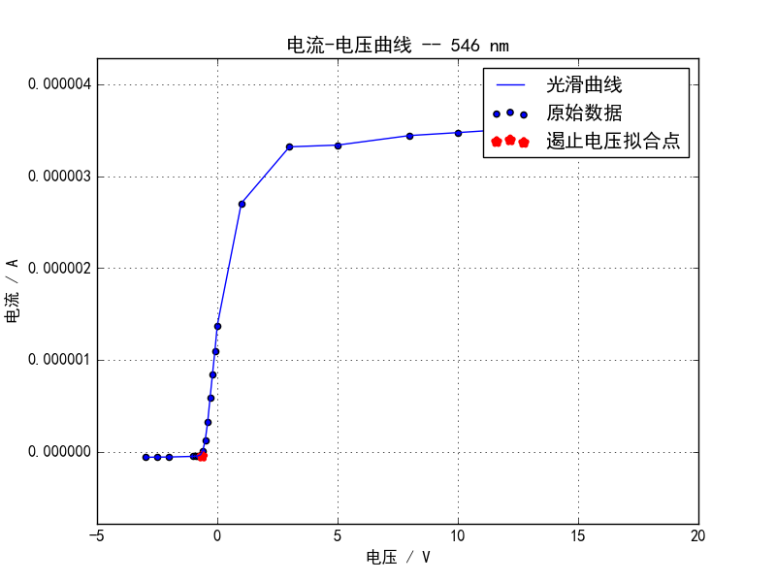

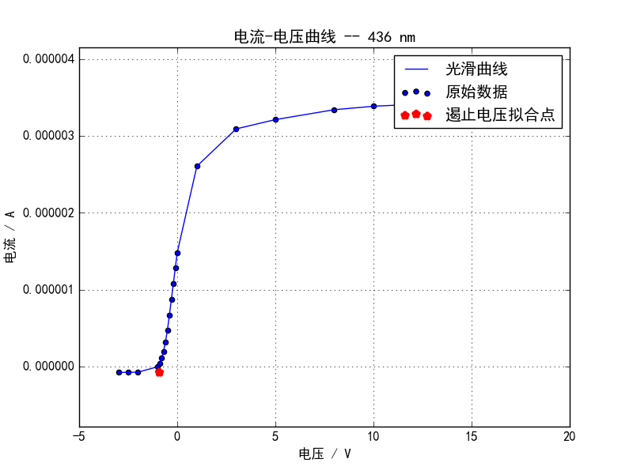

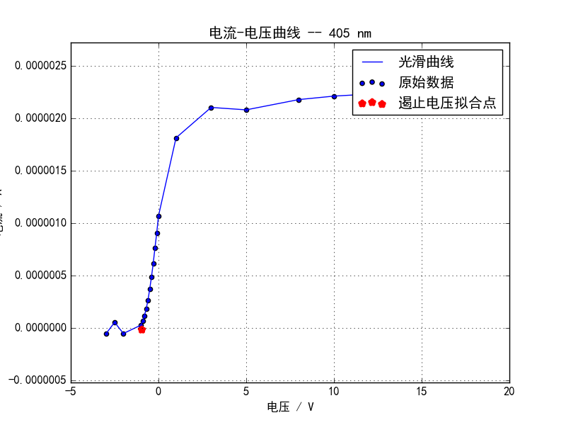

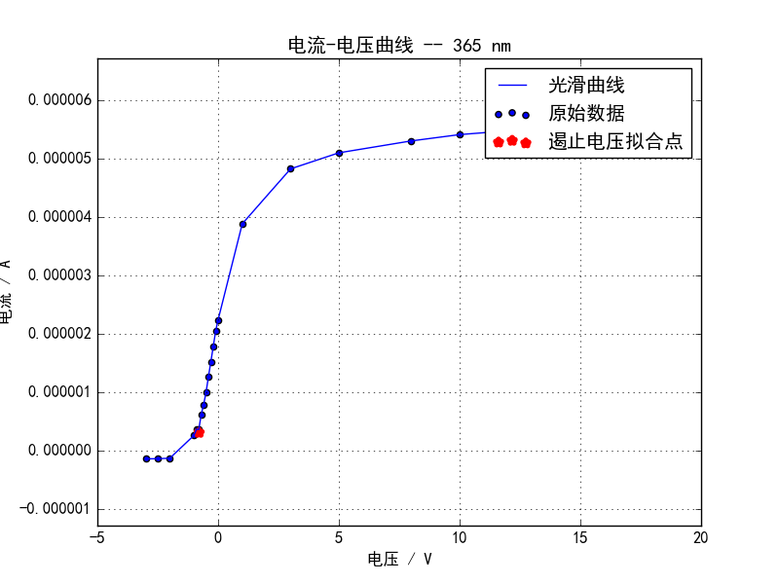

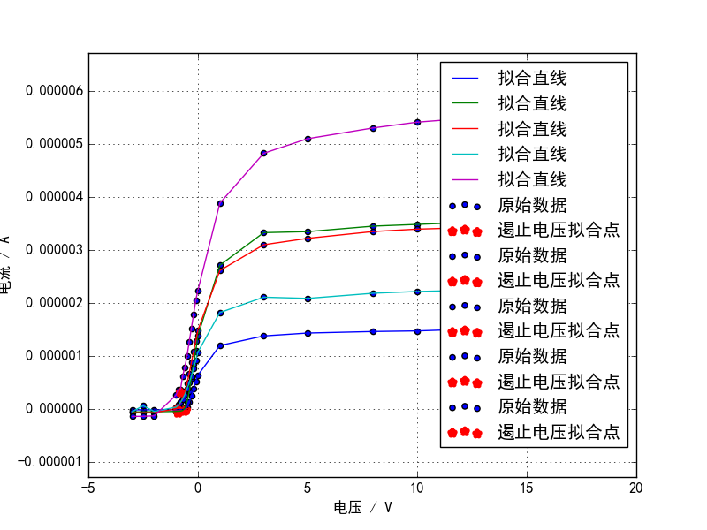

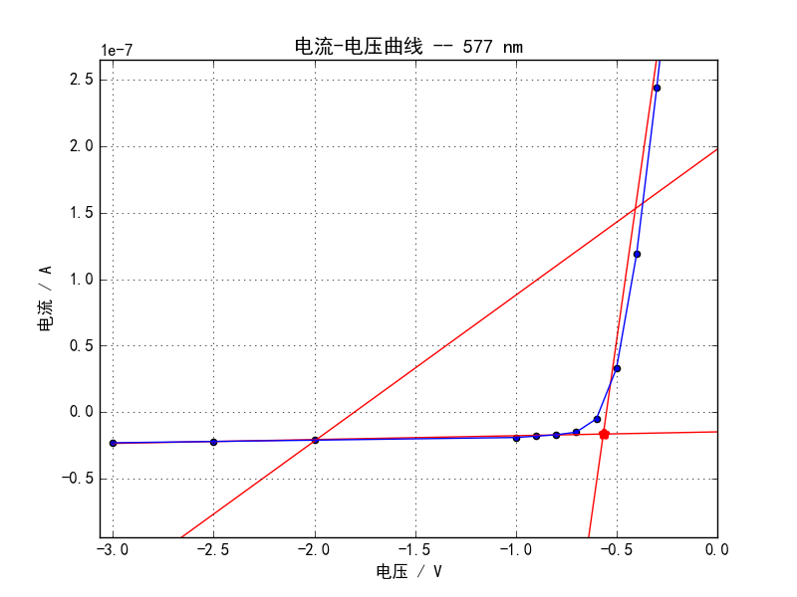

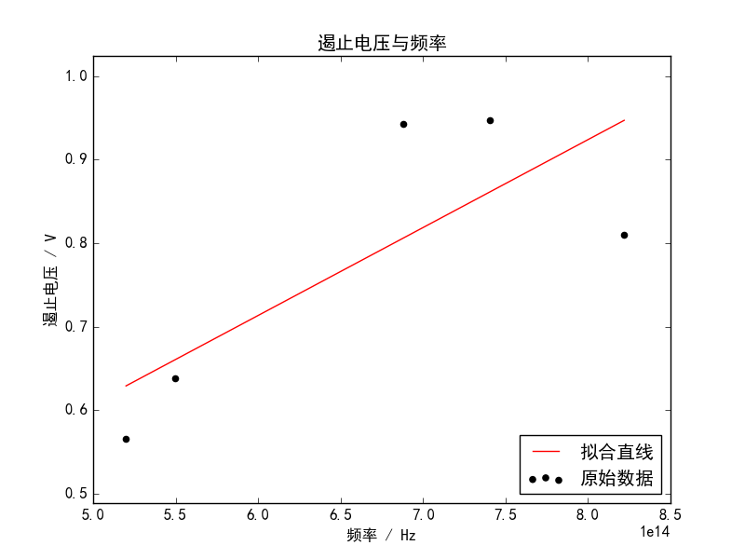

linear regression:   
 slope: 1.05242e-15   
 intercept: 0.0819916   
 r-value: 0.770757   
 p-value: 0.12713   
 std-err: 5.02272e-16   
 r-squared: 0.594067   
 斜率标准差: 5.02272e-16   
 截距标准差: 0.338422

