大物实验数据 古宜民 2018/05/04

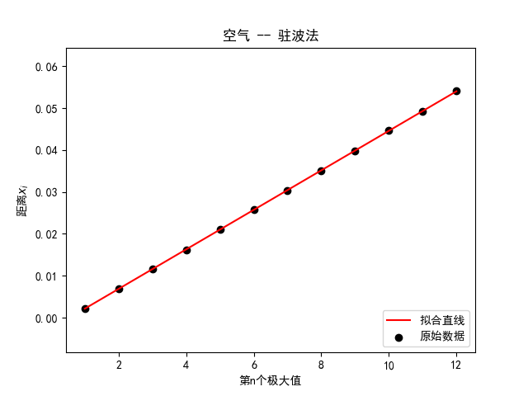

linear regression:   
 slope: 0.00471545   
 intercept: -0.00256212   
 r-value: 0.999986   
 p-value: 4.32624e-24   
 std-err: 7.90734e-06   
 r-squared: 0.999972   
 斜率标准差: 7.90734e-06   
 截距标准差: 5.81964e-05

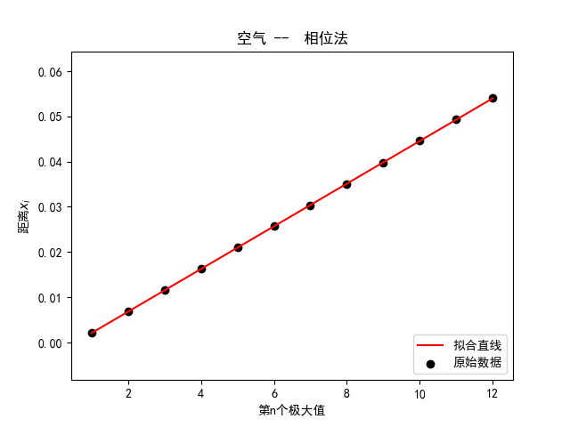

linear regression:   
 slope: 0.00471902   
 intercept: -0.00262364   
 r-value: 0.999999   
 p-value: 9.86792e-30   
 std-err: 2.15856e-06   
 r-squared: 0.999998   
 斜率标准差: 2.15856e-06   
 截距标准差: 1.58866e-05

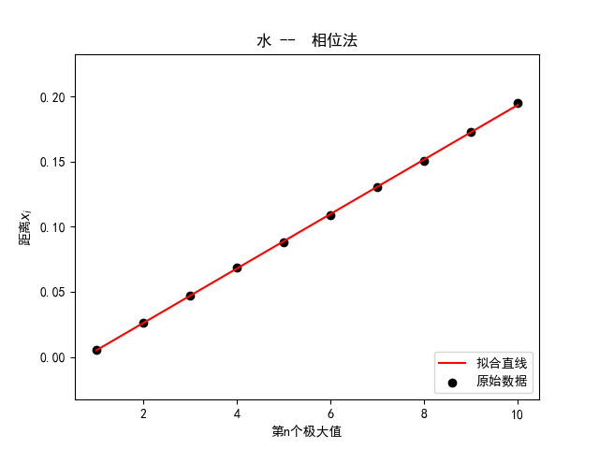

linear regression:   
 slope: 0.0209255   
 intercept: -0.01588   
 r-value: 0.999946   
 p-value: 3.62905e-17   
 std-err: 7.6651e-05   
 r-squared: 0.999893   
 斜率标准差: 7.6651e-05   
 截距标准差: 0.000475607