大物实验数据 古宜民 2018/11/04

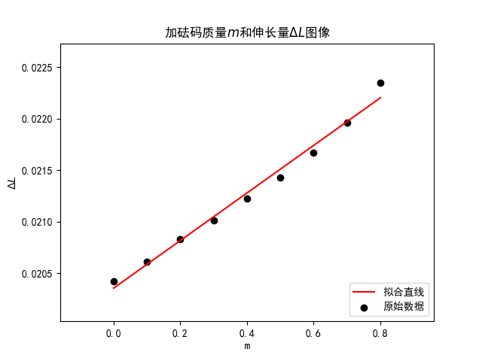

linear regression:   
 slope: 0.00230848   
 intercept: 0.0203552   
 r-value: 0.99362   
 p-value: 6.78696e-08   
 std-err: 9.90336e-05   
 r-squared: 0.987281   
 斜率标准差: 9.90336e-05   
 截距标准差: 4.71954e-05

E的值：13044141436.713682

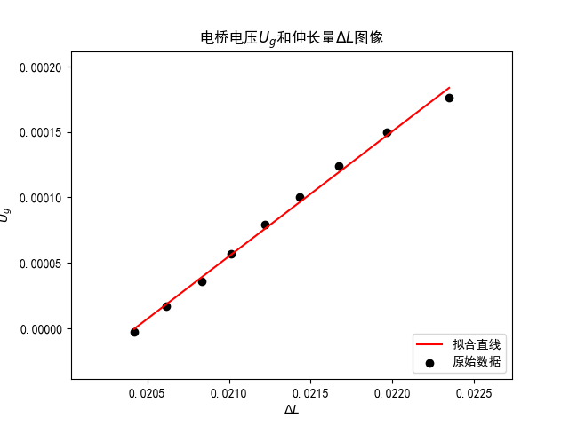

linear regression:   
 slope: 0.0955631   
 intercept: -0.00195176   
 r-value: 0.997839   
 p-value: 1.54129e-09   
 std-err: 0.00237839   
 r-squared: 0.995683   
 斜率标准差: 0.00237839   
 截距标准差: 5.06313e-05

μ的值：0.168978